**QUES-17.1- Write a program that accepts the job_id as argument and returns a custom counter and a system counter (total records input to the map tasks) associated with that job.**

**ANS-17.1-**

**Driver-**

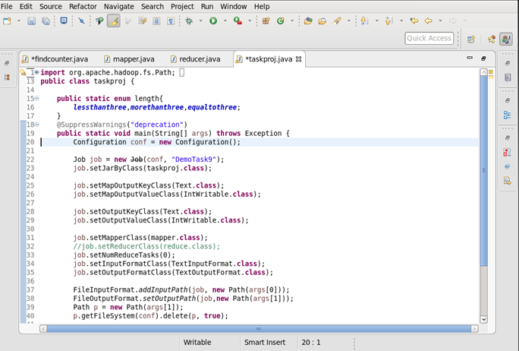

**Mapper-**

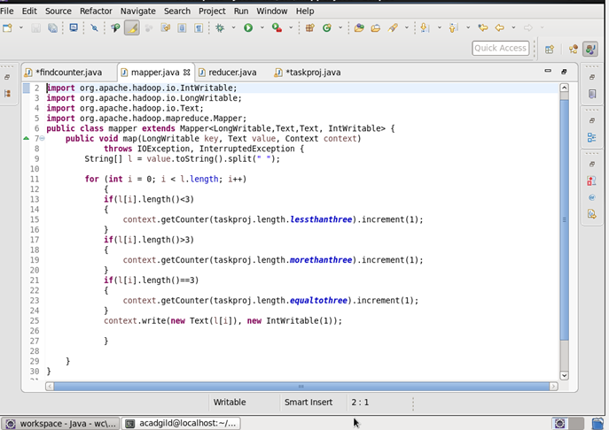

**Reducer-**

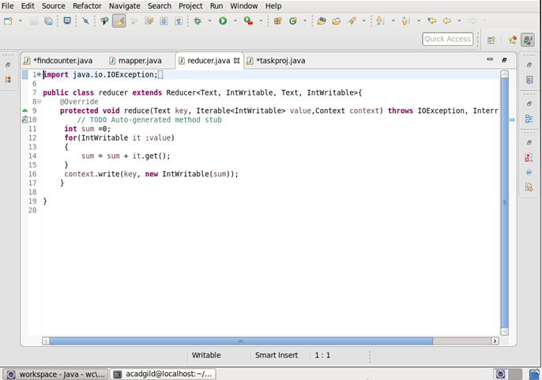

**Job Counter-**

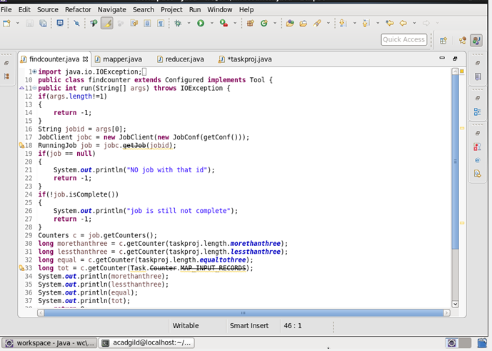

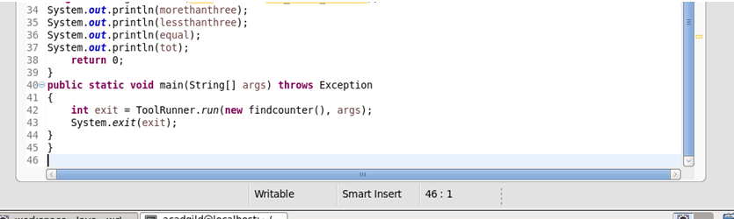

**Output-**

