**QUE-17.5- Write a map reduce program to desing a custom counter to count number of people are affected with 'PULMONARY' disease and 'BRONCHITIS & ASTHMA' in the state 'CA'.**

**ANS-17.5-**

***PROGRAM-***

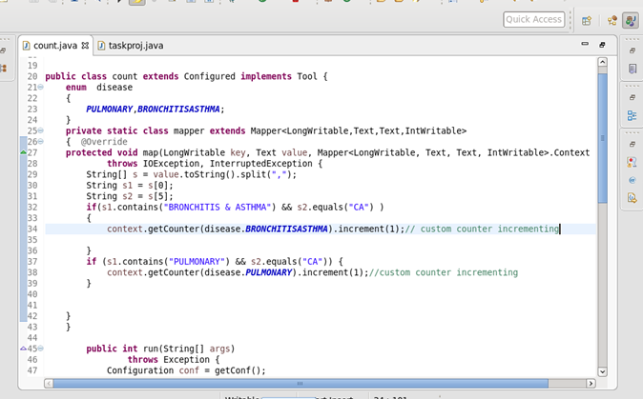

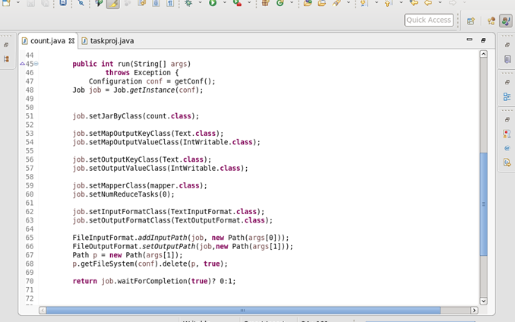

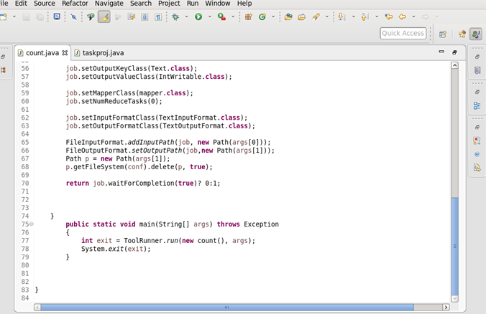

***OUTPUT-***

