**ASSINGMENT-25.6-**

***Commands for creating table-***

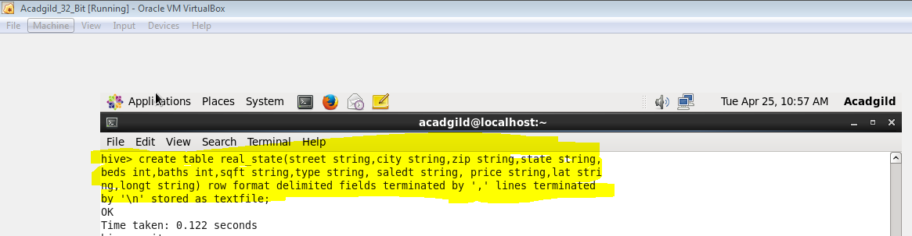

***Commands to load the file-***

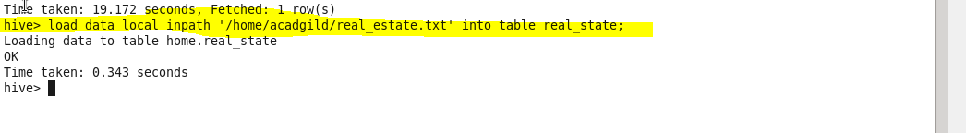

1. **Write a hive query to find the city wise list all the Condos which is not less than ten thousand.**

**ANS-1-**

***COMMAND-***

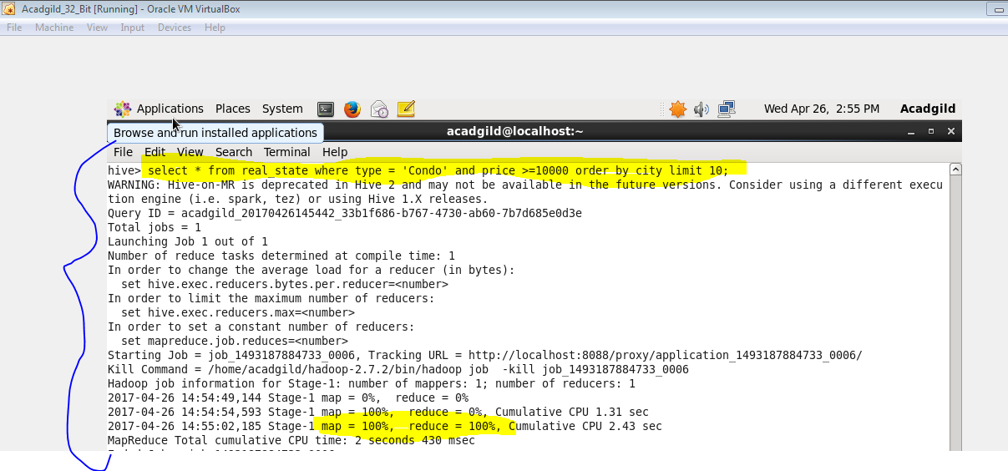

***OUTPUT-***

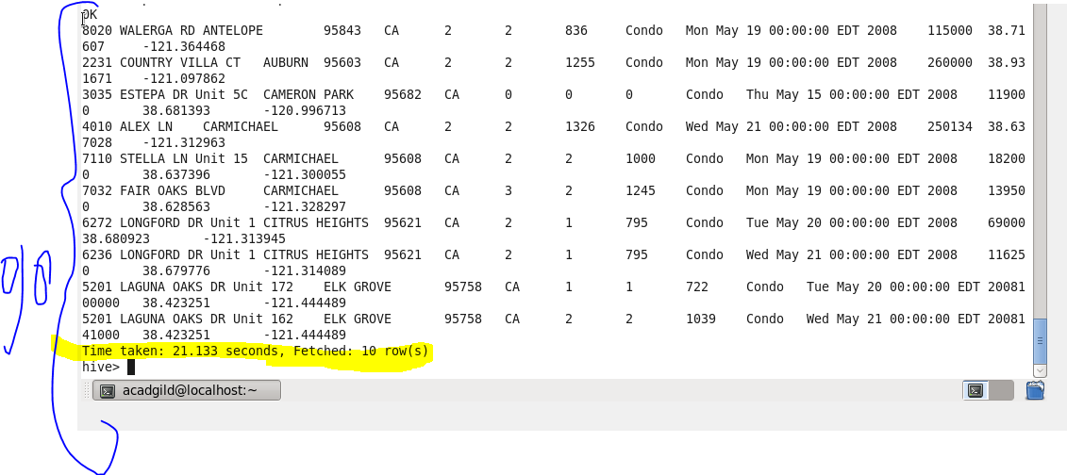

**2.Write a hive query to find which is the cheapest Condo in CA. name the city,street and price for the Condo.**

**ANS-2-**

***OUTPUT-***

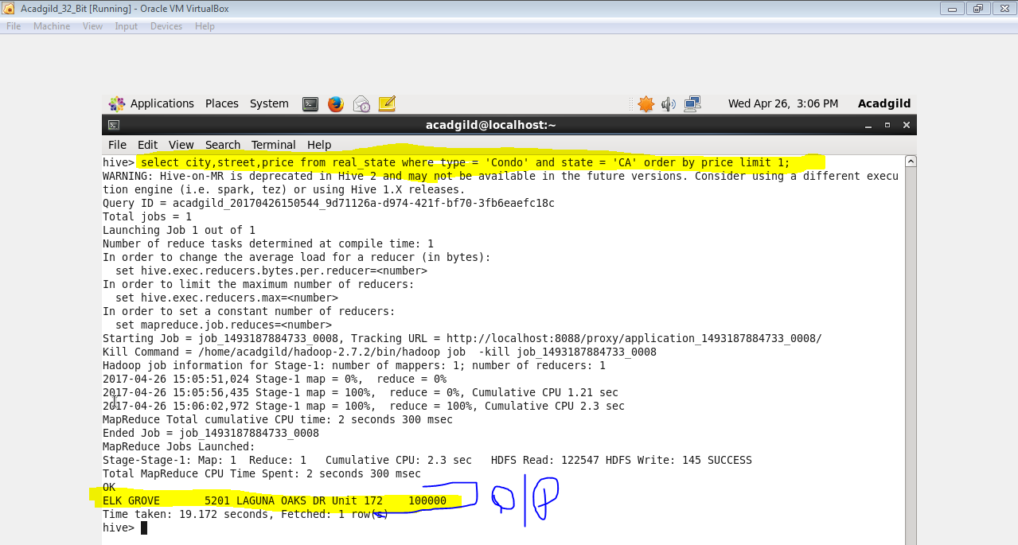

**3.Write a hive query to list top 5 residency details which lie in the budget of 60000-120000, an area more than 1450, sold after 17th may, min bedroom 3 and, min bathroom 2.**

**ANS-3-**

***COMMAND-***

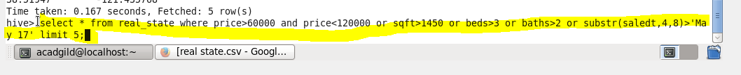

***OUTPUT-***

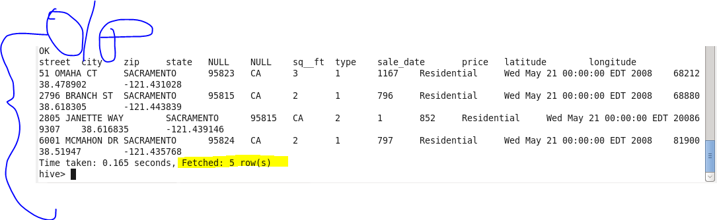

**4. Write a hive query to separate list of residential apartments with more than 2 beds. Also include columns in following order City, Baths, Sq_feet, Price, flat_type, Beds respectively.**

**ANS-4-**

***COMMAND-***

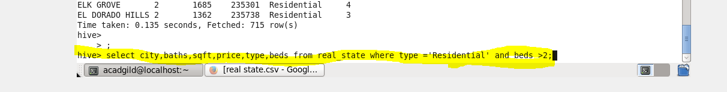

***OUTPUT-***

