**QUE-7.5- Write a map only job for the word count program and set the output format as sequence file.**

**ANS-7.5-**

**DRIVER-**

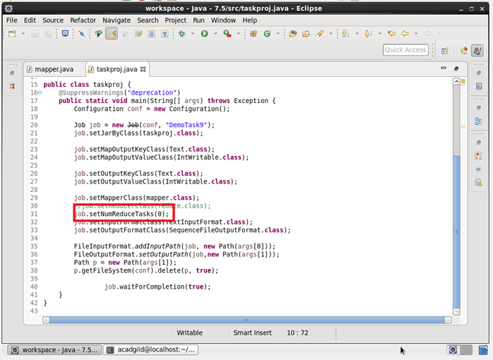

**MAPPER-**

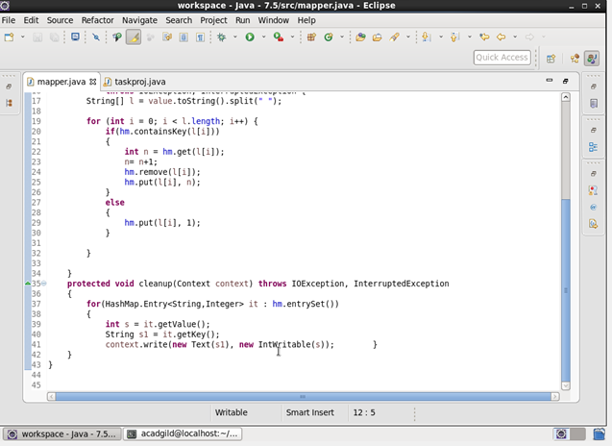

**IMPLEMENTATION-**

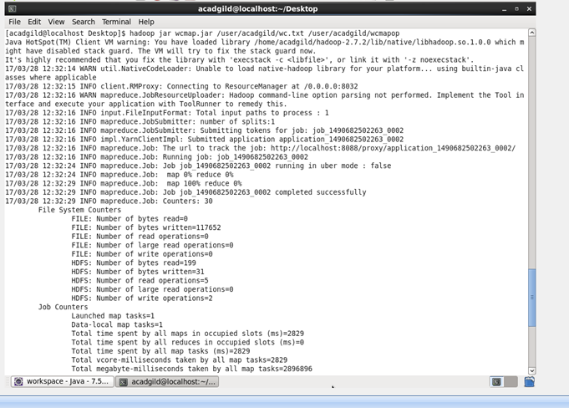

**DATASET-**

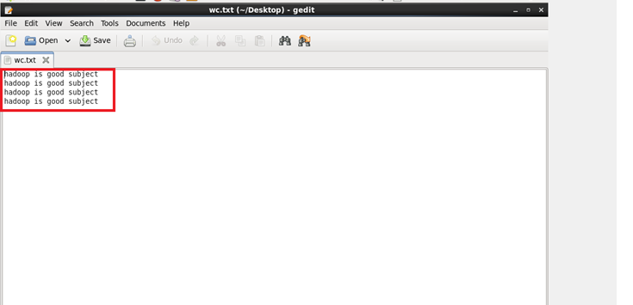

**OUTPUT-**

