**QUE-8.5- Download and import HDP into your virtual box and explain how Ambari is useful and the features of Ambari.**

**ANS-8.5-**

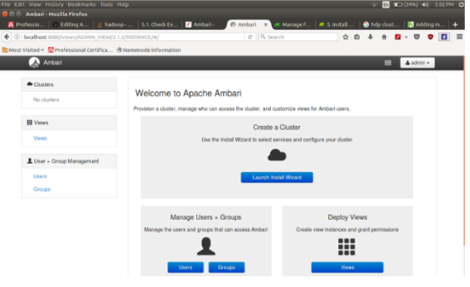

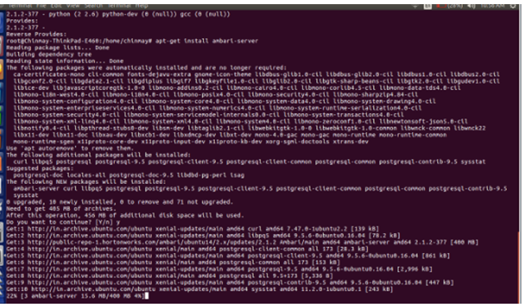

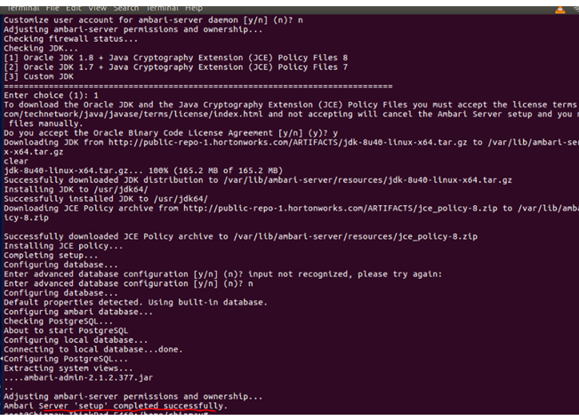

**FEATURES OF AMBARI-**

The Apache Ambari project is aimed at making Hadoop management simpler by developing software for provisioning, managing, and monitoring Apache Hadoop clusters. Ambari provides an intuitive, easy-to-use Hadoop management web UI backed by its RESTful APIs.

Ambari enables System Administrators to:

* Provision a Hadoop Cluster
  + Ambari provides a step-by-step wizard for installing Hadoop services across any number of hosts.
  + Ambari handles configuration of Hadoop services for the cluster.
* Manage a Hadoop Cluster
  + Ambari provides central management for starting, stopping, and reconfiguring Hadoop services across the entire cluster.
* Monitor a Hadoop Cluster
  + Ambari provides a dashboard for monitoring health and status of the Hadoop cluster.
  + Ambari leverages [Ambari Metrics System](https://issues.apache.org/jira/browse/AMBARI-5707) for metrics collection.
  + Ambari leverages [Ambari Alert Framework](https://issues.apache.org/jira/browse/AMBARI-6354) for system alerting and will notify you when your attention is needed (e.g., a node goes down, remaining disk space is low, etc).

Ambari enables Application Developers and System Integrators to:

* Easily integrate Hadoop provisioning, management, and monitoring capabilities to their own applications with the [Ambari REST APIs](https://github.com/apache/ambari/blob/trunk/ambari-server/docs/api/v1/index.md).