**ANS-23.1-**

**INPUT FILE-**

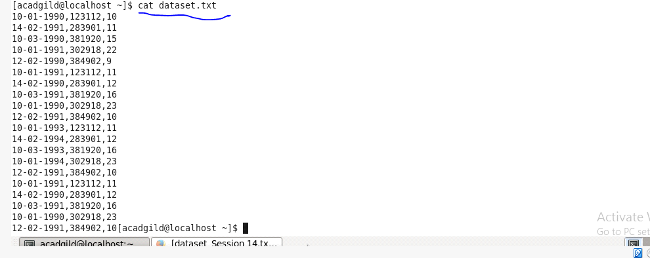

**CREATING DATABASE CUSTOM-**

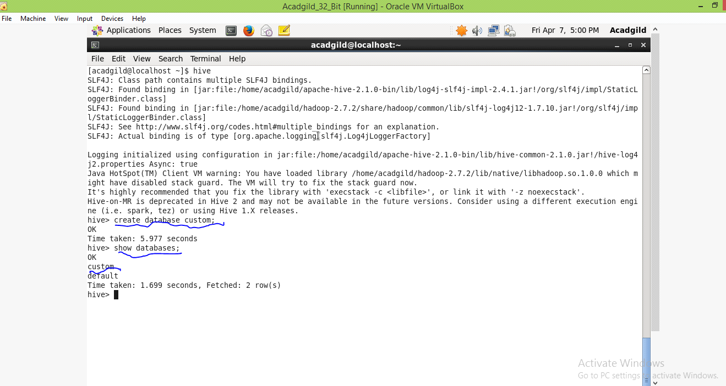

**CREATING TABLE TEMPERATURE_DATA-**

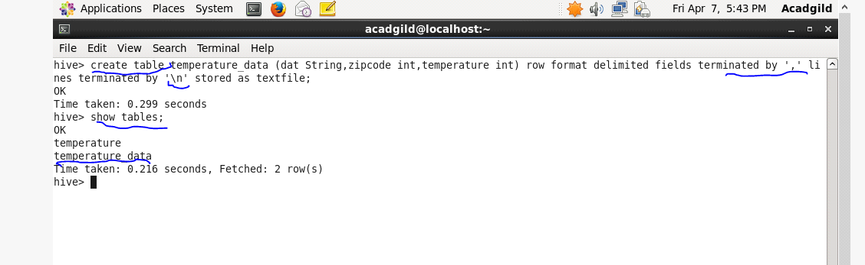

**LOADING DATASET.TXT**-

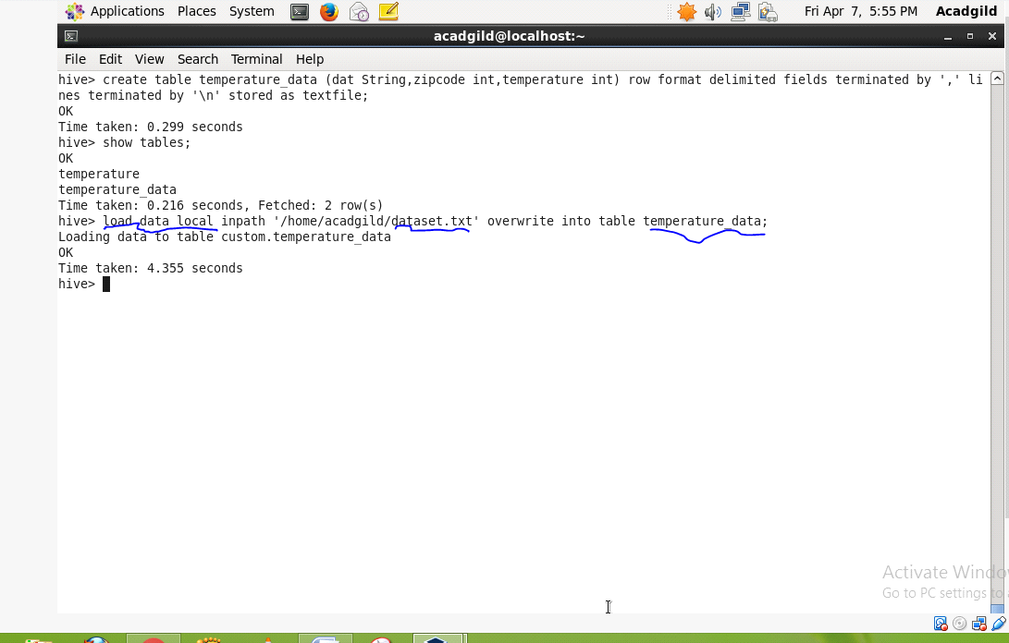

**SHOWING THE DATA OT TABLE TEMPERATURE_DATA-**

