**Que-8.1.1- Write a mapreduce program to find the total amount of petrol in volume sold by every distributor.**

**Ans-8.1.1-**

**Driver-**

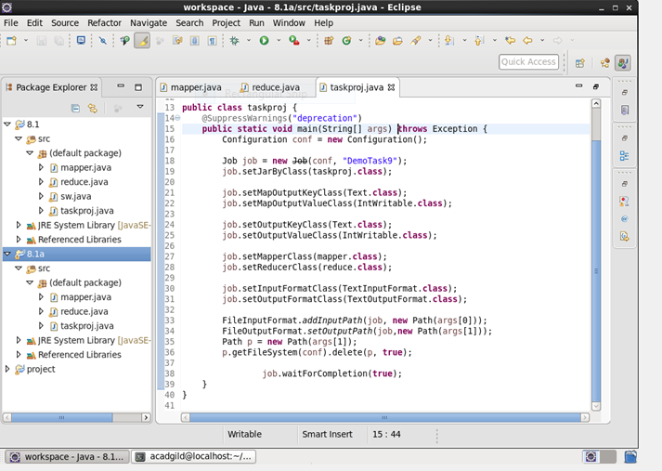

**Mapper-**

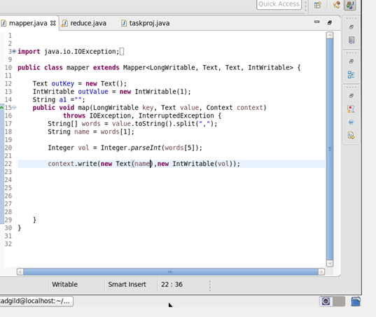

**Reducer-**

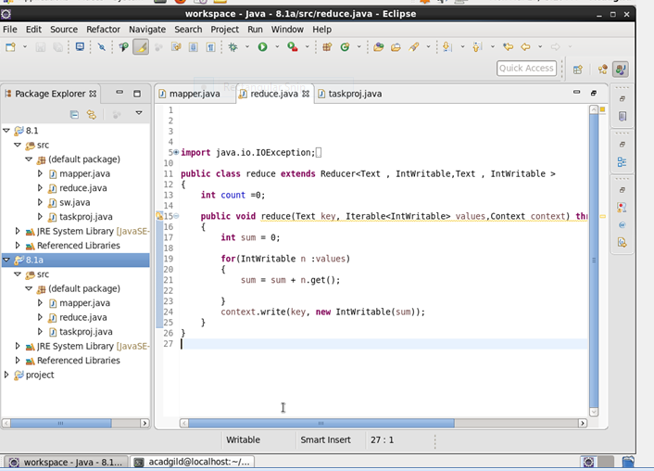

**Output-**

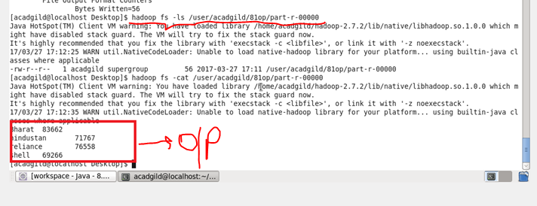

**QUE-8.1.2- Write a mapreduce program to find which are the top 10 distributors ID's for selling petrol and also display the amount of petrol sold in volume.**

**Ans-8.1.2-**

**Driver-**

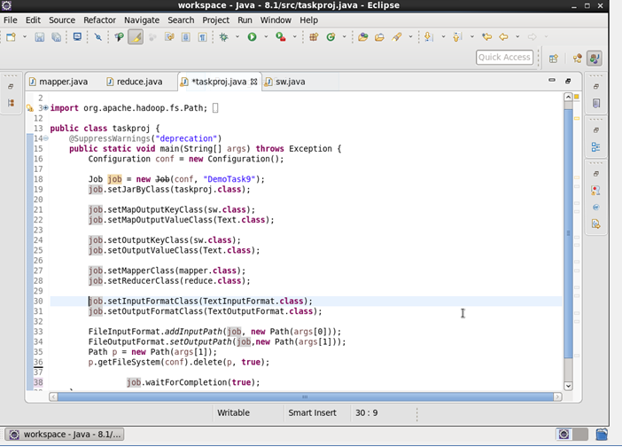

**Mapper-**

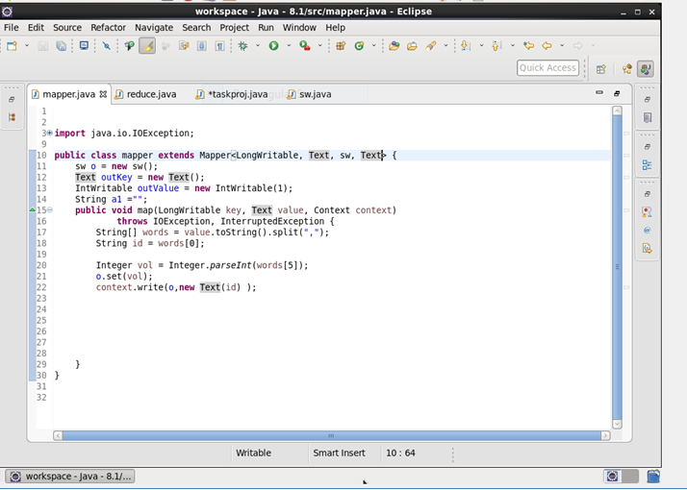

**Reducer-**

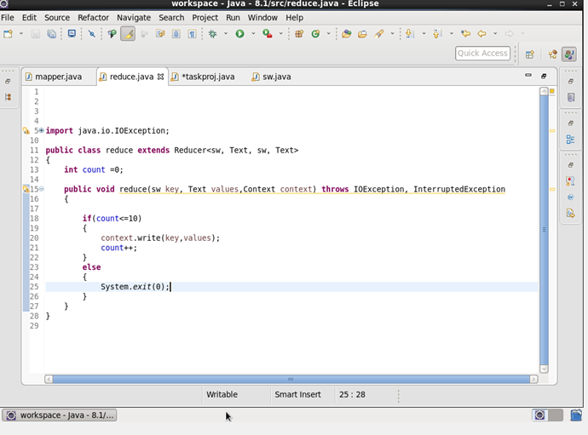

**Custom writable-**

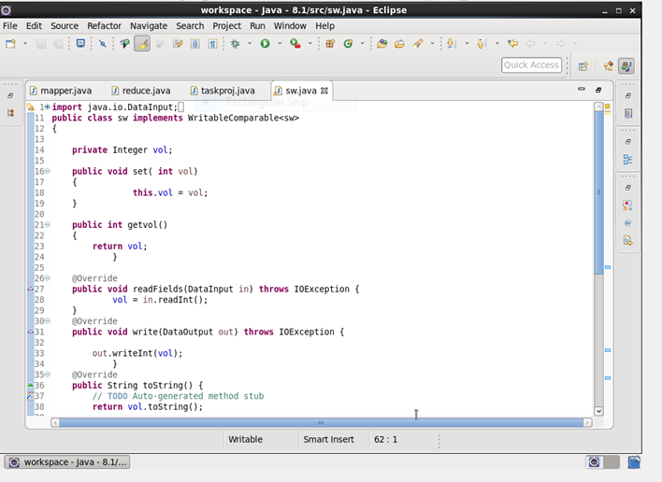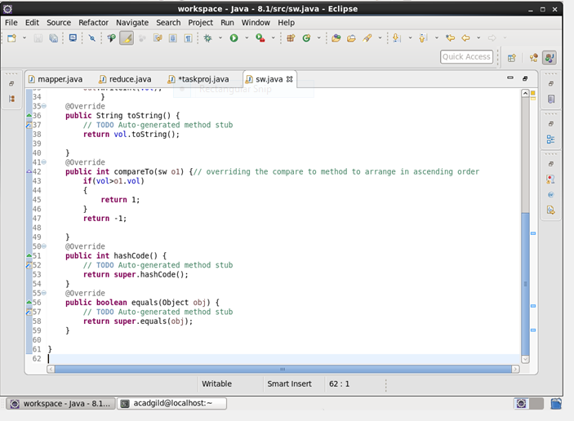

**Output-**

