**Ans-10.1-**

**Load the data from Local-**

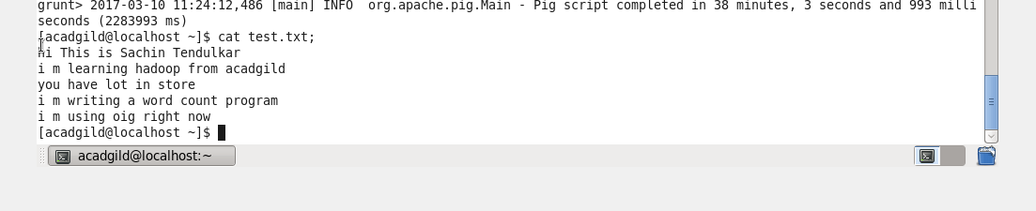

**Convert the sentence into words-**



**Convert column into rows-**



**Apply group by -**



**Generate word count-**

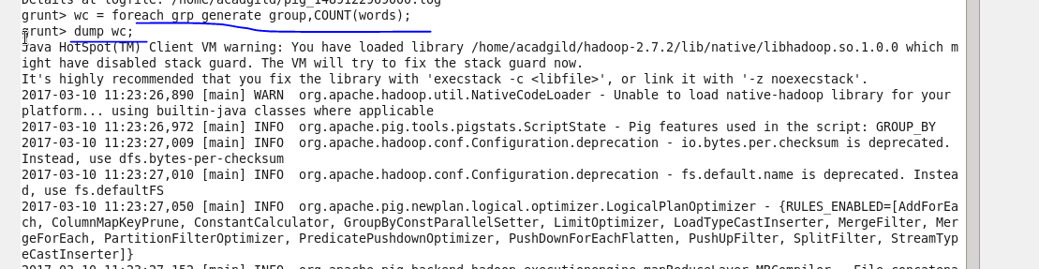

**Output-**

