# RESULTS

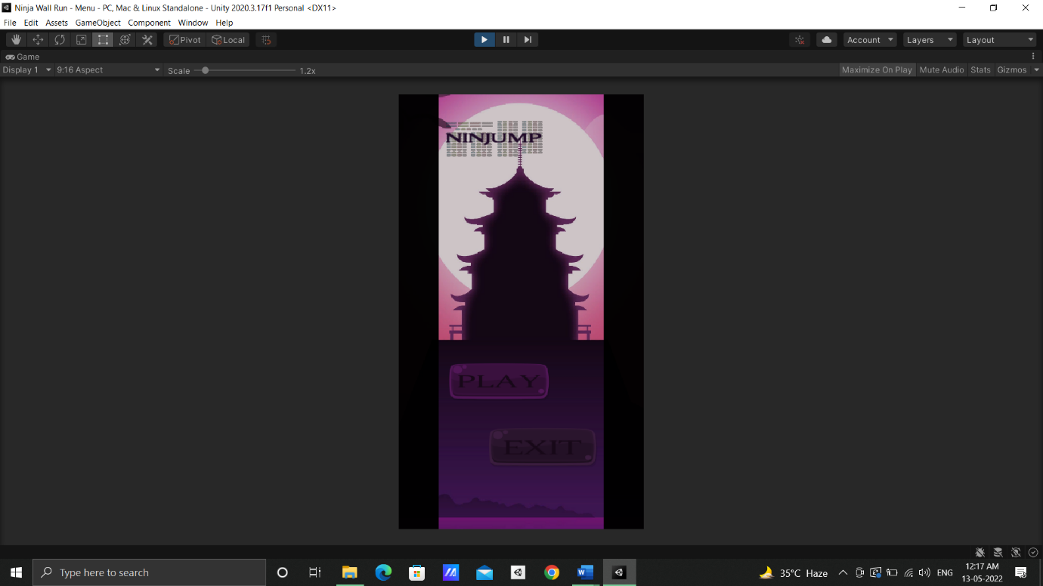

Fig 1 Main Menu

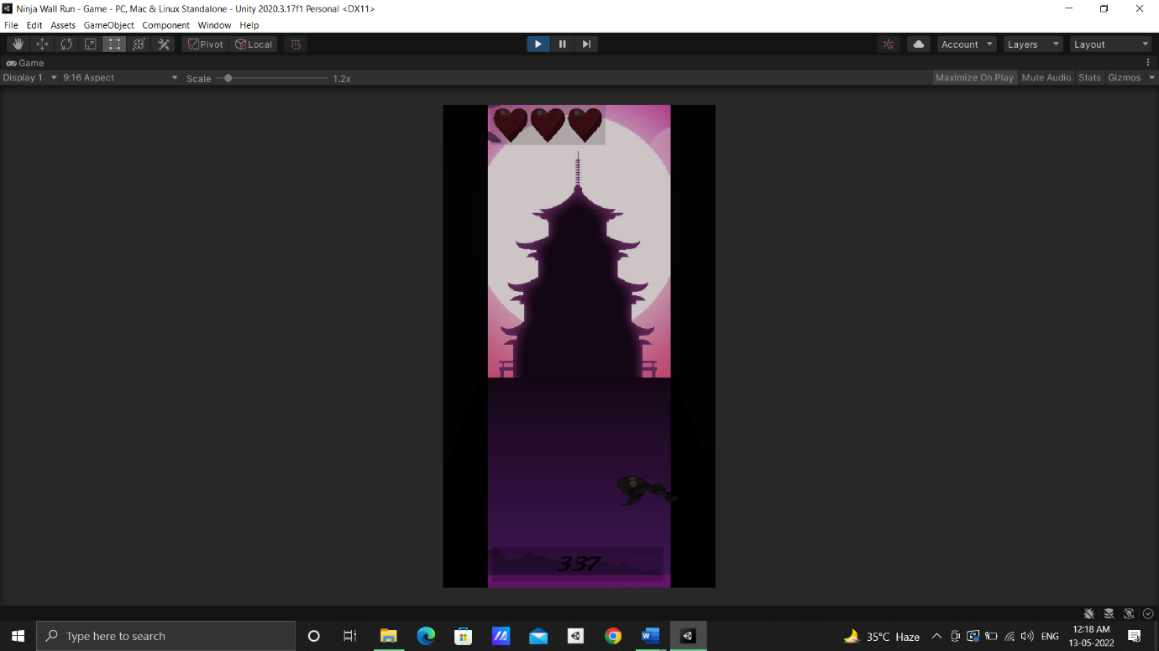

Fig. 2 Game Starting

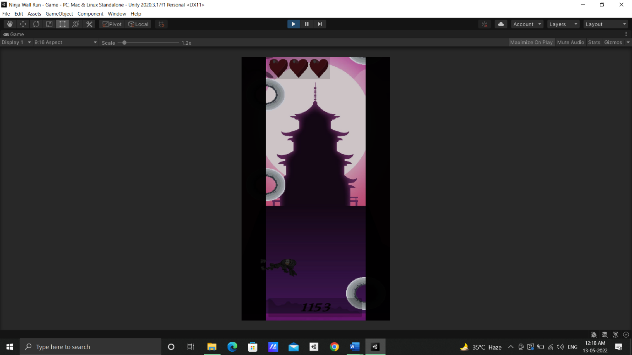

Fig. 3 Avoiding Obstacles

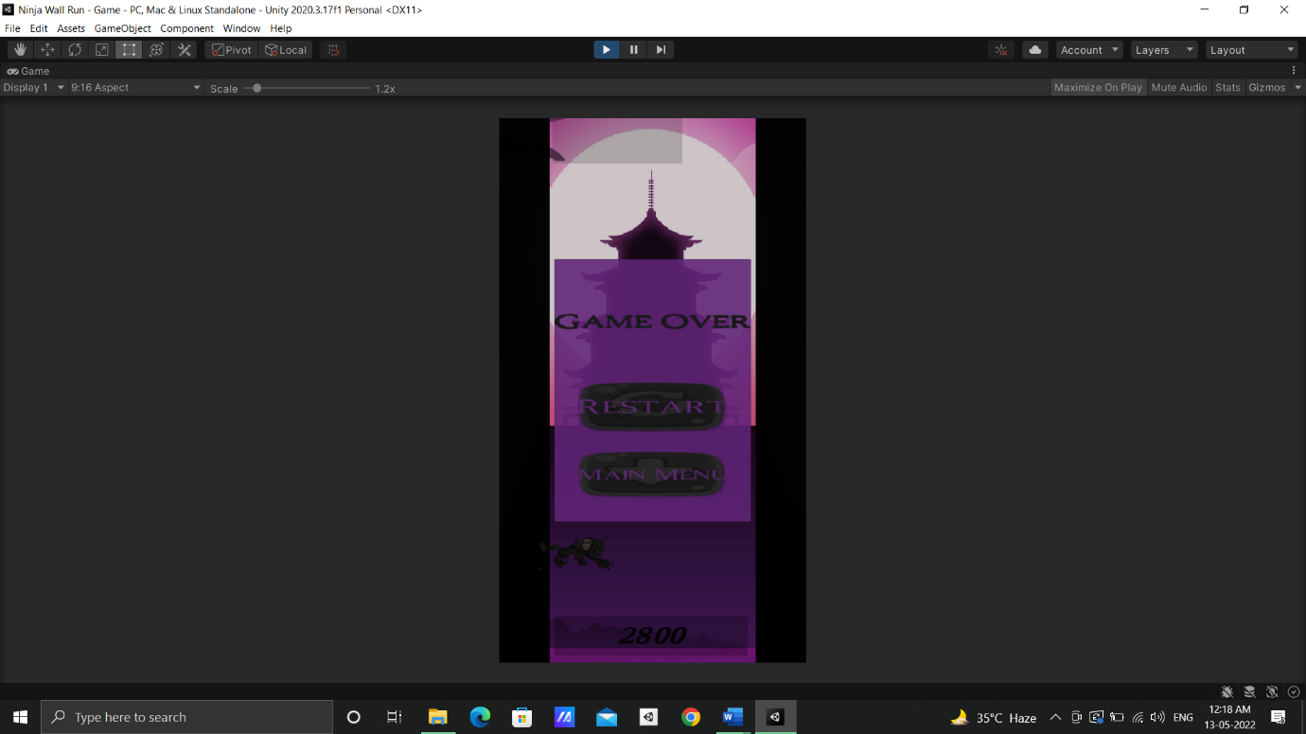

Fig. 4 Game Over

# CONCLUSION & FUTURE PROSPECTS

Games are undeniably a source of entertainment for everyone but they are not so easily produced. Games, just like any other software require a lot of resources, time and a good design to perform well and meet the expectations of the users. This Project is an attempt to create a game following such prospects and live up to the expectations. Surely this project can be improved in a lot of ways with better resources and design. All the same, this is a good representation of creating something from scratch and delivering before deadline while meeting the requirements. This project (NINJUMP) is a 2D endless runner game, in which the player can "run" through the game until an obstacle stops him, with the goal of getting the highest score possible. They are an accessible genre that virtually anyone can pick up and play due to their quick play, addictive nature, and simple controls. This is developed using Unity Game engine and C#. Many people are already familiar with Unity, which is one of the most widely used game engines of all time. Unity is primarily used to create 3D games, but it can also be used to create 2D games.