# An efficient approach to find optimal network route using Swarm Intelligence

A Synopsis Submitted

in Partial Fulfillment of the Requirements

for the Course of

# Minor Project - I

In

Third year – Fifth Semester of

**Bachelor of Technology**

specialization

In

# DevOps, CCVT and OSS.

Under

**Mr. Ahatsham**

By

# 500060720 R171217041 Nishkarsh Raj

# 500060110 R171217031 LakshikaParihar

# 500060183 R100217030 Harsh Joshi

# 500060668 R110217119 Priyanka Yadav



DEPARTMENT OF CYBERNETICS AND VIRTUALIZATION

SCHOOL OF COMPUTER SCIENCE

UNIVERSITY OF PETROLEUM AND ENERGY STUDIES, BIDHOLI, DEHRADUN, UTTRAKHAND, INDIA

# Aug, 2019

**Abstract**

# 

In today’s world, fast and efficient communication on network between the sender and receiver is very important. For this communication, data is converted into packets and sent over the network using routing algorithms. In a network or over multiple networks, routing refers to the process of determining a path for a packet to travel from. The traditional algorithms used in networking for finding the minimum spanning tree and shortest path include Prim’s algorithm and Kruskal’s Algorithm. These methods solve the problem of traffic in networking in the narrow investigation of search space and hence result in inferior solutions. In this project, we aim to propose the basic idea of optimizing network routing using swarm intelligence. Particle swarm intelligence is a technique that utilizes the behavior of self-organizing, decentralized systems. It is considered to be a very optimum global search algorithm.

*Keywords: Network Routing, Optimization, Swarm Intelligence, PSO Algorithm, Minimum Spanning Tree*

**Introduction**

This project aims to compare and summarize the computer network routing strategies while investigating the optimization of these using PSO techniques. The project focuses on minimal spanning tree and solves the shortest path problem using swarm intelligence. Particle Swarm Intelligence utilizes the combination of the behavior of swarms which is considered efficient for optimization and discrete multidimensional problems.

The algorithm is based on a population-based technique which was discovered by Kennedy and Eberhart in 1995. The technique is inspired by the natural social behavior of particles insides swarms. One of the examples depicting the same is the flocks of birds. Technically, the particles also referred to as agents travel/swarm through the N-dimensional space. The governing rules for the movement are based on natural flocking rules which make the agents flow through the best-found solution hoping to find the better one.

Networks are treated as graphs G(V,E) consisting of V vertices/nodes and E edges.

* The graphs are bi-directional (undirected) because data can flow both sides.
* Weighted graph is used where weight indicates distance/cost etc.
* Connected graph is used as all nodes in a network are connected with each other.

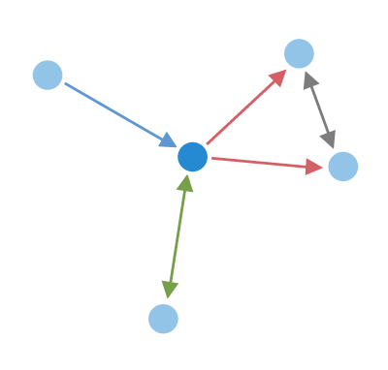

Figure 1. Network G(V,E) with V = 5 and E =5

Figure 1 depicts a graph containing 5 vertices and 5 edges. It is a connected and undirected graph that can be used to represent a network.[1]

In Particle Swarm Optimization Algorithm, a subset of Swarm Intelligence, we optimize network routing by modifying traditional graph algorithms like Minimum Spanning trees by Kruskal’s or Prim’s methods by using cognitive intelligence algorithm to get better optimization and solve MDR(Multi Destination Routing) problem which cannot be solved effectively using traditional methods.

Particle Swarm Optimization algorithm implementation on network routing gives fast convergence speed, has an easy implementation, is cognitive and supports dynamic traffic.

# Motivation

The motivation for this project is to optimize the networking route by modifying the traditional routing algorithms with Swarm Intelligence to account for dynamic changes in network like traffic.

While Kruskal’s algorithm is extremely easy to implement and gives optimum results when there are large number of edges or vertices, but it fails when edges have same weights or in the presence of a cycle. The concept of same weight increases its complexity, while it gets really slow and is hard to program for cases where there is a cycle in the graph.

To overcome the shortcomings, Particle Swarm Optimization offers much simpler algorithm that proves to be quite effective and efficient for a wide range of functions.

It has the following advantages –

1. Easy to implement
2. Free of any derivatives
3. Takes in very few input parameters
4. Provides a globally efficient search algorithm.
5. Can be parallelized easily, for cases that need concurrent processing.

**Problem Statement**

The problem in traditional network routing approach is that they are only meant for finding the shortest path from one node in the system to other. They do not account for other costs like network traffic, delay, conversion time for packets to messages and intermediate nodes etc.

Also, their solution path for one connection is also static but different paths may be optimum depending on the network traffic; i.e., they do not account for experience gathered by previous packets sent in the system.

**Objective**

The main objective of the project is to optimize the network route for packets in data transmission. Another major objective is to tackle the issue of dynamic network factors like traffic, network delay, noise factors etc. For this, we modify the traditional Minimum Spanning Tree algorithms with Particle Swarm Optimization algorithm.

**Literature Review**

In the research paper for SIBCast, Jaffar and Subramanyam describe the basics of Swarm Intelligence and Particle Swarm Optimization algorithm. The research paper focuses on gaining cognitive knowledge for decision making.[2]

The research paper “Steady state particle swarm” depicts an easy implementation of Particle Swarm Optimization algorithm, which this project tries to emulate in the context of networking. The paper also defines features and advantages of PSO algorithm.[3]

In the paper, “Network Routing Optimization using Swarm Intelligence”, Hassan defines the PSO algorithm in context of network routing. The paper focuses of network routing optimization with use of PSO algorithm and probabilistic. [4]

**Proposed Method**

**Using PSO Algorithm of Swarm Intelligence with traditional Minimum Spanning Tree algorithms to find Optimum Network route**

**Particle Swarm Optimization Algorithm for Network Routing Optimization:[5]**

Swarm Intelligence Algorithms are based on Swarms (large population living together, example, Birds, Fishes, and Ants etc.) and Artificial Intelligence.

They used cognitive experience of each individual to increase the global intelligence to take consensual decision best for the population.

All particles move together in sync, they may diverge from each other occasionally but always regroup to share their experience.

Swarm Intelligence’s Particle Swarm Optimization Algorithm simulates the social behavior of living people by using a computer aided model.

PSO Algorithm is simple to implement, uses little memory and even works in limited resource environments.

**Minimum Spanning Tree Algorithms [5]**

1. **Kruskal’s Algorithm**
2. Each node is an individual and independent set initially denoted by superset S.
3. Sort edges in increasing order E.
4. Add shortest edge that connects two nodes from set E.
5. Repeat step 3 until all nodes of set S are connected.
6. **Prim’s Algorithm**
7. Create a set MST that keeps track of vertices already in MST (initially empty.)
8. Assign a key value for all vertices in the graph.  
   Initialize all key values as infinity except the source vertex marked as 0.
9. While MST set does not include all the nodes of the graph, perform following steps:
10. Pick a vertex U which is not in MST set and has minimum key value.
11. Include U in MST set.
12. Update key values of all adjacent nodes of U.  
    For every adjacent vertex Vi, if weight U to Vi is less than previous key value of Vi, update the key value of Vi else continue.

**Methodology**

**Basic flow of Particle Swarm Optimization (PSO) Algorithm:[4]**

1. Fill the N-Dimensional space with randomly placed particles.
2. Initialize each particle property with random inputs for their location and velocity.
3. Iterate over all particles and perform the **Objective function:**

If fitness of the current particle is better than its personal best fitness (pbest), change its pbest value to current location vector.

If updated pbest is better than the global particle fitness, update gbest with current pbest value.

1. Update the current particle location vector and velocity and work on the next particle of the population.
2. If the global fitness gbest value meets the minimum threshold condition value, exit the current iteration cycle and stop the algorithm
3. The location vector and velocity for each particle depicts the independent solution for given network.

**Particle Swarm Optimization algorithm:[4]**

1. Calculate personal best fitness (pbest) and location of the corresponding particle.
2. Loop over counter variable to count number of iterations for the algorithm
3. Loop over number of particles and update each particle’s location and velocity.
4. Change the weight of each node/particle along the path of each node by using a randomness parameter.
5. Calculate fitness of each particle and determine pbest for each particle in nth iteration.
6. Calculate the minimal personal best (pbest) and global best (gbest) for each particle to decide the shortest path in terms of weight of the associated links.

**System Requirements:**

1. **Software:**

* GCC compiler

* Supports Windows XP, Vista, 7, 8, 8.1 and 10

1. **Hardware:**

* 512 MB RAM or above
* I3 5th Generation or above processors

**Plan of Work**

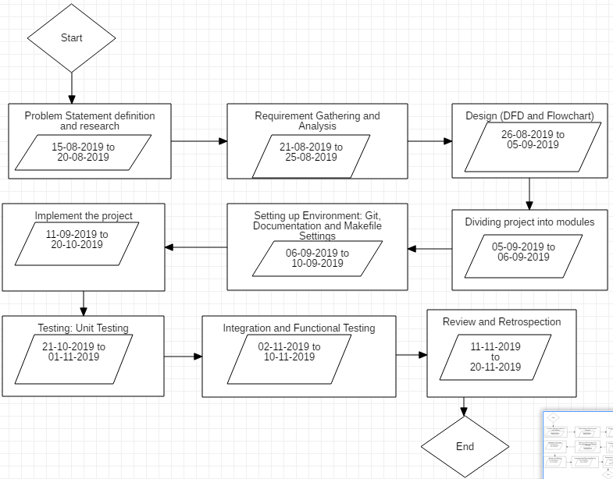

**Figure 2: Plan of Work**

**References**

[1] Network Graph: https://socilyzer.com/guide/highlighted_person.png

[2] Shaik Jaffar, Dr. MV Subramanyam, *“SIBCast: Swarm Intelligence based broadcasting for mobile Ad hoc networks”,* International Journal of Scientific & Engineering Research, Volume 4, Issue 11, November-2013.

[3] Carlos M. Fernandes1, Nuno Fachada, Juan-Julián Merelo and Agostinho C. Rosa, “*Steady state particle swarm*”, Creative Commons, 2019.

[4] Mohammed Hassan, “*Network Routing Optimization using Swarm Intelligence*”, IEEE Conference, 2012.

[5] Thomas H. Cormen, Charles E. Leiserson and Ronald L. Rivest, *“Introduction to Algorithms”* 3rd Edition, MIT Press, 2009.

[6] StarUML tool. <https://docs.staruml.io/>