APEXPLANET INTERNSHIP
TASK 4 – EXPLOITATION & SYSTEM SECURITY

APEXPLANET SOFTWARE PVT. LTD.
Domain: Cybersecurity and Ethical Hacking

Penetration Testing, Password Attacks, Security Awareness,
Malware Basics and System Hardening

Submitted by :
NIMMALA NISHEK RATNA
Department: Computer Science and Engineering
Sathyabama Institute of Science and Technology

Date: 12 September 2026

Internship Domain | Cybersecurity and Ethical Hacking
Task | Task 4 – Exploitation & System Security
Testing Environment | Kali Linux + Metasploitable2 (isolated lab)
Target IP | 192.168.56.102

Table of Contents

1. Abstract
2. Objectives
3. Scope and Test Environment
4. Penetration Testing Methodology
5. Exploitation with Metasploit
6. Password Attacks
7. Social Engineering Awareness Simulation
8. Malware Basics and File Analysis
9. System Hardening
10. Findings and Risk Summary
11. Mitigation and Recommendations
12. Conclusion
13. Evidence / Screenshot Index

Abstract

This report documents Task 4 of the ApexPlanet Cybersecurity and Ethical Hacking internship. The work was performed in an isolated and intentionally vulnerable laboratory using Kali Linux as the testing machine and Metasploitable2 as the target. The activities covered penetration-testing methodology, exploitation with Metasploit, password attacks using Hydra, password-hash cracking using John the Ripper, a safe social-engineering awareness simulation, basic malware/file analysis, and system hardening.
The practical work demonstrated how weak services, default credentials, weak password hashes, and insufficient defensive controls can increase security risk. All testing described in this report was limited to the authorized laboratory target.

Objectives

- Understand a basic penetration-testing workflow from reconnaissance to reporting.
- Identify and exploit an intentionally vulnerable FTP service using Metasploit.
- Demonstrate the security impact of weak/default credentials with Hydra.
- Demonstrate password-hash recovery with John the Ripper using a harmless test hash.
- Understand common phishing indicators through a non-deceptive awareness simulation.
- Perform basic static file analysis and integrity verification using SHA-256.
- Apply and verify a firewall hardening rule using nftables/iptables on Kali.
- Document findings, risks, evidence, and recommended mitigations.

Scope and Test Environment

Item | Details
Attacker / Testing OS | Kali Linux
Target OS | Metasploitable2
Kali IP | 192.168.56.101
Target IP | 192.168.56.102
Network | Isolated Host-Only laboratory network
Metasploit module | exploit/unix/ftp/vsftpd_234_backdoor
FTP service | TCP/21
SSH service | TCP/22; legacy OpenSSH 4.7p1
Tools | Nmap, Metasploit Framework, Meterpreter, Hydra, John the Ripper, iptables/nftables

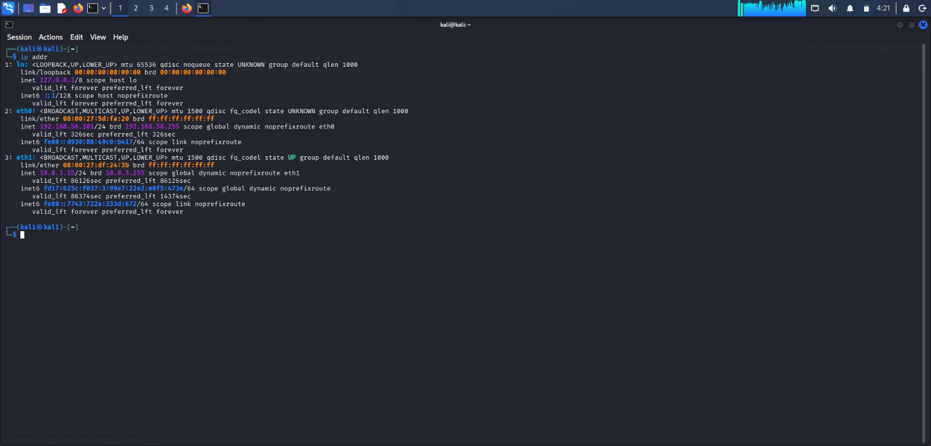
Figure 1. Kali Linux IP configuration

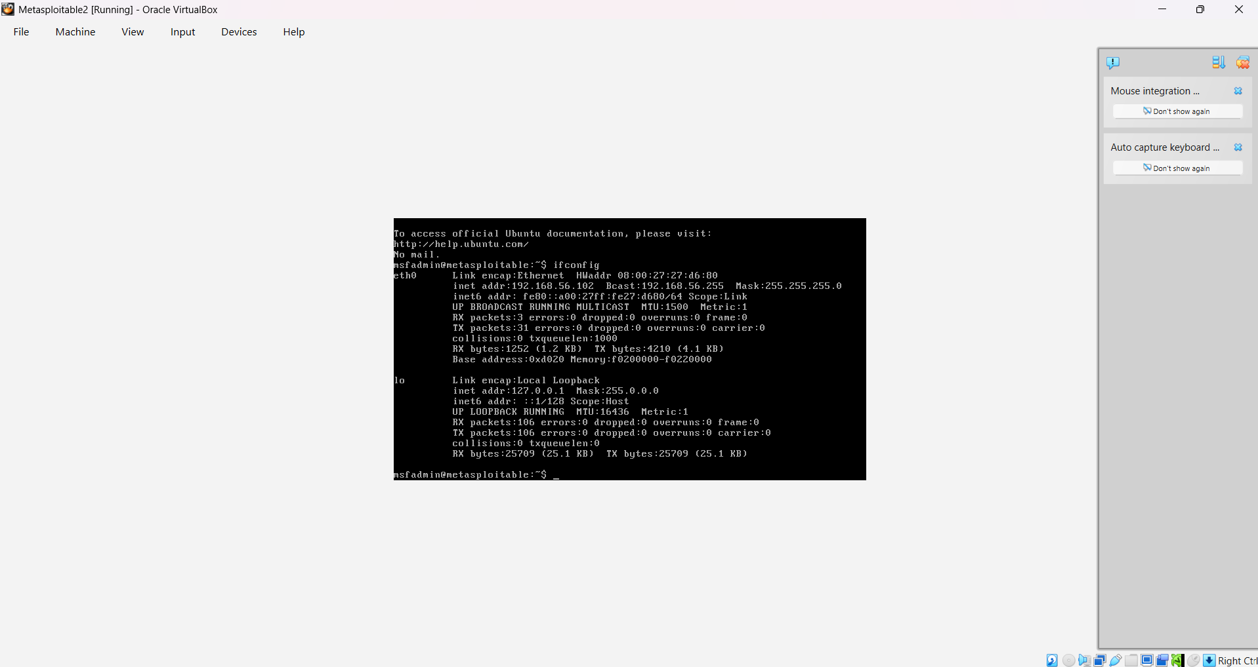
Figure 2. Metasploitable2 target IP configuration

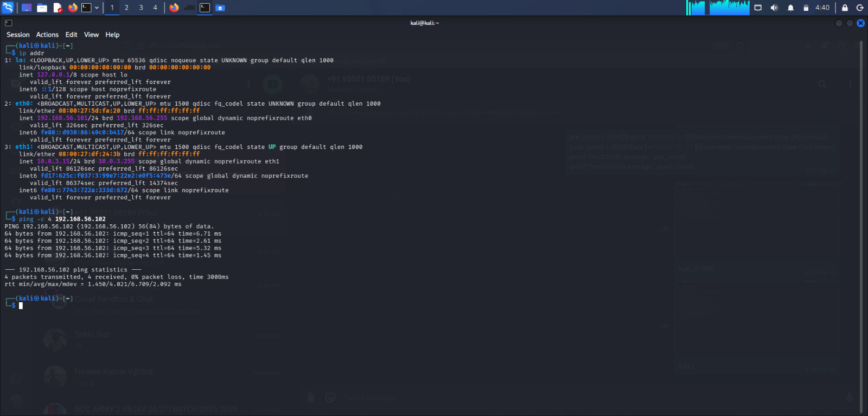
Figure 3. Connectivity test between Kali and Metasploitable2

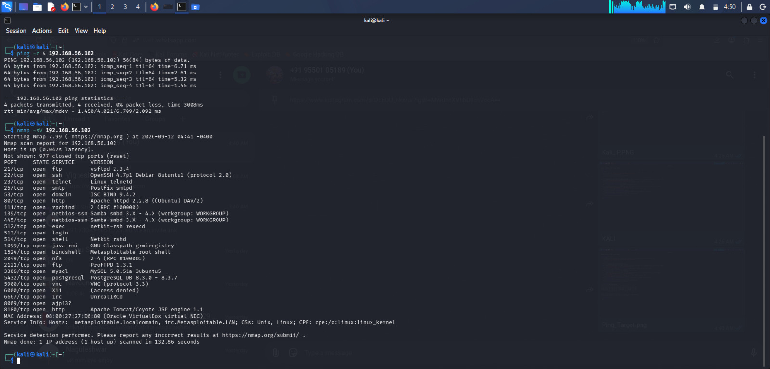
Figure 4. Service discovery / Nmap scan of the target

Penetration Testing Methodology

A simple penetration-testing lifecycle was followed:
- Reconnaissance – identify the target and available network services.
- Scanning and Enumeration – identify open ports, service versions, and potential attack surfaces.
- Exploitation – use a suitable Metasploit module against the intentionally vulnerable service.
- Post-Exploitation – verify the obtained session and privilege level.
- Password Testing – demonstrate weak credential risk with a controlled wordlist.
- Analysis and Documentation – record limitations, findings, evidence, and mitigations.
- Hardening – apply a defensive control and verify the resulting configuration.

5. Exploitation with Metasploit

5.1 Vulnerability Identification
The target was identified as an intentionally vulnerable Metasploitable2 system. Nmap service enumeration was used to identify exposed services. The FTP service on TCP port 21 was suitable for testing because the target contains the vulnerable VSFTPD 2.3.4 backdoor.
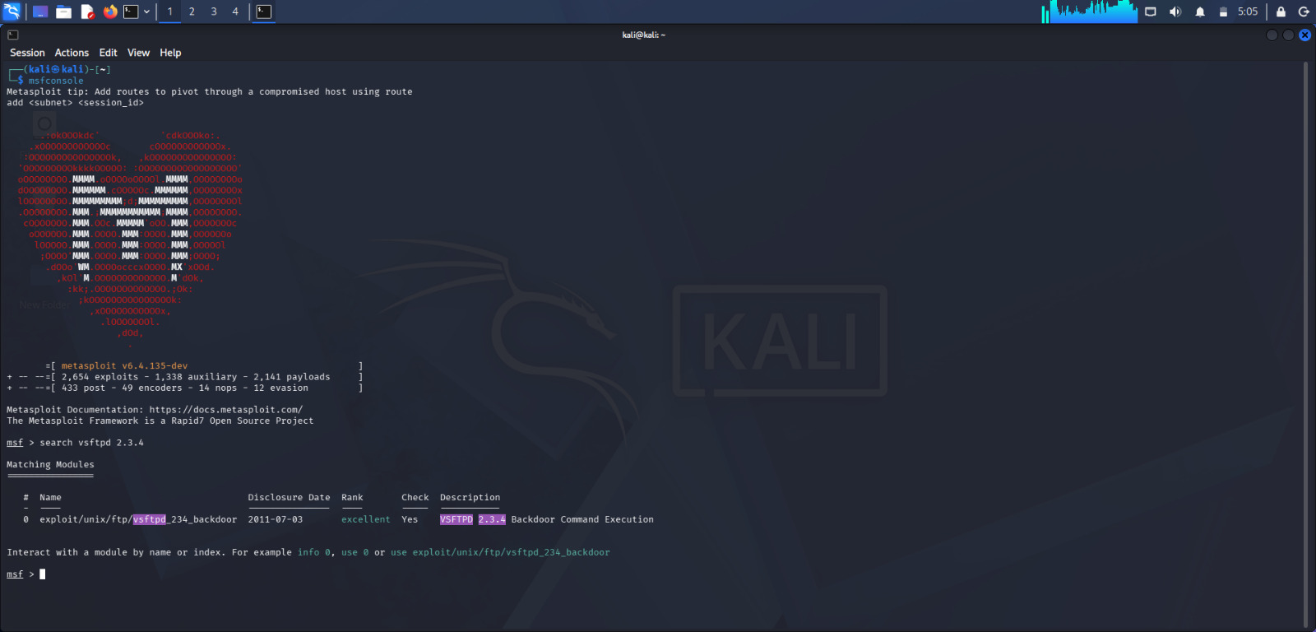
Figure 5. Metasploit search results showing the VSFTPD 2.3.4 backdoor module.

5.2 Module Configuration
The Metasploit module exploit/unix/ftp/vsftpd_234_backdoor was selected. The remote target was configured as 192.168.56.102 and the Kali callback address was configured as 192.168.56.101.
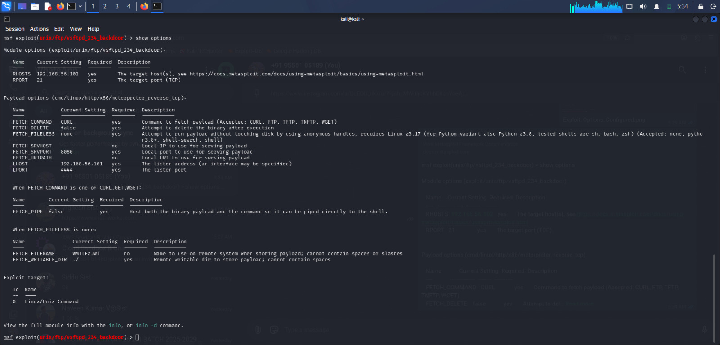
Figure 6. Configured Metasploit options for the authorized lab target.

5.3 Exploitation and Session
The exploit was executed against the Metasploitable2 FTP service. A Meterpreter session was obtained. The session was then checked with sysinfo and getuid.
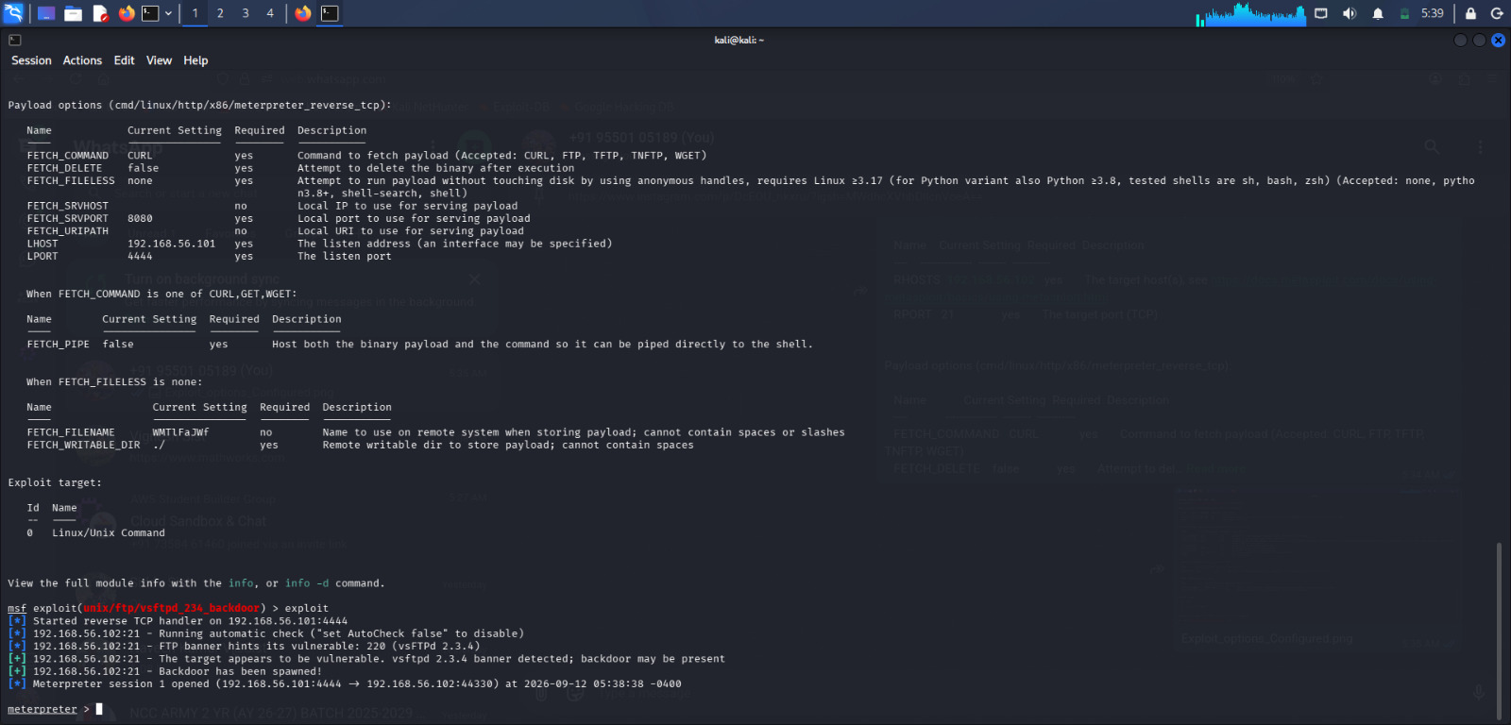
Figure 7. Successful exploitation and Meterpreter session.

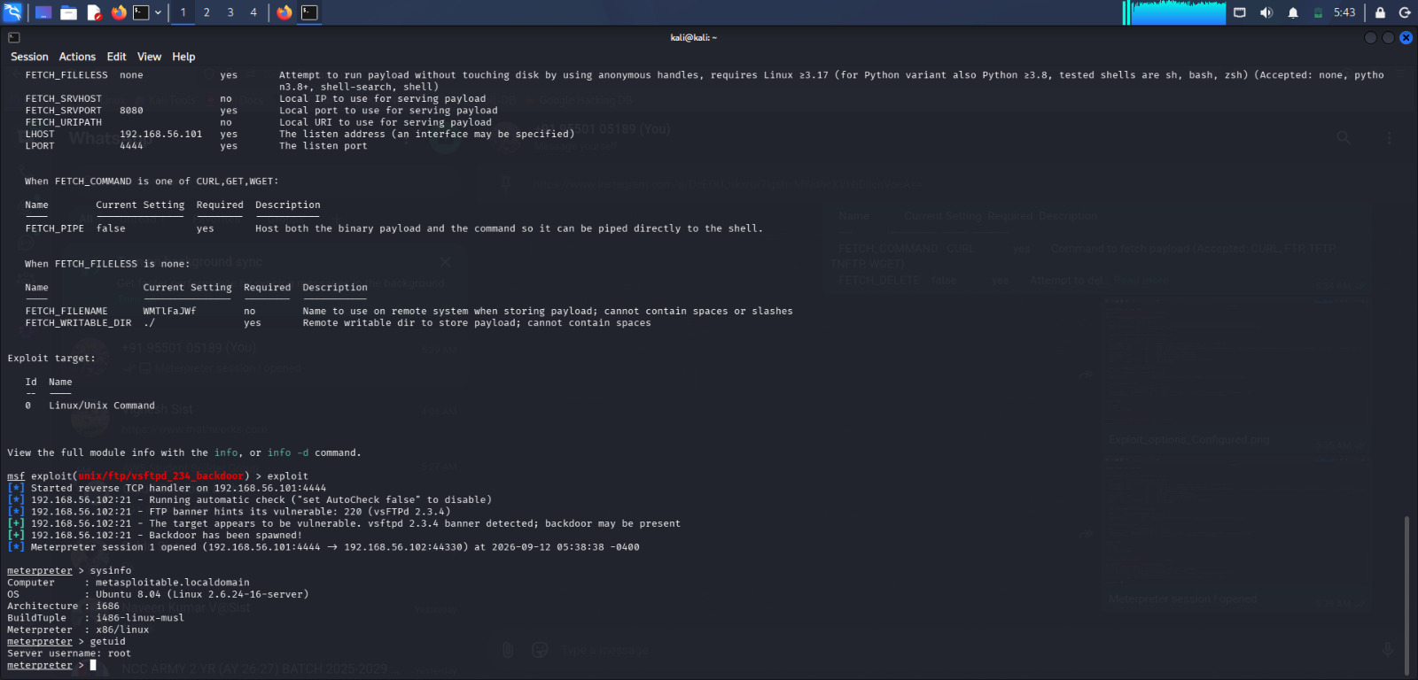
Figure 8. Meterpreter system information and user identity verification.

5.4 Privilege Verification
A shell was opened from Meterpreter and the identity was verified as uid=0(root) gid=0(root). This demonstrated root-level access on the intentionally vulnerable target.

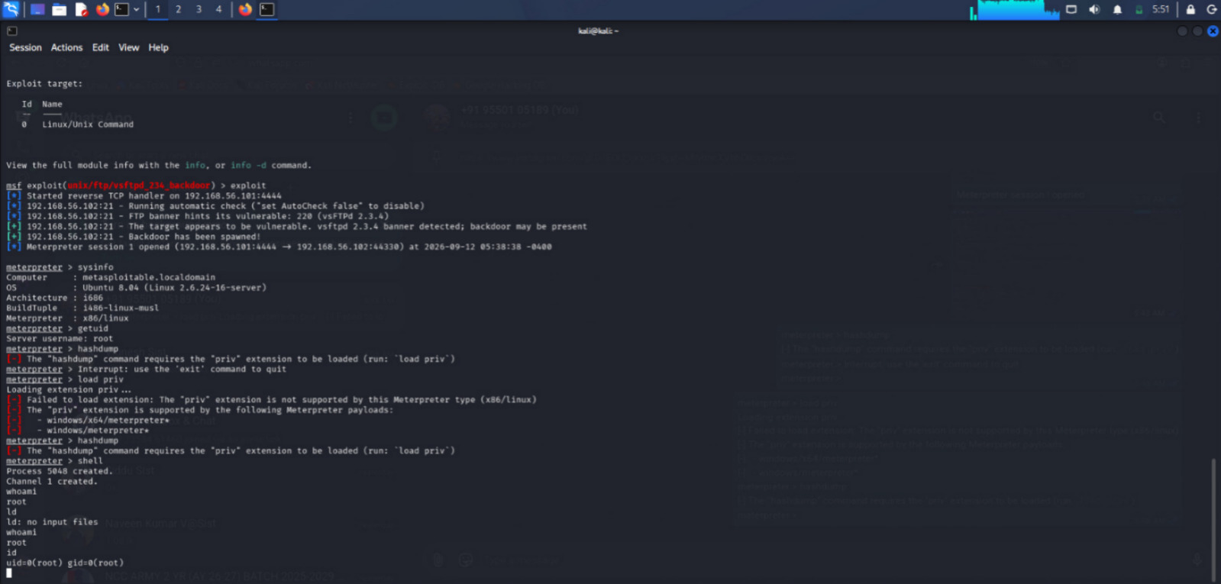
Figure 10. Post-exploitation shell showing root privileges.

5.5 Exploitation Limitation
The hashdump command was attempted, but the selected Linux x86 Meterpreter type did not support the required priv extension. The error was documented rather than bypassed. This illustrates that post-exploitation capabilities depend on the payload and target platform.

6. Password Attacks

6.1 Hydra – SSH Compatibility Test
Hydra was initially tested against the target SSH service. The attempt did not proceed because the legacy OpenSSH server and the modern Hydra SSH client had no mutually supported MAC algorithm. The target was identified as OpenSSH 4.7p1. This result was retained as evidence of a legacy-compatibility limitation.
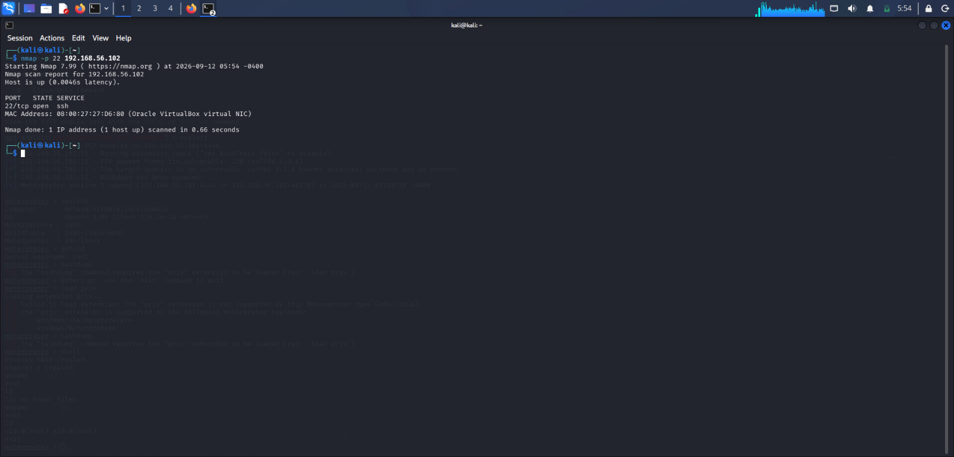
Figure 11. SSH service available on TCP port 22.

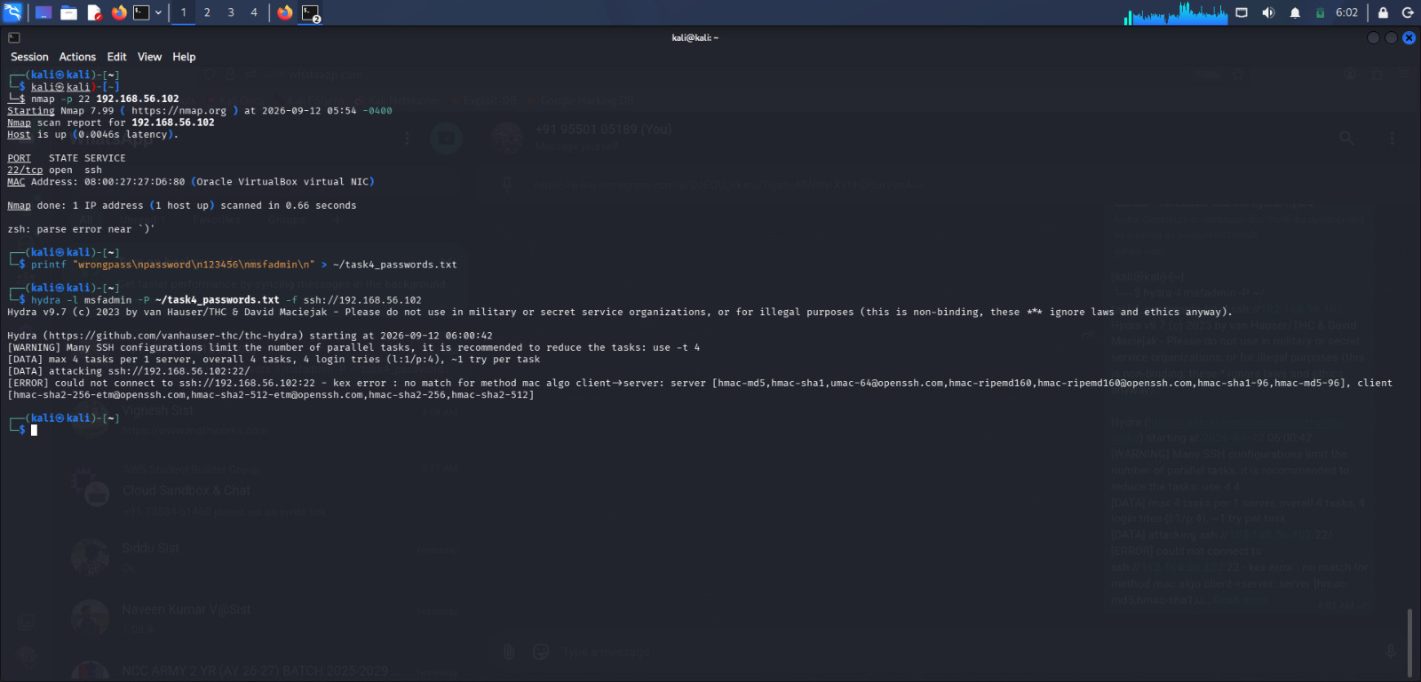
Figure 12. Hydra SSH attempt stopped by MAC algorithm incompatibility.

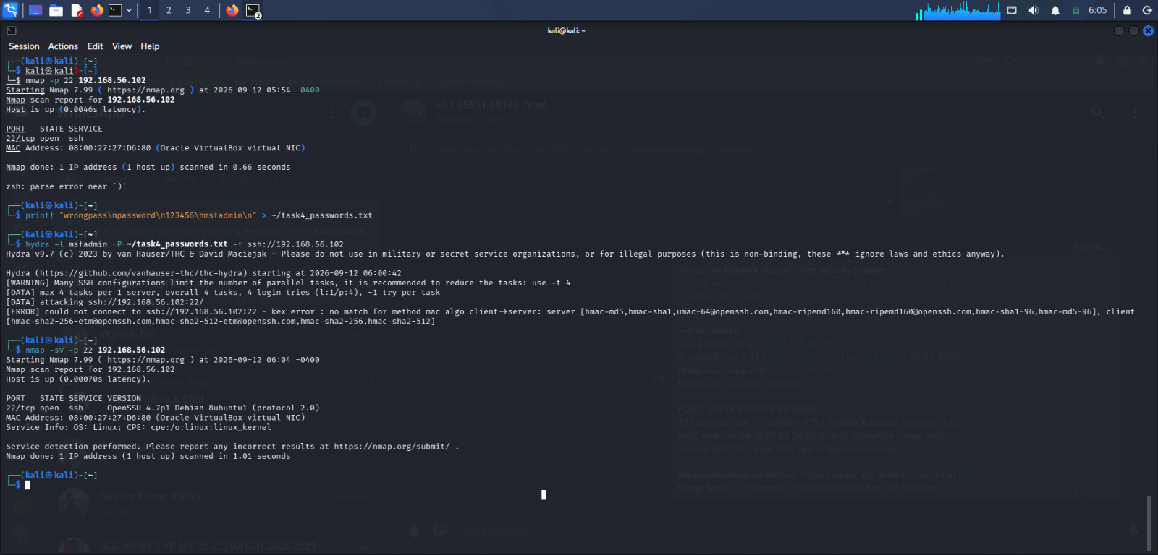
Figure 13. Legacy SSH service version identified during enumeration.

6.2 Hydra – FTP Password Attack
Because the target's SSH service was incompatible with the modern Hydra client, the controlled password test was moved to FTP on the same authorized lab target. A small four-entry wordlist was used against the msfadmin account.
Hydra successfully identified the valid credential pair: username msfadmin and password msfadmin. This demonstrates the security risk of default or weak credentials.
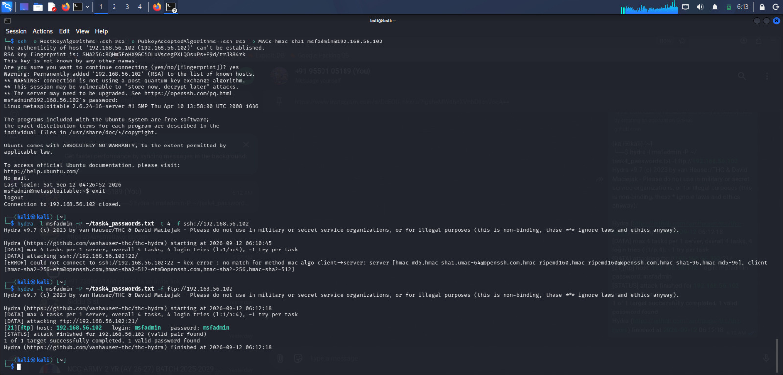
Figure 14. Successful controlled Hydra FTP password test.

6.3 John the Ripper – Password Hash Demonstration
John the Ripper was verified as installed. A harmless test password, 'password', was converted to an MD5 hash and stored in a local test file. John the Ripper was then run with the Raw-MD5 format and successfully recovered the original password.
Test SHA/MD5 evidence: the MD5 hash used was 5f4dcc3b5aa765d61d8327deb882cf99, which corresponded to the test password 'password'. This was a locally generated demonstration and did not involve another person's credentials.
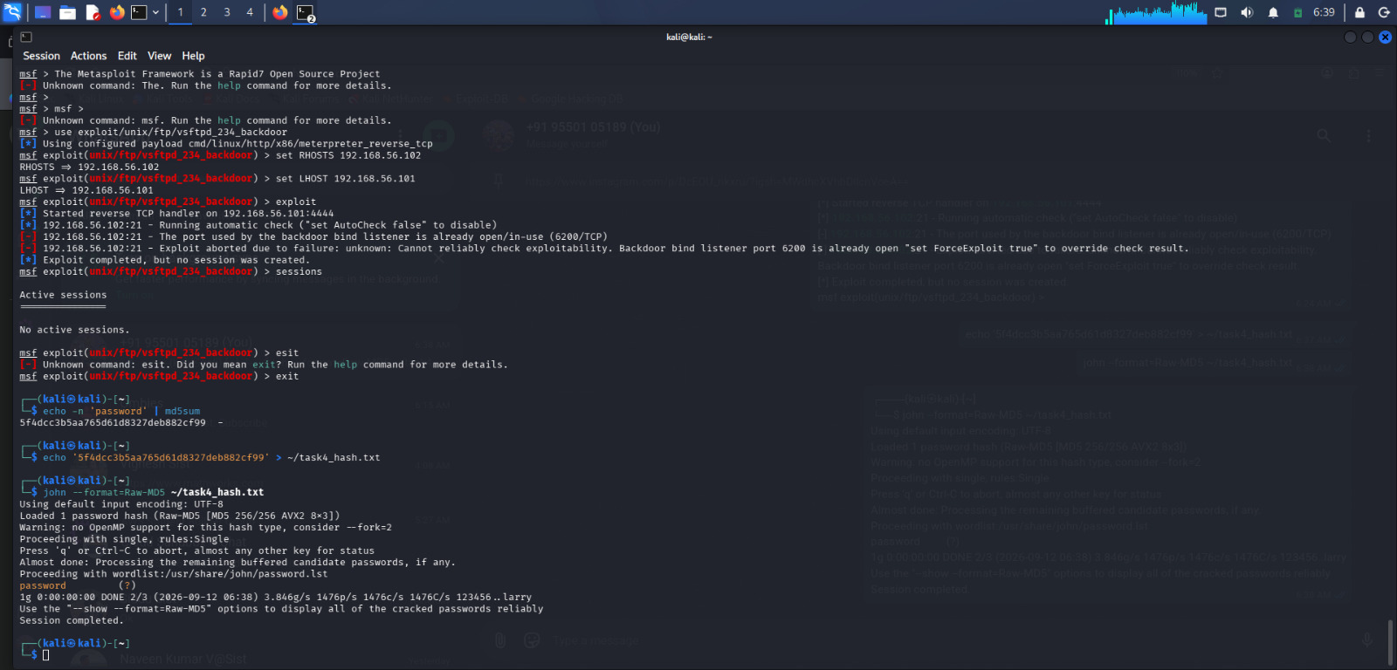
Figure 15. John the Ripper successfully recovering the harmless test password.

7. Social Engineering Awareness Simulation
A safe social-engineering awareness exercise was created without sending messages to real users and without collecting credentials. The simulation listed common phishing warning signs such as urgency, requests for sensitive information, suspicious links or attachments, unusual sender addresses, and pressure to act immediately.
The recommended defensive response was to avoid suspicious links, never provide passwords or OTPs, verify the sender through an official channel, and report suspicious messages.
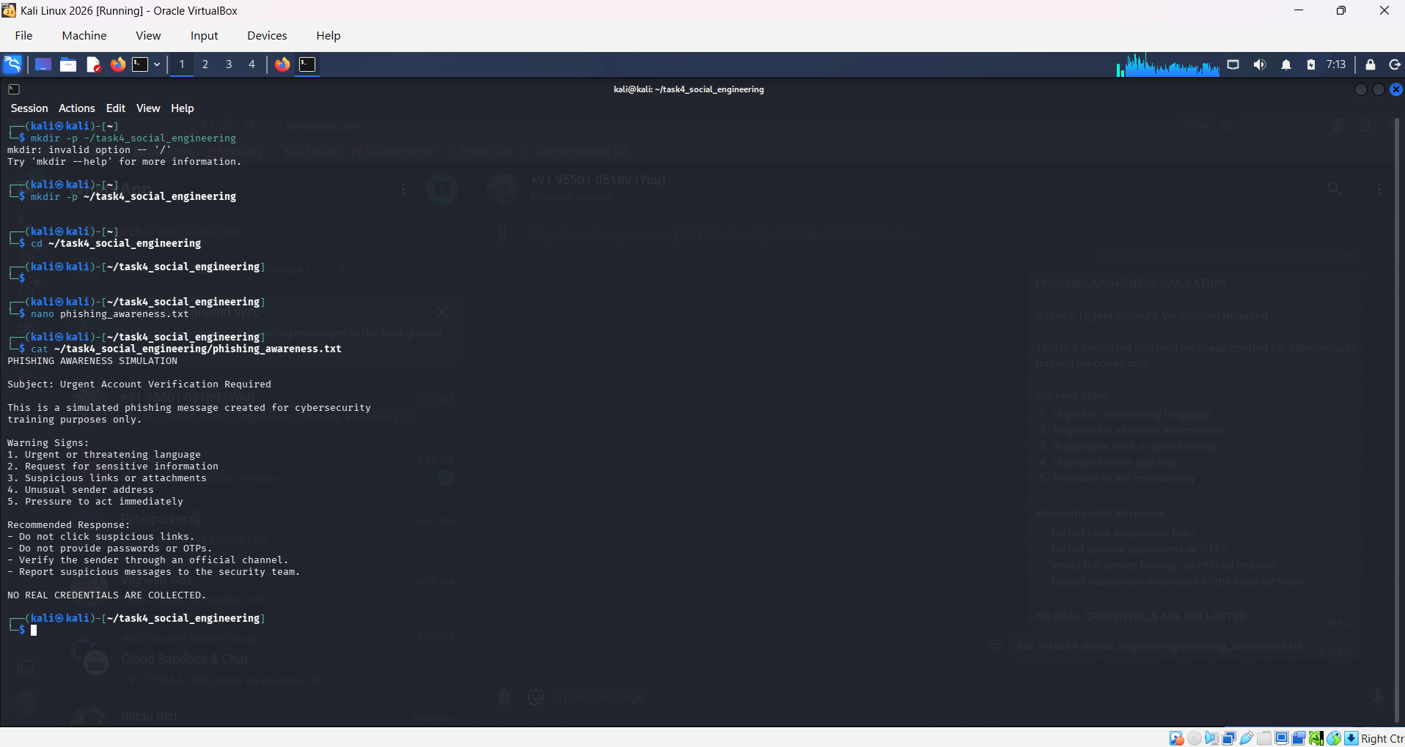
Figure 16. Harmless phishing-awareness simulation and defensive guidance.

8. Malware Basics and File Analysis
For the malware-basics exercise, a harmless text file named sample.txt was created for analysis. The file was examined using standard file-identification and integrity-checking commands. No malware was created, deployed, or executed.
SHA-256 hash recorded for the harmless test file:
f7cca62adafada6274b3babd49ee1168a0d45ca7b69385c41f6090c9ebbfbf12
The file command identified sample.txt as ASCII text. The ls -lh command showed a size of 77 bytes and ownership by the Kali user. Hashing is useful for verifying whether a file has changed and for comparing a suspicious file against a known reference.
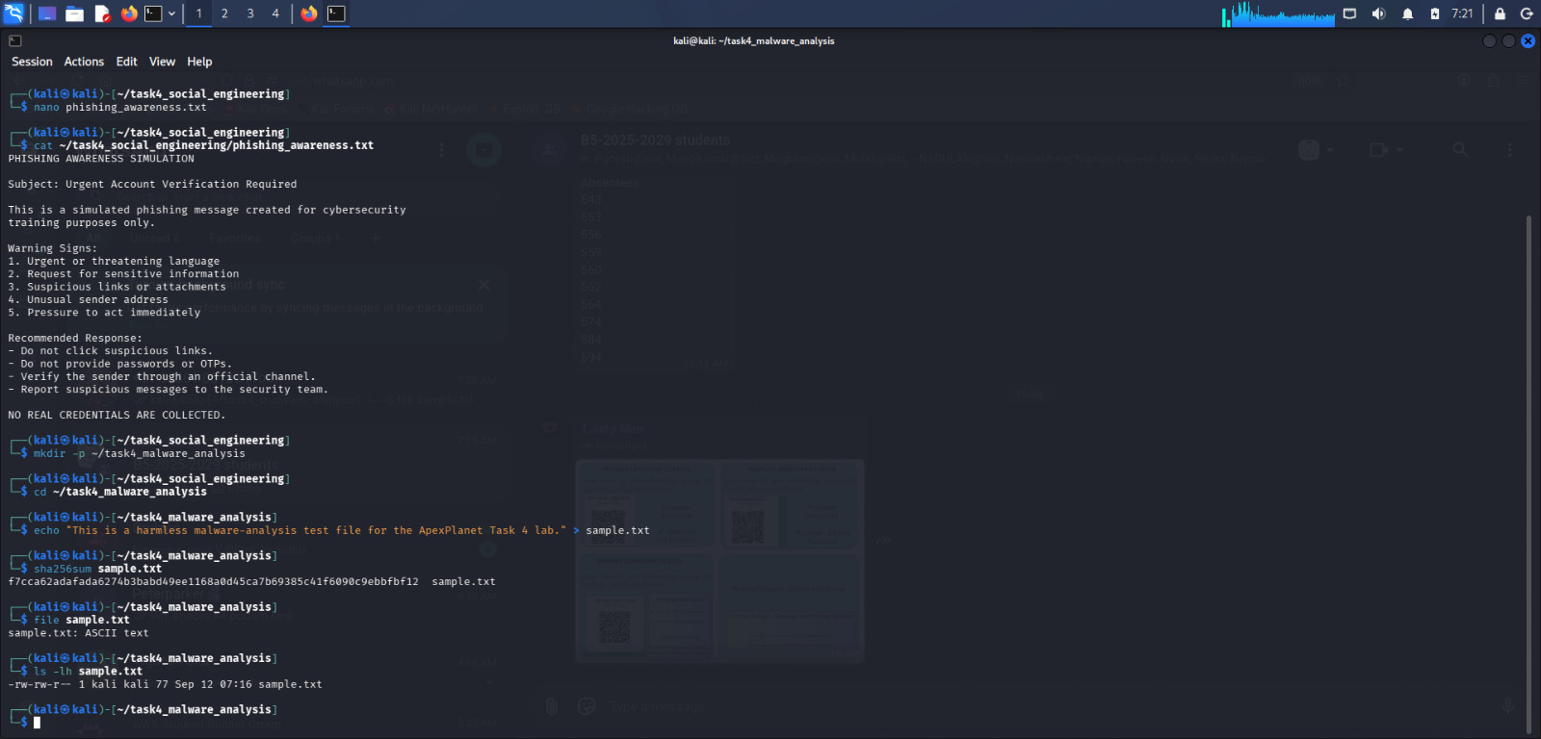
Figure 17. Basic static analysis showing file type, size, ownership, and permissions.

9. System Hardening

9.1 Firewall Baseline
The initial iptables listing showed INPUT, FORWARD, and OUTPUT chains with policy ACCEPT and no specific rules. This indicated that no restrictive input rule was present in the displayed baseline.
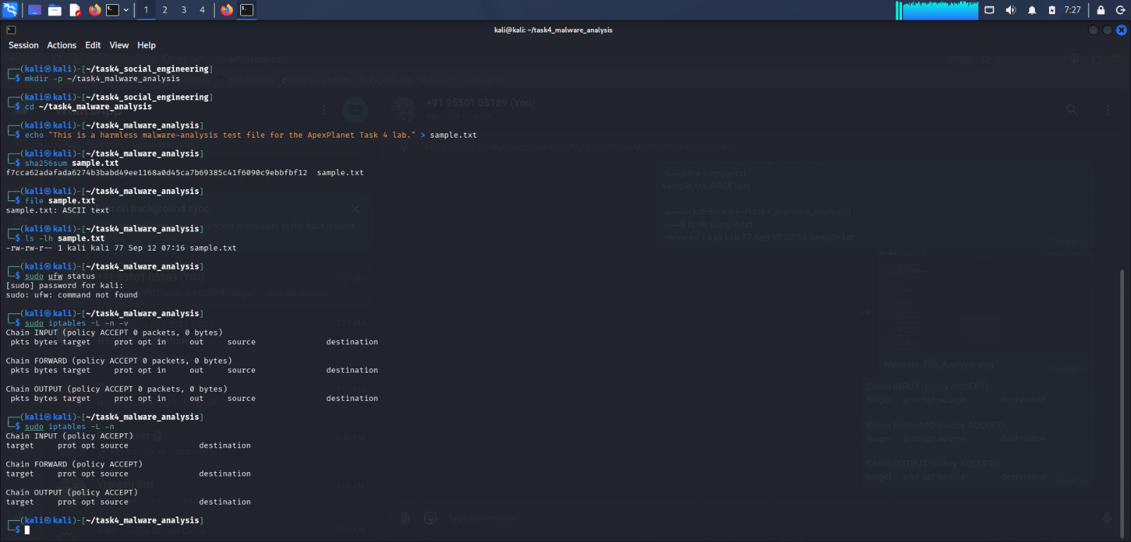
Figure 18. Initial firewall rule state.

9.2 Firewall Hardening Rule
A defensive firewall rule was added to drop incoming traffic from the isolated Metasploitable2 lab IP address 192.168.56.102. Because Kali was using the nftables backend, the resulting nftables ruleset was verified directly.

Verified rule:
ip saddr 192.168.56.102 counter packets 0 bytes 0 drop
This rule demonstrates host-based traffic filtering for the lab target. In a production environment, firewall rules should be designed according to the organization's approved network policy and tested carefully to avoid unintended service disruption.
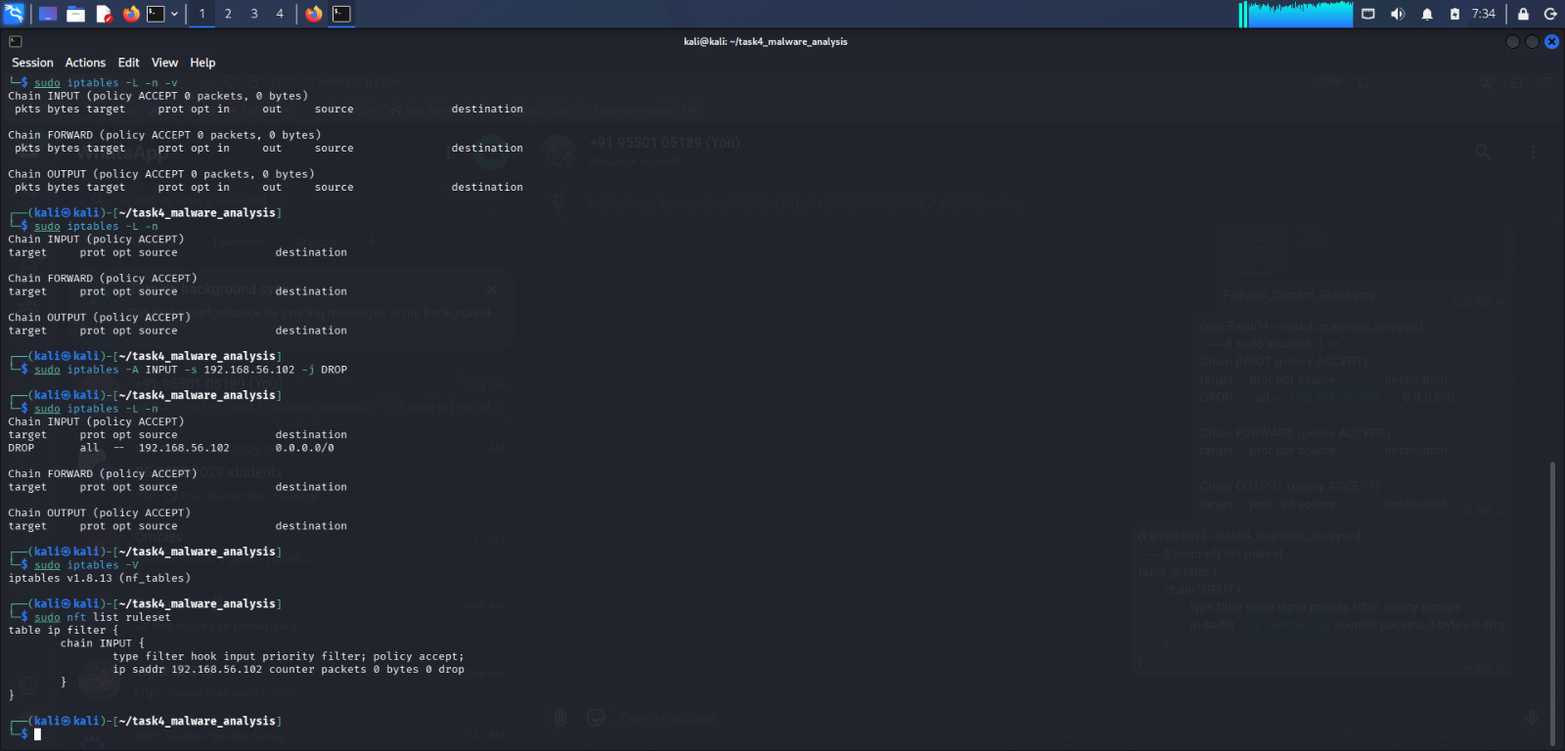
Figure 19. Verified nftables rule dropping incoming traffic from the lab target.

10. Findings and Risk Summary
Finding | Evidence | Risk | Severity
VSFTPD 2.3.4 backdoor | Metasploit exploitation | Remote command execution and root-level compromise in the lab | Critical
Default/weak FTP credential | Hydra valid pair | Unauthorized access to FTP resources | High
Weak password hash demonstration | John the Ripper | Weak hashes/passwords can be recovered rapidly | High
Legacy SSH cryptography | Hydra SSH error / OpenSSH 4.7p1 | Modern tools may not interoperate; legacy algorithms are weak | Medium
Phishing susceptibility | Awareness simulation | Users may disclose information when social-engineering indicators are missed | Medium
Insufficient baseline filtering | Initial iptables state | Unrestricted inbound traffic may increase attack surface | Medium

11. Mitigation and Recommendations
- Remove or isolate obsolete vulnerable software such as VSFTPD 2.3.4 and replace unsupported services with maintained versions.
- Disable unnecessary network services and close unused ports.
- Immediately change all default credentials such as msfadmin/msfadmin.
- Use strong, unique passwords and enforce password policies.
- Prefer modern password-hashing schemes such as Argon2id, scrypt, or bcrypt instead of unsalted MD5.
- Upgrade legacy SSH implementations and disable obsolete cryptographic algorithms according to current security policy.
- Use host and network firewalls with least-privilege rules.
- Train users to recognize phishing and verify unusual requests through trusted channels.
- Monitor authentication logs and network activity for suspicious behavior.
- Regularly patch operating systems and applications and perform vulnerability assessments.

12. Conclusion
Task 4 provided practical experience with both offensive and defensive cybersecurity activities in an isolated laboratory. The VSFTPD 2.3.4 vulnerability was exploited successfully with Metasploit and root access was verified. Hydra demonstrated the impact of default FTP credentials, while John the Ripper demonstrated recovery of a weak MD5 test password. A harmless social-engineering awareness exercise and basic file-integrity analysis were also completed. Finally, a firewall rule was applied and verified using nftables.
The main lesson from the exercise is that exploitation risk is strongly influenced by outdated software, unnecessary services, weak/default credentials, weak password storage, and insufficient defensive controls. Applying timely updates, strong authentication, least-privilege firewall policies, user awareness, and continuous monitoring can significantly reduce these risks.

