APEXPLANET INTERNSHIP

TASK 3 – WEB APPLICATION SECURITY TESTING REPORT

APEXPLANET SOFTWARE PVT. LTD.
Domain: Cybersecurity and Ethical Hacking

Submitted by :
NIMMALA NISHEK RATNA
Department: Computer Science and Engineering
Sathyabama Institute of Science and Technology

Date: 10 September 2026

TABLE OF CONTENTS

1. Introduction
2. Objectives
3. Testing Environment
4. DVWA Installation and Configuration
5. SQL Injection
6. Cross-Site Scripting (XSS)
7. Cross-Site Request Forgery (CSRF)
8. File Inclusion
9. Command Injection
10. Burp Suite Login Request Interception
11. Burp Suite Intruder
12. Web Security Headers
13. Security Headers and Their Purpose
14. Vulnerability Summary
15. Security Recommendations
16. Overall Findings
17. Conclusion
18. Screenshot Evidence
19. Final Statement

1. INTRODUCTION
Web applications may contain security vulnerabilities that can allow attackers to access sensitive information, modify data, execute unauthorized commands, or perform actions without permission. The objective of this task was to identify and demonstrate common web application vulnerabilities using Damn Vulnerable Web Application (DVWA) in a controlled Kali Linux environment.
The vulnerabilities and security mechanisms tested during this task include SQL Injection, Cross-Site Scripting, Cross-Site Request Forgery, File Inclusion, Command Injection, Burp Suite Intruder testing, and HTTP Security Headers. Mitigation techniques were also demonstrated wherever applicable.

2. OBJECTIVES
- To install and configure DVWA in Kali Linux.
- To perform SQL Injection testing.
- To demonstrate SQL Injection prevention using Prepared Statements.
- To perform Stored, Reflected, and DOM-based XSS testing.
- To demonstrate XSS mitigation using input validation and Content Security Policy.
- To demonstrate a CSRF attack and token-based protection.
- To test File Inclusion vulnerabilities.
- To demonstrate Command Injection.
- To intercept and analyze login requests using Burp Suite.
- To perform basic fuzzing using Burp Suite Intruder.
- To configure HTTP Security Headers in Apache.
- To document vulnerabilities, impact, and mitigation techniques.

3. TESTING ENVIRONMENT
Component | Details
Operating System | Kali Linux
Web Application | DVWA
Web Server | Apache
Database | MariaDB
Testing Tool | Burp Suite Community Edition
Browser | Firefox
Command-Line Tool | cURL
Target | Local DVWA Installation
Target URL | http://127.0.0.1/DVWA/
Environment | Controlled Local Laboratory
All testing was performed against the locally installed DVWA application.

4. DVWA INSTALLATION AND CONFIGURATION
Damn Vulnerable Web Application (DVWA) was installed and configured in the Kali Linux environment. The application files were located at /var/www/html/DVWA and the application was accessed using http://127.0.0.1/DVWA/. Apache was configured as the web server and MariaDB was used as the database service. The DVWA security level was configured for vulnerability testing.
Result: DVWA was successfully installed and accessed through the local web browser.
Figure 1: DVWA Welcome Page
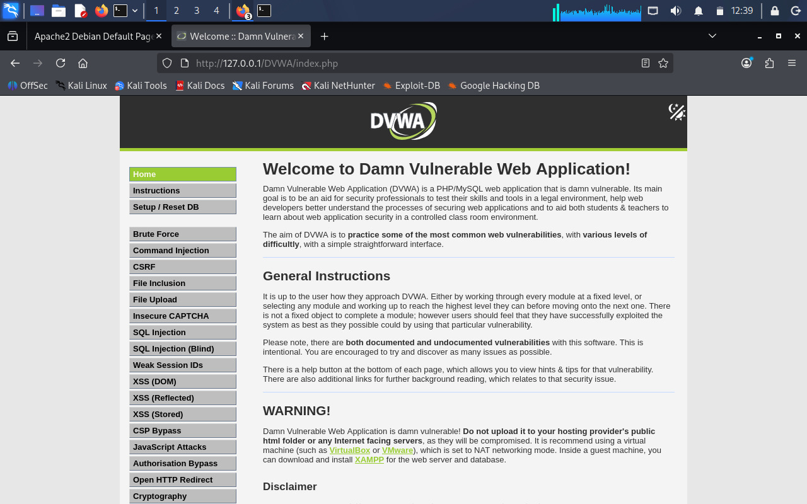

Figure 2: DVWA Security Level
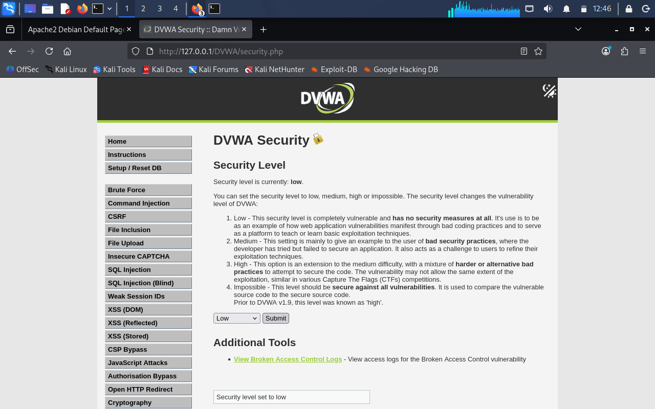

5. SQL INJECTION

5.1 Objective
The objective of SQL Injection testing was to determine whether user input could be manipulated to alter the SQL query executed by the application.

5.2 Testing Procedure
The SQL Injection module of DVWA was opened. A normal user ID was entered first to observe the normal application response. Different input values were then tested to determine whether the SQL query could be manipulated through user input. The testing demonstrated that unsanitized user input could affect the database query.

5.3 Result
The application returned user information from the database. The test demonstrated the risk of SQL Injection in an intentionally vulnerable application.
Figure 3: SQL Injection Testing
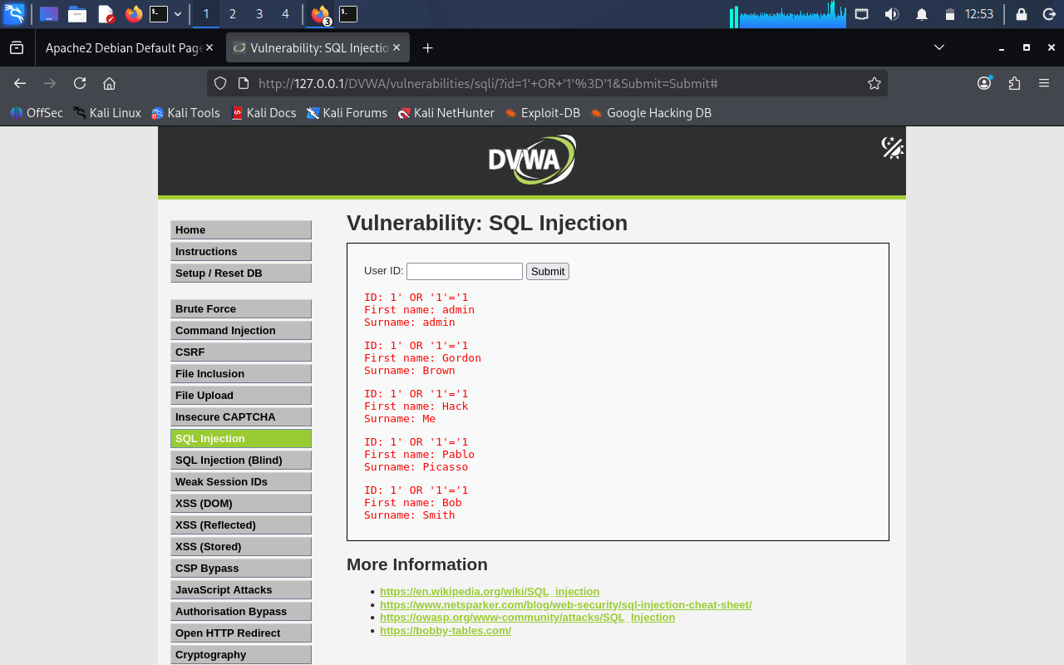

Figure 4: Blind SQL Injection Testing
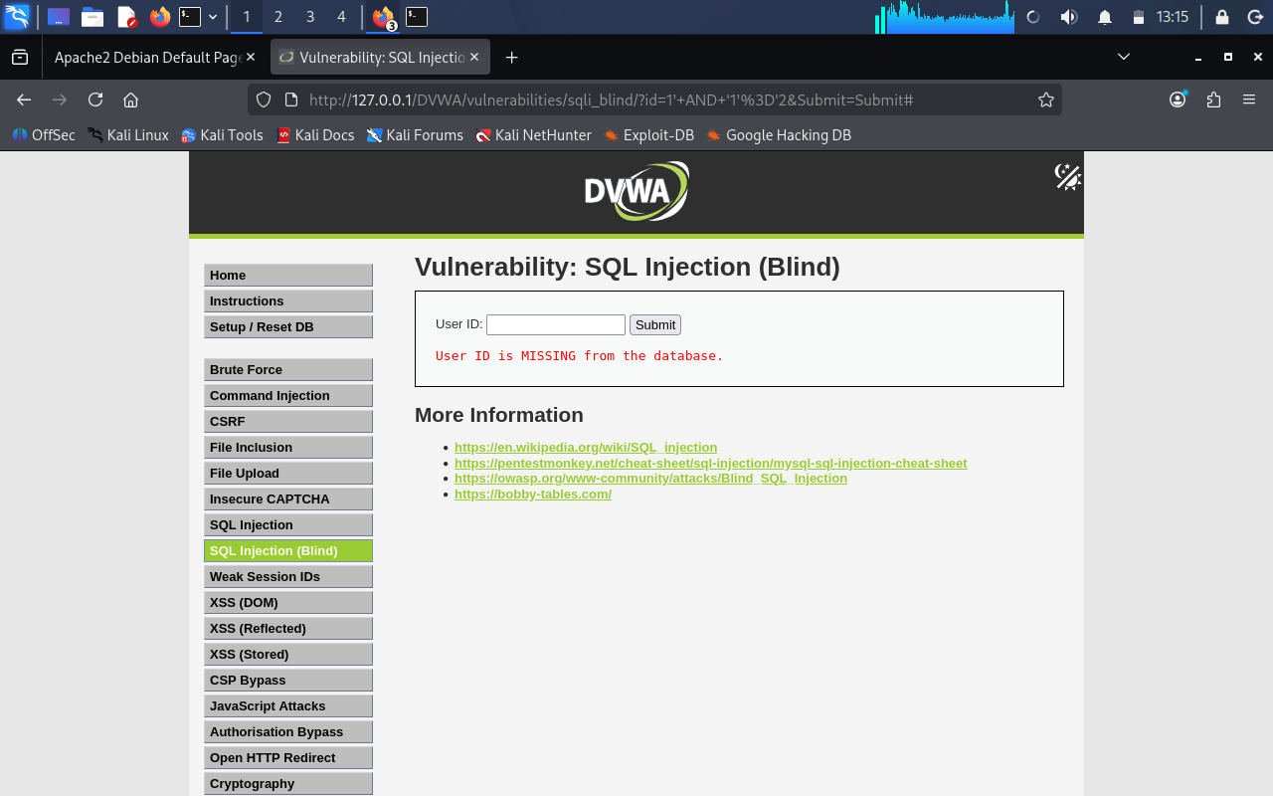

5.4 Impact
- Retrieve unauthorized database information.
- Bypass application restrictions.
- Manipulate database queries.
- Modify or delete database information.
- Potentially access sensitive application data.

5.5 Mitigation Using Prepared Statements
A separate PHP mitigation example was created using Prepared Statements. Prepared Statements separate SQL commands from user-supplied data. This prevents user input from being directly interpreted as SQL syntax. The mitigation example successfully processed the requested user information.

5.6 Mitigation
- Use Prepared Statements.
- Use parameterized SQL queries.
- Validate user input.
- Avoid directly concatenating user input into SQL queries.
- Apply least privilege to database accounts.

6. CROSS-SITE SCRIPTING (XSS)
Cross-Site Scripting (XSS) is a vulnerability in which attacker-controlled input is executed or rendered in a victim's browser.

6.1 Stored XSS
The DVWA Stored XSS module was tested to determine whether user-controlled content could be stored and rendered by the application.
Figure 5: Stored XSS Testing
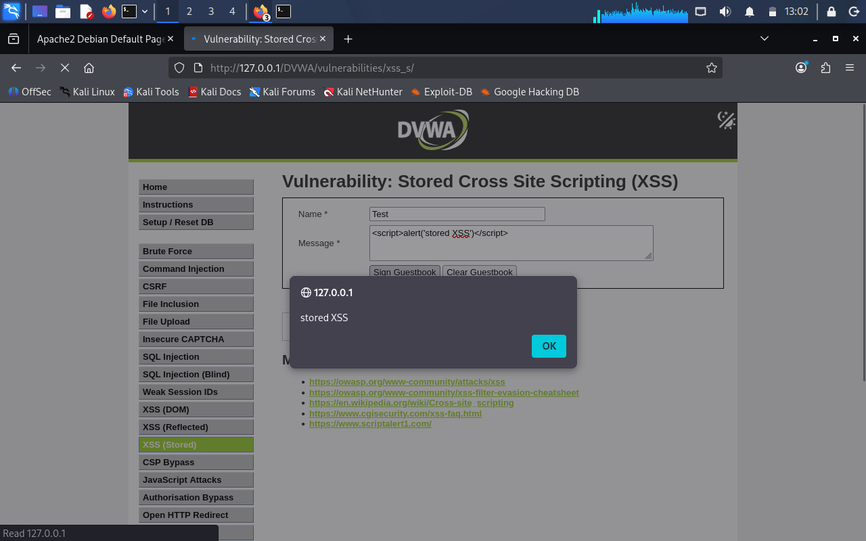
Impact: Stored XSS can potentially allow attackers to execute scripts in the browsers of users who view affected content.

6.2 Reflected XSS
The DVWA Reflected XSS module was tested using user-controlled input. The application reflected the supplied input in the response.
Figure 6: Reflected XSS Testing
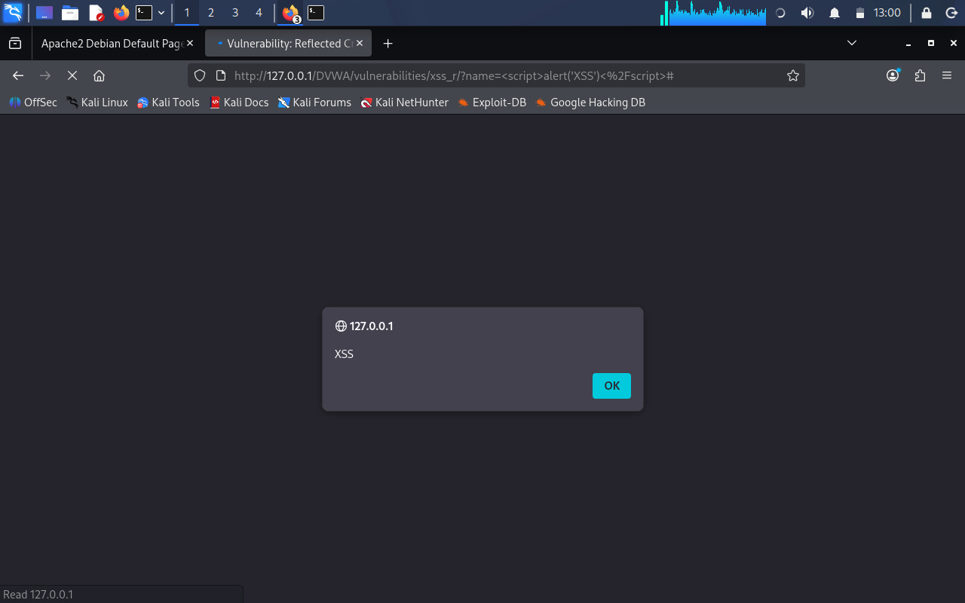
Impact: Reflected XSS can be used to execute malicious client-side code when a victim interacts with a specially crafted request.

6.3 DOM-Based XSS
DOM-based XSS occurs when client-side JavaScript processes attacker-controlled data and inserts it into the web page without proper validation or sanitization.
Figure 7: DOM-Based XSS Testing
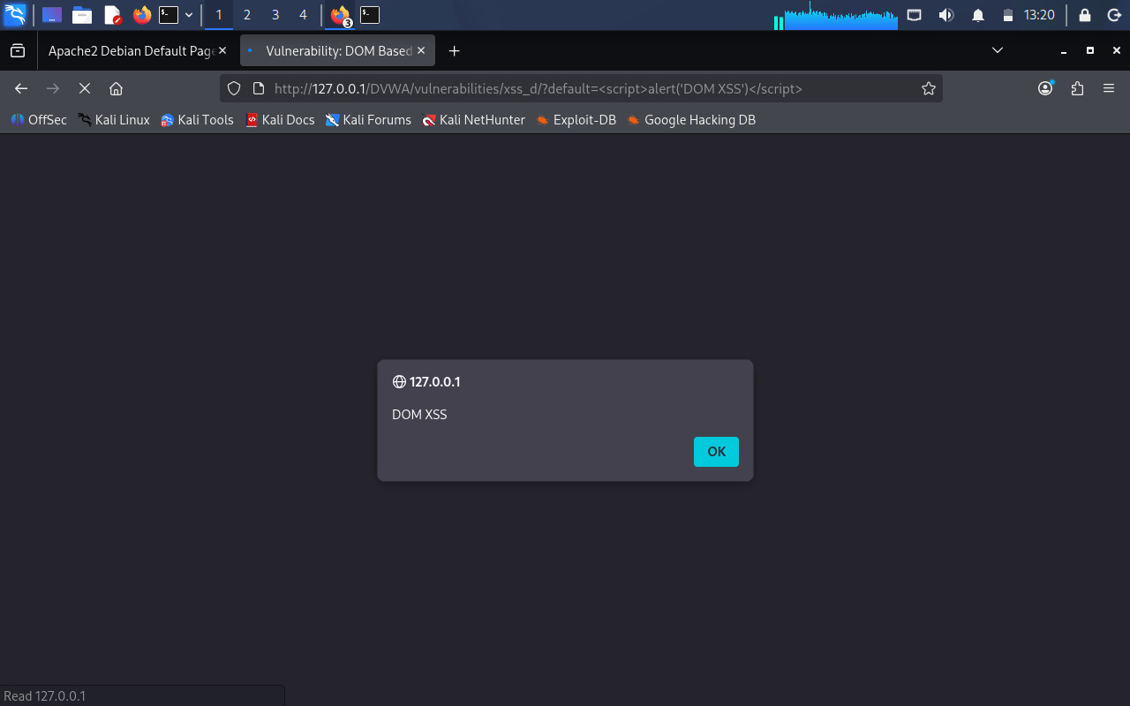

6.4 XSS Mitigation
A separate PHP mitigation example was created to demonstrate protection against XSS. Input validation was implemented and a Content Security Policy was configured.
CSP used: default-src 'self'
Figure 8: XSS Mitigation

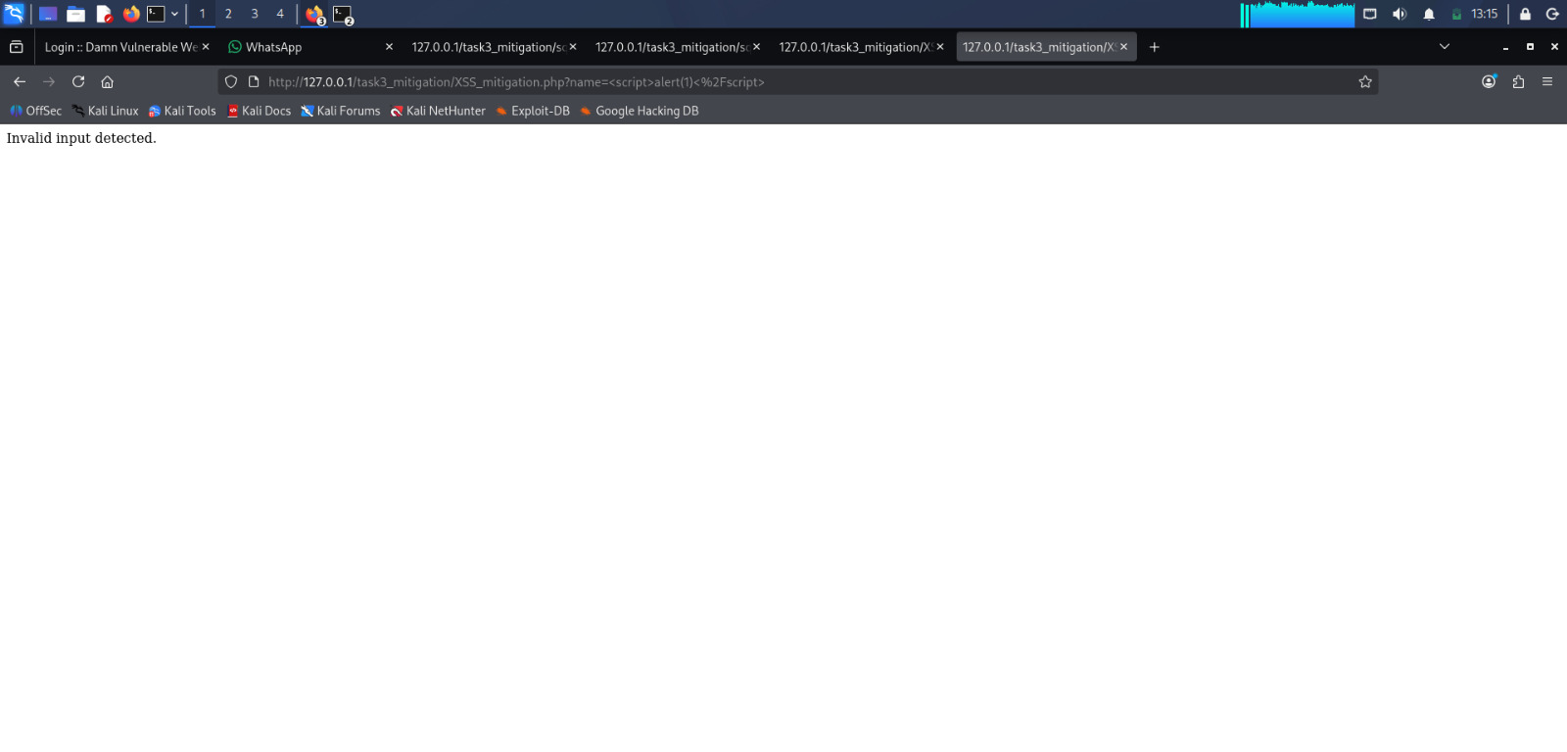
Recommended protections include input validation, output encoding, sanitization where appropriate, and Content Security Policy.

7. CROSS-SITE REQUEST FORGERY (CSRF)

7.1 Objective
The objective was to demonstrate how an attacker could attempt to make an authenticated user perform an unwanted action.

7.2 Testing
The DVWA CSRF functionality was tested using the password-change feature. A password-change request was examined during testing.

7.3 Result
The vulnerable application accepted the password-change request, demonstrating the risk of CSRF when sensitive state-changing requests are not adequately protected.

Figure 9: CSRF Testing
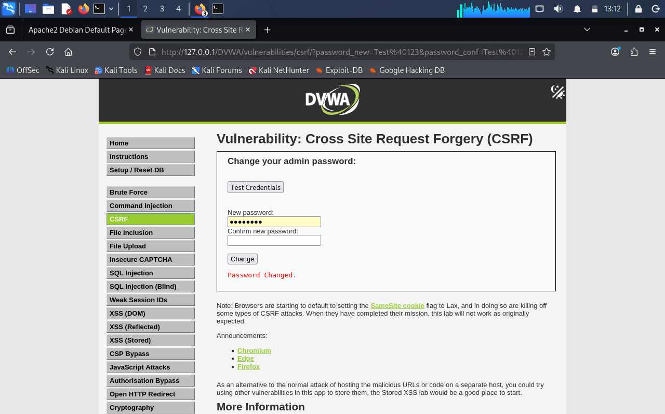

7.4 CSRF Mitigation
A token-based protection mechanism was demonstrated. A CSRF token can be generated for the user's session and included in a sensitive form. When the request is submitted, the server verifies the token.
Basic protection flow:
User opens the form → Server generates a CSRF token → Token is included in the form → User submits the request → Server verifies the token → Valid token: Request accepted; Invalid token: Request rejected.
Recommended protections include unpredictable CSRF tokens, server-side token verification, SameSite cookie protections where appropriate, and protection of important state-changing requests.

8. FILE INCLUSION

8.1 Objective
The objective was to test whether user-controlled parameters could be used to load unintended files. File Inclusion vulnerabilities commonly include Local File Inclusion (LFI) and Remote File Inclusion (RFI).

8.2 Testing
The DVWA File Inclusion functionality was tested using controlled inputs to determine whether user-controlled parameters could influence which file was loaded.

8.3 Result
The testing demonstrated the security risks associated with insecure file inclusion.

Figure 10: File Inclusion Testing
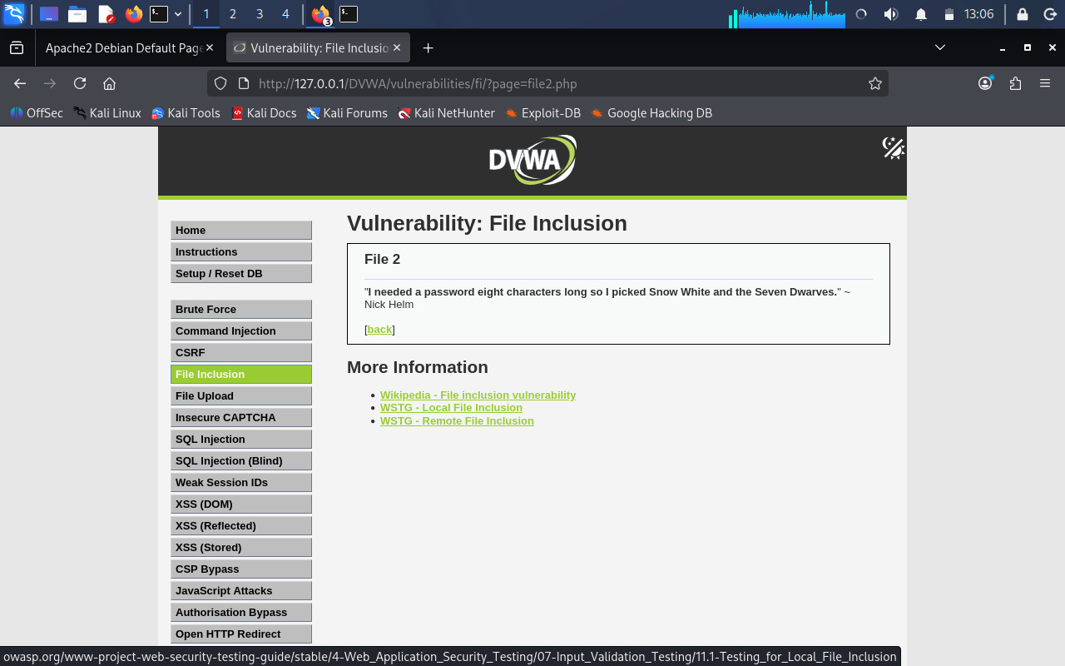

8.4 Impact
- Read sensitive files.
- Access configuration information.
- Expose credentials or secrets.
- Potentially execute unintended code in vulnerable configurations.

8.5 Mitigation
- Use an allowlist of permitted files.
- Validate file paths.
- Never directly use untrusted input as a filename.
- Disable unnecessary remote file inclusion functionality.
- Apply appropriate filesystem permissions.

9. COMMAND INJECTION

9.1 Objective
The objective was to determine whether user-controlled input could influence operating-system commands executed by the web application.

9.2 Testing
The DVWA Command Injection functionality was tested in the controlled local environment. A network command was executed against the local system.

9.3 Result
The application executed the supplied command, demonstrating the risk of passing untrusted input directly to operating-system commands.
Figure 12: Command Injection Testing
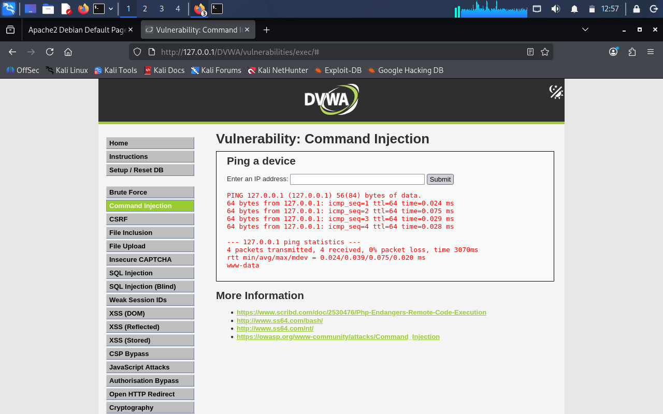

9.4 Impact
Command Injection can potentially allow an attacker to execute unauthorized operating-system commands with the privileges of the web server.

9.5 Mitigation
- Avoid executing shell commands using user input.
- Use safe application APIs instead of shell commands.
- Validate input using strict allowlists.
- Apply appropriate escaping where required.
- Run web applications with minimum required privileges.

10. BURP SUITE LOGIN REQUEST INTERCEPTION

10.1 Objective
Burp Suite was used to intercept and analyze HTTP requests generated by DVWA.

10.2 Testing
The DVWA login request was intercepted using Burp Suite Proxy. The HTTP request contained parameters including username, password, and user_token. The request was inspected before being forwarded to the application.
Result: The login request was successfully intercepted and analyzed.

Figure 13: Burp Suite Login Request
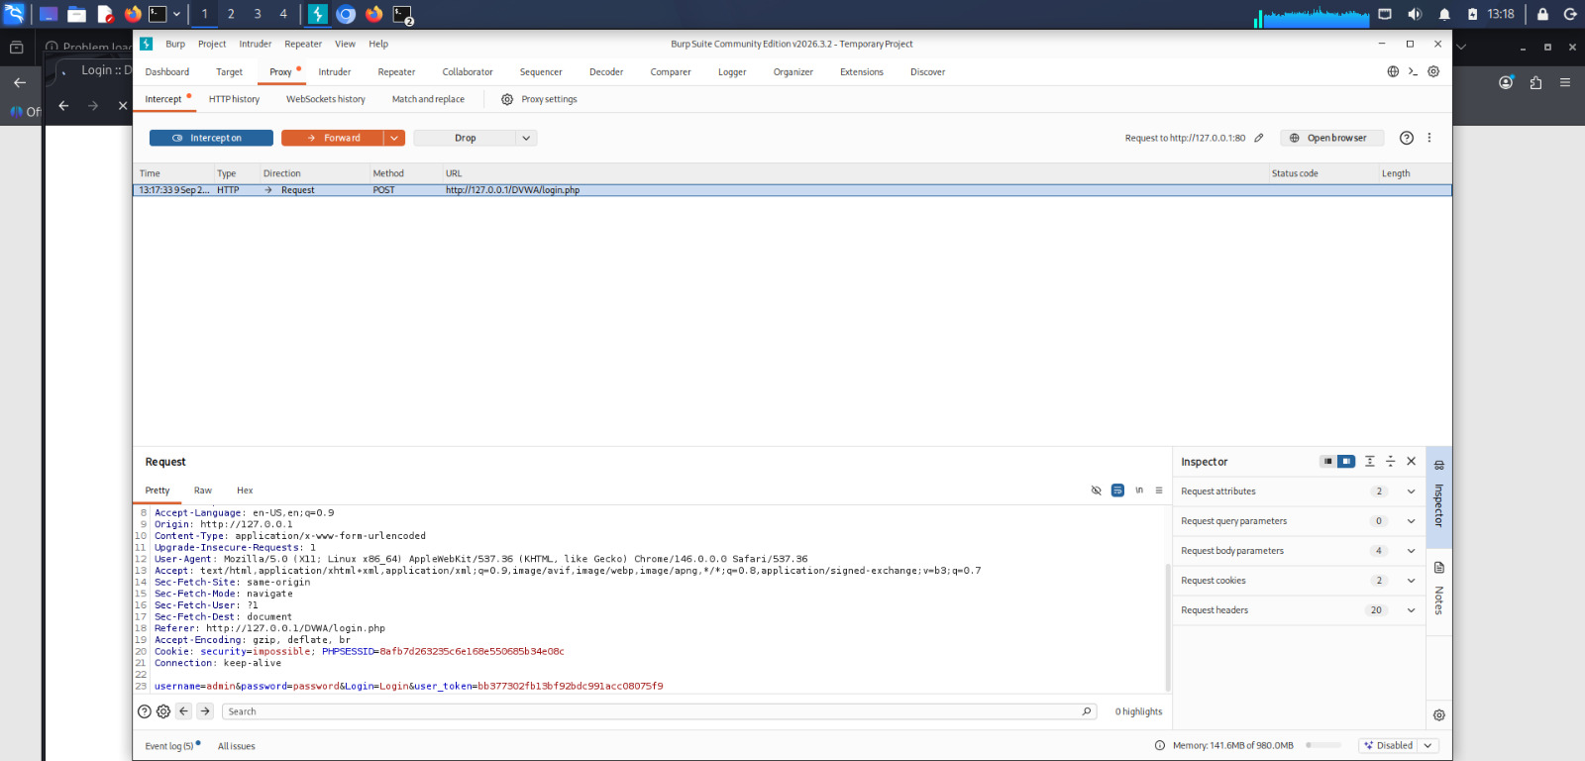

Figure 14: Burp Suite HTTP History
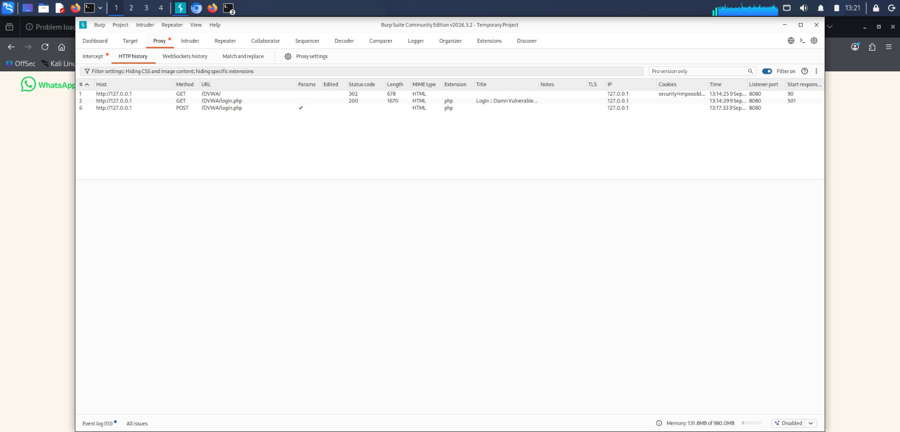

11. BURP SUITE INTRUDER

11.1 Objective
The objective was to perform basic fuzzing of a DVWA login request using Burp Suite Intruder.

11.2 Testing
The captured login request was sent to Burp Suite Intruder. The username parameter was selected as the payload position. Test payloads used were admin, user, test, and guest.
The Intruder results table displayed request number, payload, status code, response time, error, timeout, response length, and comments.

11.3 Result
The requests returned HTTP 302 responses. HTTP 302 indicates that the server redirected the request. Burp Suite Community Edition also displayed a notification explaining that Intruder functionality is limited and attacks are time-throttled in the Community Edition.
Figure 15: Burp Suite Intruder Results
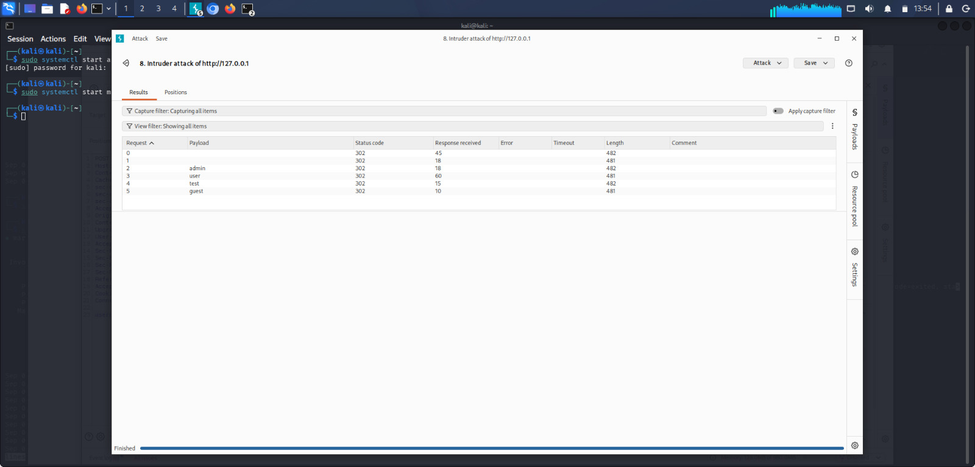

12. WEB SECURITY HEADERS

12.1 Objective
The objective was to configure appropriate HTTP security headers in Apache and verify that they were being returned by the web server.

12.2 Apache Configuration
The Apache headers module was enabled. The following security headers were configured:
Header always set X-Content-Type-Options "nosniff"
Header always set X-Frame-Options "SAMEORIGIN"
Header always set Referrer-Policy "strict-origin-when-cross-origin"
Header always set Content-Security-Policy "default-src 'self'"

12.3 Configuration Verification
The Apache configuration was tested using:
sudo apache2ctl configtest
The result was: Syntax OK. Apache was then started successfully.

12.4 Header Verification
The headers were verified using cURL. The following headers were successfully returned:
X-Content-Type-Options: nosniff
X-Frame-Options: SAMEORIGIN
Referrer-Policy: strict-origin-when-cross-origin
Content-Security-Policy: default-src 'self'
Figure 16: Security Headers Verification
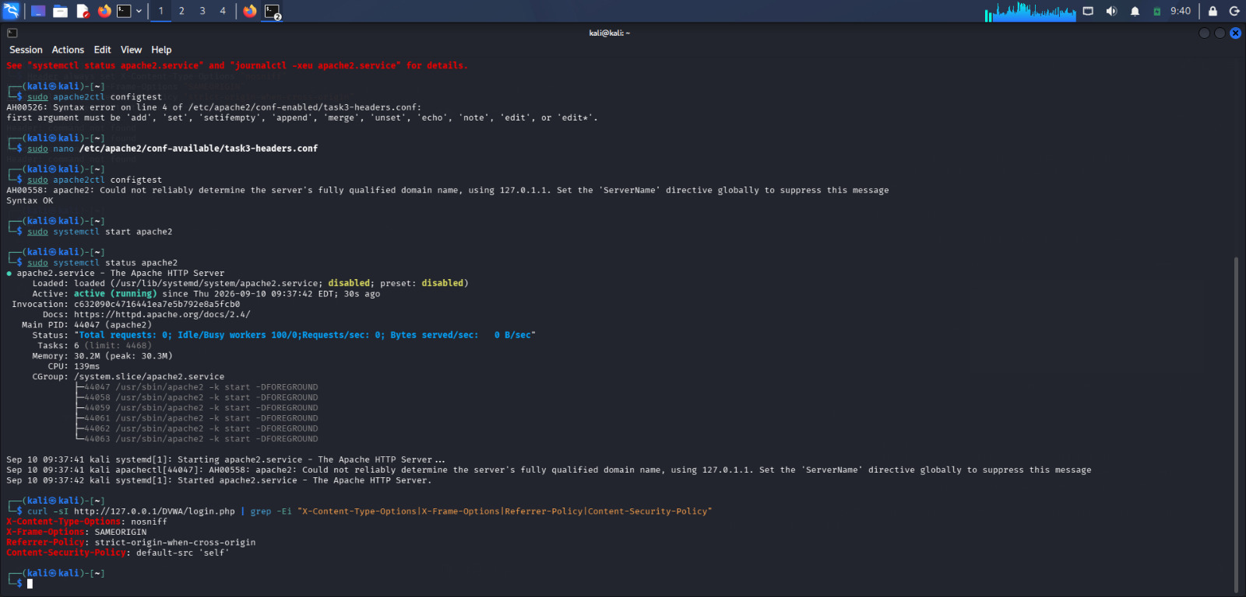

13. SECURITY HEADERS AND THEIR PURPOSE
Header | Purpose
X-Content-Type-Options | The nosniff value helps prevent browsers from incorrectly interpreting the content type of a resource.
X-Frame-Options | SAMEORIGIN helps restrict framing by different origins and provides protection against certain clickjacking attacks.
Referrer-Policy | Controls how much referrer information is included when navigating between pages.
Content-Security-Policy | Restricts permitted content sources and can reduce the impact of certain XSS attacks.

14. VULNERABILITY SUMMARY
Vulnerability / Security Test | Status | Mitigation
SQL Injection | Tested | Prepared Statements
Blind SQL Injection | Tested | Prepared Statements
Stored XSS | Tested | Input Validation and Output Encoding
Reflected XSS | Tested | Input Validation and Output Encoding
DOM XSS | Tested | Safe DOM Handling and Validation
CSRF | Tested | CSRF Tokens
File Inclusion | Tested | File Allowlisting and Validation
Command Injection | Tested | Input Validation and Safe APIs
Burp Login Interception | Completed | Secure Authentication Practices
Burp Intruder Fuzzing | Completed | Input Validation and Rate Limiting
Security Headers | Configured | Apache Security Headers

15. SECURITY RECOMMENDATIONS
- Always use Prepared Statements for database queries.
- Validate and sanitize user input.
- Encode output before displaying untrusted data.
- Implement Content Security Policy.
- Use CSRF tokens for sensitive state-changing operations.
- Restrict file access using allowlists.
- Avoid passing user input directly to operating-system commands.
- Use secure authentication mechanisms.
- Configure appropriate HTTP Security Headers.
- Apply the principle of least privilege.
- Regularly perform vulnerability assessments.
- Keep web servers, frameworks, libraries, and dependencies updated.

16. OVERALL FINDINGS
The testing demonstrated that vulnerable web applications can be affected by several different classes of security vulnerabilities. SQL Injection demonstrated the importance of parameterized database queries. XSS testing demonstrated the importance of input validation, output encoding, and Content Security Policy. CSRF testing demonstrated the importance of protecting state-changing requests using CSRF tokens. File Inclusion and Command Injection demonstrated the risks of allowing untrusted input to control files or operating-system commands. Burp Suite provided a practical method for intercepting, inspecting, and fuzzing HTTP requests. Apache security headers were successfully configured and verified using cURL.

17. CONCLUSION
Task 3 provided practical experience in identifying and understanding common web application security vulnerabilities in a controlled environment. SQL Injection, XSS, CSRF, File Inclusion, and Command Injection were successfully tested using DVWA. Burp Suite was used to intercept HTTP requests and perform Intruder fuzzing. Security mitigation techniques including Prepared Statements, input validation, CSRF token protection, Content Security Policy, and Apache Security Headers were demonstrated. This task improved practical understanding of both offensive web application security testing and defensive security techniques.

