**Visvesvaraya Technological University**

jnana sangama, BelAGAVI – 590 018



**An Report on**

***Restaurant Management System***

*Submitted in partial fulfillment of the requirements as a part of the DBMS Lab for the award of degree of*

**Bachelor of Engineering**

**in**

**Information Science and Engineering**

Submitted by

**NishithA**

**1RN16IS059**

|  |  |
| --- | --- |
| **Faculty Incharge**  **Mr. Manoj Kumar H**  **Assistant Professor**  **Dept. of ISE, RNSIT** | **Lab Incharge**  **Mr. R Rajkumar**  **Assistant Professor**  **Dept. of ISE, RNSIT** |



**Department of Information Science and Engineering**

**RNS Institute of Technology**

Channasandra, Dr. Vishnuvardhan Road, RR Nagar Post,

Bengaluru – 560 098

2018 – 2019

**RNS Institute of Technology**

Channasandra, Dr.Vishnuvardhan Road, RR Nagar Post,

Bengaluru – 560 098

**Department of Information Science & Engineering**



**CERTIFICATE**

This is to certify that the internship report entitled ***RESTAURANT MANAGEMENT SYSTEM*** has been successfully completedby**NISHITH. A** bearingUSN**1RN16IS059**, presently V semester student of **RNS Institute of Technology** in partial fulfillment of the requirements as a part of the DBMS Laboratory for the award of the degree***Bachelor of Engineering in Information Science and Engineering*** under **Visvesvaraya Technological University, Belagavi**during academic year 2018 – 2019. It is certified that all corrections/suggestions indicated for Internal Assessment have been incorporated in the report deposited in the departmental library. The mini project report has been approved as it satisfies the academic requirements as a part of DBMS Laboratory for the said degree.

**Mr. R Rajkumar Dr. M V Sudhamani**

Faculty Incharge Professor and HOD

Assistant Professor

# External Viva

**Name of the Examiners Signature with date**

1. _________________ __________________
2. ________________ ___________________

**ABSTRACT**

The project “Restaurant Management System” is implemented to reduce the manual work and enhances the accuracy of work in a restaurant. This system manages and maintains the record of customers and staff in the restaurant. This software has been made in a user friendly interface. So that normal person can add and delete the entries of customers and handle all the transactions easily. This project is also designed with full consideration to help the users in an easy manner without any unnecessary wastage of time. This system can be implemented in big restaurant where customers can order their food. The menu card consists of various food varieties available in the restaurant.

Through the ordering form, the customer can simply click and order the food. The billing system prepares the bill according to the ordered food. This system entirely reduces the unnecessary time waste inside the restaurant as well as it reduces unnecessary noise.

**ACKNOWLEDGMENT**

The fulfillment and rapture that go with the fruitful finishing of any assignment would be inadequate without the specifying the people who made it conceivable, whose steady direction and support delegated the endeavors with success.

I would like to profoundly thank **Management** of **RNS Institute of Technology** for providing such a healthy environment to carry out this Project work.

I would like to thank our beloved Director **Dr. H N Shivashankar**for his confidence feeling words and support for providing facilities throughout the course.

I would like to express my thanks to our Principal **Dr. M K Venkatesha**for his support and inspired me towards the attainment of knowledge.

I wish to place on record my words of gratitude to **Dr. M V Sudhamani,** Professor and Head of the Department, Information Science and Engineering, for being the enzyme and master mind behind my Project work.

I would like to express my profound and cordial gratitude to my Faculty incharge **Mr. R Rajkumar**, Assistant Professor, Department of Information Science and Engineering for their valuable guidance, constructive comments and continuous encouragement throughout the Project work.

I would like to express my profound and cordial gratitude to my Faculty Incharge

**Mr**. **Manoj Kumar H**, Assistant Professor, Department of Information Science and Engineering for his valuable guidance in preparing Project report.

I would like to thank all other teaching and non-teaching staff of Information Science & Engineering who have directly or indirectly helped me to carry out the project work.

And lastly, I would hereby acknowledge and thank my parents who have been a source of inspiration and also instrumental in carrying out this Project work.

**NISHITH. A**

**USN: 1RN16IS059**

**TABLE OF CONTENTS**

**CERTIFICATE**

**ABSTRACT i**

**ACKNOWLEDGMENT ii**

**TABLE OF CONTENTS iii**

**LIST OF FIGURES iv**

**ABBREVIATIONS v**

**1. INTRODUCTION 1**

**2. ER DIAGRAM & SCHEMA DIAGRAM 3**

**3. SYSTEM DESIGN 5**

3.1 Tables

**4. IMPLEMENTATION 8**

4.1 Software’s Used

4.2 Snapshots

**5. CONCLUSION 17**

**6. FUTURE ENHANCEMENTS 18**

**REFERENCES** **19**

**LIST OF FIGURES**

**Figure No.** **Descriptions**  **Page**

Figure 2.1 Entity Relationship Diagram 03

Figure 2.2 Schema Diagram 04

Figure 3.1 Customer Table of restaurant 05

Figure 3.2 Login Table of restaurant 05

Figure 3.3 Employee Table of restaurant 06

Figure 3.4 Menu Table of restaurant 06

Figure 3.5 Dish Table of restaurant 07

Figure 3.6 Relation Table of restaurant 07

Figure 4.1 MySQL Server 09

Figure 4.2 User Signup of restaurant 14

Figure 4.3 Admin Login of restaurant 14

Figure 4.4 User Home Page of restaurant 15

Figure 4.5 Staff Information of restaurant 15

Figure 4.6 Customer Information of restaurant 16

**ABBREVIATIONS**

|  |  |  |
| --- | --- | --- |
| ER Diagram | - | Entity Relationship Diagram |
| RDBMS | - | Relational Database Management System |
| SQL | - | Structured Query Language |

**Chapter 1**

# INTRODUCTION

**1.1 Background**

A relational database management system is a database management system based on the relational model invented by Edgar F. Codd at IBM's San Jose Research Laboratory. Most databases in widespread use today are based on his relational database model.SQL is widely used in Storing and Retrieving Data. Data is stored in the form of a Data Base. A front end tool , like c# can be used to make an user interface which makes it easy for end users to manage the data.

This reduces the amount of Paper Work required in traditional storage . When compared with file Structures, DBMS makes the searching process easier.Using suitable front end tools, end users need not write queries to retrieve data. But they can easily access the Data with the help of suitable front end tool. The design of back end and its connections to front end is the job of Data Base

Engineers.

**1.2 Introduction to Restaurant Management System**

The mini project titled Restaurant Management System is a Library Management software for monitoring and controlling the transactions in a library .The mini project “Restaurant Management System” is developed using Visual Studio, which mainly focuses on basic operations in a restaurant like adding new customers, taking their order from the menu and updating their bill accordingly and maintains a record of all the staff present in the restaurant.

This mini project of “RESTAURANT MANAGEMENT” gives us the complete information about the menu present in the restaurant. We can enter the record of new customer and table number and retrieve the details of customer present in the restaurant. Throughout the project the focus has been on presenting information and content in an easy and intelligible manner.

**Objective of the Project**

* The main objective of the project is to develop software that facilitates the

data storage, data maintenance and its retrieval for the restaurant in an igneous

way.

* To store the record of the customers and the staff, only the admin has the privilege to access any database.
* To develop easy-to-use RDBMS software which handles the customer-staff

relationship in an effective manner.

* To develop a user friendly system that requires minimal user training. Most

of features and function are similar to those on any window platform.

**Purpose of the project**

The Project was made in order to effectively and efficiently cater to requirements of restaurant management. With many customers visiting a restaurant at any given time it can be difficult to keep track of all the customers and their orders.

This project helps in streamlining the ordering process and updates the bill as the customer orders from the menu. The customer can check for the running bill to track of their expenses and avoid over spending. The admin can access the database to access the information of the customers and the staff that are working in the restaurant.

**Chapter 2**

**Chapter 2**

# R Diagram of Restaurant Database

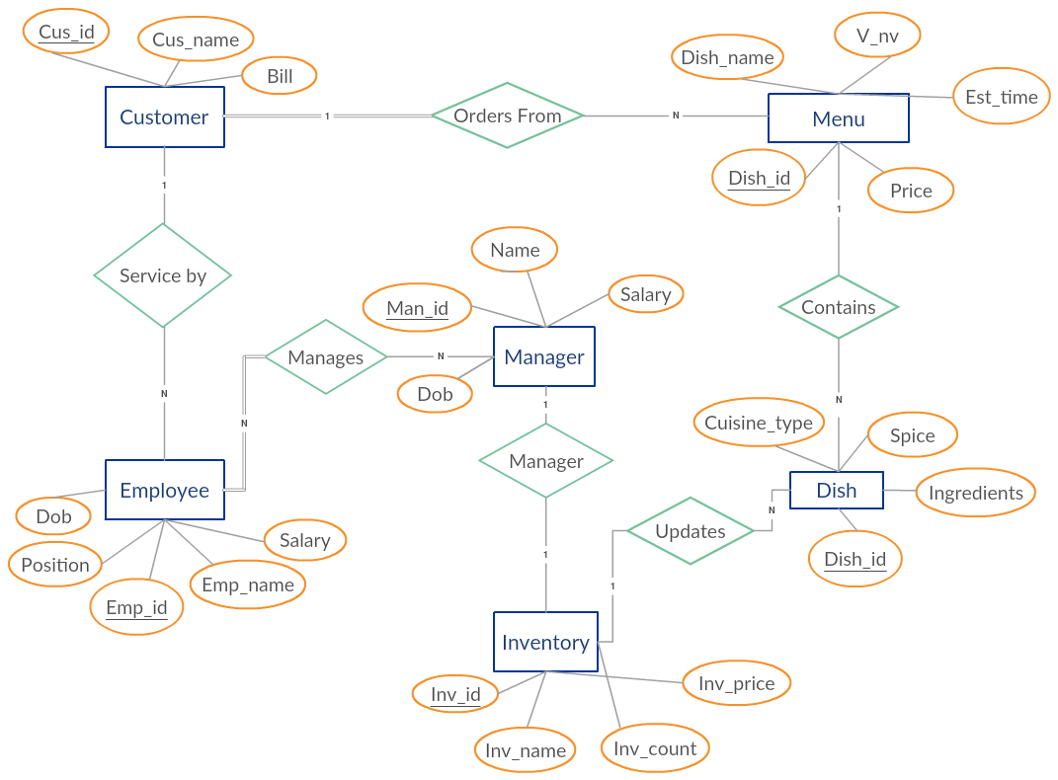

**Figure 2.1: E-R Diagram of Restaurant Database**

# Relational Schema Diagram of Restaurant Database

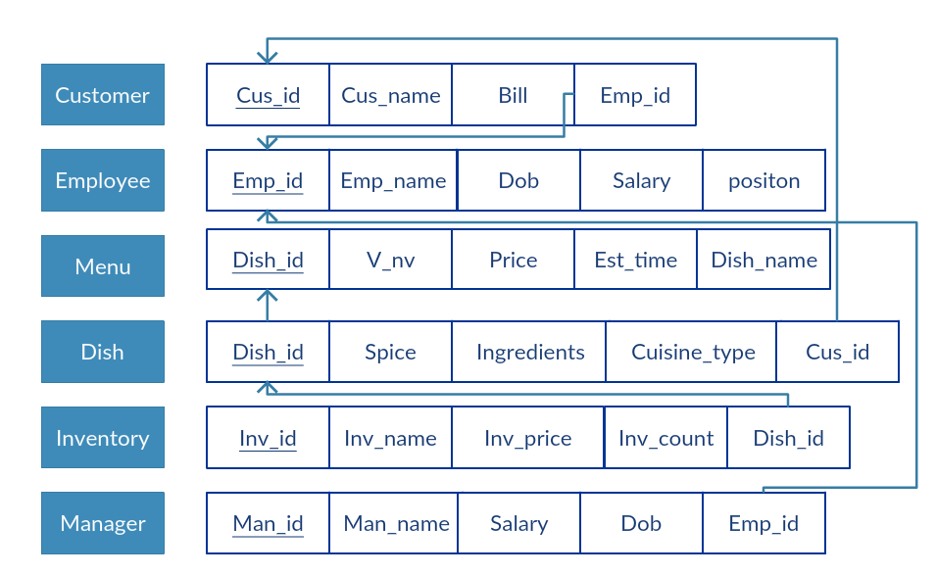

**Figure 2.2: Relational Schema Diagram of Restaurant Database**

**Chapter 3**

# System Tables

**Customer Table**

Customer table stores the details of the table number, the bill number and the employee id affiliated with the table**.**

Table structure for table `Customer` as shown in Table 3.1

CREATE TABLE Customer (

[Customer_name] VARCHAR (50) NOT NULL,

[Table_no] INT NOT NULL,

[Bill] INT NULL,

[Emp_id] INT NULL,

PRIMARY KEY CLUSTERED ([Customer_name] ASC),

CONSTRAINT [FK_Customer_ToTable] FOREIGN KEY ([Emp_id]) REFERENCES [dbo].[Employee] ([Emp_id])

);

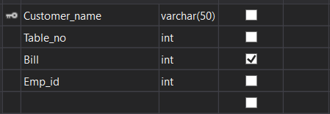

**Figure 3.1: Customer Table of Restaurant**

**Login Table**

This table contains the username and the password of the user.

Table structure for table `Customer` as shown in Table 3.2

CREATE TABLE loginTable (

[username] VARCHAR (20) NOT NULL,

[password] VARCHAR (20) NOT NULL,

PRIMARY KEY CLUSTERED ([username] ASC)

);

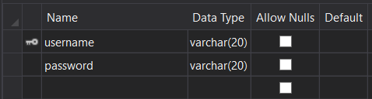

**Figure 3.2: Login Table of Restaurant**

**Employee Table**

This table contains the details of the employee and his/her position in the restaurant.

Table structure for table `Customer` as shown in Table 3.3

CREATE TABLE Employee (

[Emp_id] INT NOT NULL,

[Emp_name] VARCHAR (20) NOT NULL,

[Dob] DATE NULL,

[Salary] INT NULL,

[Position] VARCHAR (20) NULL,

PRIMARY KEY CLUSTERED ([Emp_id] ASC)

);

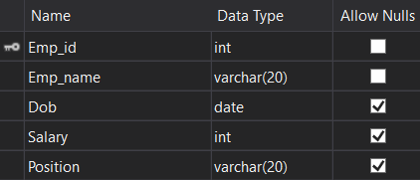

**Figure 3.3: Employee Table of Restaurant**

**Menu Table**

This table contains the information about the food to be served to the customers.

Table structure for table `Customer` as shown in Table 3.4

CREATE TABLE Menu

(

[Dish_id] INT NOT NULL PRIMARY KEY,

[DIsh_name] VARCHAR(20) NOT NULL,

[V_nv] VARCHAR(2) NOT NULL,

[Time] INT NULL,

[cost ] INT NULL

PRIMARY KEY CLUSTERED ([Dish_id] ASC)

);

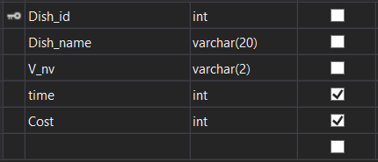

**Figure 3.4: Menu Table of Restaurant**

**Dish Table**

This table contains the details of the food which will be served to the customer.

Table structure for table `Customer` as shown in Table 3.5

CREATE TABLE Dish

(

[Dish_id] INT NOT NULL PRIMARY KEY,

[Spice ] VARCHAR(20) NOT NULL,

[Ingredients] VARCHAR(20) NOT NULL,

[Cusine ] VARCHAR(20) NOT NULL,

PRIMARY KEY CLUSTERED ([Dish_id] ASC)

CONSTRAINT [Dish] FOREIGN KEY ([Dish_id]) REFERENCES [Menu]([Dish_id])

);

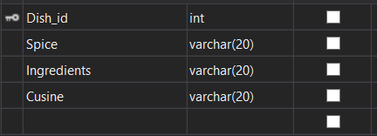

**Figure 3.5: Dish Table of Restaurant**

**Relation Table**

This table contains the information about the food to be served to the customers.

Table structure for table `Customer` as shown in Table 3.6

CREATE TABLE relations (

[Emp_id] INT NOT NULL,

[Customer_name] VARCHAR (50) NOT NULL,

PRIMARY KEY CLUSTERED ([Emp_id] ASC),

CONSTRAINT [FK_relations_ToTable_1] FOREIGN KEY ([Customer_name]) REFERENCES [dbo].[Customer] ([Customer_name]),

CONSTRAINT [FK_relations_ToTable] FOREIGN KEY ([Emp_id]) REFERENCES [dbo].[Employee] ([Emp_id])

);

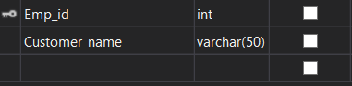

**Figure 3.6: Relation Table of Restaurant**

**Chapter 4**

# Implementation

**Software Used**

Front End tools: Visual Studio 2017

Back End tools: C#,MySQl

Browser that supports HTML and Java script

IES EXPRESS

MySQL Database

**Hardware Used**

CPU: Pentium processor and above

RAM: 2 GB

HDO: 40 GB

**Implementation**

To run this software, any version of Visual Studio must be installed. The Software must be pasted in Documents folder of the computer.

**Front end and Back end used**

**MySQL**

MySQL can be used for a variety of application, but it is most commonly found on Web servers. A Website that uses MySQL may includes Web pages that access information from a database. These pages are often referred to as “dynamic,” meaning the content of each page is generated from a database as the page loads. Website that use dynamic Web pages are often referred to as database-driven websites.

Many database-driven websites that use MySQL also use a web scripting languages like Php to access information from the database. MySQL commands can be incorporated into the Php code, allowing part or all of a web page to be generated from database information. Because both MySQL and Php are open source, the Php/MySQL combination has become a popular choice for database-driven websites.MySQL is used as back end. MySQL is a powerful Relational Database Management System (RDBMS) which we will use the learn the basic principles of database using Structures Query Language (SQL) statement. SQL is a database language that is used to retrieve, insert, delete, update store data. This is achieved by constructing conditional statements that conform to a specific syntaxes.

**How does MySQL works**

MySQL is a database server program and as such is installed on the machine, but can be used as a ‘server’ for the database to a variety of location. Figure 4.1 shows the working of MySQL

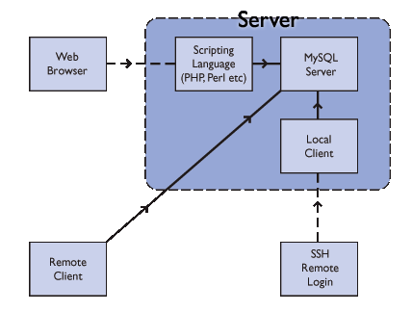

Figure 4.1 MySQL Server

The MySQL Server is installed on a Server and can be accessed directly via various client interfaces, which send SQL statements to the server and then display the results to a user. Some of these are:

**A Local Client -** a program on the same machine as the server. An example of this is the command line MySQL client software we will be using in the rest of the MySQL workshops (although there are other programs including graphical interfaces).

**A Scripting Language** - can pass SQL queries to the server and display the result.

**A Remote Client -** a programme on a different machine that can connect to the server and run SQL statements.

You can also use two more indirect methods.

**Remote Login -** You may be able to connect to the Server Machine to run one of its local clients.

**Web Browser -** you can use a web browser and scripts that someone has written (we're going to use this method for the rest of the workshop).

**Visual Studio**

Microsoft Visual Studio is an integrated development environment (IDE) from Microsoft. It is used to develop computer programs, as well as websites , web apps, web services and mobile apps. Visual studio uses Microsoft software development platforms such as Windows API ,Windows Forms, Windows Presentation Foundation, Windows Store and Microsoft Silverlight. It can produce both native code and managed code.

Visual studio includes a code editor supporting IntelliSense (the code completion component) as well as code refactoring . The integrated debugger works both as a source level debugger and a machine-level debugger. Other built in tools include a code profiler ,forms designer for building GUI applications, web designer ,class designer ,and database schema designer. It accepts plug-ins that enhance the functionality at almost every level including adding support for source control systems and adding new toolsets like editor and visual designers for domain specific languages or toolsets for other aspects of the software development lifecycle .

Visual studio supports 36 different programming languages and allows the code editor and debugger to support nearly any programming language, provided a language specific service exists.

**Coding** :

**Code for Login page**

namespaceFoodApp

{

publicpartialclasshome : UserControl

{

publicstatic String username;

privatestatic home _instance;

publicstatic home Instance

{

get

{

if(_instance==null)

{

_instance = newhome();

}

return _instance;

}

}

public home()

{

InitializeComponent();

}

SqlConnection con = newSqlConnection("Data Source=(LocalDB)\\MSSQLLocalDB;AttachDbFilename=\"|DataDirectory|\\Database1.mdf\";Integrated Security=True");

privatevoidsign_Click(object sender, EventArgs e)

{

Random random = newRandom();

intech = random.Next(102, 103);

int n = 0;

username = textBox1.Text;

SqlCommandcmd = newSqlCommand("NewCustomer",con);

cmd.CommandType = CommandType.StoredProcedure;

cmd.Parameters.AddWithValue("@Customer_name",textBox1.Text);

cmd.Parameters.AddWithValue("@Table_no",textBox2.Text);

cmd.Parameters.AddWithValue("@Bill",n);

cmd.Parameters.AddWithValue("@Emp_id", ech);

con.Open();

try

{

cmd.ExecuteNonQuery();

}

catch(Exception ex)

{

MessageBox.Show(" " + ex);

}

con.Close();

User us = newUser();

this.Hide();

us.Show();

}

}

}

**Code for Admin Login**

namespaceFoodApp

{

publicpartialclassstaff : UserControl

{

privatestatic staff _instance;

publicstatic staff Instance

{

get

{

if (_instance == null)

{

_instance = newstaff();

}

return _instance;

}

}

public staff()

{

InitializeComponent();

}

privatevoidlogin_Click(object sender, EventArgs e)

{

SqlConnection con = newSqlConnection("Data Source=(LocalDB)\\MSSQLLocalDB;AttachDbFilename=\"|DataDirectory|\\Database1.mdf\";Integrated Security=True");

SqlDataAdaptersda = newSqlDataAdapter(" select count(*) from systemTable where username='" + box1.Text + "' and password='" + box2.Text + "'", con);

DataTabledt = newDataTable();

sda.Fill(dt);

if(dt.Rows[0][0].ToString()=="1")

{

admin ad = new admin();

this.Hide();

ad.Show();

}

else

{

MessageBox.Show("Please check your username and password");

}

}

privatevoidstaff_Load(object sender, EventArgs e)

{

}

}

}

**Code for Checkout**

namespace FoodApp

{

public partial class checkout : UserControl

{

private static checkout _instance;

public static checkout Instance

{

get

{

if (_instance == null)

{

_instance = new checkout();

}

return _instance;

}

}

public checkout()

{

InitializeComponent();

}

SqlConnection con = new SqlConnection("Data Source=(LocalDB)\\MSSQLLocalDB;AttachDbFilename=\"|DataDirectory|\\Database1.mdf\";Integrated Security=True");

SqlCommand cmd;

SqlDataReader dr;

private int getdata()

{

con.Open();

string ise = home.username;

cmd = new SqlCommand("select Bill from Customer where Customer_name='"+ise+"'", con);

dr = cmd.ExecuteReader();

dr.Read();

int temp = (int)dr[0];

con.Close();

return temp;

}

private void button1_Click(object sender, EventArgs e)

{

int bill = getdata();

label2.Text = "Rs:" + bill;

//MessageBox.Show("Final Bill:" + bill);

}

private void button2_Click(object sender, EventArgs e)

{

Form1 op = new Form1();

this.Hide();

op.Show();

}

}

}

**Snapshots**

Here the user can enter his/her name and table number. As seen in the figure 4.2

**User Sign Up**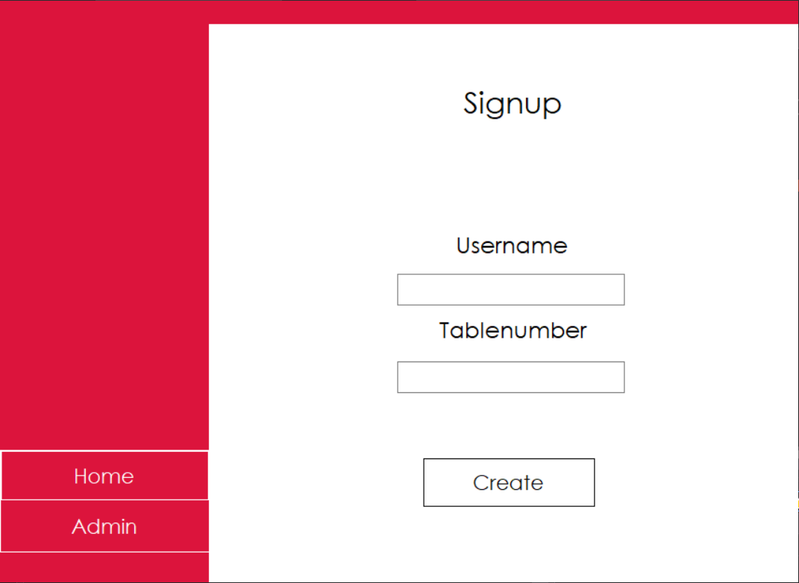

**Figure 4.2: User Sign Up of Restaurant**

After the user logins, they can access the home page from where the various menu options are displayed. As seen in the figure 4.3

**Admin Login**

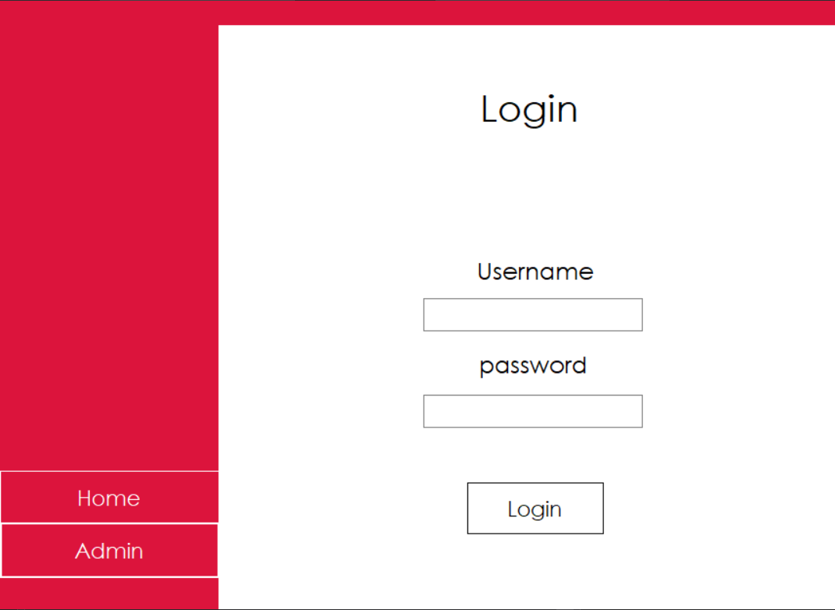

**Figure 4.3: Admin Login of Restaurant**

**User Home page**

In this page the admin can access the system .As seen in the figure 4.4

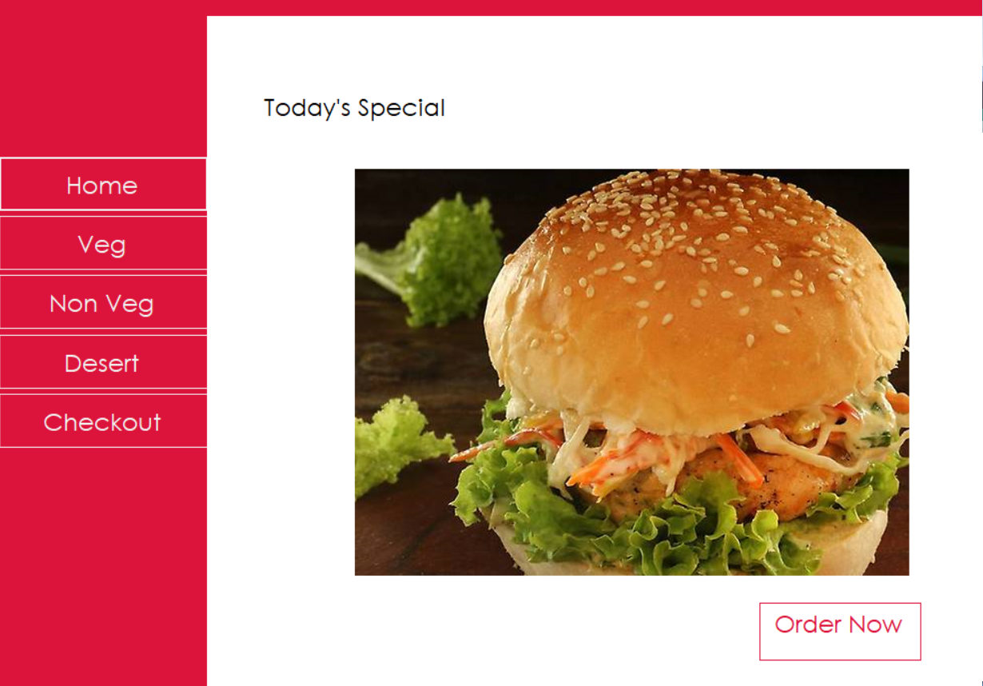**Figure 4.4: User Home page of Restaurant**

After the admin login,he/she can view the information about the employees who work in the restaurant.As seen in the figure 4.5

**Staff Information**

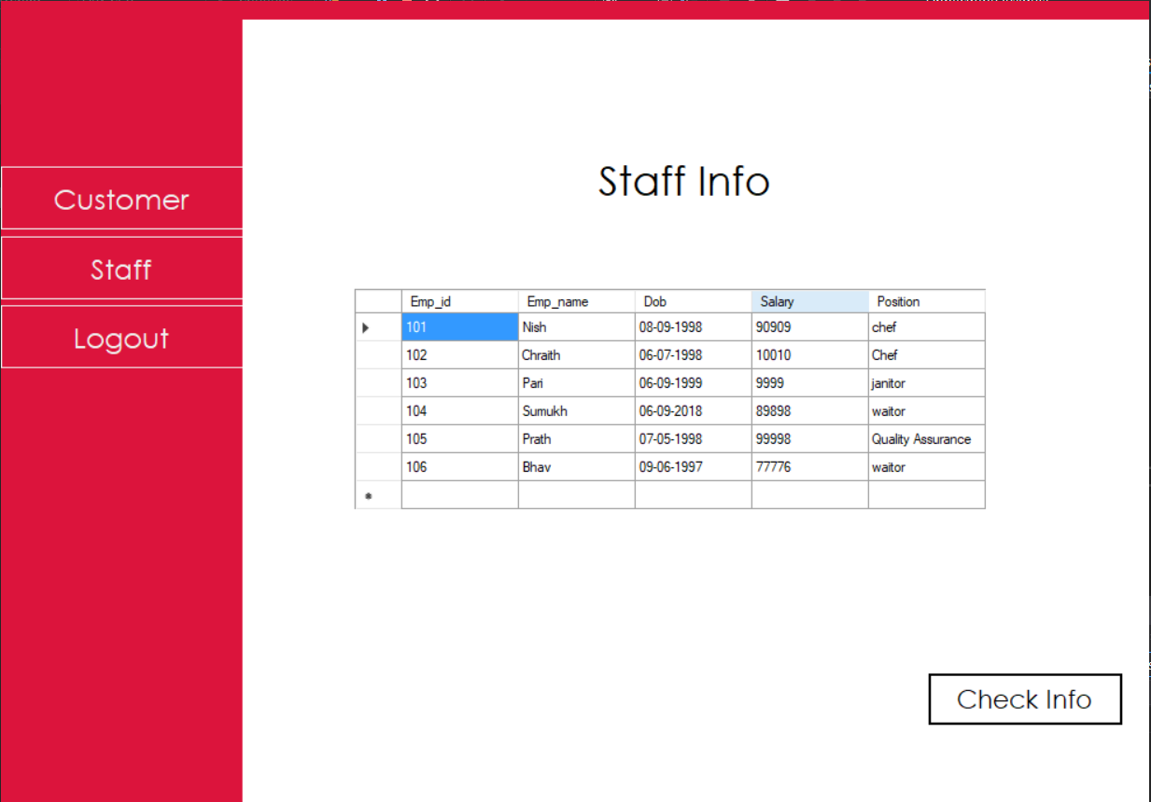

**Figure 4.5: Staff Information of Restaurant**

The admin can view the details about the customer who have visited the restaurant.As seen in the figure 4.6

**Customer information**

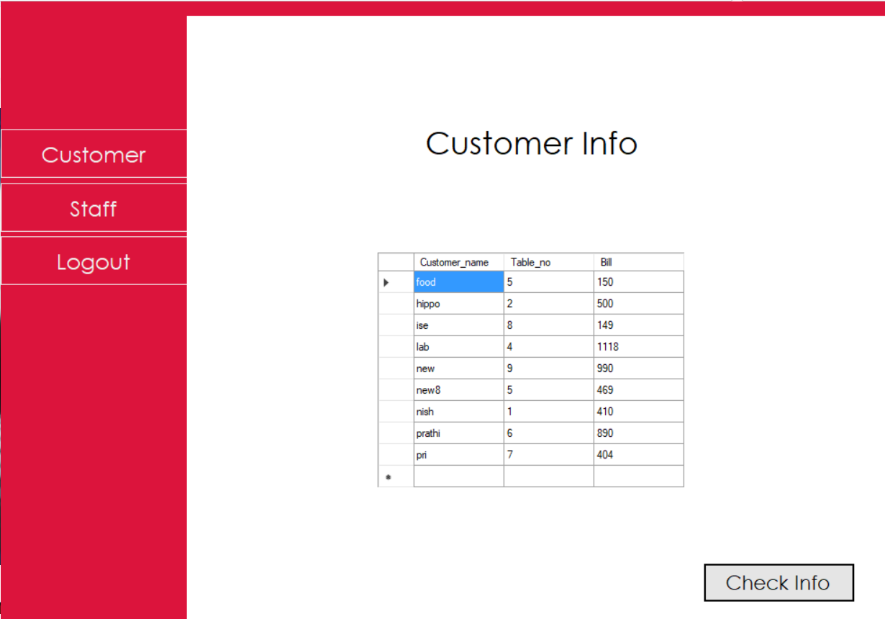

**Figure 4.6: Customer information of Restaurant**

**Chapter 5**

# Conclusion

The mini project “Restaurant Management System” is implemented to reduce the manual work and enhances the accuracy of the work in a restaurant .This system manages and maintains the record of customers and staff in the restaurant.

This software has been made in a user friendly interface. So that normal person can add customer entries and view data present in the table. This project is also designed with full consideration to help the users in an easy manner without any unnecessary wastage of time. This system can be implemented in big restaurants where customers can order their food . The menu card consists of various food varieties present in the restaurant .Through the ordering form, the customer can simply click and order the food. The billing system prepares the bill according to the ordered food. This system entirely reduces the unnecessary time waste inside the restaurant as well as it reduces unnecessary noise.

**Chapter 6**

# Future Enhancements

In future all employee basic salary along with bonuses can be calculated based on their performance. Employee’s images and figure print can be stored in the database.

Verification of the customer by email can also be included. Any offers to the regular customers can be provided.

Further improvisations can be done by including cloud database management which can provide real time tracking of the orders by the customer.

# References

1. Fundamentals of Database Systems 5th edition by Shamkant B.Navathe.
2. Database Management Systems 3rd edition by Ramakrishnan and Gehrke.
3. [www.stackoverflow.com](http://www.stackoverflow.com)
4. [www.youtube.com](http://www.youtube.com)