**Experiment 6**

**Aim: To Implement** **light-based audio response circuit using LDR sensor and buzzer with Arduino**

**Components Required:** Breadboard; Arduino Board; Buzzer, LDR, LED, two Resistors and Jumper Wires.

**Theory:**

LDR (Light Dependent Resistor) is a special type of resistor that works on the photoconductivity principle means that resistance changes according to the intensity of light. Its resistance decreases with an increase in the intensity of light. It is often used as a light sensor, light meter, automatic street light, and in areas where we need to have light sensitivity. LDR is also known as a Light Sensor. LDR are usually available in 5mm, 8mm, 12mm, and 25mm dimensions. The Light-dependent resistors made with photosensitive semiconductor materials like Cadmium Sulphides (CdS), lead sulfide, lead selenide, indium antimonide, or cadmium selenide and they are placed in a Zig-Zag shape. Two metal contacts are placed on both ends of the Zig-Zag shape these metal contacts help in creating a connection with the LDRs as seen in Figure 1.1. A transparent coating is applied on the top so that the zig-zag-shaped photosensitive material gets protected and as the coating is transparent the LDR will be able to capture light from the outer environment for its working.

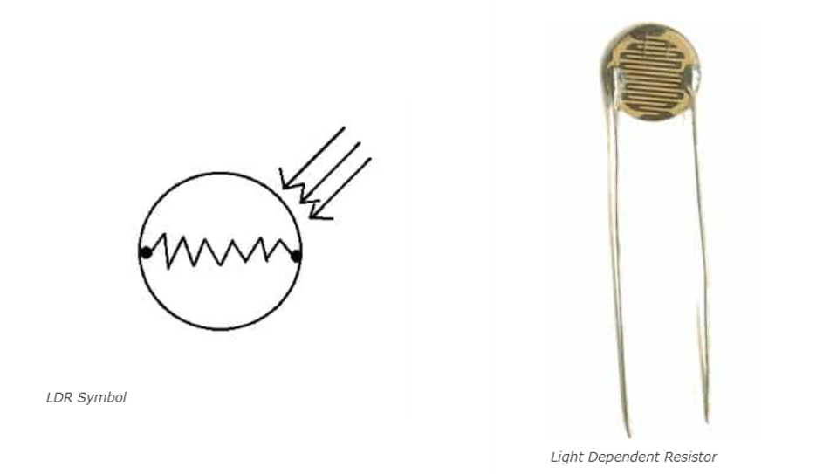

Figure 1.1: Symbol and structure of LDR

**LDR Working Principle:**

It works on the principle of photoconductivity whenever the light falls on its photoconductive material, it absorbs its energy and the electrons of that photoconductive material in the valence band get excited and go to the conduction band and thus increasing the conductivity as per the increase in light intensity. Also, the energy in incident light should be greater than the bandgap gap energy so that the electrons from the valence band got excited and go to the conduction band. The LDR has the highest resistance in dark around 1012 Ohm and this resistance decreases with the increase in Light. As per the property of LDRs, the amount of light entering the LDR the inversely proportional to the resistance of the sensor, and the graph is hyperbolic in nature.

LDR application includes an automatic light that switch on and off according to light, Simple Smoke Detector Alarm, Clock with automatic light, Optical circuit design, Photo proximity switch, Laser-based security systems, Solar Street Lamps, Camera light meters, Clock radios.

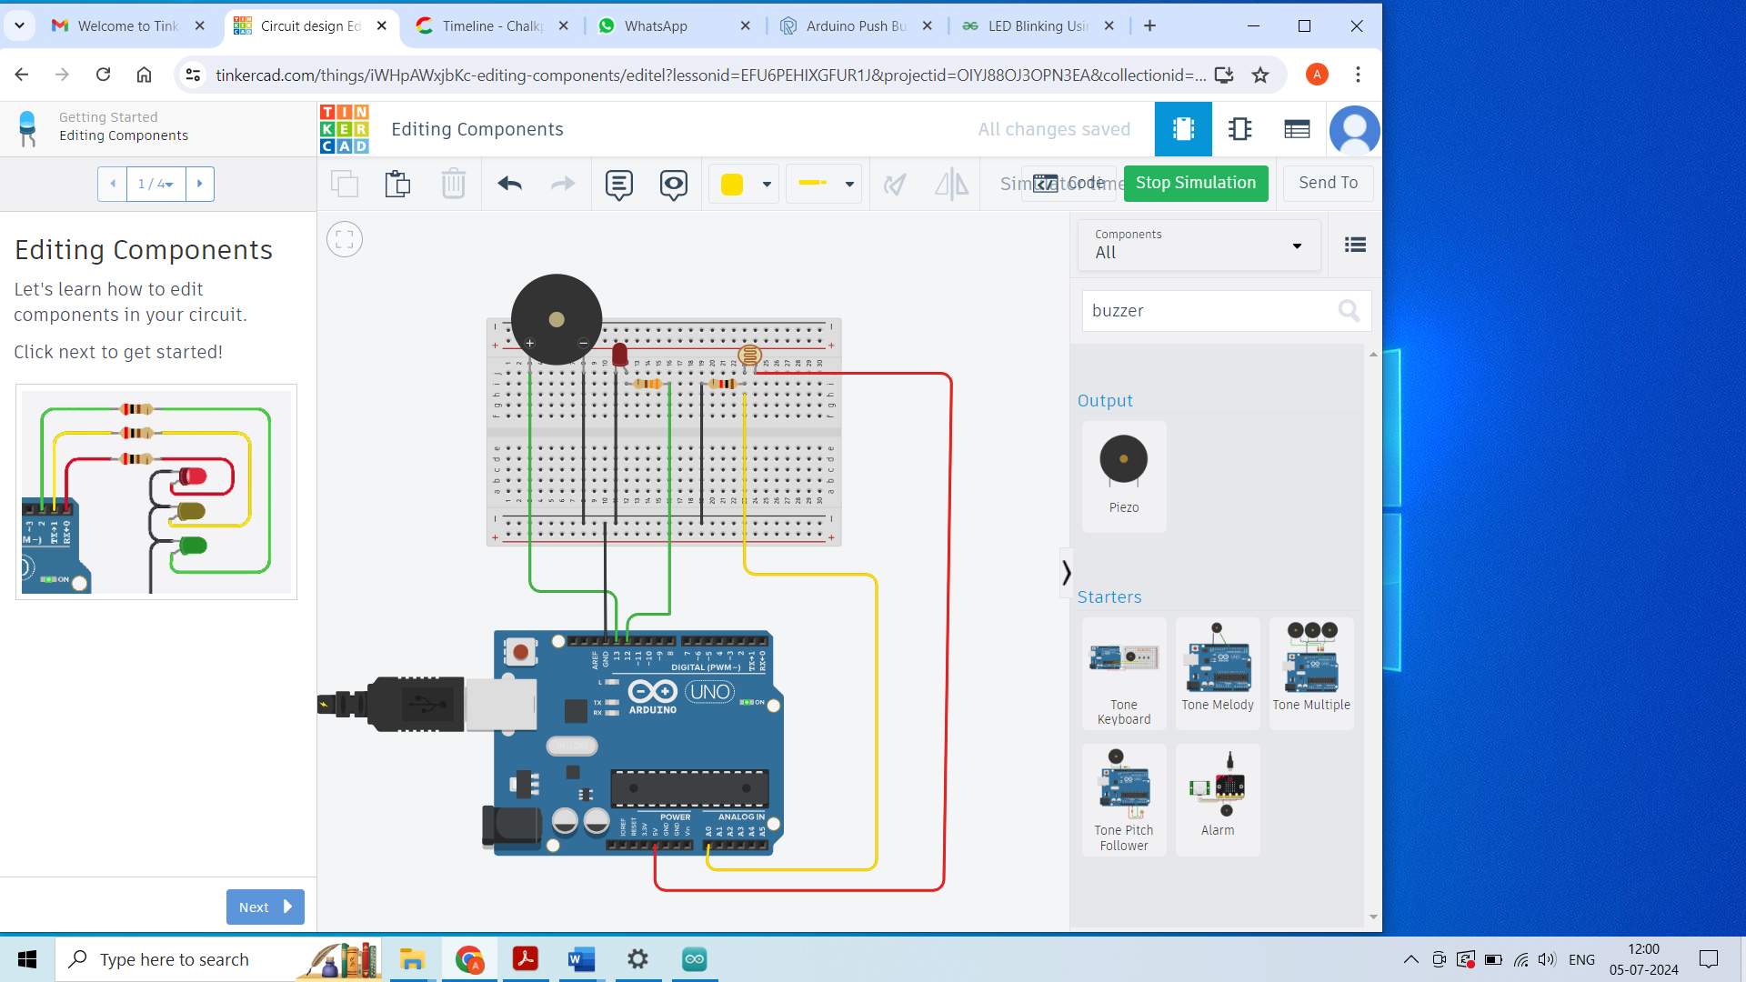

Figure 1.2: Circuit connection of light-based audio response circuit using LDR sensor and buzzer.

**Procedure:**

1. Make sure to power off the Arduino.
2. Plug the Buzzer, LDR and the LED to the vertical rail of the breadboard as shown in Figure 1.2.
3. Place a 220 ohms resistor to the positive leg of the LED. Connect the other end of resistor to the Digital pin 12 on the board using jumper wires.
4. Connect the right leg (terminal 2) of the LDR to the 5V on the board and the other end to analog pin A0. Connect a 10k ohms resistor to the left leg (terminal 1) of the LDR and connect the other end of resistor to the GND.
5. Connect the short leg of LED and the short leg (-) of the buzzer to one common rail and then connect it to the GND on the uno board.
6. Connect the long leg (+) of the buzzer to the Digital pin 13 on the board using jumper wires.
7. Connect the power supply to Arduino. Write code in Arduino IDE Platform.

**Arduino IDE Platform Code:**

The Arduino code programed in Arduino IDE Platform as shown in Figure 1.3. In the code, the LED pin is output and connected to pin 12. The buzzer is output and connected to pin 13. The LDR pin is input and connected to analog pin 0. The baud rate is set to be 9600. When the state of LDR value reaches beyond 400, the LED glows and buzzer is activated.

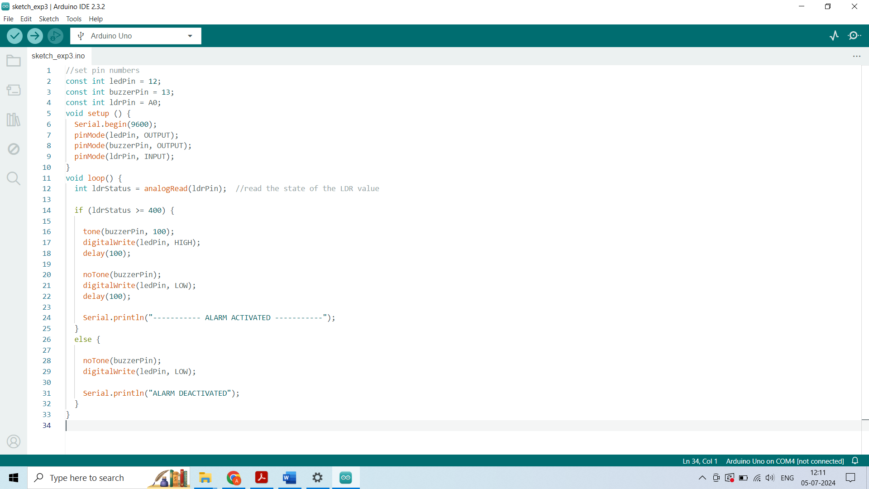

Figure 1.3: Code of light-based audio response circuit using LDR sensor and buzzer.

## Result

The light-based audio response circuit using LDR sensor and buzzer with Arduino gives an overview of how LDR is used to activate a buzzer and an LED. It is observed that when light falls on LDR, the buzzer starts the tone and the LED start blinking, if we block the light passing through the LDR, the buzzer and LED should be deactivated.