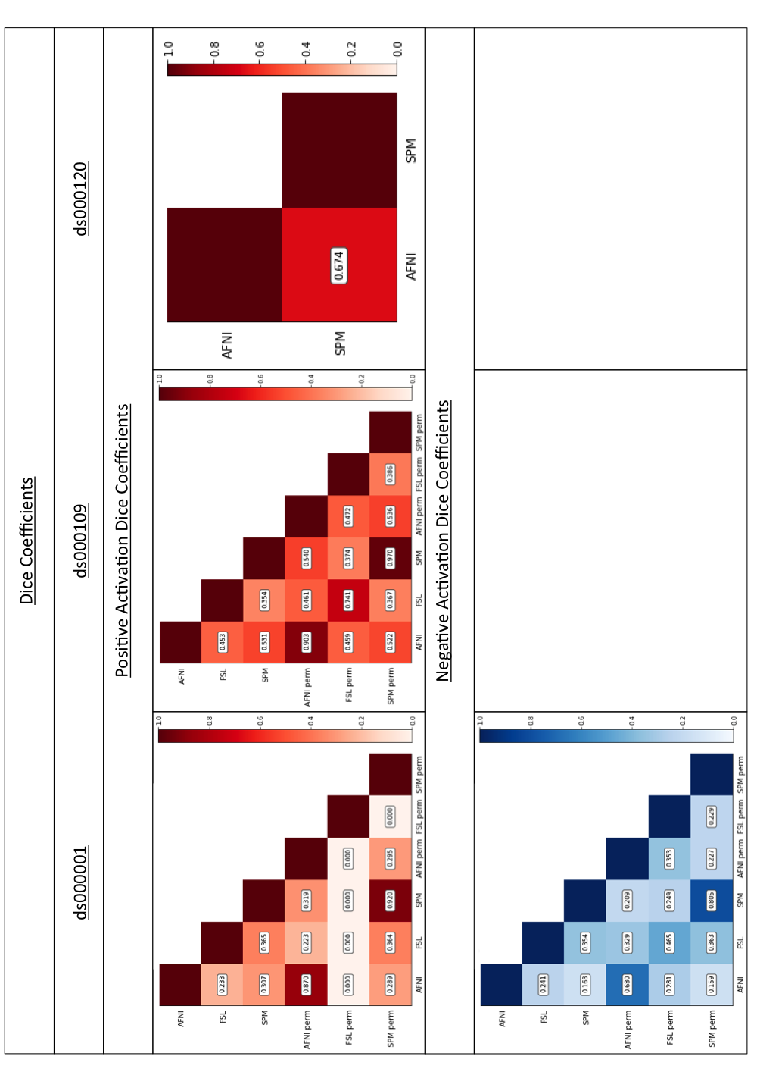

Figure 2

Dice coefficients comparing the thresholded positive and negative T-statistic maps computed using each software package and inference method for each of the three reproduced studies. Dice is the size of the overlapping region of two images divided by the average size of each region. In this context, a Dice coefficient of 1 would indicate perfect agreement between software on the regions of significant activation, whereas a coefficient of 0 would imply that no voxel was declared significant in both packages after thresholding the T-statistic images.

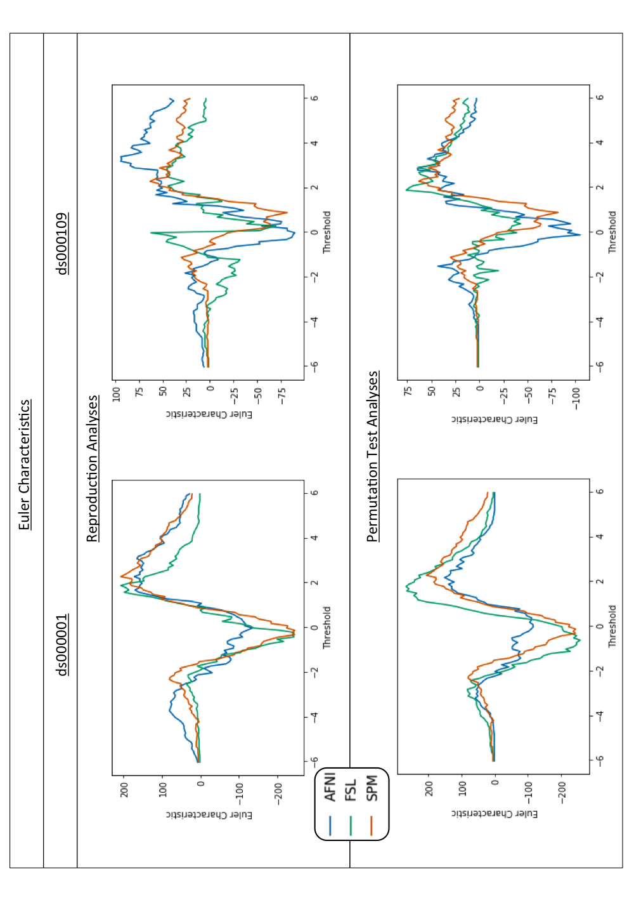

Figure 3

Euler Characteristic plots for ds000001 and ds000109. On top, comparisons of the Euler Characteristics computed after thresholding each software’s T-statistic map from our reproduction analyses using a range of T-values between -6 and 6. Below, comparisons of the Euler Characteristics calculated using the same thresholds on the corresponding T-statistic images obtained via permutation inference within each package.