Iris Report

Name Name

10/04/2024

Table of Contents

# Introduction

The Iris dataset has petal and sepal width and length for three species of Iris flower (*Iris setosa*, *versicolor* and *virginica*). There are fifty samples for each species. Petal and sepal width and length can be used to predict which species of Iris a flower is.

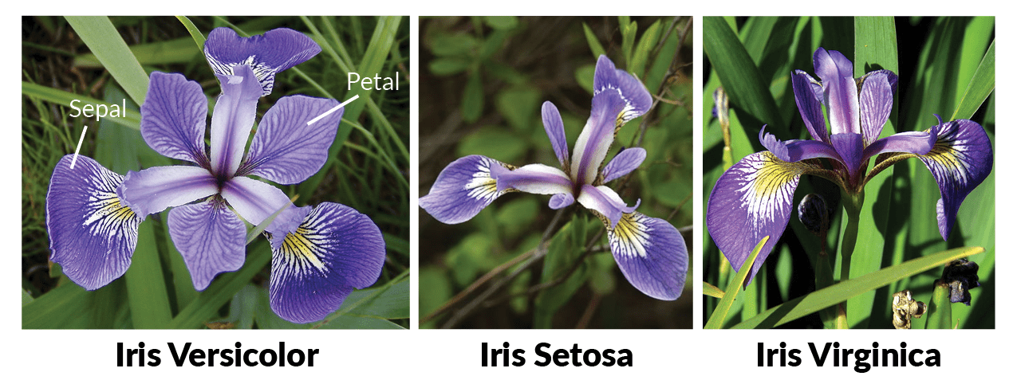

**Figure 1: Iris species**

# Exploring the data

First, lets explore the data by plotting a histogram of all four measurements, grouped by each species of iris.

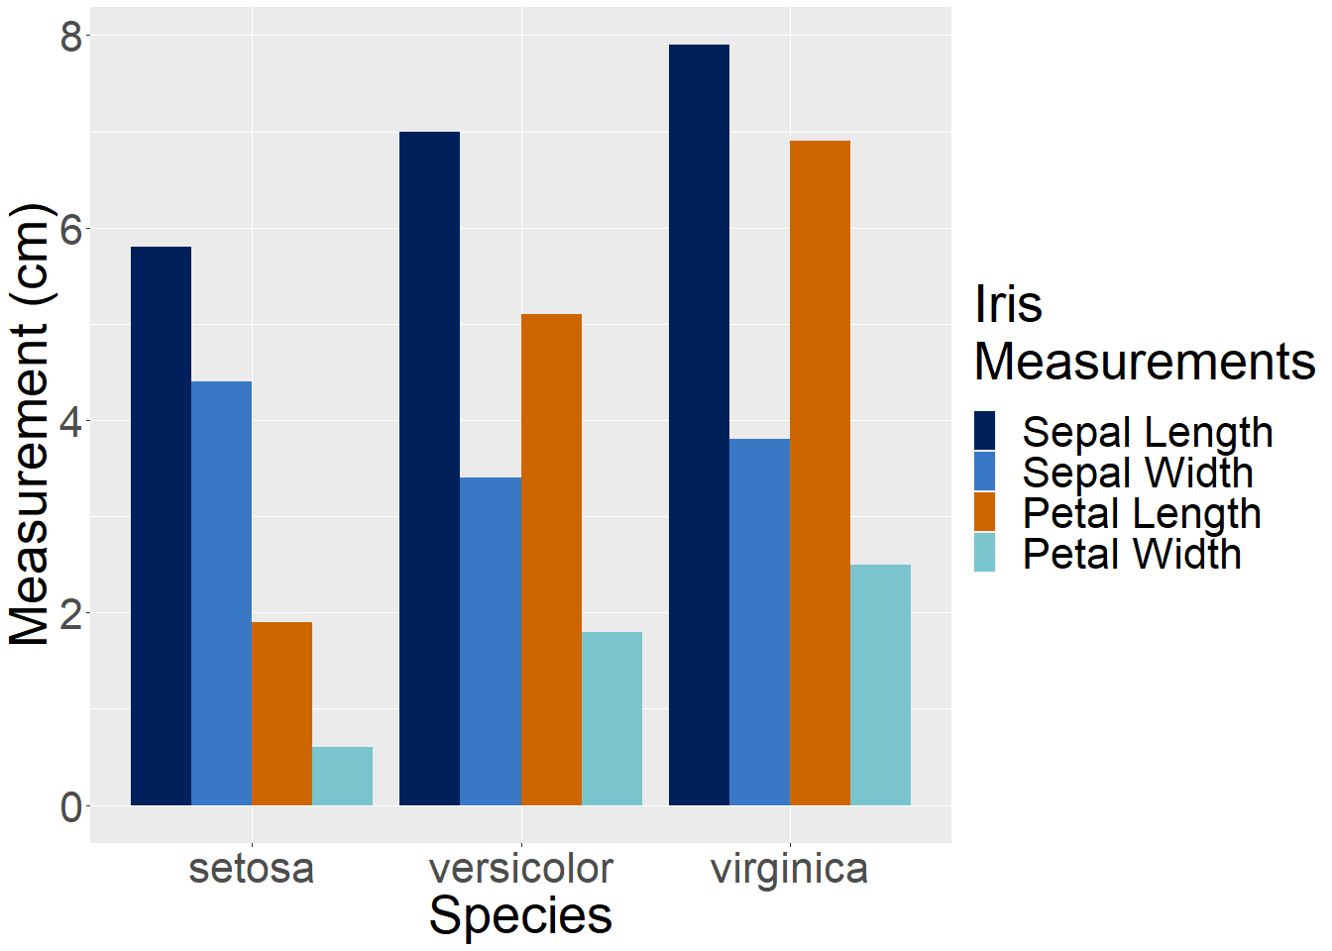

Petal and sepal length and width in cm by Iris species

From the barchart we can see that all four measurements vary between iris species. Lets calculate some summary statistics for the whole data set.

## Average sepal and petal width and length

* The average petal width for all species of Iris is 1.2 cm.
* The average petal length for all species of Iris is 3.76 cm.
* The average sepal width for all species of Iris is
* The average sepal length for all species of Iris is

## Petal petal width by species

The average petal width by Iris species are..

* *Iris setosa* = 0.2
* *Iris versicolor* = 1.33
* *Iris virginica* = 2.026

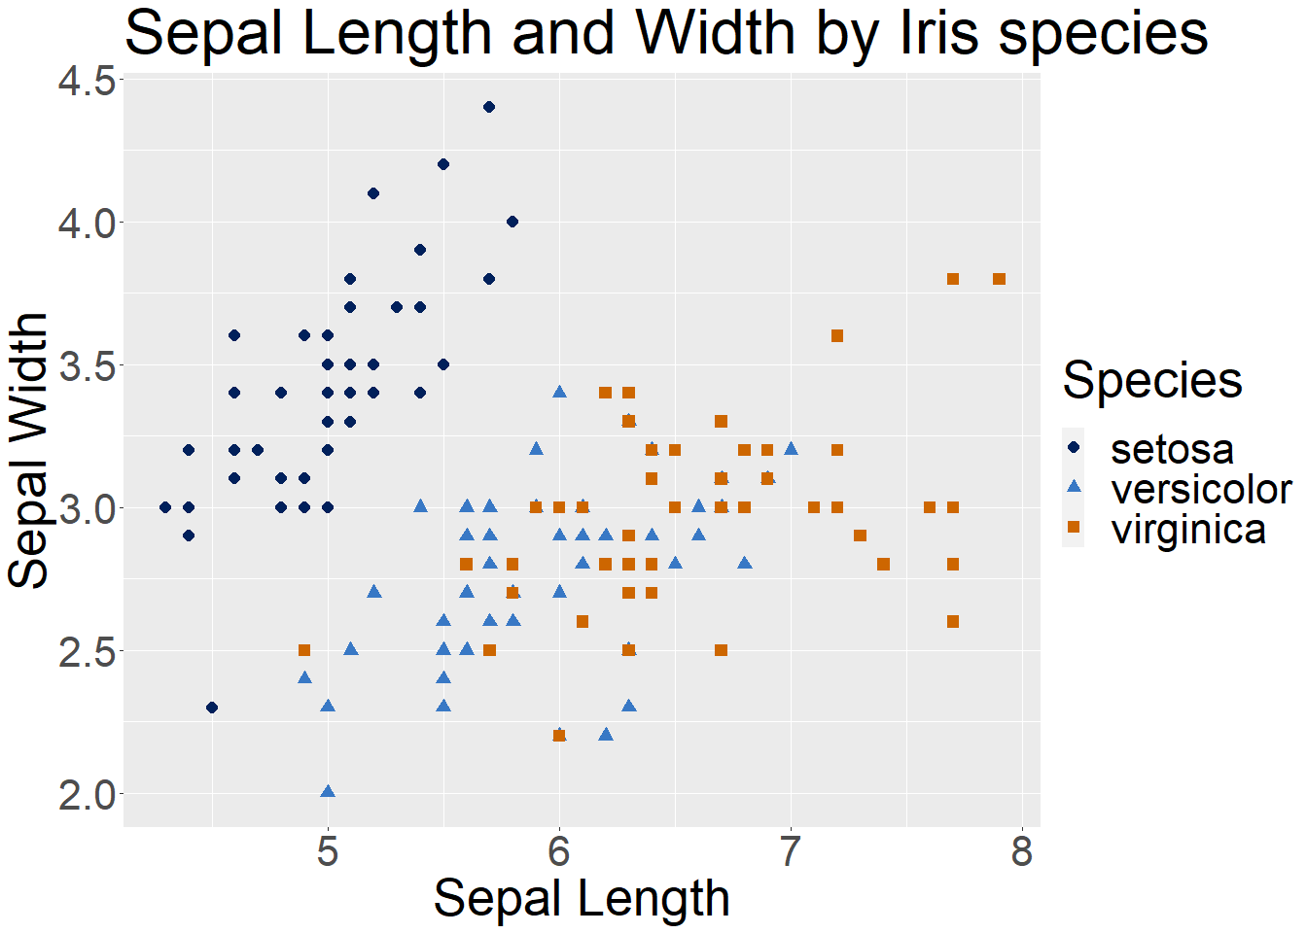

Sepal length and Sepal width in cm by Iris species