BANSHEE Distribution System

Combined Heat and Power (CHP) Plant

Technical Description

This work is sponsored by the Department of Energy, Office of Electricity Delivery and Energy Reliability under Air Force Contract #FA8721-05-C-0002. Opinions, interpretations, conclusions and recommendations are those of the author and are not necessarily endorsed by the United States Government.

DISTRIBUTION STATEMENT A. Approved for public release; distribution is unlimited.

# Introduction

The BANSHEE power distribution system model that was used in the 2017 Microgrid Symposium (MIT Samberg Center, 16 February 2017) featured a notional hardware-in-the-loop natural gas (NG) fueled CHP plant (see Figure 1). The thermal portion of the CHP plant was designed to be used as a demonstrator for the basic mechanism that allows a thermal load to be supplied or augmented by take-off heat from an engine, and so the model was not validated to correspond to a particular site or manufacturer’s equipment. The engine portion of the model was intended to incorporate most of the response characteristics of an actual NG engine-generator, including the action associated with a real hardware engine controller (Woodward easYgen 3500). In the Figure,



*Figure 1. Natural Gas fueled CHP plant*

the orange blocks represent hardware components and the gray blocks represent simulated components.

The balance of this report will focus in some detail the implementation of the NG engine/governor and the thermal model (including boiler). The operation and configuration of the Microgrid Controller and easYgen 3500 will also be described.

# NG Fueled engine/Governor model

The NG engine was modelled in Simulink™ and was based on information extracted from References 2 and 3. Reference 2 contains detailed, validated dynamic data from a bus-sized (i.e., several hundred horsepower) engine. The current model relies heavily on the dynamics described in Reference 2, but parametric scaling was applied to achieve a roughly 10 MW engine. The scaled components were primarily the volumes of the intake manifold and the number of combustion chambers. The scaling was done to approximate the size, power, dynamics and other published characteristics of the GE/Jenbacher J620 natural gas CHP engine; however no attempt was made to validate the resulting model due to proprietary performance data and information held by the manufacturer.

The sections below describe in detail the model developed for the NG engine/governor which is shown in

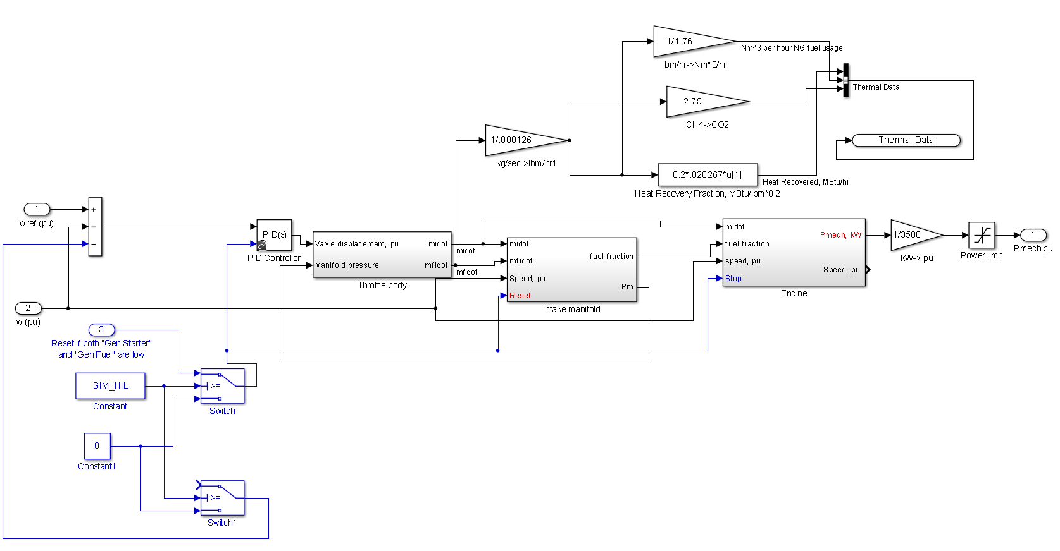

*Figure 2. Engine/Governor Block Diagram*

Figure 2. The “governor” is simply a speed regulating loop that compares the electrical per-unit speed from the generator (“(pu)”) with the commanded speed made up of 1 p.u. constant plus the easYgen bias signal (“ref(pu)”). A PID compensator block is used to implement the governor characteristic. The major bocks comprising the engine model are labelled “throttle body”, “intake manifold” and “engine”. These blocks are described in the sections that follow. Table 1 gives a list of the main parameters used in the engine/governor model.

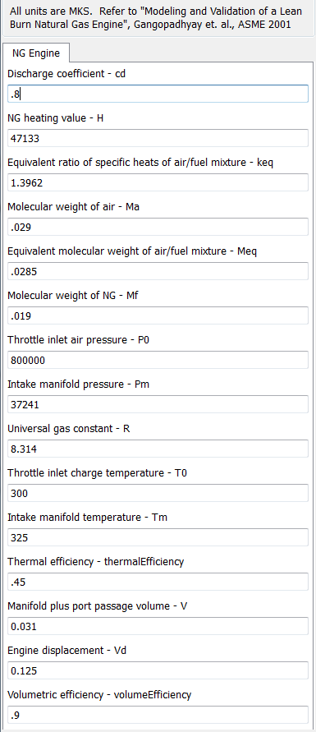

*Table 1. Natural gas engine parameters*

## throttle body

The NG engine valve assembly was assumed to have flow characteristics that could be adequate modelled using Equation (1) from Reference 2. (The theoretical basis for this equation can be found in Reference 3.) The intent was to capture the flow characteristics of a variable orifice-area gas valve with sufficient fidelity to satisfy the system-level dynamic goals of the CHP plant model. Figure 3 shows the resulting Simulink model. The heart of the model resides in the function blocks which implement the flow coefficient of Equation 1 in Reference 2.

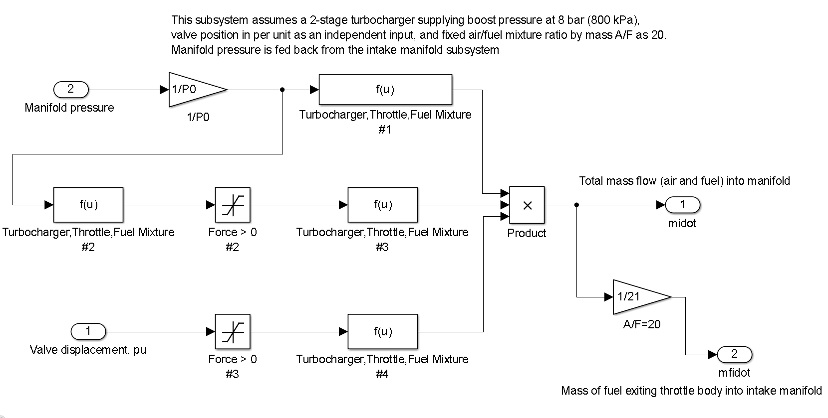

*Figure 3. Valve assembly (“throttle body”) from Equation (1) of Reference 2*

A fixed air/fuel ratio of 20:1 is assumed along with a boost pressure of about 8 bar, which results in a specific mass flow rate out of the valve assembly for a given manifold pressure and valve displacement. This mass flow is fed to the next block, which is the intake manifold.

## Intake Manifold

The NG engine intake manifold basically functions as a gas accumulator that buffers the air/fuel mixture flow between the valve body and the combustion chambers. Figure 4 shows the Simulink™ implementation of the relevant equations from Reference 2, which are Equation (11) and Equation (18). The lower half of the block diagram implements Equation (11) and the upper half implements Equation (18).

As explained in Reference 2, the manifold fuel fraction dynamics represents a significant difference between the dynamics of a gas engine versus a liquid-fueled (e.g. diesel) engine. The rate of change of manifold pressure due to an increase in valve displacement determines the rate at which the air/fuel mixture mass flows into the combustion chambers, and due to the compressibility of natural gas fuel, the resulting rate of change of combustion energy tends to be slower in a gas engine.

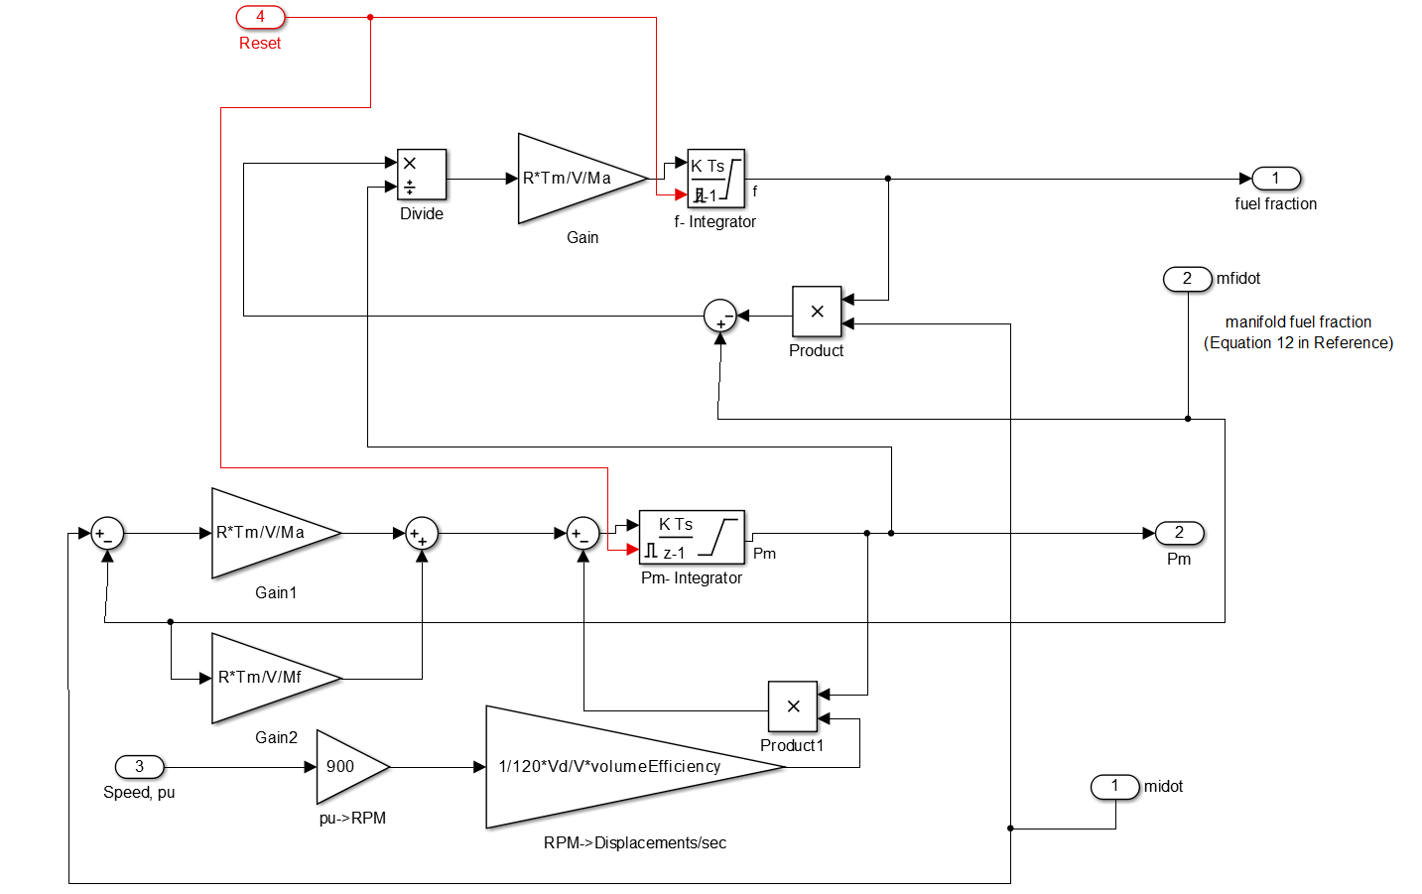

*Figure 4. Intake Manifold from Equations (11) and (18) of Reference 2*

## engine

Figure 5 shows the block diagram for the natural gas engine, which is based on Equation (19) from Reference 2. A constant thermal efficiency of .45 was used which represents the peak value to be expected from the engine. (An alternative implementation using a polynomial to approximate the curve of Figure 2. in Reference 2 led to numerical instabilities in the RT-LAB™ solver.) As explained in Reference 2, a delay of 120 degrees of crankshaft angle was used to approximate average combustion cylinder delay, although this value is conservative for a 20 cylinder engine. However this delay does not play a major role in engine dynamics when operating at 1800 RPM.

A “stop brake” was added to the simulation to cause the engine to decelerate quickly when the model cuts the fuel flow to the engine. This was added for convenience since the easYgen 3500 controller will not restart the engine until speed has decayed below a threshold (the easYgen “crank failure” alarm). Without the brake, the modelled pumping losses decelerate the combined inertia of the engine and generator according to an exponential decay which is excessive.

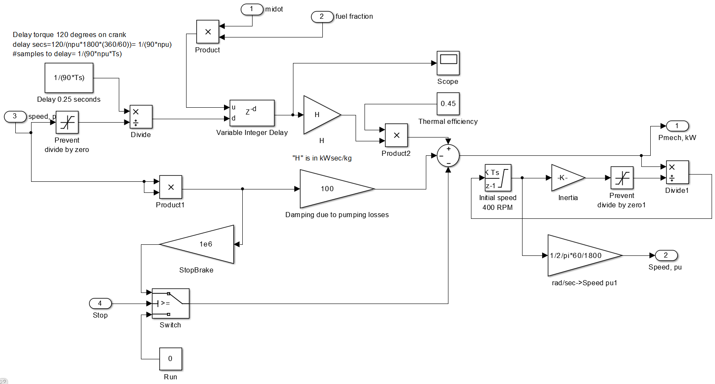

*Figure 5. Natural gas engine model from Equation (19) of Reference 2*

## unit test results

A description of the unit test configuration and results can be found on the public Github [here](https://github.com/PowerSystemsHIL/EPHCC/blob/master/Components/SimulinkOpal/Genset/NGGenset_Test_Model_SummaryDescription.vsd). In addition, a description of the Simulink library block is available [here](https://github.com/PowerSystemsHIL/EPHCC/blob/master/Components/SimulinkOpal/Genset/NGGensetDocumentation.docx).

# thermal model

## Basic configuration and block diagram

The thermal section of the CHP plant is modelled as a very simple, notional thermal load represented by the heat required to maintain an ambient temperature of 73 degF in a research building complex along with steam provided by a natural gas fueled boiler augmented with take-off heat from the NG engine. It is assumed that 20% of the energy consumed by the NG engine can be drawn off the exhaust with a heat exchanger and used to preheat the condensate return to the boiler. The block diagram of Figure 6 shows the major components of the thermal

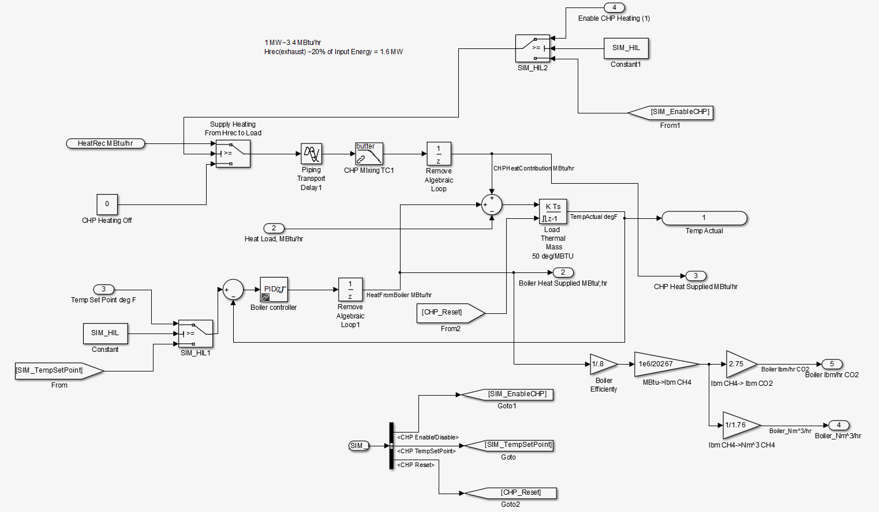

*Figure 6. CHP plant thermal model*

model. The site thermal load is modelled as a “thermal mass” along with a heat load applied to a heat summing junction that feeds the thermal mass (center-right portion of the block diagram). The site temperature is fed back to a PID temperature controller that throttles steam from a notional boiler to maintain site temperature at the set point (input 3 to the block diagram). If CHP heat is available, a logic signal can be generated to apply CHP heat to the heat summing junction through a path that includes a piping transport delay and a mixing delay (center-upper portion of the block diagram) to offload the boiler. The logical variable “SIM_HIL” determines whether the model is running off-line (“SIM_HIL”=0) or in real time using inputs from a Modbus interface which is shown in Figure 7.

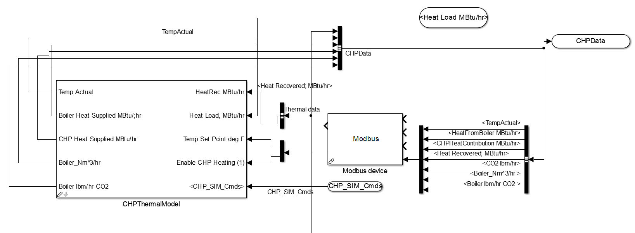

*Figure 7. CHP plant Modbus interface*

Figure 8 shows the thermal load profile that feeds the model. The data was acquired for a particular site in January 2014, but was scaled in time by a factor 0f 600 (150 hours compressed to 15 minutes) to allow the model to execute in a reasonable amount of time. The last 15 minutes of the 30 minute interval are a mirrored version of the first 15 minutes. This was done to allow the model to run continuously without discontinuities at the end of the run if desired. The description of the thermal system library block for Simulink™ is located on the public Github [here](https://github.com/PowerSystemsHIL/EPHCC/blob/master/Components/SimulinkOpal/CHPandThermal/CHPThermalDocumentation.docx).

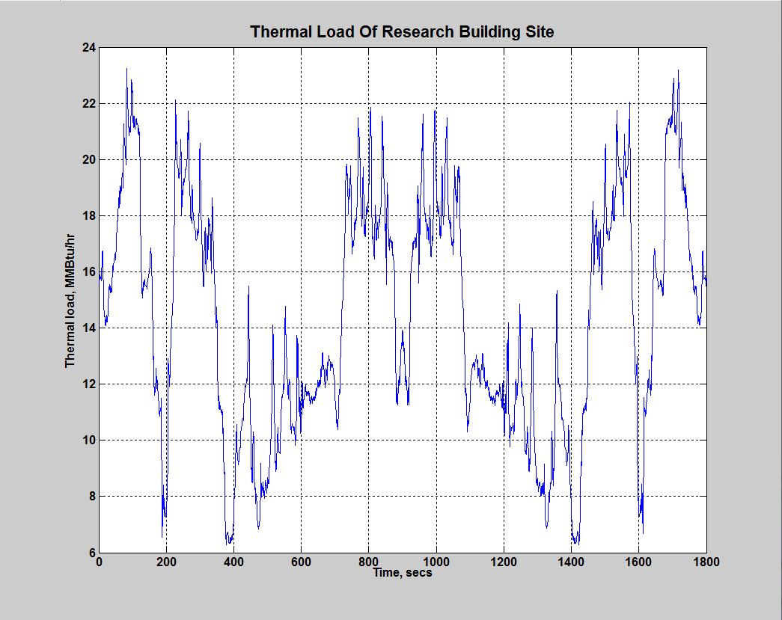

*Figure 8. Thermal load data for January 2014*

## Unit test of chp plant

The results of the CHP plant unit test are located on the public Github [here](https://github.com/PowerSystemsHIL/EPHCC/blob/master/Components/SimulinkOpal/CHPandThermal/CHP_Test_Model_SummaryDescription.vsd). Figure 9, which is extracted from the unit test results, shows the temperature and heat behavior for the CHP plant while offloading the notional boiler. (Note that in the Figure, temperature is in deg C and not deg F.)



*Figure 9. CHP plant unit test partial results*

# Reference Documents

1. *“Hardware-in-the-Loop Microgrid Controller Information Packet v1.8”*, MIT Lincoln Laboratory, November 2016
2. Gangopadhyay, A. and Meckl, P. *“Modeling and Validation of a Lean Burn Natural Gas Engine”, ASME 2001*
3. Heywood, J. B., *Internal Combustion Engine Fundamentals,* McGraw Hill, 1988
4. Woodward EasYgen-3000 Series Manual. Available online: <http://www.woodward.com>.