Test Sequence And Results For Microgrid Controller Symposium 16 February 2017

# Test Sequence

This section describes the test sequence demonstrated at the 2nd Microgrid Controller Symposium held at the MIT Samberg Center on 16 February 2017 utilizing the OPAL-RT HIL microgrid testbed. The structure and definition of the sequence was the result of a collaborative effort between MIT Lincoln Laboratory engineering staff and technical representatives of commercial microgrid controller vendors. The major goals of the test sequence were to demonstrate the microgrid controllers’ performance of the following functions:

1. Minimization of load outage duration
2. Minimization of energy cost (as quantified by emissions)
3. Maximization of islanded operation duration and microgrid survivability
4. Compliance with interconnection requirements (PF and export limits)
5. Ability to meet dispatch order/demand response request
6. Maximization of PV production
7. Minimization of O&M Costs
8. Maximization of PV penetration
9. Minimization of GHG emissions

The features listed above were captured as nine key performance parameters (KPPs) as defined on pp. 19 and 20 in the vendor information packet document residing on the public EPHCC Github server at [this URL](https://github.com/PowerSystemsHIL/EPHCC_Docs/blob/master/2016%20HIL%20Microgrid%20Controller%20Packet%20v1.8.pdf)

In order to expedite execution of the HIL demonstration at the Symposium, the test sequence was shortened from a planned duration of several hours to duration of 30 minutes so that all Symposium attendees would have an opportunity to view the full demonstration. Figure 1.1 below shows the test sequence and DMS command sequence that was used to drive the 30 minute scenario. Vendors were not required to interact with the DMS, but the results given in this section reflect discrepancies where failure to comply with DMS commands apparently occurred. For example, the vendor designated as Vendor #1 apparently did not implement controls to comply with the DMS request to limit imported power (see results for KPP #5).

The test sequence did not incorporate the solar irradiance profile shown in Figure 1.1 due to the limited time available for implementation of the PV and BESS inverters and hardware controllers. Therefore, a constant DC voltage source was assumed for the DC side of the PV array, and a simple battery model was used for the BESS. The components referred to in the Figure (e.g., “BUS106” and “motor1”, etc.) can be found on the one-line diagram that is available on the public EPHCC Github server.

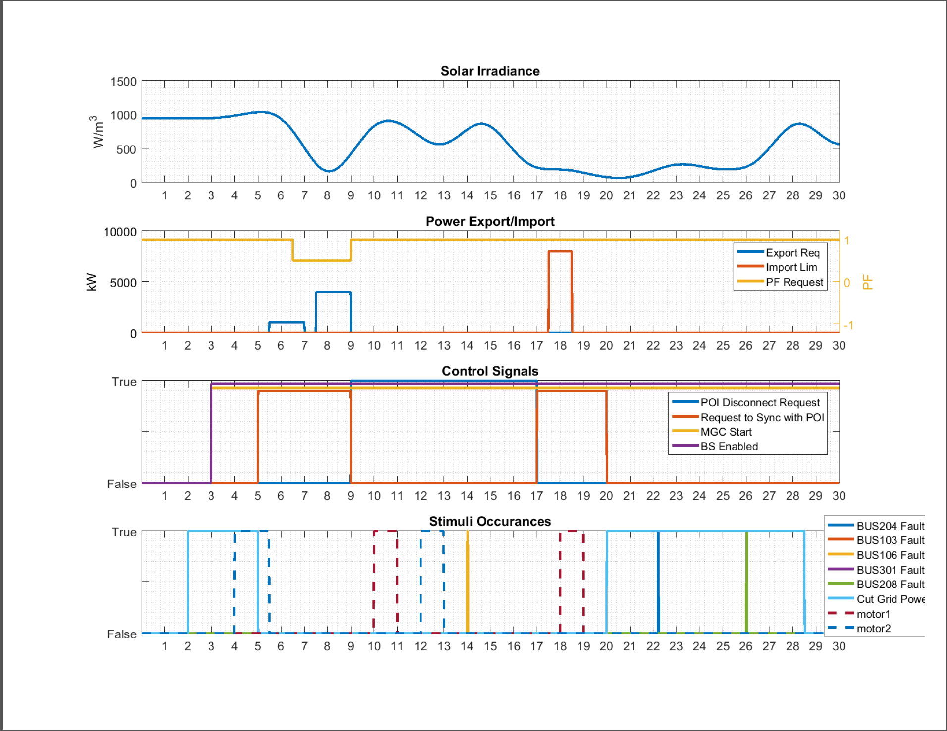

*Figure 1. Symposium Test Sequence and DMS Commands*

# Test Results

## Evaluation Metrics for Microgrid Controller

One of my main objectives with the HIL platform was for it to enable vendors to demonstrate their products' capabilities, differentiate working functionality from marketing "vaporware," and set themselves apart from their competition with hard performance metrics. The Microgrid Controller Symposium event brought together a wide spectrum of stakeholders in the microgrid community to witness a demonstration of the power and potential of Hardware-in-the-Loop technology for the purpose of:

1. **Demonstrating and showcasing** the features and capabilities of the microgrid controller hardware that is currently being offered by manufacturers
2. Eventual cost-effective application as a **commissioning platform** for microgrid deployment
3. Eventual application as a **validation platform** for vendors, test labs and utilities to verify standards compliance.

Matlab™ scripts were written to evaluate the nine KPPs referred to in Paragraph 1.1.1 above for the two test sequences conducted by MITLL using the OPAL-RT based “HILLTOP” hardware-in-the-loop testbed. The first test sequence was run using a microgrid controller provided by a vendor designated “Vendor #1” and the second test sequence was run using a microgrid controller provided by a vendor designated as “Vendor #2”.

## Summary of Results

### Key Performance Parameter #1: Load Outage Duration

Figure 1.2 shows the results for KPP#1. Most notable is how similar the results for load-not-served turned out to be for Vendor #1 and Vendor #2, given that the microgrid controller architecture and firmware were developed independently. As shown in Figure 1. above, the test scenario is rather severe, and included three segments of islanding, one that was requested by DMS near the middle of the scenario and two that were “unintended” (one at the beginning of the scenario and one later in the scenario.) The severity of the scenario and the limited power available from the DERs led to the need to load shed the critical loads for about 20% of the test run. The priority and interruptible loads were given low priority by both vendors during islanding as evidenced by the very high outage numbers, but the values are likely due in part to nuisance tripping/resetting of certain interruptible and priority loads as shown in Figure 3. Another possibility is data dropouts. This issue needs further investigation.



*Figure 2. KPP#1 Results*

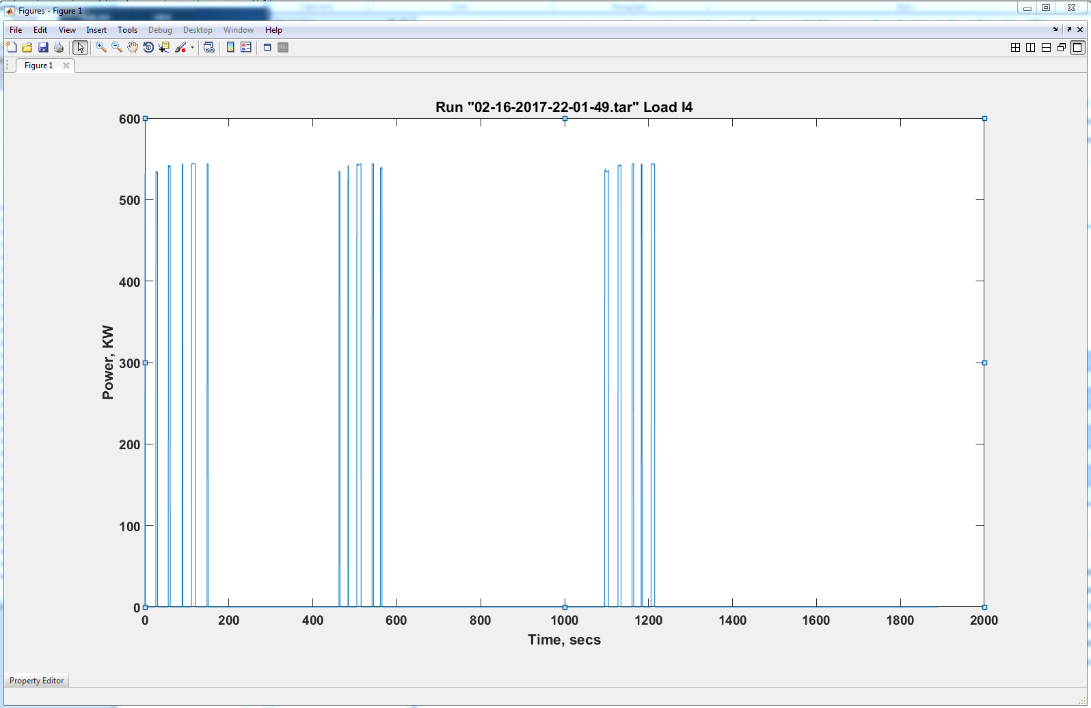

*Figure 3. Evidence of possible nuisance tripping on interruptible load I4*

### Key Performance Parameter #2: Energy Cost

As described in the vendor information packet referred to above, KPP#2 (Energy Cost) is evaluated using power generator emissions for the purposes of this test scenario, and the results are shown in Figure 4.



*Figure 4. KPP#2 Results*

The main difference in the results for the two vendors is due to the fact that Vendor #1 did not run the diesel genset in feeder #1 when grid-tied, which reduced the GHG emissions slightly. In the Figure, the emissions labelled “PG&E” are from published data for that utility, and are used as a baseline emissions rate for power imported from the utility. The data implies that when grid-tied, the best way to reduce emissions (other than maximizing use of PV) is to import power from the grid unless the CHP heat can be used to full advantage, due to the disparity between emissions rate of diesel and NG (about 1425 lb CO2 per MWh and 1027 lb CO2 per MWh respectively) vs. the rate claimed for PG&E (457 lb CO2 per MWh).

### Key Performance Parameter #3: Fuel Consumption During Islanded Condition

Figure 5 shows the comparison for fuel consumption as defined for KPP#3. Vendor #1 makes slightly better use of CHP to offset boiler usage. As mentioned previously, Vendor #1 needs to start the diesel genset in feeder #1 each time an islanding event occurs, which results in slightly lower fuel usage (and higher load not served) for the diesel genset.



*Figure 5. KPP#3 Results*

### Key Performance Parameter #4: Compliance With Interconnection Requirement

Figure 6 shows the comparison of compliance with DMS requests for PF management and export limits. As shown in Figure 6., the levels used in the scenario are a target PF error not to exceed ± 0.05 and a target power export error not to exceed +100 KW over the limits show in the second trace of Figure 1. Both vendors



*Figure 6. KPP#4 Results*

perform poorly in PF compliance, but never exceed export request. It is likely that neither vendor implemented the PF control function in their microgrid controller. In addition, due to the limited capability of the DERs it was easier to meet the export compliance requirement which is a not-to-exceed export requirement as described in the vendor information packet.

### Key Performance Parameter #5: Ability To Meet Demand Response Request

Figure 7. shows the results of the comparison for KPP#5 establishing the ability to meet the DMS demand



*Figure 7. KPP#5 Results*

response request. The results strongly suggest that Vendor #1 is more reliant on the grid and probably disregarded DMS request to limit imported power. On the other hand, Vendor #2 is more aggressive in the use of DERs and was able to satisfy the import request at all times.

### Key Performance Parameter #6: Amount Of PV Production

As shown in Figure 8 below, the vendor performance in utilization of PV was very similar. The



*Figure 8. KPP#6 Results*

actual amount of PV produced was a function of the state of the PV controller, which experienced safety trips during the operation that are not accounted for by scenario planning. The level of 48 KWh results from a peak power of about 1.6 MW.

### Key Performance Parameter #7: O&M Related Metrics

As explained in the vendor information packet, the O&M related metrics are quantified by total GHG emissions as well as number of battery cycles. The calculation for number of battery cycles is shown in Eq. 1

and the results are shown in Figure 9. Vendor performance is very nearly equivalent. The GHG results are based



*Figure 9. KPP#7 Results*

only on emissions from the DERs (diesel genset and CHP genset) since emissions correlate to fuel consumption.

### Key Performance Parameter #8: Voltage Deviation Greater Than 5%

Both vendors experienced difficulty maintaining battery bus voltage during islanded conditions. This resulted in roughly 50% - 60% of the time when voltage exceeded 5% of nominal voltage on the low side, i.e., about 12.45 KV. Figure 10 below shows these results, and Figure 11 shows an example of the voltage deviation for Vendor #1. In Figure 11, only the periods of time when the bus voltage was within 0.5 p.u. of nominal were considered in determining voltage deviation because it was assumed for voltage differences greater than 0.5 p.u. the DER was probably shut down.



*Figure 10. KPP#8 Results*

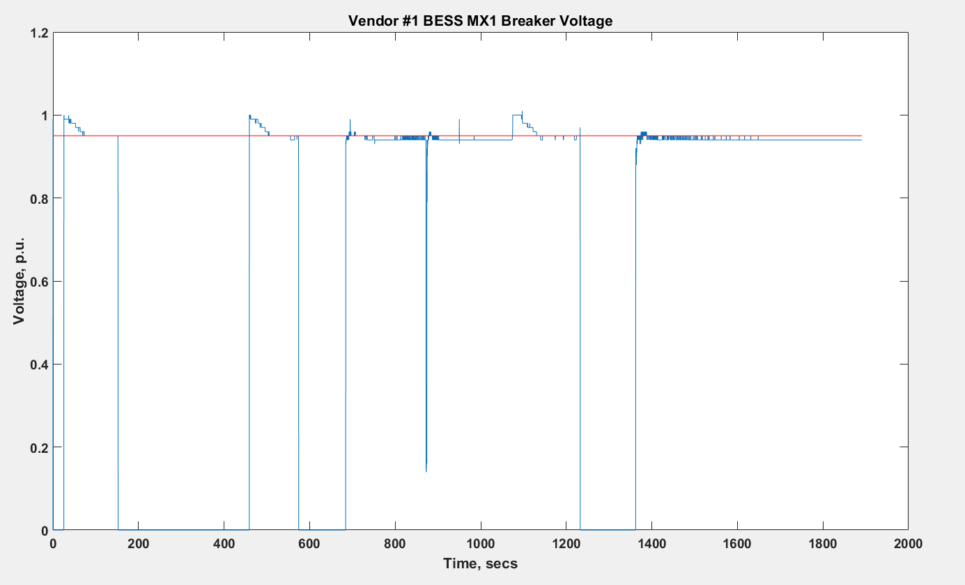

*Figure 11. Voltage Trace at BESS MX1 Breaker For Vendor #1*

### Key Performance Parameter #9: Emissions

Since emissions were used as a surrogate metric for some of the previous KPPs, the results of KPP#2 can be used to represent the emissions results. Specifically, from Figure 4. it can be seen that Vendor #1, who relied more on the grid, utilized CHP more and also shut down the diesel genset when grid-tied generated an amount of CO2 that was 278 lb less than Vendor #2. The total load served by Vendor #1 was comparable to the overall load served by Vendor #2 as shown in Figure 2.

# Appendix

The scripts used to generate the data above is available on the public Github [here](https://github.com/PowerSystemsHIL/EPHCC/tree/master/DataProcessing).

# Reference Documents

1. *“Hardware-in-the-Loop Microgrid Controller Information Packet v1.8”*, MIT Lincoln Laboratory, November 2016
2. *IEEE Standard for Recommended Practice for Electric Power Distribution for Industrial Plants*, IEEE Standard 141-1993.
3. *NFPA 70, National Electric Code, 2011, Article 450.*
4. *Caterpillar Diesel Generator Sets. Available online:* [*http://www.cat.com*](http://www.cat.com)
5. Woodward EasYgen-3000 Series Manual. Available online: <http://www.woodward.com>
6. *Schweitzer SEL-751 Feeder Protection Relay*. Available online: <http://www.selinc.com/SEL-787/>

.