Cell Tracker Help

[I. INSTALLATION 2](#_Toc364539438)

[II. GETTING STARTED 2](#_Toc364539439)

[A. Tips: 2](#_Toc364539440)

[B. Loading a Previous Session 2](#_Toc364539441)

[III. BATCH MODE 3](#_Toc364539442)

[A. Parameters List 4](#_Toc364539443)

[B. Example Using Batch Mode 5](#_Toc364539444)

[IV. Folders Tab 5](#_Toc364539445)

[V. Tracking Parameters Tab 7](#_Toc364539446)

[A. Cost Function Parameters 7](#_Toc364539447)

[B. Mitotic Parameters 9](#_Toc364539448)

[C. Confidence Index Parameters 10](#_Toc364539449)

[D. Fusion Parameters 11](#_Toc364539450)

[VI. Results Tab 12](#_Toc364539451)

[A. Confidence index 13](#_Toc364539452)

[B. Birth and Death 14](#_Toc364539453)

[C. Division Matrix 15](#_Toc364539454)

[D. Fusion Matrix 16](#_Toc364539455)

[E. Apoptosis 17](#_Toc364539456)

[F. Lineage and Migration Plots 18](#_Toc364539457)

[G. Explore Tracked Images 20](#_Toc364539458)

# INSTALLATION

To run the Cell Tracker you will need to install the free MCR from Matlab MathWorks website at: [**http://www.mathworks.com/products/compiler/mcr/index.html**](http://www.mathworks.com/products/compiler/mcr/index.html)**.** Please download the **R2013a 64-bit** windows version.

To launch the GUI, double click the Cell\_Tracker\_GUI.exe. Note: the GUI can be run from the command line, see the ***BATCH MODE*** section.

# GETTING STARTED

The Cell Tracker expects a segmented image sequence in TIFF format. Segmented images are images where the regions of interest are labeled sequentially from 1 to maximum number of objects per image. The numbering of these objects can be random. The Cell tracker requires defining the paths to the input segmented images folder and the output one as indicated in ***Folders Tab*** section.

The ***Tracking Parameters Tab*** controls what data the Cell Tracker will report and can be used to define cell property characteristics. The *Start Tracking* button will start the tracking session and if completed successfully will unlock the ***Results Tab*** for review of the data.

## Tips:

1. **When navigating tabs, parameters will be saved automatically and checked for user input at each tab navigation. Only when pressing "Cancel" the user input will be discarded.**
2. **There are help icons throughout the GUI. Whenever possible click on the icon “?” and you can read the help related to the corresponding section**

## Loading a Previous Session

The ***Load Tracking Parameters*** button located within the ***Main Tab*** panel will allow the results from a previous session to be reloaded for review. To load a previous session, please follow the steps below:

1. Choose the *Load Tracking Parameters* button
2. Navigate to the session’s *Tracking Images* directory.
3. Select the “parameters.mat” file and choose Open.

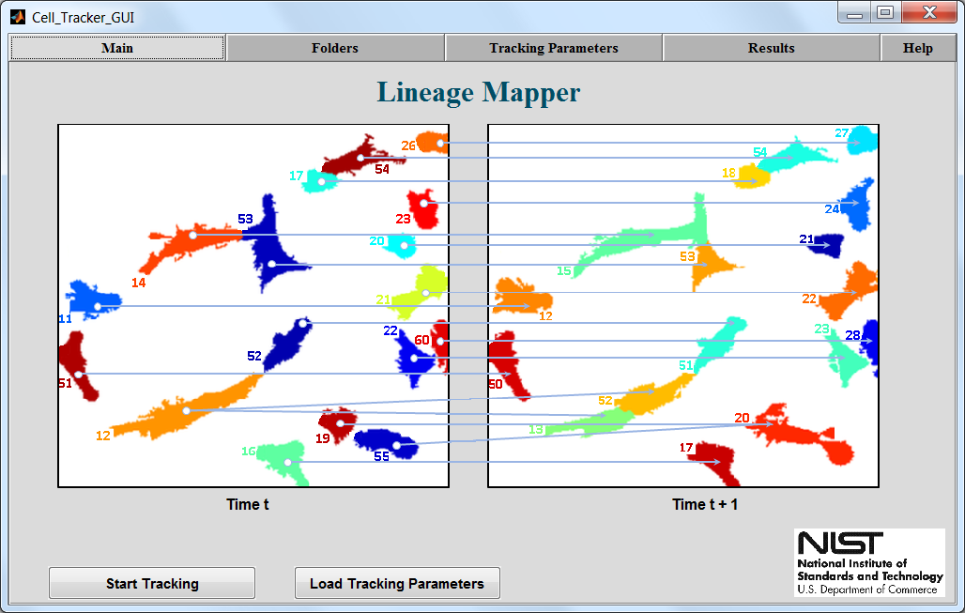

# BATCH MODE

Batch mode will run a tracking session without opening the user interface. To launch a tracking session, follow the steps below:

1. Run the *Windows Command Prompt* by navigating to *Windows Start* and searching for “cmd”. Then launch the CMD.exe for a new command prompt.
2. Navigate to the folder with the Cell\_Tracker\_GUI.exe: cd C:\path\to\cell\tracker\exe
3. Enter: Cell\_Tracker\_GUI.exe segmented\_images\_path C:\path\to\segmented\images\folder tracked\_images\_path C:\path\to\chosen\output\directory

Batch mode requires parameters to be entered in the format of *(parameter name, parameter value)* separated by a space. The only required parameter is the segmented\_images\_path. The Cell Tracker will use default parameters for any parameters that are not specified. Please see the ***Parameters List*** section below for all parameters and their associated types that are accepted by the Cell Tracker.

## Parameters List

|  |  |  |  |
| --- | --- | --- | --- |
|  | **Parameter Name** | **Parameter Type** | **Parameter Value** |
| **Folder Parameters** | segmented\_images\_path | char | "C:\path\to\segmented\images\folder" |
| raw\_images\_path | char | "C:\path\to\raw\images\folder" |
| tracked\_images\_path | char | "C:\path\to\tracked\images\folder" |
| segmented\_images\_common\_name | char | "Common Name" |
| raw\_images\_common\_name | char | "Common Name" |
| tracked\_images\_common\_name | char | "Common Name" |
| **Cost Function Parameters** | weight\_overlap | numeric | 0 to 100 |
| weight\_centroids | numeric | 0 to 100 |
| weight\_size | numeric | 0 to 100 |
| max\_centroids\_distance | numeric | Positive |
| frames\_to\_track | char | 'All' or a range. See  **Frames to** Track |
| **Mitotic Parameters** | division\_overlap\_threshold | numeric | 0 to 100 |
| daughter\_size\_similarity | numeric | 0 to 100 |
| daughter\_aspect\_ratio\_similarity | numeric | 0 to 100 |
| circularity\_threshold | numeric | 0 to 100 |
| number\_of\_frames\_check\_circularity | numeric | 0 to total number of frames |
| enable\_cell\_mitosis\_flag | logical | true or false |
| **Confidence Index Parameters** | cell\_life\_threshold | numeric | Positive |
| cell\_apoptosis\_delta\_centroid\_thres | numeric | Positive |
| cell\_density\_ci\_flag | logical | true or false |
| border\_cell\_ci\_flag | logical | true or false |
| **Fusion Parameters** | cell\_size\_threshold | numeric | 0 to 100 |
| fusion\_overlap\_threshold | numeric | Positive |
| enable\_cell\_fusion\_flag | logical | true or false |

## Example Using Batch Mode

An example command to run the Cell Tracker in batch mode:



Below is an example with some default parameters overridden:



# Folders Tab

The ***Segmented Images*** directory path is required. It is the path to the folder containing the labeled segmented images the user would like to track. This folder should contain the output from segmentation and it requires the masks to be labeled sequentially or randomly from 1 to maximum number of object per image.

The ***Raw Images*** *Directory* is optional. This path, if specified, should be the path to the original raw images that were used for segmentation. These images will be used only for visualization purposes. This will allow color contour outlines to be displayed over the raw images within the Explore Tracking Images dialog. See the Explore Tracking section.

The ***Tracked Images***directory path is optional. If it is not supplied, the data will be written to the ***Segmented Images*** directory by default. The cell tracker will write all of the outputs into that folder that includes: (1) The globally labeled masks where each cell is labeled with a unique ID number that identify that cell from frame to frame these masks can be explored using Explore Tracking, (2) Matrices saved in a csv format that holds the tracking indexing outputs: the birth and death of each cell, when a mother cell divides and the number of its daughters in the division matrix, the confidence index associated with every cell tracked, the fusion matrix that shows the numbers of cells or colonies that fused together and formed the fused cell or colony area and the apoptosis vector that shows cell death. For more detailed description please refer to section Results Tab.

All ***common names*** inputs are optional and can be used to specify specific images within a folder. For example, if a folder contains a sequence of images similarly named to *segmented\_image\_001.tif*, the common name could be defined as *segmented\_image\_* or *segmented\_* or *segm* or *\_image\_* etc.

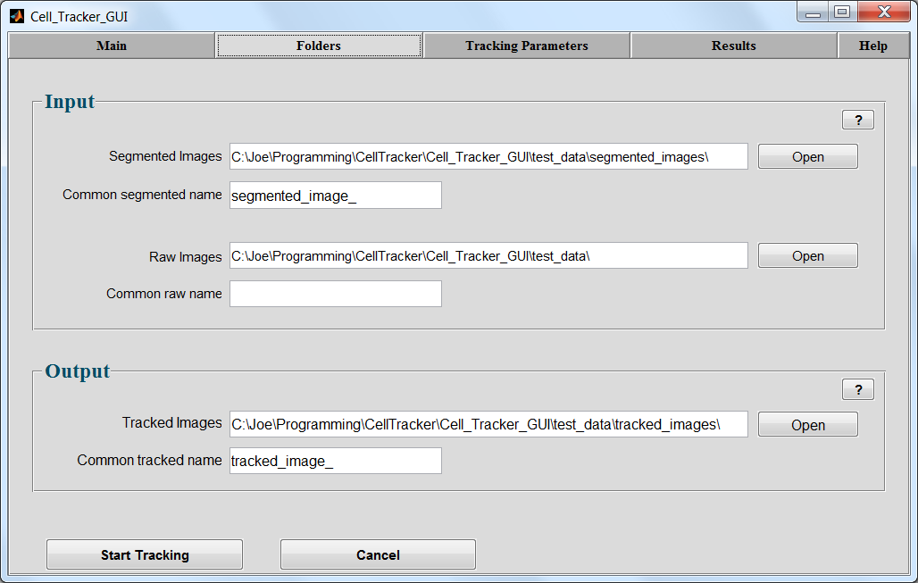

# Tracking Parameters Tab

The ***Tracking Parameters***tab contains variables to control cell properties and cell tracking decisions within the Cell Tracker. The following sections describe each input parameter.

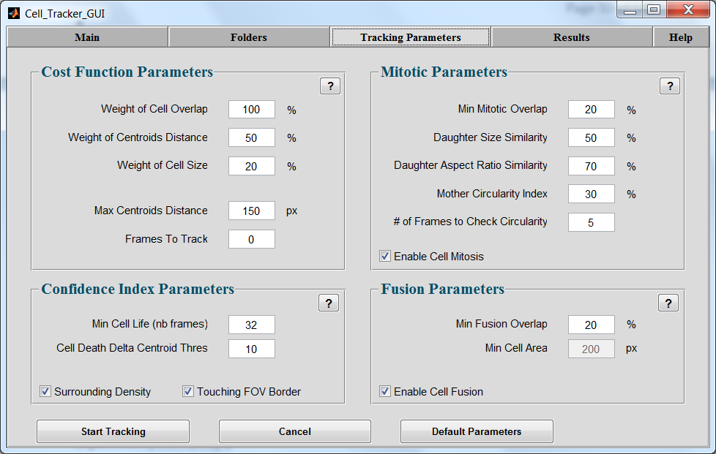

## Cost Function Parameters

The cell tracker uses a cost function to create a tracking decision between cells in consecutive frames. The cost function that relates two Cellular objects between consecutive frames is computed using the following normalized weighted 3 time-lapse cell characteristics:

1. **Weight of Cell Overlap**

If cells tend to move slowly and have big overlapping areas between consecutive frames, then this value should be the highest among all other cost function weights.

1. **Weight of Centroids Distance**

In the event when cells don't overlap as much and/or amount of overlap is almost similar, the distance of their centroids movement will make the difference in the tracking decision.

1. **Weight of Cell Size**

If cells retain their size between consecutive frames then this weight value should be high. However, if cells go into mitosis and their respective size changes rapidly then this value should be low.

The weights represent the importance of each term in the computation of the cost function. The higher the weight the more important is that term.

Some possible scenarios for cell tracking: Problem 1 is our typical problem encountered in most cases, when cells change shape often and go into mitosis and image acquisition rate is high enough that there are good cellular overlaps between consecutive acquisitions. In general, the overlap weight should be proportional to the acquisition rate. Problems 2 and 3 are considered to have low acquisition rates. In problem 2 cells change shape but don’t move long distances and in problem 3 like for particle tracking problems where objects don’t change shape and we have low image acquisition rate. A proposed weight combination to solve each of these problems is given in the table below. It is important to note that the cell tracker is very robust with regards to the weights. The three weights don’t need to be changed for solving similar problems like the ones displayed in the table below.

|  |  |  |  |
| --- | --- | --- | --- |
|  | Problem 1 | Problem 2 | Problem 3 |
| *Red denotes the current frame*  *Blue denotes the next frame* |  |  |  |
| Weight Cell Overlap | 100% | 10% | 20% |
| Weight Centroid Distance | 50% | 100% | 50% |
| Weight Cell Size | 20% | 50% | 100% |

Max Centroids Distance

The maximum centroid distance (in pixels) is used to consider which cells could possibly be tracked together. The radius from a cell centroid to the max centroid distance represents the area of a possible cell migration. For example, the red cell represents the current frame, whereas the blue cells represent the next frame. The Cell Tracker would consider the upper blue cell as a possible tracking option to the red cell and the lower blue cell would be ignored.

Max Centroids Distance Example

Frames to Track

This controls the number of frames to be tracked. If “All” is specified then all available frames in the segmented images folder will be tracked. Specific frame tracking is also provided. The syntax for specifying specific frames to be tracked is a comma separated list. A colon can also be used to specify a range of frames. For example “1:2:300” track every other frame until 300. “9:120” track every frame from 9 to 120. “1,5,20,28:50” track frames 1, 5, 20 and 28 to 50

## Mitotic Parameters

The cell tracker bases its decision on detecting mitotic events using cell overlap between mother and its 2 daughter cells. If the cell overlap between one frame and the next is above the ***Min Mitotic Overlap*** threshold, the Cell Tracker will label that as a possible mitosis event. The Cell Tracker will then test the ***Daughter Size Similarity*, *Daughter Aspect Ratio Similarity***, and ***Mother* *Circularity Index***thresholds to determine if a mitotic event has occurred. If all of the tests pass, the Cell Tracker will record the mitotic event in the division matrix.

Enable Cell Mitosis

If cell mitosis is enabled, the daughter cells of a mitotic event will be assigned new cell labels, different from their mother cell label. If disabled, the daughters will keep the same label as the mother cell and no mitotic e vent will be considered. This functionality is helpful when dealing with particle tracking or colony tracking.

Min Mitotic Overlap

If cell overlap in percent is above this threshold between one frame and the next the Cell Tracker will record a possible mitotic event. The following table illustrates the value of this parameter with respect to the overlapping positions between a red cell from the current frame and the blue cell from the next frame. If this parameter is set to 0%, all cases will be considered as a potential mitotic event. If this parameter is set to 100% cell mitosis is discarded where the daughter cell that overlaps the most with the mother cell will keep its unique global ID label and the other one will get a new label.

|  |  |  |
| --- | --- | --- |
|  |  |  |
| >75% overlap | >30% Overlap | 0% Overlap |

Daughter Size Similarity

This parameter is a measure of the size similarity between daughter cells. In a real mitotic event the size of the daughter cells should be very similar to each other. A mother cell doesn’t really produce a large daughter and a small one. Set this parameter to 0% to discard it.

|  |  |  |
| --- | --- | --- |
|  |  |  |
| 95% Daughter Size Similarity | 55% Daughter Size Similarity | 40% Daughter Size Similarity |

Daughter Aspect Ratio Similarity

This parameter is a measure of the aspect ratio similarity between daughter cells. In a real mitotic event daughter cells should have similar shapes to each other. Set this parameter to 0% to discard it.

|  |  |  |
| --- | --- | --- |
|  |  |  |
| 100% Daughter Aspect Ratio Similarity | 50% Daughter Aspect Ratio Similarity | 20% Daughter Aspect Ratio Similarity |

Mother Circularity Index

For a cell to be considered a mother cell in a possible mitotic event it must have been round within the previous ***Number of Frames to Check Circularity*** parameter. This circularity threshold determines what is round enough to be considered a mitotic cell. Set this parameter to 0% to discard it.

|  |  |  |
| --- | --- | --- |
|  |  |  |
| 80% Circularity Index | 55% Circularity Index | 25% Circularity Index |

Number of Frames to Check Circularity

The Cell Tracker will determine if the cell had a circularity threshold above the ***Mother Circularity Index*** between the current frame and the previous number of frames. If the cell’s circularity is not above the threshold at least for one frame within this range, then the mitotic event will not be recorded.

## Confidence Index Parameters

The Cell Tracker assigns a tracking confidence index for each tracked object in the time-lapse sequence. The confidence index is only an indicator of how well we trust the track of a given cell during its entire cell cycle. There are three components that can affect the computation of the confidence index; each one can be disabled if needed: cell lifetime threshold, neighbor density, and border distance. All cells start with the same confidence index value of 1, and then we analyze the confidence index parameters of each cell. For example, if a cell meets the minimum expected lifetime defined by the user, the confidence increases by a point. The confidence index decreases if a cell was in a very confluent area and was touching other cells or if a cell was too close to the border (as defined by the user).

Surrounding Density

If enabled, a lower confidence index will be assigned to cells that have grouped into colonies or become close to other cells.

Touching FOV Border

If enabled, only cells that never touch the Field of View boundaries will increase their corresponding confidence index by a point.

Min Cell Life (nb frames)

The minimum cell life is the number of frames a cell must be present throughout to increase its confidence by a point. This index does not affect cells that are present at the beginning of the experiment (first frame).

Cell Death Delta Centroid Threshold

If a cell centroid does not move more than this value (in pixels) the cell will be recorded as dead.

## Fusion Parameters

Cell fusion occurs when multiple cells get together and form one cellular object. It can come from an actual fusion where for example two colonies merging into one or from cells migrating so close together that segmentation technique consider them a single cell.

Enable Cell Fusion

If enabled, the cell tracker will assign a new unique global ID number to the fused region and will consider all the cells from the previous frame as dead. If disabled, the cell tracker will separate the cellular area in the current frame into group of single cells by relying on the previous frame information.

Min Fusion Overlap

This parameter represents the amount of overlap in percent of cell area, above which an area at the current frame is considered as a group of cells from the previous frame and that this area needs to be split into multiple single cells. For example: if 2 cells A & B at frame t have tracks to the same cell C at frame t+1 and the amount of overlap between A&C = 45% of size A and the overlap between B&C = 50% of size B, then C should be split into 2 single cells.

Min Cell Area

This parameter represents the minimum size that any cellular object must have in order to be recognized as a cell. Any object with size smaller than this threshold will be discarded after splitting the group of cellular area into single cell segments

# Results Tab

Once the Cell Tracker has successfully completed a tracking session the ***Results Tab*** will be enabled. All tracking data collected during the session will be available in this panel. Furthermore, the ***Tracking Images*** directory specified within the ***Folders Tab*** will contain the data displayed here. You can load previous tracking sessions with the ***parameters.mat***file, see ***Loading a Previous Session***

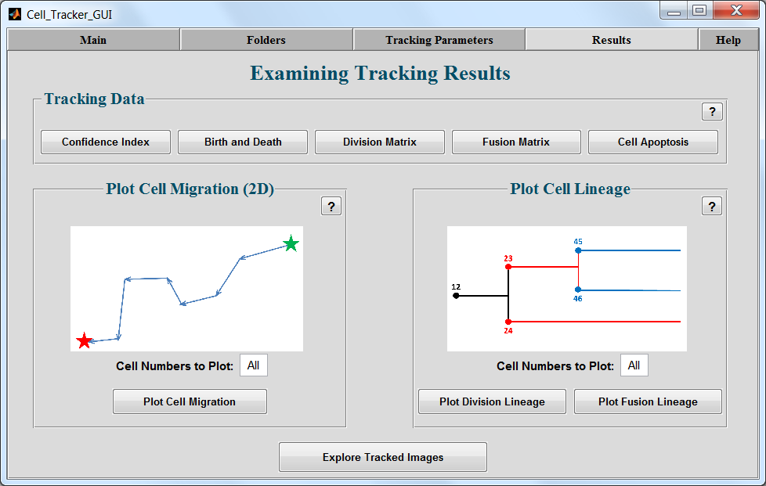

The following Tracking Data buttons will display a table of results: ***Confidence Index****,* ***Birth and Death, Division Matrix, Fusion Matrix****,* and***Cell Apoptosis****.* Note: the ***Fusion Matrix*** button is dependent upon the ***Enable Cell Fusion*** checkboxes. If the checkbox is disabled in the ***Tracking Parameters Tab***the corresponding button within the ***Results Tab*** will also be disabled.

## Confidence index

The confidence index is a matrix of two columns and n rows where n is the total number of cells globally labeled throughout the experiment. The first column is the global cell ID number and the second column is the confidence index of that cell. The matrix is sorted in a descending order with respect to the confidence index. Higher confidence index value corresponds to more trust in the entire track of a cell during its lifetime.

For example: cell number 5 has one of the highest confidence index that is equal to 4.

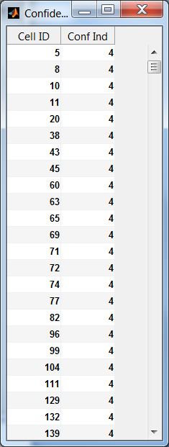

## Birth and Death

The Birth and Death is a matrix of three columns and n rows where n is the total number of cells globally labeled throughout the experiment. The first column is the global cell ID number. The second column (Birth) is the frame index where the cell first appeared in the Field of View and the third column (Death) is the frame index where the cell last appeared in the Field of View.

For example: cell number 1 was born at frame 1 and died at frame 215. Cell number 5 was born at frame 1 and died at frame 19.

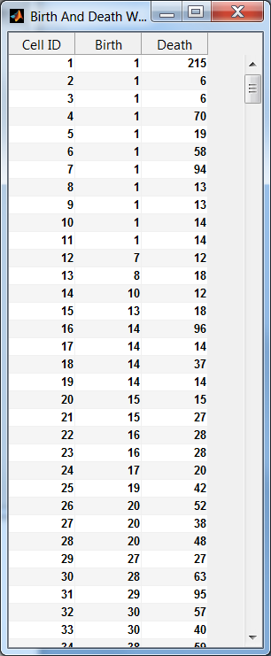

## Division Matrix

The Division Matrix is a matrix of three columns and n rows where n is the total number of cells globally labeled throughout the experiment. The first column is the global cell ID number of the mother cell. The second column is the global cell ID number of the one of the daughter cells and the third column is the global cell ID number of the other daughter cell. The Cell Tracker considers mitosis between a mother cell and its two daughter cells.

For example: cell number 5 went into mitosis and divided into two daughter cells 26 and 28. If you look at the Birth and Death matrix, cell 5 died at frame 19 and cells 26 and 28 are born at frame 20.

In that experiment cell 3 for example did not have any daughters (value =0) and hence never went into mitosis throughout the experiment.

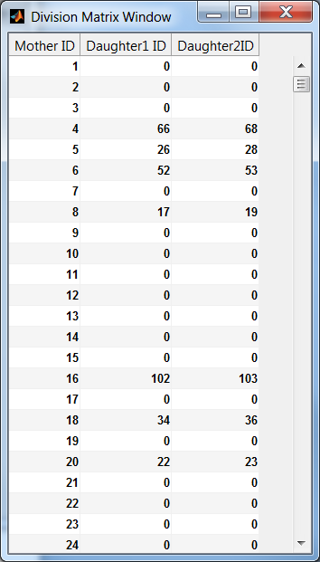

## Fusion Matrix

The Fusion Matrix is a matrix of (m+1) columns where m is the maximum number of cells that fused together at frame *t* to form one object at frame *t+1*. There are n rows where n is the total number of cells globally labeled throughout the experiment. The first m column is the global cell ID number of the cells that fused together and the last column is the global ID number of the area that these m cells formed at frame *t+1.*

For example: cells number 2 and 3 fused together and formed cell 12. Cell 12 is a fused area so are cells 20 and 21 for example. If you look at the Birth and Death matrix, cell 2 and 3 died at frame 6 and cell 12 is born at frame 7.

In that experiment cell numbers 1 to 11, 13,14, 16 to 19, etc are not born from fusion. All of the fused cells at time *t* have a value = 0.

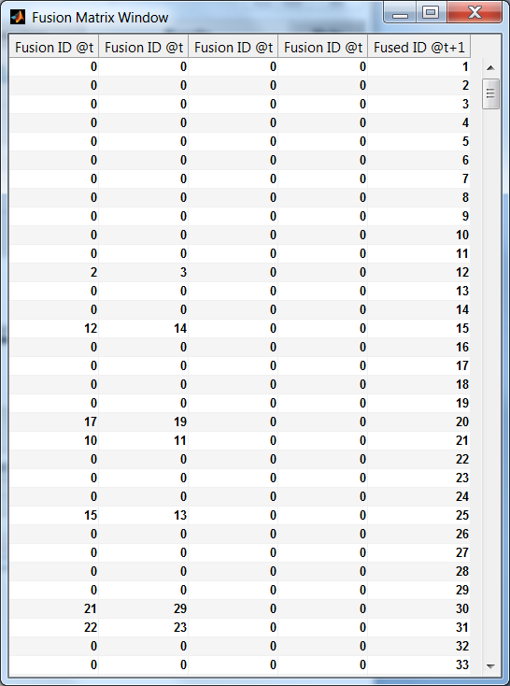

## Apoptosis

Apoptosis refers to cell death. The Cell Tracker will analyze the movement and size of each cell through its entire lifetime and if they are similar throughout, it will be reported in matrix of two columns and n rows where n is the total number of cells globally labeled throughout the experiment. The first column is the global cell ID number and the second column is a binary indicator (1 is dead). For example: cell number 1 is declared dead.

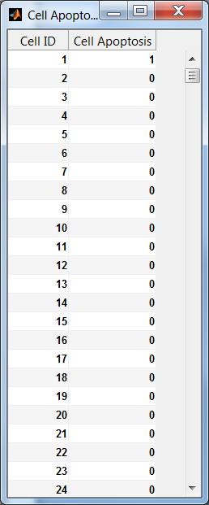

## Lineage and Migration Plots

The cell lineage supports statistical analysis of the cells like for example, the number of descendant generations of a cell, the length of the cell cycle, when it divided or died. The Cell Tracker has the ability to plot 2 kinds of lineage trees (see figures below): (1) the first one is the regular lineage tree that shows the mitosis events and the cell cycle. (2) The second one is for plotting cell or colony fusion or merging. When the user checks the enable fusion checkbox, a cell fusion lineage tree is built by the Lineage Mapper that shows the fusion tree as the reverse from the division lineage tree. That tree shows multiple cells or colonies that fused together at a time t and created a new group of cells or colonies at time t+1.The ***Plot Division Lineage***and***Plot Fusion Lineage***buttons allow visualization of cell lineages.

***Plot Cell Migration*** button allow visualization of cell centroid migration through time. The birth of a cell is marked with a green star and the death with a red x and the migration between frames is represented with an arrow.

The ***Cell Numbers to Plot***input parameter allows all of the data or only specific cell data to be plotted. The syntax for specifying specific frames to be tracked is a comma separated list. A colon can also be used to specify a range of cells. For example “1:2:80” plot every other cell from 1 to 80. “9:120” plot every cell from 9 to 120. “1,5,20,28:50” plot cells 1, 5, 20 and 28 to 50

C:\Joe\Papers & Patents\By Projects\Cell_Tracker\Division_Lineage.tif

Cell Division Lineage Tree

C:\Joe\Papers & Patents\By Projects\Cell_Tracker\Fusion_Lineage.tif

Cell Division Lineage Tree

C:\Joe\Papers & Patents\By Projects\Cell_Tracker\Cell_Migration.tif

Cell Migration Plot

## Explore Tracked Images

***Explore Tracked Images*** allows visualization of the tracked images saved in the output folder as specified by the user. Note: If a ***Raw Images Directory*** is supplied within the ***Folders Tab*,** the Cell Tracker will allow contour images to be displayed. Otherwise, only the tracked image masks will be displayed.

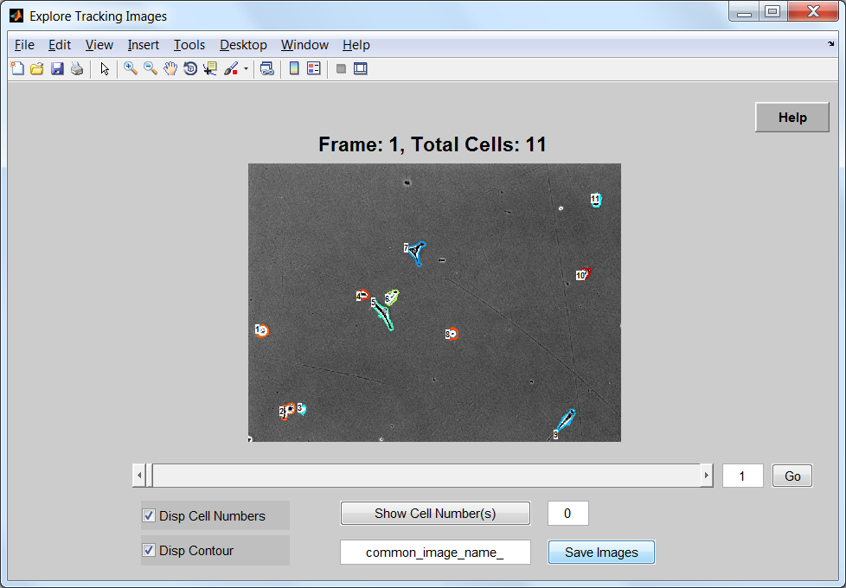

Contour Image Mask and Raw Image

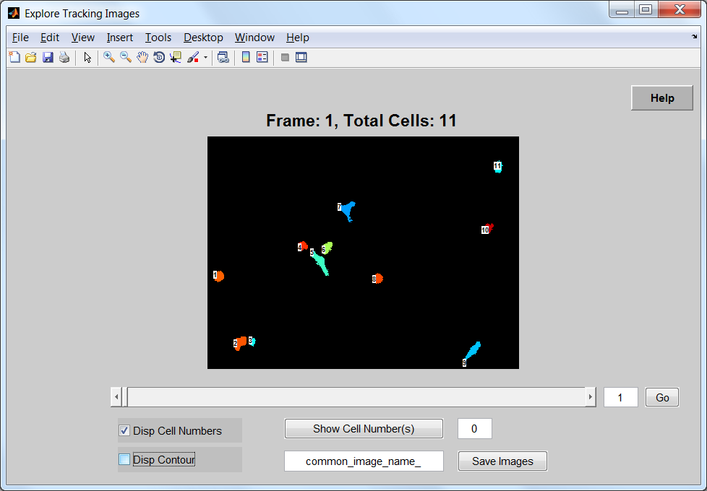

Tracked Image Masks

The***Show Cell Number(s)*** input parameter allows all of the data or only specific cell data to be plotted. The syntax for specifying specific cell numbers to be displayed is a comma separated list. For example, “1,3,5,9” will only display cells “1,3,5,9.” A colon can also be used to specify a range of cells. For example, “1,4:8,12 ” would display cells “1,4,5,6,7,8,12.”

The save images button will open a window to a specified directory and save the images as displayed in that directory with a common name as specified in the ***common\_image\_name\_*** edit box.

To jump to a specific frame, enter the frame number at the end of the slider bar and choose “Go” or hit the “Enter” button on your keyboard. You can also move the slider by clicking with the left mouse button or by using the left and right arrow after clicking at least once on the slider bar with the mouse.