PXI HANDS-ON EXERCISES
Device Characterization Workflow with the ESP32-C6
Qualcomm Tech Exchange 2026

Introduction
In this hands-on session, PXI instrumentation will be used to make measurements on an Espressif ESP32-C6 DevKit — a low-cost, low-power BLE microcontroller board.
Figure 1: Espressif ESP32-C6
What makes it useful here isn't the radio itself, but what happens on its (nominally) 3.3V supply rail when it does anything RF. In this session, sequences of Bluetooth Low Energy advertising packets generated from the device cause a brief current draw spike (and corresponding voltage droop) as the radio powers up, transmits, and powers back down. Sitting in deep sleep between events, current draw drops to near-idle levels, then jumps sharply during each ~370 µs advertising burst — giving you clean, repeatable, real-world transient events to trigger on and measure, without needing to know any details of the BLE protocol.
A diagram of the PXI system and the DUT connections are below.
- The SMU powers the 3.3 V rail and measures current draw in both deep-sleep and active BLE transmission states.
- The 2-channel oscilloscope provides triggered, high-sample-rate, synchronized captures of rail voltage and current, with current measured through a 0.1 Ω shunt resistor.
- The arbitrary waveform generator injects controlled ripple onto the rail to evaluate DUT brownout behavior in the presence of supply disturbances.
- The PXI Trigger Bus provides shared timing across the controller and all instruments, synchronizing measurements with each other and with DUT activity.

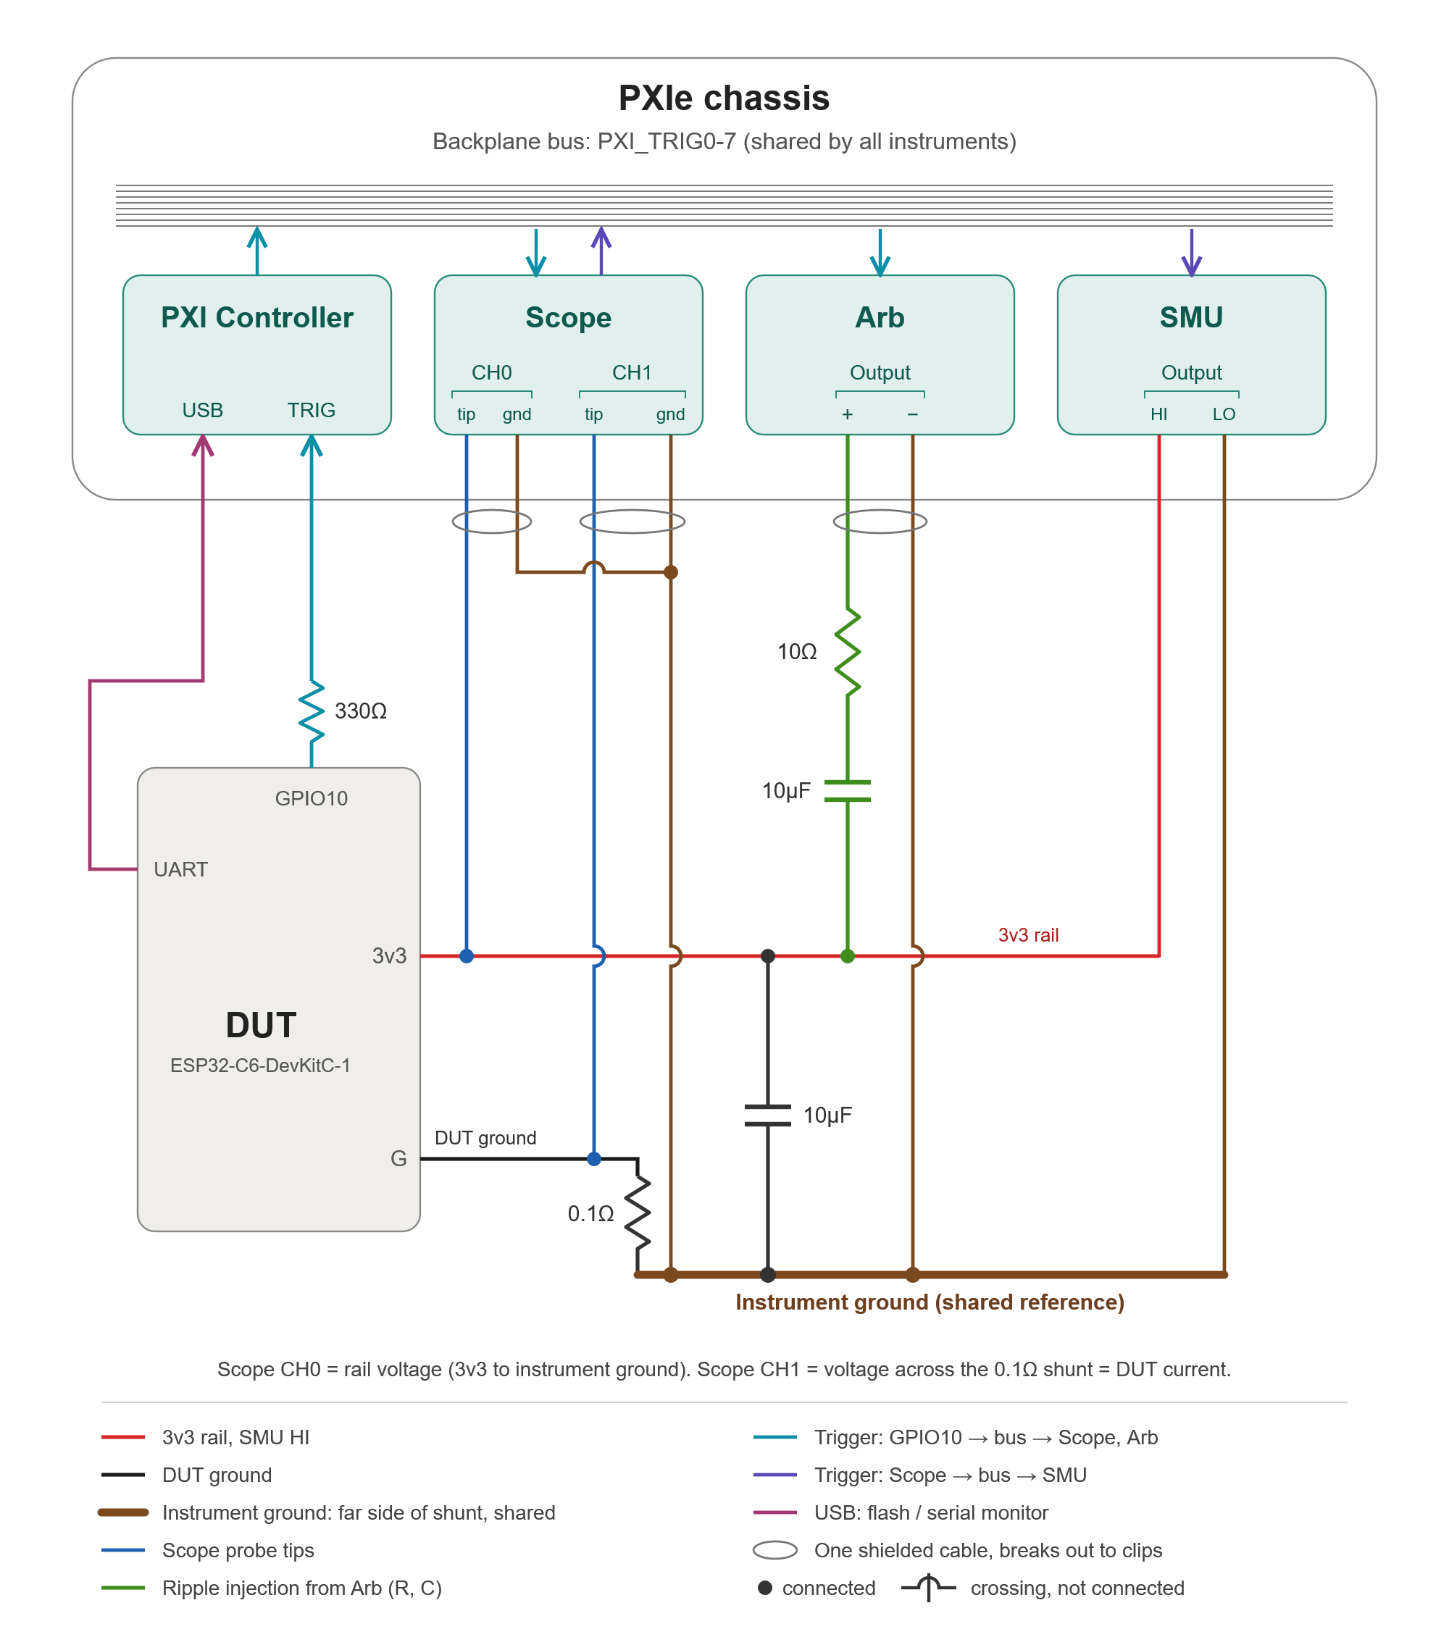
Figure 2: Instrument Connections diagram

Exercise Overview: A Device Characterization Flow on PXI
The exercises in this session follow the same progression a characterization team might implement when characterizing a new device. They start with simple static measurements, move to triggered dynamic captures, then stress the device’s supply margins. Demos will then be shown in C# and Python that automate the measurements to build statistical confidence. Each stage builds on the instrument setup and skills from the one before.
· Static power characterization (SMU). The DUT is placed in deep sleep and the SMU measures its idle current while sourcing the 3.3 V rail. This introduces the SMU as both a precision supply and a measurement instrument, including remote sensing, which regulates the voltage at the DUT’s pins rather than at the instrument.
· Dynamic transient capture (Scope + SMU). With the DUT transmitting BLE advertising packets, the oscilloscope captures the voltage droop and current spike of each ~370 µs burst. Scope triggering is set up so that every capture lands on the same event, and the trigger is shared with the SMU so its sampled current stays aligned with the scope’s view. These are the same techniques used to characterize load transients on any power rail.
· Synchronizing to device activity (PXI Trigger Bus). The DUT firmware raises a digital trigger on GPIO10 just before each transmission. That trigger is routed through the controller onto the PXI trigger bus and shared with every instrument. This shows how a device’s own activity can drive synchronized measurements across a whole system, a technique that stays reliable even when signal edges become noisy.
· Supply margin and fault injection (Arb + Scope + SMU). The arbitrary waveform generator injects controlled ripple onto the rail. You sweep supply voltage while you watch for brownout resets. This mirrors how supply-margin testing is done on real silicon.
· From interactive to automated measurement. Instructor-led demonstrations show the same measurements driven programmatically through the instrument APIs. One sweeps the supply voltage to map brownout probability. Another collects droop-depth and settling-time statistics over many bursts. This is the step from exploring a behavior interactively in InstrumentStudio to characterizing it repeatably via application code.
By the end of the session, you will have used the core PXI instruments together as one synchronized system and seen how that system supports each stage of a characterization flow, from first power-up to automated, statistically meaningful results.

Exercise 1: Power the DUT and measure Sleep Current
In this exercise, you will use the InstrumentStudio SMU panel to power the DUT’s 3.3 volt supply, then measure sleep current after putting the DUT into a sleep state.
In the search bar on your system, start typing “InstrumentStudio” then select the InstrumentStudio Icon under Best Match.
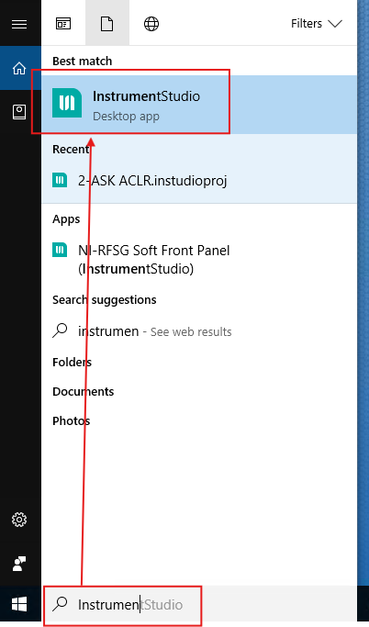
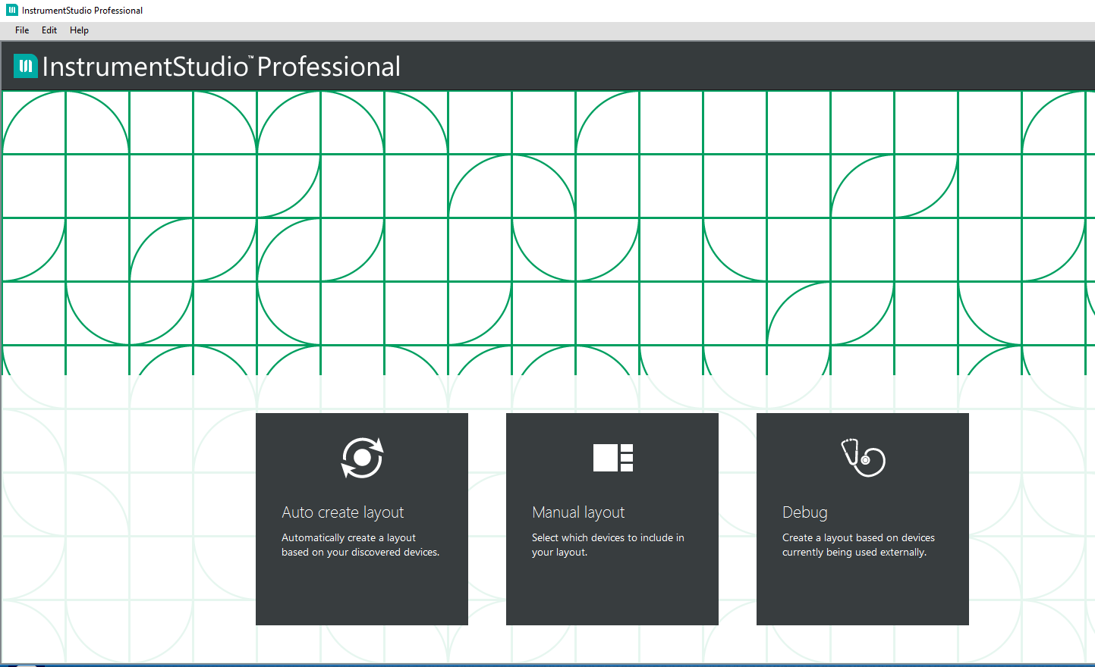
Select “Manual Layout”
Under SMU/Power Supply, select Create Large Panel. Select OK to accept.
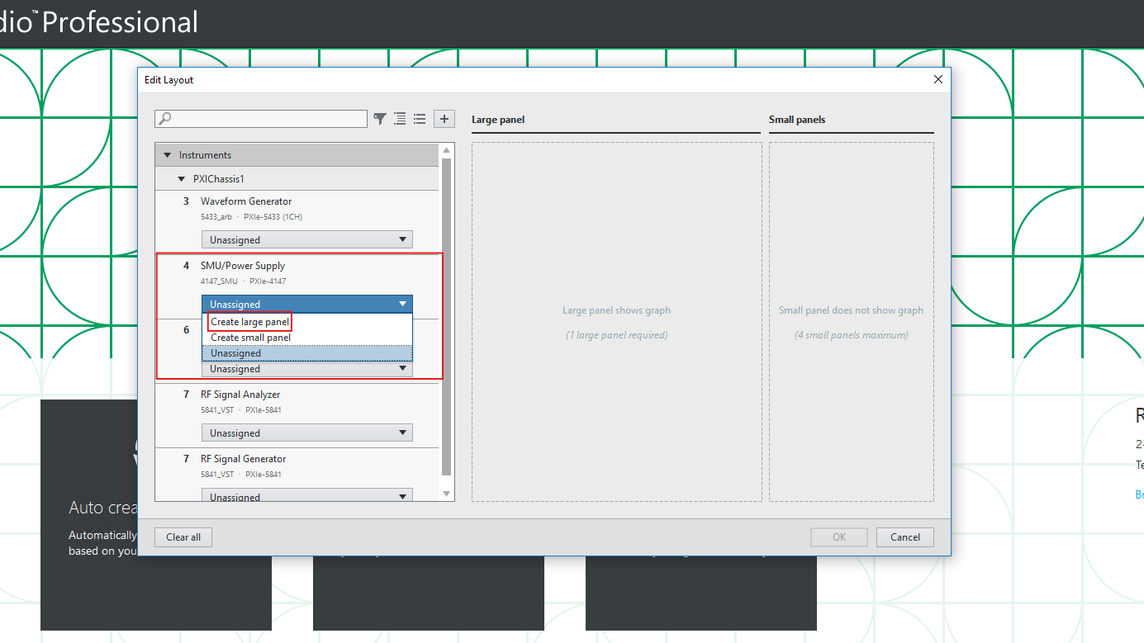
The SMU in the system has either 1 or 4 independently controlled channels. The Model will be one of the following:
- PXIe-4147
- PXIe-4139
- PXIe-4138
On the left, Voltage and Current for the selected channel are displayed in the top and bottom plots. Tabulated values and statistics for parameter values on selected channels are below the voltage and current traces.
Refer to Instrument Connections Diagram: Channel 0 of the SMU is connected to the voltage rail of the Espressif esp32c6, and will be used to provide power. Configure Channel 0 of your SMU as below:
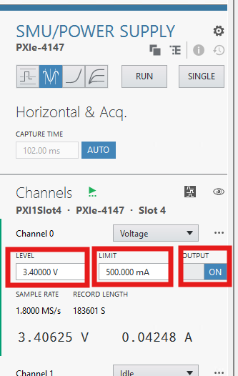
In order to ensure that the DUT is in a sleep state, navigate to C:\PXI_Training. Double-click on 1_Flash_and_Monitor_SLEEP.bat, which will put the DUT to sleep. 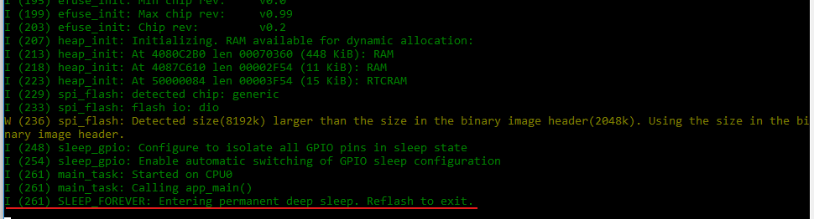
Leave the DUT powered, but change the current limit to ~1mA. Note the sleep current- expect something in the 10-20uA range
The Y Axes are set to AutoScale. You can change to Manual and select the desired Minimum and Maximum values for the plots if desired.
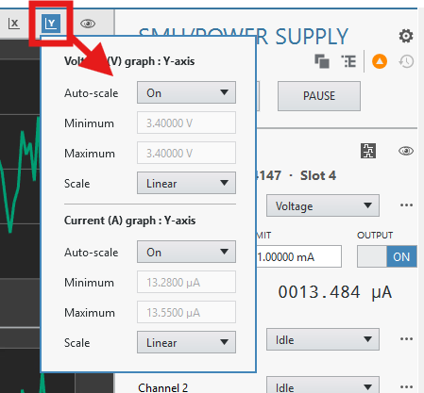
- Close the command window that resulted from running the batch file
END OF EXERCISE
Exercise 2: Monitor BLE Advertising Current and Voltage
IMPORTANT: Set the current limit to 500 mA before generating BLE packets. The current will rise dramatically once packet generation begins.
In this exercise, you will flash the ESP32 so it repeatedly generates a sequence of three Bluetooth Low Energy (BLE) advertising packets on BLE channels 37, 38, and 39. You will then use the SMU panel to observe the induced current and voltage transients on the 3.3 V rail. Set the Current Limit to 500mA as shown below. You will not be able to flash the DUT without the voltage rail powered.
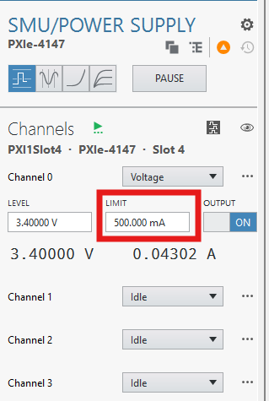
Navigate to C:\PXI_Training and double-click 2_Flash_and_Monitor_BEACON.bat. After the script runs, the command window should resemble the example below.
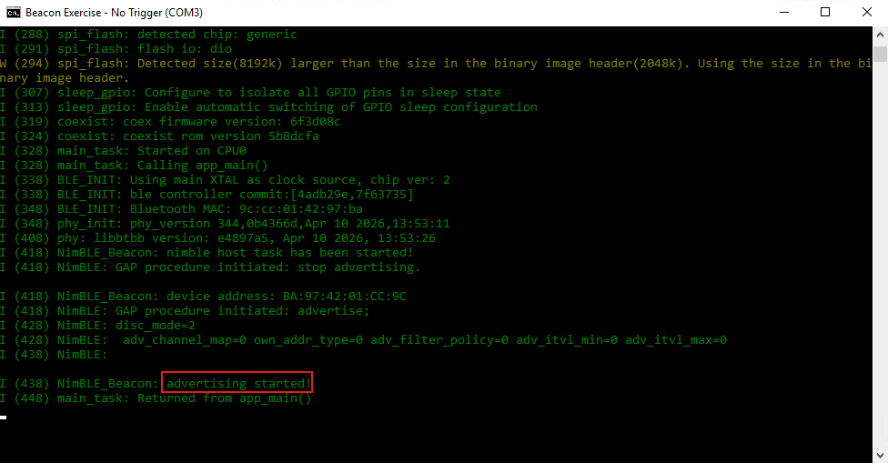
Return to the InstrumentStudio SMU panel. After about a minute, the traces should show a series of current spikes. These correspond to the BLE advertising packets sent on channels 37, 38, and 39.
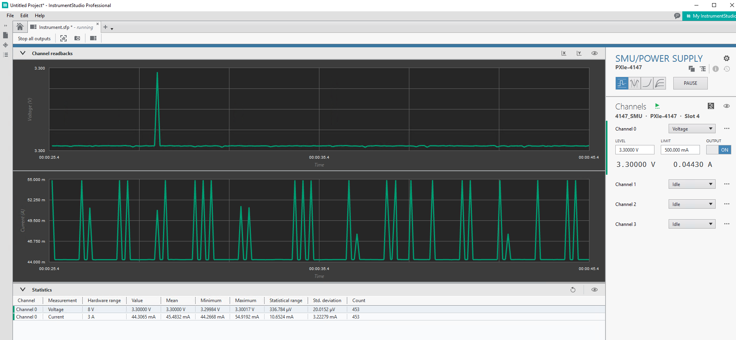
Switch from Charting mode to Waveform mode, then click Run.
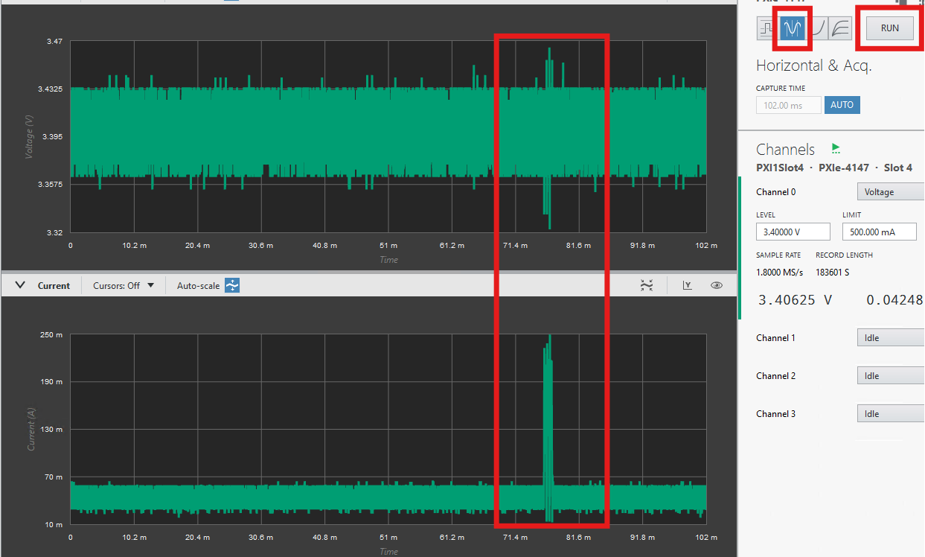
The current and voltage traces will appear to march across the screen because the 1.8 MS/s acquisition is not yet governed by a trigger. Set CAPTURE TIME to approximately 25 ms, then click SINGLE until one complete set of advertising events is captured. This may take 10-30 clicks.
Because the acquisitions are not yet synchronized to the BLE advertising events, each capture will start at an indeterminate time. Repeatedly pressing SINGLE increases the chance of capturing one complete advertising sequence within the selected capture window. In a later exercise, we will lock the capture to the start of an advertising event.
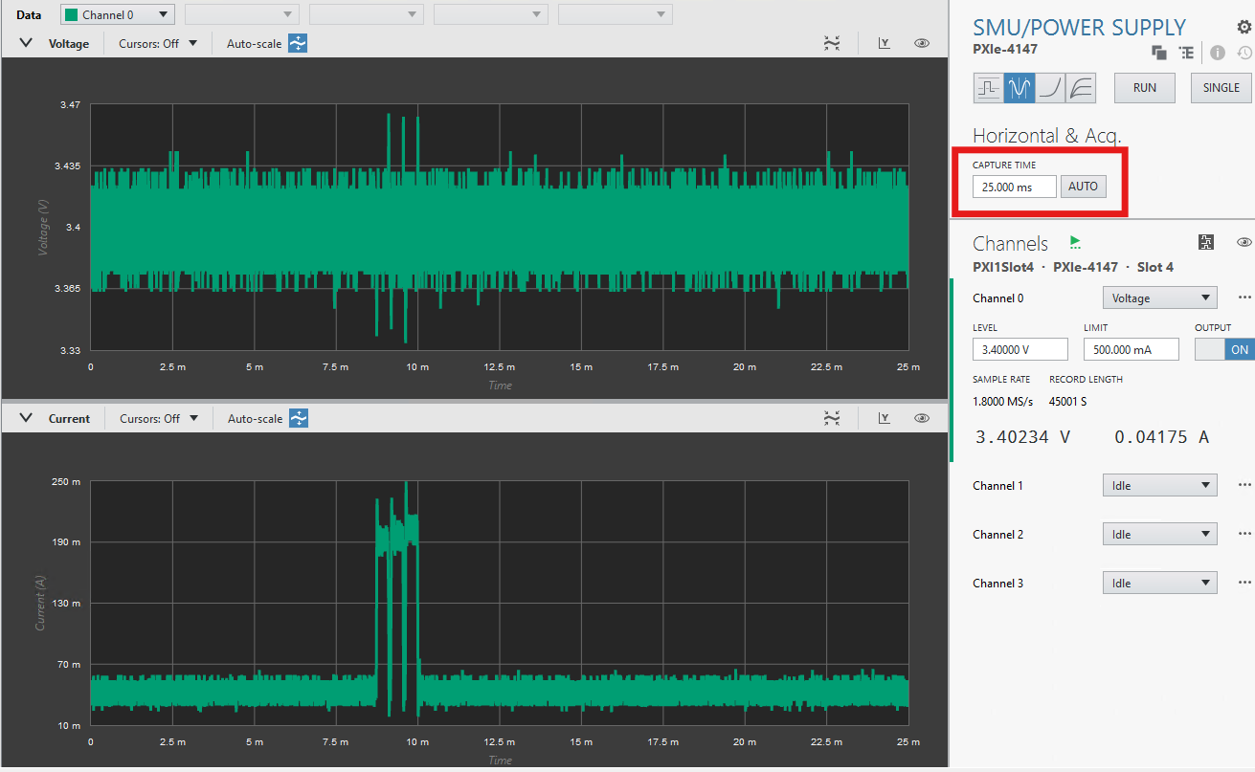
END OF EXERCISE

High-speed, triggered rail-voltage and current capture
In this exercise, you will capture and compare the rail voltage and a shunt-based current measurement during a BLE advertising event. You will use a scope edge trigger to align high-speed voltage and current measurements, then export that trigger to synchronize the SMU capture. Finally, you will save the waveforms and analyze them in NI DIAdem. Zooming in on individual bursts shows exactly how each current step, spike, and recovery translates into voltage droop on the rail, which is a cause-and-effect relationship commonly desired for power rail validation.
- Create a new panel using Manual layout.
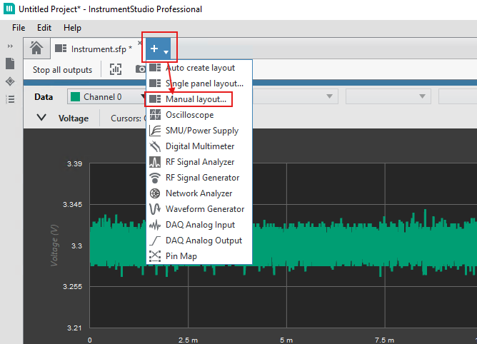
Add a large Oscilloscope panel and a small Waveform Generator panel. The Edit Layout window should resemble the image below.
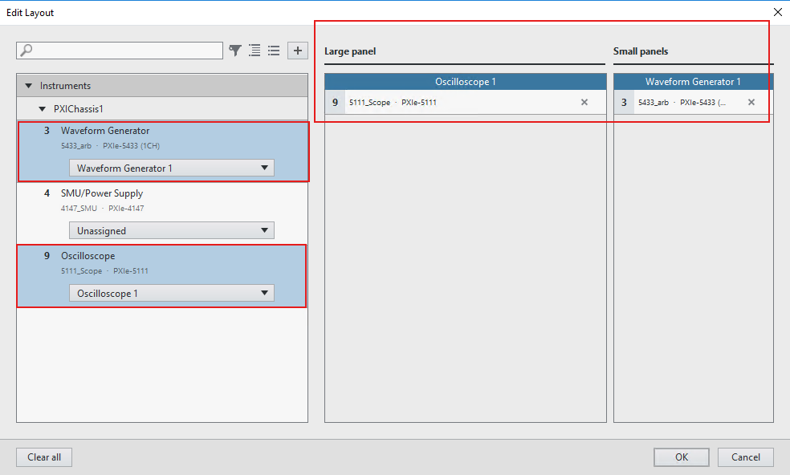

Click OK to accept.
The screen should resemble the image below.
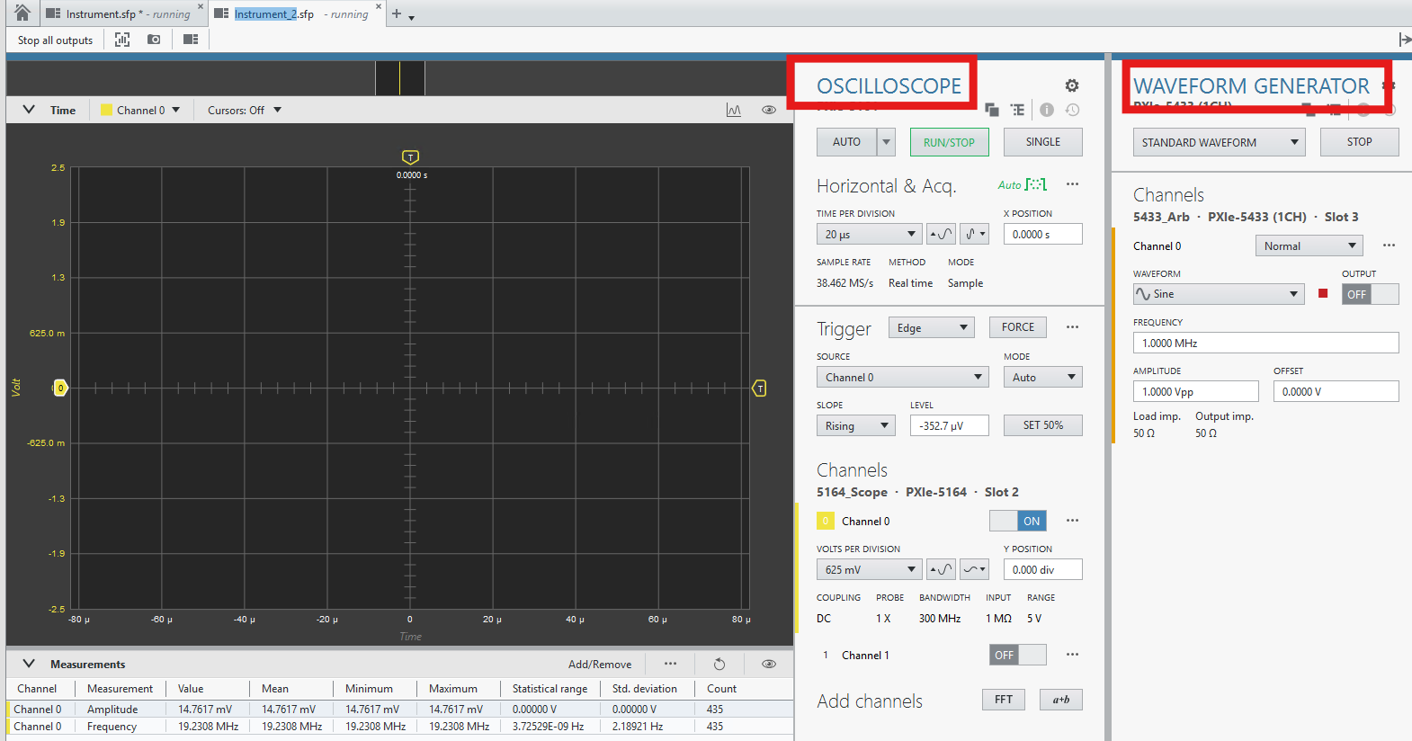
Channel0 of the scope is enabled by default
- Set Channel0VOLTS PER DIVISION to 1 Volt
- Set Horizontal & AcquisitionTIME PER DIVISION to around 2ms
You should see a trace of the voltage rail, with a transient similar to the boxed item appearing intermittently. This is the rail voltage transient induced by the Bluetooth bursts.
Since our interest is in the transient, the rest of the exercise will be simplified by using AC coupling- this will make it easier to isolate the details of the transient.
Click on the ellipses next to Channel0, and change the 3 boxed settings as shown.
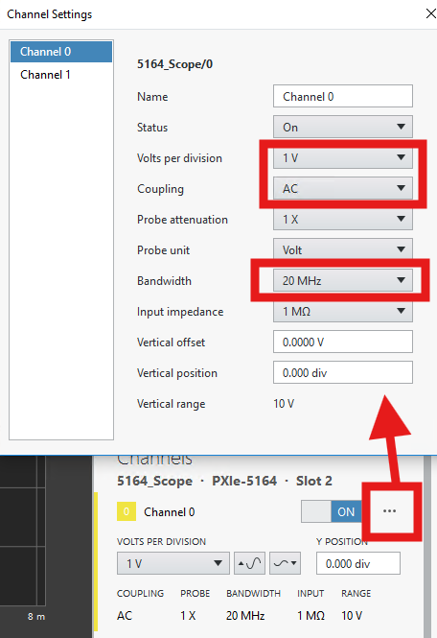
The Scope trace should now resemble the following:
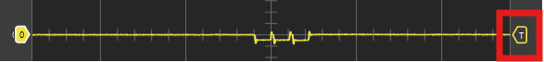
The “T” icon in the box represents the vertical position of the Edge trigger. This is the default trigger when an InstrumentStudio Scope panel is opened.
- Set TriggerSLOPE to Falling
- Use the other boxed settings to adjust the size and position of the trace to your liking
- Left-click and drag anywhere on the scope display to center the trace to your liking
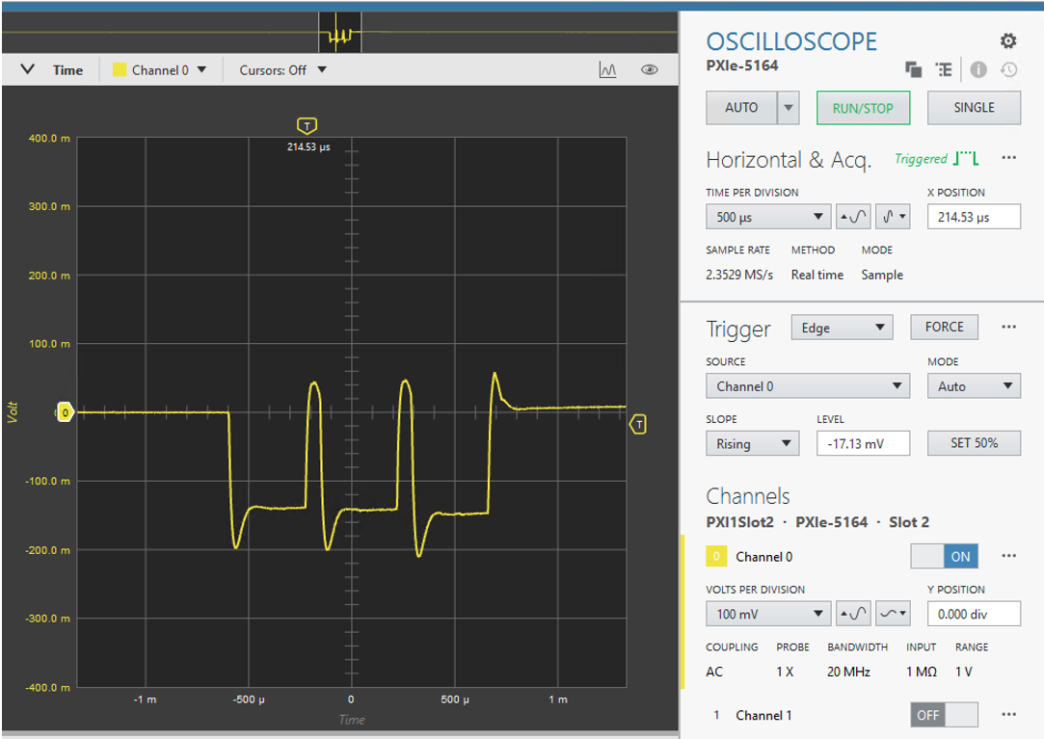

What you are seeing ing the trace is a combination of
- The actual voltage transient induced by the Bluetooth bursts
- the electrical limitations (capacitance, inductance, resistance) of the solderless beadboard.
You can’t change item 1, because that’s the DUT doing what it does. You can, however, reduce how much item 2 distorts the SMU’s response.
What is SourceAdapt?
Most SMUs use a fixed control loop, sometimes with a few selectable settings such as “slow,” “medium,” and “fast.” These settings are general-purpose compromises. They aren’t tuned for any particular load. NI SourceAdapt exposes manual tuning, so you can optionally adjust the control loop settings to match your actual load.
That matters here because the SMU’s “load” isn’t just the DUT. It also includes the breadboard’s parasitics. Tuning the loop for that combination reduces ringing and speeds recovery after each burst. SourceAdapt can’t reach everything. Very fast spikes and IR drop in the breadboard contacts are outside the loop’s reach, so good fixturing still matters: short leads, local decoupling, and remote sense.
- Go back to the InstrumentStudio SMU panel used in the first two exercises
- Click on the ellipses next to Channel 0
- Scroll down to the section entitled SourceAdapt tuning parameters
- Click on FAST as a starting point
- Change VoltageGainBandwidth (the bandwidth of the voltage control loop) to 100kHz. Whether this setting has a positive impact will depend somewhat on the current capacity of the SMU model. If it reduces the transient without adding unacceptable ringing, keep the setting- otherwise revert to the original value.
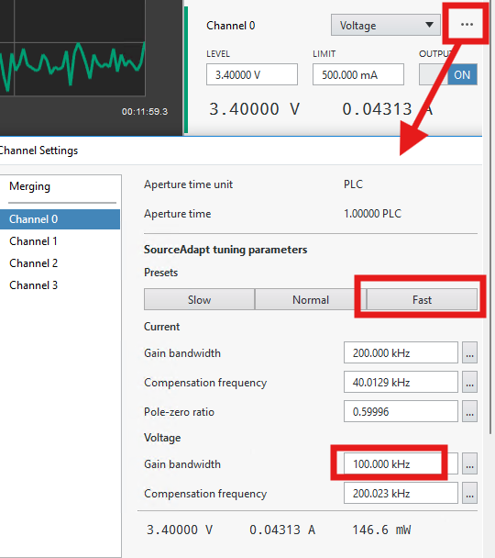

- Return to the Scope panel to see the impact on the voltage trace.
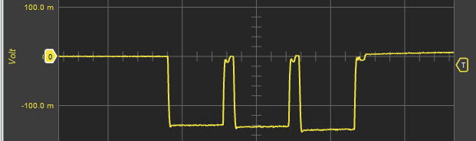
Rail Current
The next step is to monitor the rail current via the .1 Ω shunt.
- Enable Scope Channel1
- Adjust Channel1VOLTS PER DIVISION until you can clearly see the current trace
- Implement these additional settings for Channel 1:
- 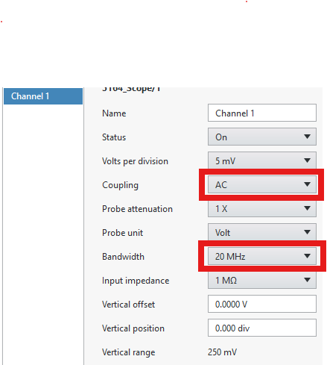
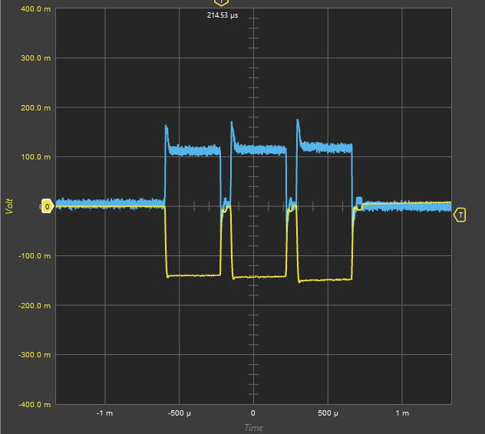

To minimize its impact on the DUT’s supply, the shunt resistor is only 0.1 Ω, so the voltage across it is just a few millivolts (Current is calculated as V/R_{shunt}). At that level, noise picked up from the DUT, the wiring, and the probe connections is significant compared with the signal. Because the BLE bursts repeat, we can enable averaging to suppress this random noise and reveal a truer current waveform.
- Enable averaging as below
- The default number of averages is 16. Feel free to adjust this to your liking
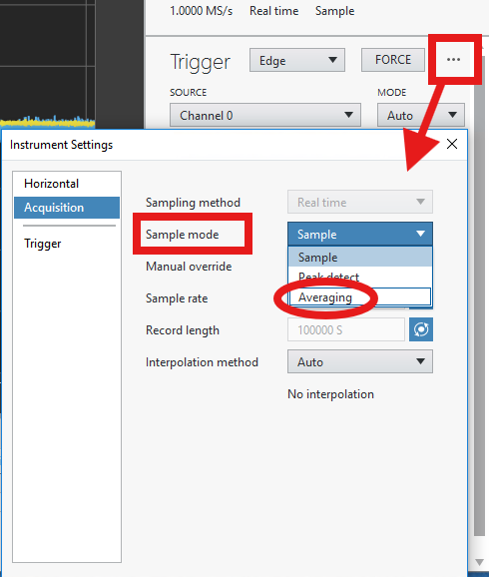
- Averaging should significantly mitigate the noise:
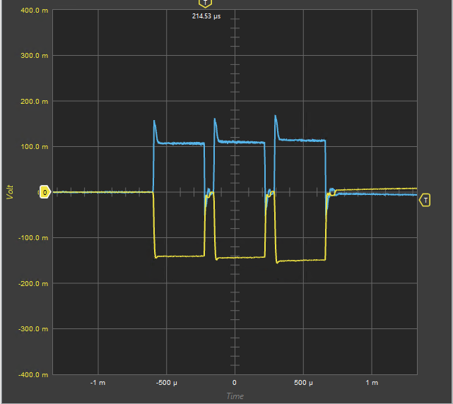

- Since coupling is set to AC on channel1, putting the baseline at 0, you can use a Maximum measurement on Channel1 combined with the known Shunt Resistance value of 0.1 Ω to measure the peak of the current transient:
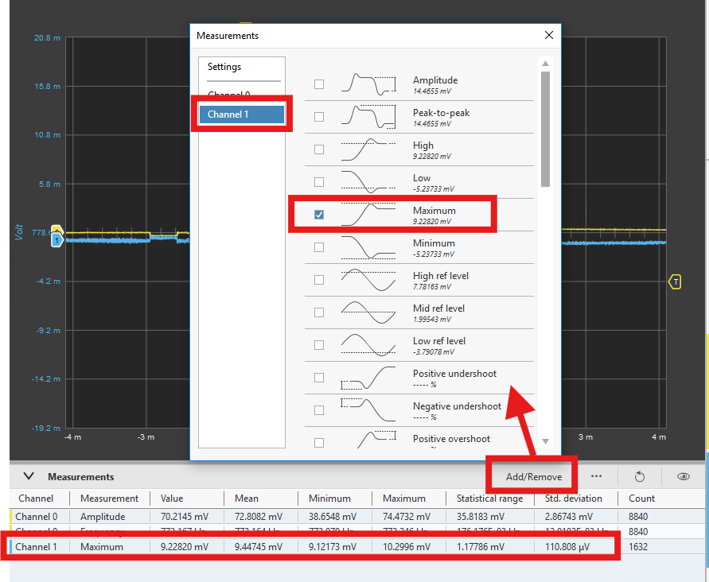
- The mean value for the front-end current spike is ~ 8.5mV
- 8.5mV/.01Ω = ~85 mA

As suggested in the system diagram in the Introduction section of this document, PXIe backplane signals can be used to synchronize measurements across devices. We will export the edge trigger established by the scope to the SMU in order to get a triggered SMU trace of the current transient on that device.
- Export the Scope’s trigger to PXI_TRIG0 as shown:
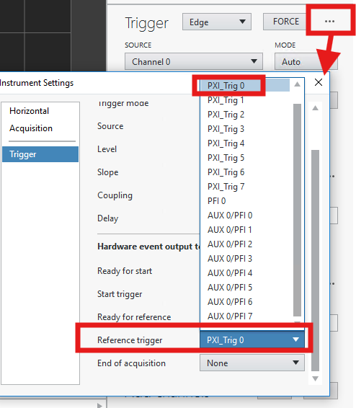
- Navigate to the SMU panel used for exercises 1 and 2
- Set the trigger source to ManualPXI_TRIG0 as shown
- Set the trigger source to PXI_TRIG0 for the SMU
- Set CAPTURE TIME to 6ms as shown

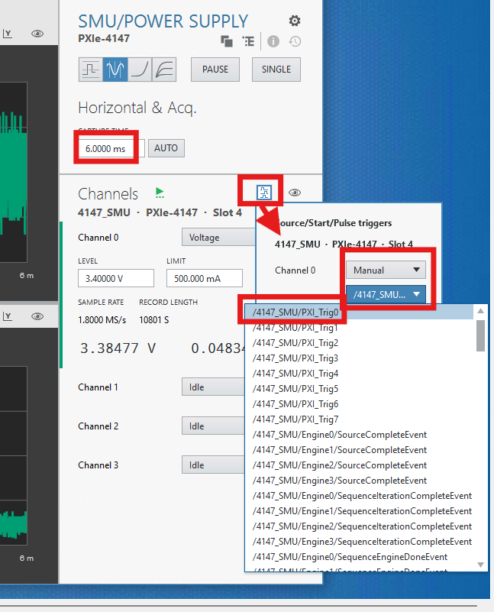
The current trace should now remain in a fixed position and resemble the following:
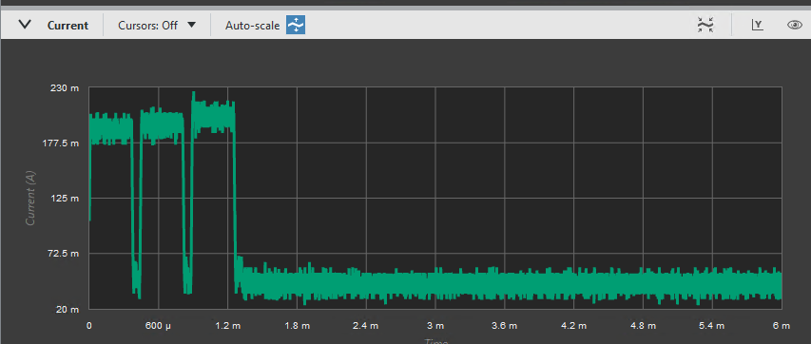
Capture and analyze the waveform data:
- Return to the Scope panel
- Right-click in the scope panel and select Data → Capture Data
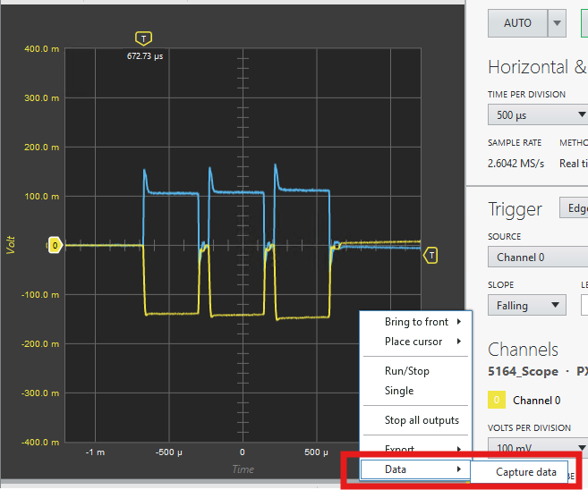
A file window will open on the left side of InstrumentStudio.
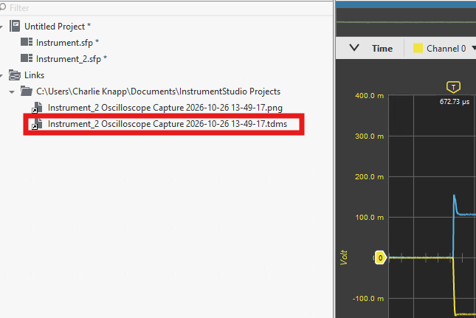
- Right-click the most recent file with a .tdms extension and select Show in Windows Explorer. This is the captured data from the scope trace.
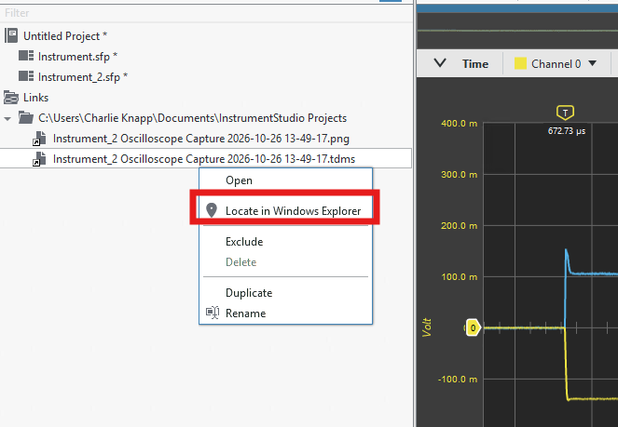
- Right-click on the highlighted file in File Explorer, and select Open with Diadem
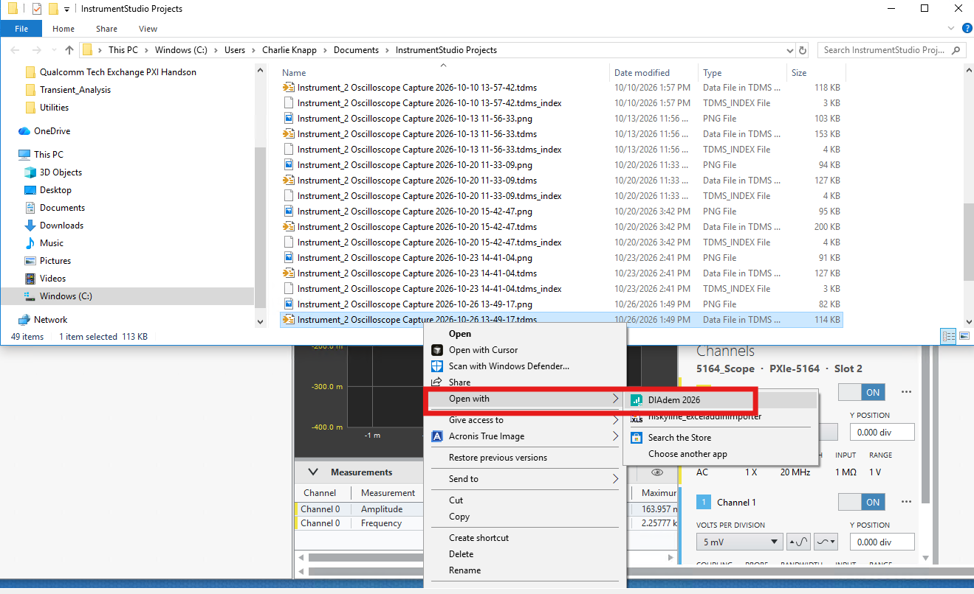

- Once Diadem opens the file
  - Select the VIEW menu towards the upper right (boxed)
  - Select the two scope waveform data channels from the menu on the right using standard windows selection techniques. Drag and drop onto the view
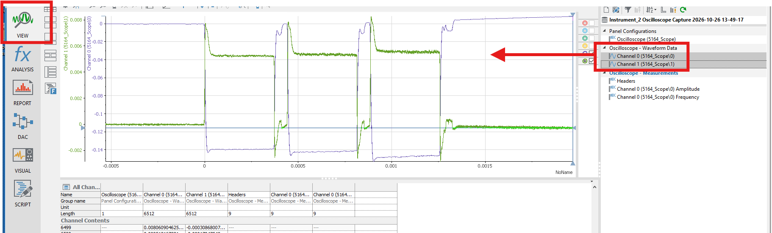

- Right-click in the VIEW area and select Band Zoom
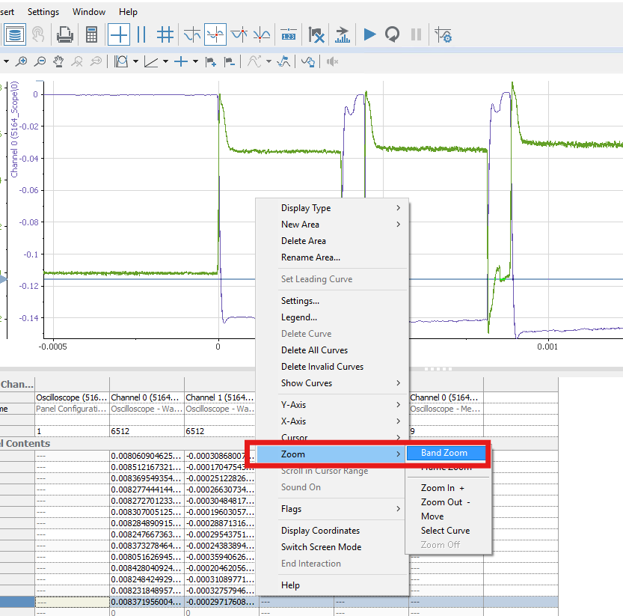
Drag a box around the first of the three bursts to zoom in. Notice how closely the voltage droop tracks the current:
- The voltage droop begins when the current steps up and recovers when the current drops.
- The brief current spike at the start of the burst produces the deepest part of the droop.
- After the burst ends, both traces ring briefly before settling.
You can zoom into any other region of interest the same way.
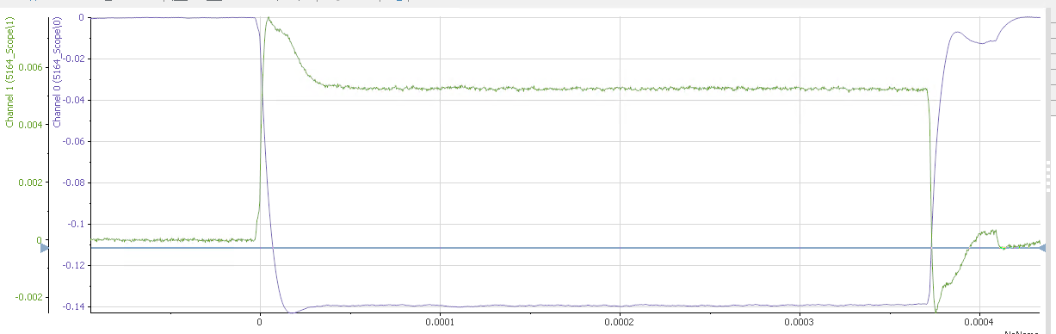
- Close the Monitor Window that opened when you ran the batch file
END OF EXERCISE

Exercise 4: Induce Rail Ripple and Observe Brownout Behavior
In In this exercise, you will inject a fixed amplitude of ripple onto the ESP32-C6’s supply rail and lower the rail’s DC level until the combination of ripple and BLE advertising load pushes it below the configured brownout threshold of 3.1 V (200 mV below the nominal 3.3V rail voltage).
The rail voltage will start at 3.4 V. This gives the device some headroom to ride through the ripple and advertising droop. Holding the ripple constant and stepping the supply voltage down isolates a single variable, so you can see exactly where the margin runs out, but both parameters will impact the onset of a brownout.
- On the SMU panel, set the rail voltage to 3.4 Volts
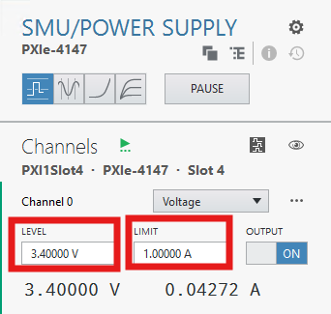
- Set the SMU Trigger to “Immediate”
The SMU has several separate triggers, including Start, Source and Measure. Application code (Python, C#, LabVIEW) can configure each one individually, but InstrumentStudio configures them as a group.
In this exercise you’ll push the DUT into brownout by lowering the rail voltage, then raise it again to recover the DUT. While in brownout the DUT stops transmitting, so no trigger is generated. If the SMU is set to wait for a trigger, it will hold off applying the higher voltage indefinitely, and the DUT never recovers. Setting the trigger to Immediate makes your voltage changes take effect right away.
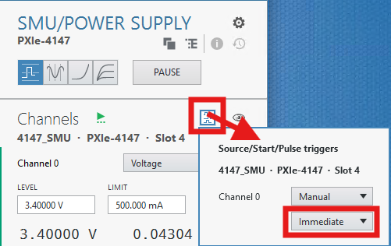

3. Flash the Brownout Test Firmware
Navigate to C:\PXI_Training and double-click 3_Flash_and_Monitor_BEACON_TRIGGERED.bat. After flashing is complete, leave the serial monitor window open so you can observe reset or brownout messages. 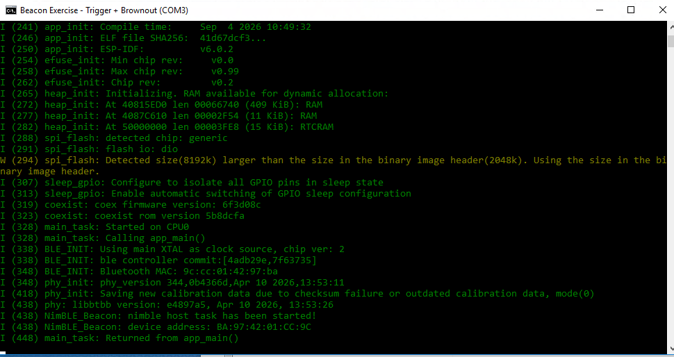
If you see immediately activity in the Monitor window, change the starting rail voltage to 3.5 V.

4. View only Channel0 using Sample mode
Return to the Scope panel. Disable Channel 1 on the scope (only the rail voltage is of interest for this exercise) and switch to Sample Mode under Acquisition Settings 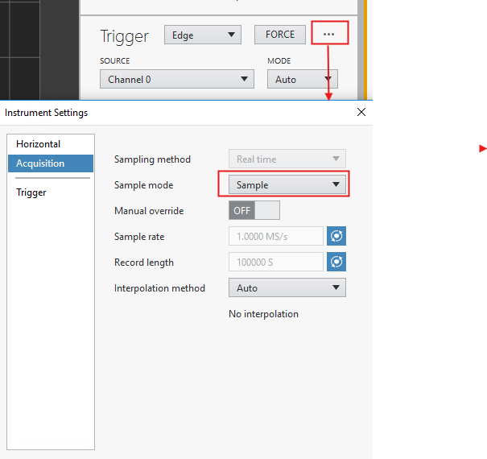
This disables averaging and enables immediate viewing of the ripple injected onto the voltage rail.
5. Configure the scope to use the trigger from GPIO10 on the ESP32-C6
You will need to know the name of your computer for this step. To retrieve your computer’s Host Name, open a command prompt. You can do this by typing cmd in the search window then pressing Enter. In the prompt, type hostname. An example is shown, but the hostname will differ for your computer:
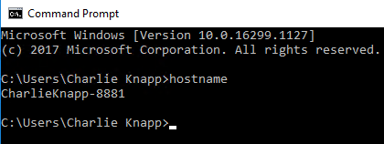

Configure the Scope’s trigger as follows:
- Trigger type: Digital
- Source /<hostname>/TRIG_SMB
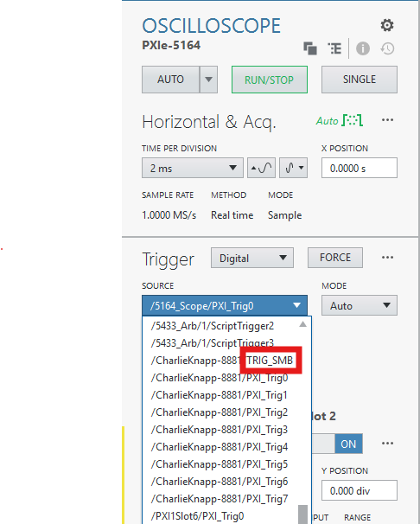

In the Firmware you flashed to the ESP32-C6, a trigger is generated each time a bluetooth burst is initiated and routed to the GPIO10 pin. This trigger signal is cabled to the TRIG port on the front panel of the PXIe controller. Thus you are triggering the Scope based on a consistent periodic event from the DUT.
The rail transient will likely no longer be centered on the scope trace.
You can drag the outlined window over to the voltage transient, or you can left-click in the scope display and pan until the transient is in view.
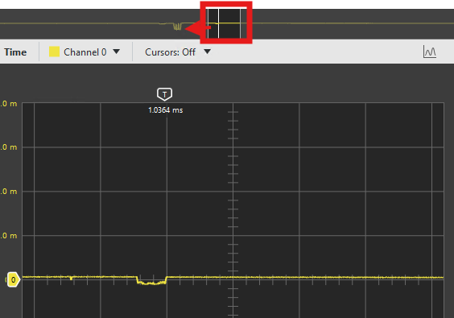
Notice the new feature in the scope trace: 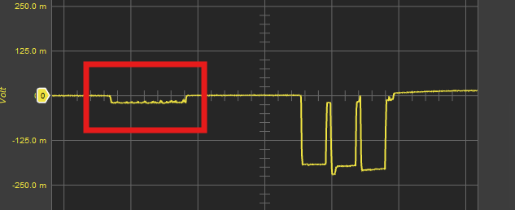
This is additional ESP32-C6 activity introduced by the firmware that generates the GPIO10 trigger pulse. Instrumenting the DUT’s firmware changes its power profile, which is worth keeping in mind whenever you add debug or trigger code to a device under test. In this case, the added load is small and ends well before the first advertising burst, so it does not affect the brownout measurement.
Also, Notice the random jitter in the position of the transient from one capture to the next. This comes from advDelay, a pseudo-random delay of 0–10 ms that the Bluetooth Low Energy specification adds to the interval between advertising events. It prevents nearby advertisers from repeatedly colliding on the same channels.
The trigger pulse is generated by the application firmware before the advertising event is scheduled, but the Bluetooth controller applies advDelay afterward. As a result, the trigger marks that an advertising event is coming, not its exact start time.
Navigate to the WAVEFORM GENERATOR panel. To align the injected ripple with each capture, you will run the waveform generator in Arbitrary Waveform mode rather than standard function mode, which outputs continuously. A sine waveform of known length is loaded from a file, and the generator outputs the full waveform once each time the GPIO10 trigger arrives on the PXI backplane. Because the scope acquisition is started by the same trigger, every capture contains one complete, time-aligned burst of ripple.
- Set GAIN to 0- it will be coerced to a minimum value.
- Load the file as shown
- Pay close attention to all other settings indicated by red boxes
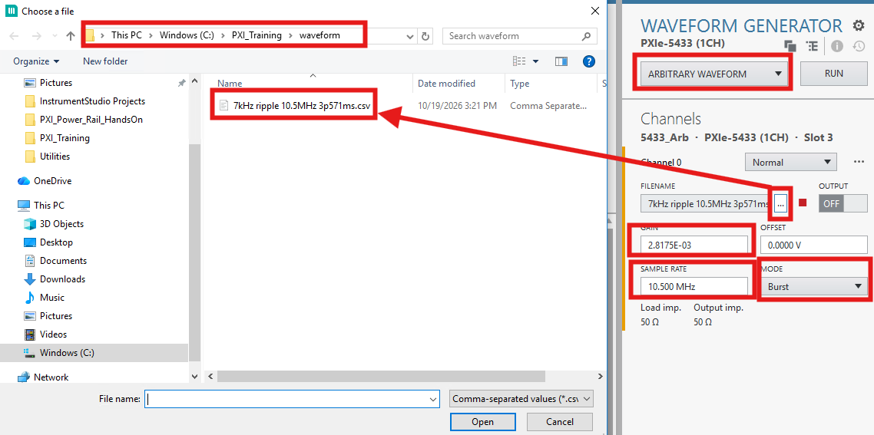

6. Configure the Waveform Generator Trigger
Use PXI_TRIG0 as the waveform-generator trigger source so the ripple waveform begins from the same firmware-generated timing reference used by the Scope (remember that in the previous exercise, you exported the Scope’s trigger to PXI_TRIG0)
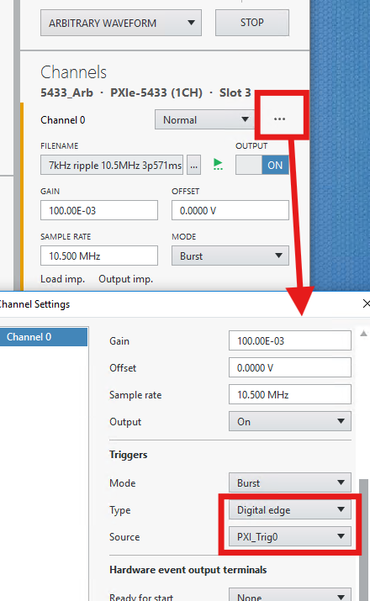

7. Enable the Arbitrary Waveform Output
Turn on the arbitrary waveform generator and enable the output.
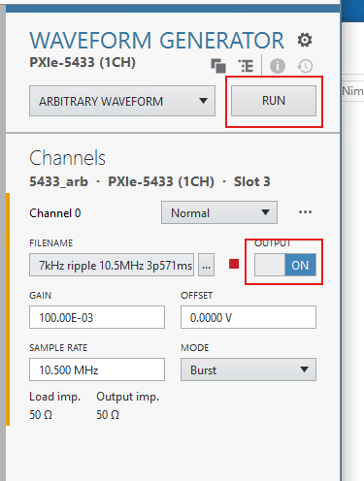

8. Increase Ripple and Observe the Rail
Start with GAIN = 0.1. You will begin to see the induced ripple. Remember that the voltage rail trace is AC coupled, and that the transient is riding on a DC component of 3.4V.

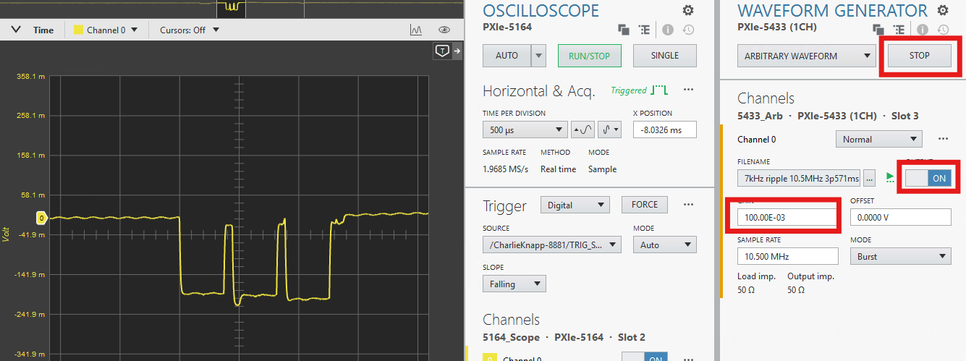

- Increase the gain to 2. The ripple will now appear significant.
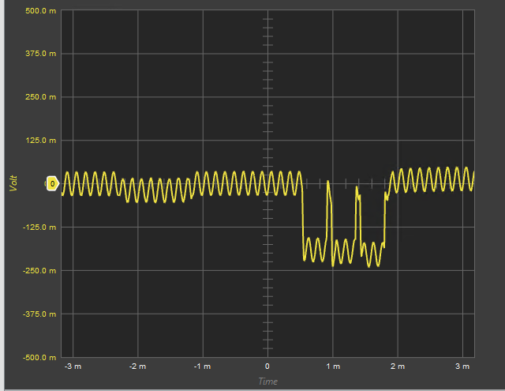
Arrange the screen so relevant windows are viewable as you induce a brownout
- Right-click on the SMU panel tab and select Float tab in new window
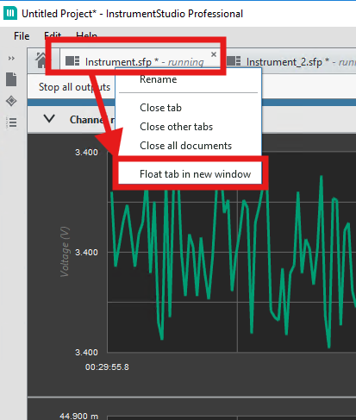
- Hide the Waveform Generator panel
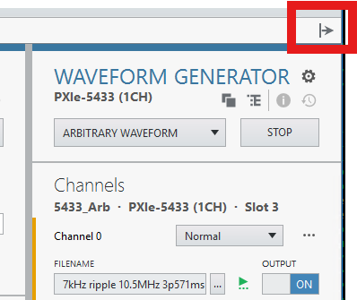
- Re-arrange your desktop and resize the InstrumentStudio windows so that all of the indicated components can be viewed. This will be a bit of a tight squeeze- here is an example:
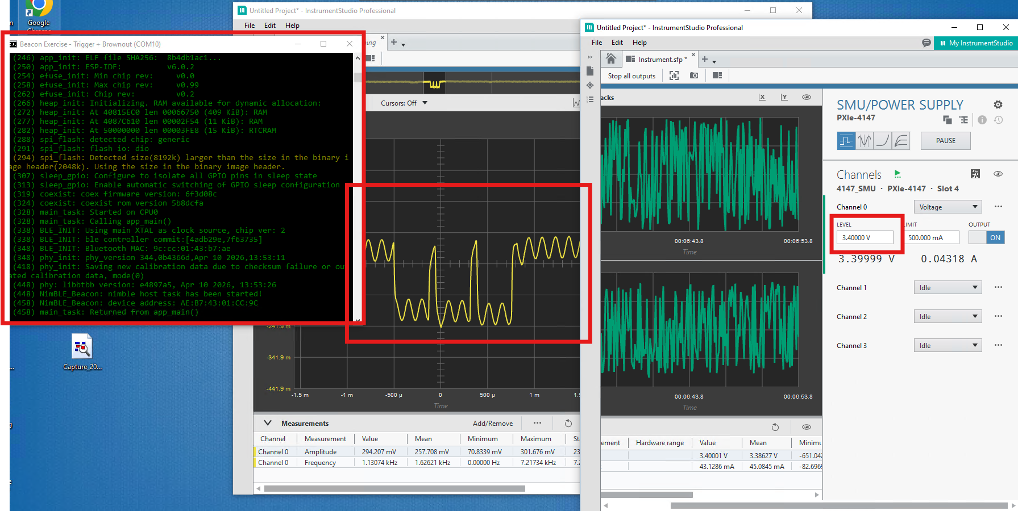
- Start decreasing the SMU voltage in .01 Volt increments. The easiest way to do this is to highlight the second decimal place digit in the LEVEL input for the SMU channel using standard Windows keystrokes, then use the UP and DOWN arrows on your keyboard to increase or decrease
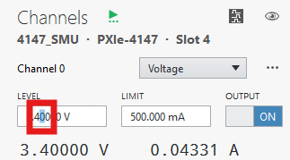
- At first, the serial monitor will be quiet. As you approach the brownout threshold (typically around 3.3 V), the DUT will reset and you’ll see boot text start scrolling in the monitor.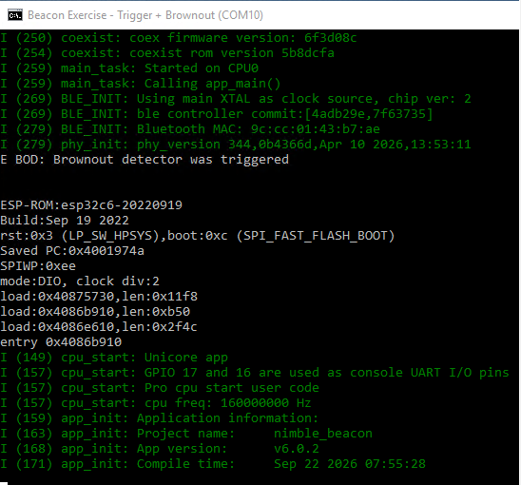
- To freeze the monitor, left-click inside the window, then scroll up to find the start of the reset sequence. The “E BOD: Brownout detector was triggered” line confirms the reset was caused by a brownout.
- Right-click inside the window to unfreeze it.
You will lose the transient trace on the scope as the DUT reboots. If you increase the voltage rail value above the brownout threshold, it will take several seconds for the DUT to start sending advertising packets again. You may notice some hysteresis as you play around. As mentioned above, the brownout threshold will not be entirely deterministic: the random 10 mS delay between advertising events will add variability to where a negative peak in the ripple sinewave hits the negative-going edge of the current transient, so you may notice a “soft” onset of brownout events.
Feel free to experiment with rail voltage, waveform generator gain or other parameters as you see fit.
END OF EXERCISE

