PXI Power-Rail Monitoring Hands-On: Setup Manual
Nov 4, 2026 · @Charlie

1. Overview
This manual is intended to cover all required steps to
- Build the Espressif ESP32-C6 DUT kit
- Set up PXI development and customer stations
- Run four customer-facing power-rail monitoring hands-on exercises
The session shows how PXI instruments characterize a device's power rail: a PXI SMU supplies and measures the rail, a PXI scope captures what the DUT draws and when, and a PXI arb injects ripple onto the power rail. The DUT is an ESP32-C6-DevKitC-1-N8 which supports the Bluetooth Low Energy (BLE) standard. Small ESP-IDF (Espressif IoT Development Framework) firmware images that make rail voltage and current transients easy to see and repeat are used.
Exercises
- Power the DUT and measure sleep current with the SMU.
- Monitor Bluetooth Low Energy (BLE) advertising current and voltage on the SMU panel.
- High-speed triggered rail-voltage and current capture: the scope captures the rail voltage and the current (via a 0.1 Ω shunt resistor), the scope's edge trigger is shared with the SMU, and the data is analyzed in DIAdem.
- Induce rail ripple and observe brownout: trigger from the DUT's GPIO10 pulse, inject ripple with the arb, and lower the rail until the DUT browns out.
The session also includes instructor-led automation demonstrations in Python and C# (Section 9). They are not hands-on exercises.
Attendee instructions are in the separate document PXI Hands-On Exercises (Complete), in the repo's docs\attendee folder; the presenter slides are in docs\presenter. This manual covers building and preparing the setups. Sections 5 to 8 follow the same four exercises and list what must be ready and what to watch for.
Before you start
- All firmware images are provided prebuilt, in two places: the complete ESP-IDF projects in the repo's firmware folder, and the build outputs in C:\PXI_Training with batch files that point to them. A new build is only needed to use different firmware or to modify a provided image.
- Only a machine where firmware is changed needs ESP-IDF, Espressif's firmware toolchain (Appendix B). Customer stations flash the prebuilt images and need no ESP-IDF (Section 4).
- If you do rebuild, build from the provided project folder, keep the target as esp32c6, and copy the new build folder into PXI_Training. A wrong target is the most common first failure (Section 10).
- Section 4 and Appendix B can be done without the chassis. Sections 3 and 5 to 9 need the PXI hardware.

2. Bill of materials
Each DUT setup needs the non-NI parts below, and each customer station needs the PXI hardware and software. The links are to items that were tested; you are free to choose your own.
Non-NI parts (per bench)
Item | Detail | Purpose
ESP32-C6-DevKitC-1-N8 (×1) | Espressif dev board, ESP32-C6-WROOM-1 module | The DUT
0.1 Ω shunt resistor, 1 W, 1% (×1) | In series with the DUT ground return | Turns DUT current into a measurable voltage (10 mV per 100 mA)
10 Ω resistor, 1/2 W (×1) | In series with a 10 µF capacitor in the arb path to the 3v3 rail | Part of the ripple injection path from the arb to the 3v3 rail
10 µF capacitor, 50 V (×2) | (1) In series with the 10 Ω resistor in the arb path to the 3v3 rail. (2) Cross-cap between the 3v3 rail and the ground rail | (1) Couples arb ripple onto the rail (a 0.1 µF capacitor was the original design and can be tested). (2) Decouples the rail
330 Ω resistor, 1 W (×1) | In series at GPIO10 | Reduces probe pickup on the trigger line
USB data cable (×1) | USB-A or USB-C to USB-C, data-capable | Flashing and serial monitor
Solderless breadboard (×1) | See Section 3.3 | Holds the DUT and the support parts
20 AWG solid-core wire kit, 6 colors (×1 kit) | (1) Red jumper: 3V3 pin to the power rail. (2) Black wire: far side of the shunt to the ground rail. (3) Leads from the SMU terminal block to the power and ground rails. 22 AWG pulls out of the breadboard | (1) Carries 3v3 to the rail. (2) Returns DUT current through the shunt to ground; its bare section is the instrument ground point. (3) Connects the SMU output to the rails
Breadboard jumper wires (optional, ×1 pack) | (1) Cut a jumper in half. (2) Strip the cut end and connect it to the SMU terminal block. (3) Leave the Dupont connector outside the terminal block | Lets the solid-core wires from the power and ground rails be connected to and disconnected from the SMU easily
Oscilloscope probe kit, 100 MHz, with BNC to minigrabber leads (×2 probes) | Set to 1x. (1) Scope CH0 on the 3v3 rail. (2) Scope CH1 on the shunt lead at the DUT G pin | (1) Monitors rail voltage. (2) Monitors shunt voltage, and so DUT current
SMA male to dual alligator clips (×1) | Arb signal and return clips | Arb to the power rail
BNC female to SMB female straight RF coaxial adapter (×1) | Connects to the controller's front-panel SMB TRIG port | GPIO10 trigger to the controller
BNC to mini-clip test leads (×1) | Connects to the BNC adapter on the controller TRIG port | GPIO10 trigger to the DUT
A charge-only USB cable is the most common reason a board does not enumerate. Use a cable that is known to carry data.
PXI station
Item | Tested | Role
PXIe chassis with at least 3 slots |  | Houses the modules
PXIe-Controller with front panel SMB TRIG port |  | Runs InstrumentStudio, the flashing tools, Diadem, example application code
SMU (PXIe-4147 has been fully tested. 4145 cannot provided adequate current) |  | Supplies the rail, measures current and voltage
Scope (2 channels are used) |  | Captures rail voltage and shunt voltage
Waveform Generator with Arbitrary Waveform capability (waveform is loaded from file) |  | Injects ripple onto the power rail
SMU terminal block |  | Power and monitor the DUT
SMU note: the exercises have been tested extensively only on the PXIe-4147. Other 3 A-capable SMUs (the PXIe-4139 and PXIe-4138) should work in principle but settings may need to be modified. Note that the 4138 does not implement Source-Adapt.
Software
Software | Where it is used
ESP-IDF (installed with the EIM GUI) | Only where firmware is changed (Appendix B)
esptool.exe and esp-idf-monitor | Customer stations, for flashing and serial monitor (Section 4)
CP210x USB-to-UART driver | Any machine that connects to the DevKit over USB
InstrumentStudio, NI-DCPower, NI-SCOPE, NI-FGEN | Customer stations
Python and C# development environments | Instructor-led demos only (Section 9)
NI DIAdem | Customer stations, Exercise 3 (analyzing the saved scope data)

3. DUT wiring and measurement system
The 0.1 Ω shunt sits between the DUT ground and a single instrument-ground net, so the SMU supplies the 3v3 rail while the scope reads current as the voltage across the shunt.

3.1 Pins used on the DUT
The exercises use three header pins and the UART port. Hold the board with the antenna up and the USB ports down, as in the photos: 3V3 is the top pin on the left, G is the top pin on the right, and GPIO10 is the ninth pin down on the left, just below GPIO8.
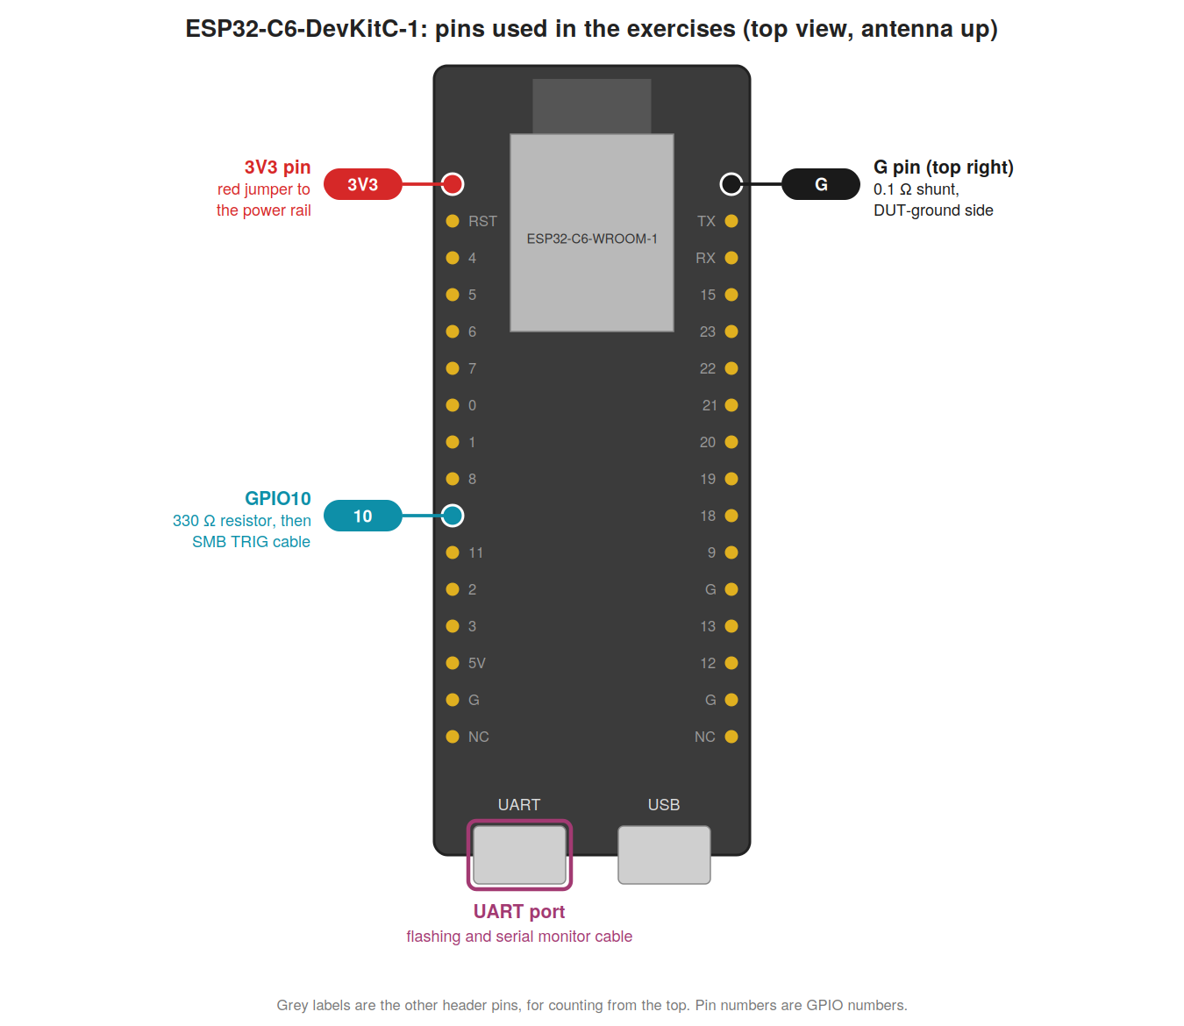

3.2 Wiring diagram and connections
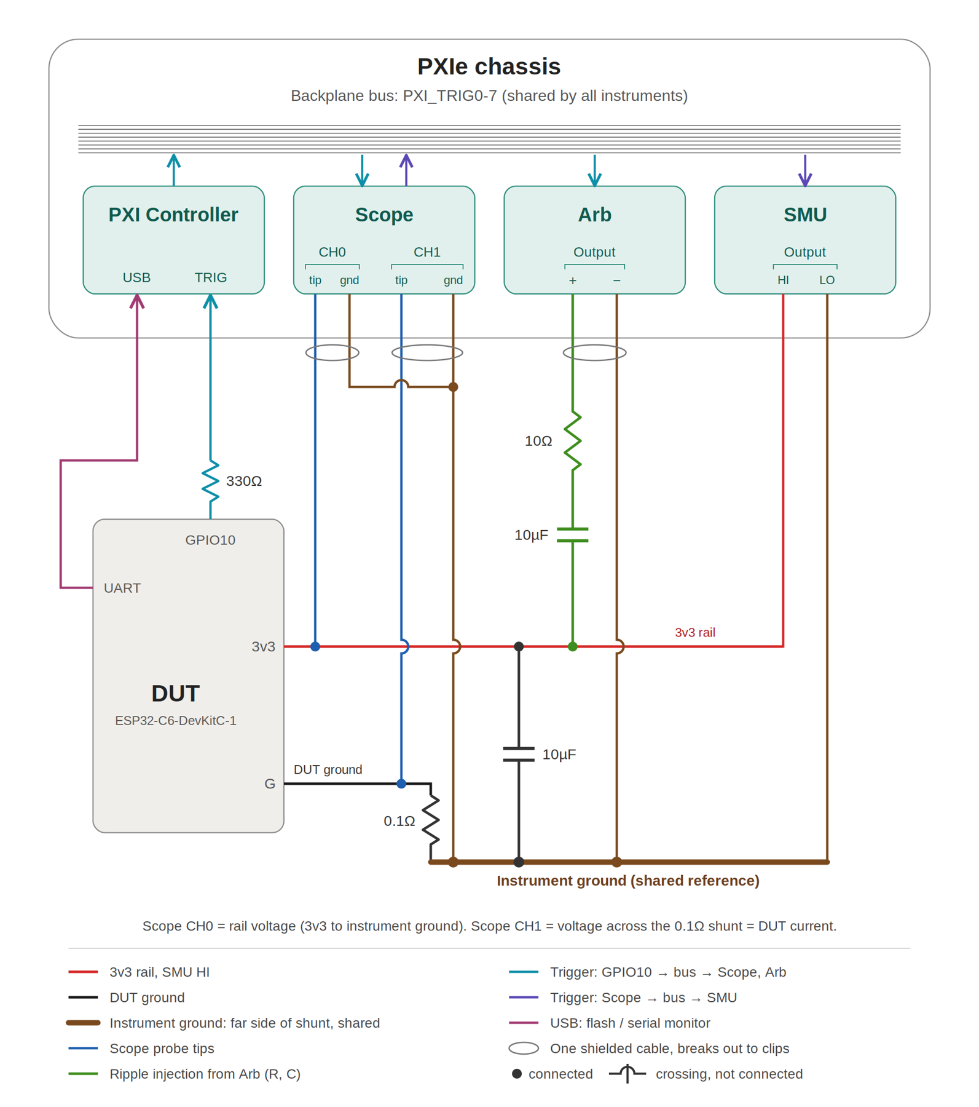
Wiring diagram v5.
Connections
- SMU: terminal-block CH0 HI to the breadboard power rail (3v3), CH0 LO to the breadboard ground rail. Dupont headers on the terminal block take the 20 AWG wires from the rails, so the SMU can be connected and disconnected easily. In order to simplify the setup, the SMU's remote-sense lines are not used. If you want remote sensing, connect sense LO to the breadboard ground rail next to CH0 LO, so the SMU uses the same instrument-ground reference as the scope. Sense HI must connect at the DUT's 3V3 pin, but the only free hole beside that pin is already used by the 3V3 jumper, so solder the sense-HI wire tip to the 3V3 jumper close to the pin. Remote sensing has not been tested on this setup: the SourceAdapt settings found with local sensing may need retuning, and both sense lines must be connected whenever remote sensing is enabled.
- Rails and shunt: a red jumper takes 3v3 from the DUT's 3V3 pin to the power rail. The 0.1 Ω shunt runs from the DUT's top-right G pin to the far side, and a black wire carries that far side to the ground rail next to the power rail. A 10 µF cross-cap connects the 3v3 rail to ground.
- Scope: CH0 tip on the 3v3 net, CH1 tip on the shunt lead at the DUT G pin (the DUT-ground side). CH0 reads the rail voltage and CH1 reads the shunt voltage, so 10 mV equals 100 mA. Set both probes to 1x, and keep the scope's probe attenuation setting at 1x to match, so the readings are not scaled.
- Arb: the signal clip goes on the free lead of the 10 Ω resistor, which is in series with a 10 µF capacitor to the 3v3 rail. The arb return clip goes on instrument ground.
- GPIO10: the DUT's GPIO10 pin goes through the 330 Ω resistor to a clip on its free lead, then over an SMB to BNC to clip cable to the controller's SMB TRIG connector. A second clip on that cable goes on instrument ground.
- Trigger routing: the scope uses the controller's SMB TRIG line directly as its trigger and exports a reference trigger on PXI_TRIG0. The arb triggers from PXI_TRIG0. The arb's InstrumentStudio panel does not expose the controller's trigger lines, which is why the arb is triggered through the scope.
- USB: the DevKit's UART port connects to the controller for flashing and the serial monitor only. The SMU supplies the rail during the exercises.
Rules that avoid problems
- Use one instrument-ground net. Every ground clip (both scope probe grounds, the arb return, the trigger cable return) goes on the bare section of the black wire that runs from the far side of the shunt to the ground rail. The SMU LO, cross-cap and ground rail are on the same net.
- Do not add a second ground path, such as a probe ground on the DUT's own G pin. It bypasses the shunt and corrupts the current reading.
- Keep the 330 Ω resistor at the GPIO10 pin. Probe pickup on this line can show up as a rare single-sample spike on the CH1 trace; the resistor reduced it to about one capture in thirty and knocked down the magnitude significantly.
- Keep the bare section of the ground wire clear of the module's pins and of the 3V3 jumper.
- Set the SMU current limit to 1 A for the ripple exercise.

3.3 Breadboard and wire
The breadboard and wire choice decides whether the DUT setup stays together. The breadboard listed in the bill of materials has been tested across multiple DUT instances (Section 2).
- Breadboards: It is recommended to use these breadboards from Amazon. Adafruit breadboards had better electrical characteristics but let even 20 AWG wire come loose easily.
- Wire: use 20 AWG solid-core only. 22 AWG pulls out of the holes easily.
- Once the DUT is seated, only one hole is free beside each pin on each side. Several things have to join the 3v3 and ground nets, so use short jumpers to carry them to the rails: the red jumper from the 3V3 pin to the power rail, and the black wire from the shunt to the ground rail.
- Components: 1/2 W - 1W resistors and 50V capacitors generally fit the holes snugly enough to make good electrical contact, so their leads can be pressed straight into the breadboard. If a lead fits loosely, solder a short length of 20 AWG solid-core wire to it.
- Arb injection path: trim the leads of the 10 Ω resistor and the 10 µF capacitor and solder the two parts together before pressing them into the breadboard. This takes the breadboard's contact resistance, capacitance and inductance out of the ripple path.
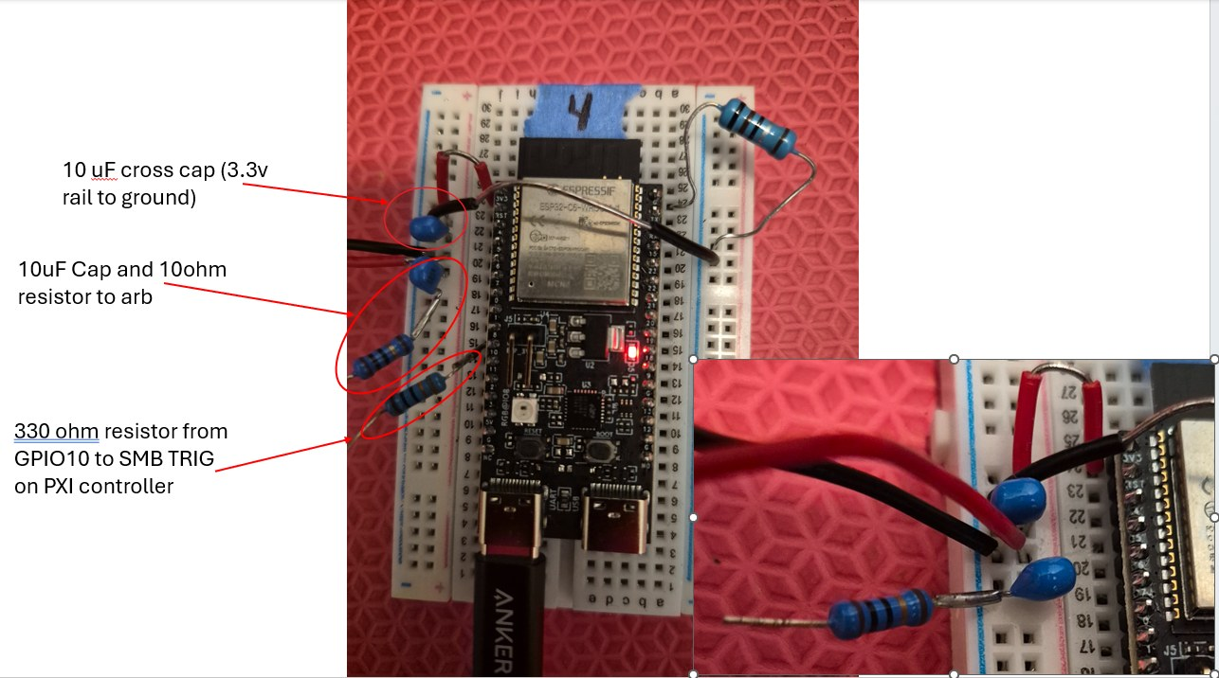
Breadboard parts: the cross-cap (3.3 V rail to ground), the 10 µF cap and 10 Ω resistor to the arb, and the 330 Ω resistor from GPIO10 to SMB TRIG on the PXI controller.

3.4 Photos of the connected DUT setup
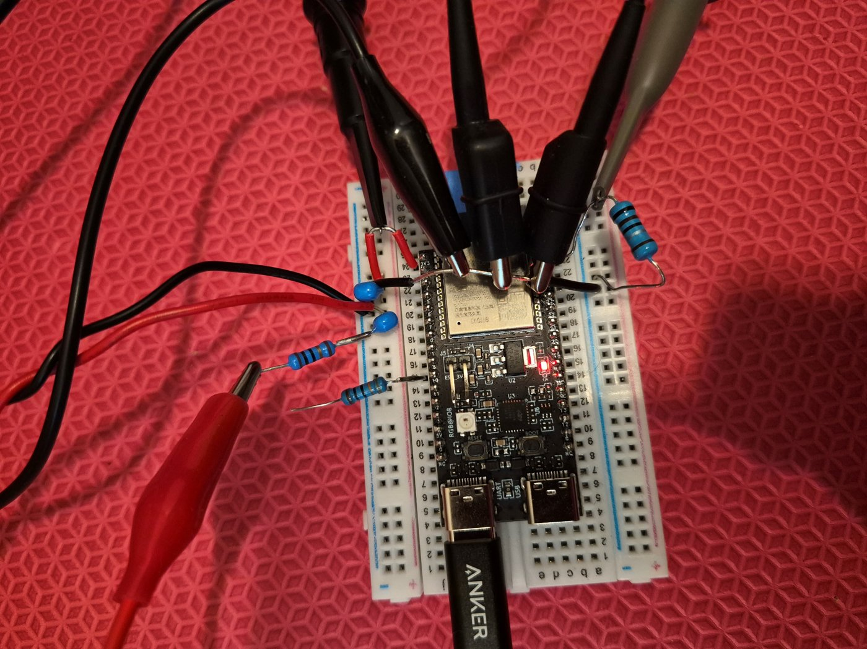
Scope probes, arb and SMU connected. The GPIO10 trigger clip is not attached in this photo (see the trigger photo below). The black clips (scope grounds, arb return) all grip the bare ground wire across the module. The red alligator clip is on the 10 Ω resistor.
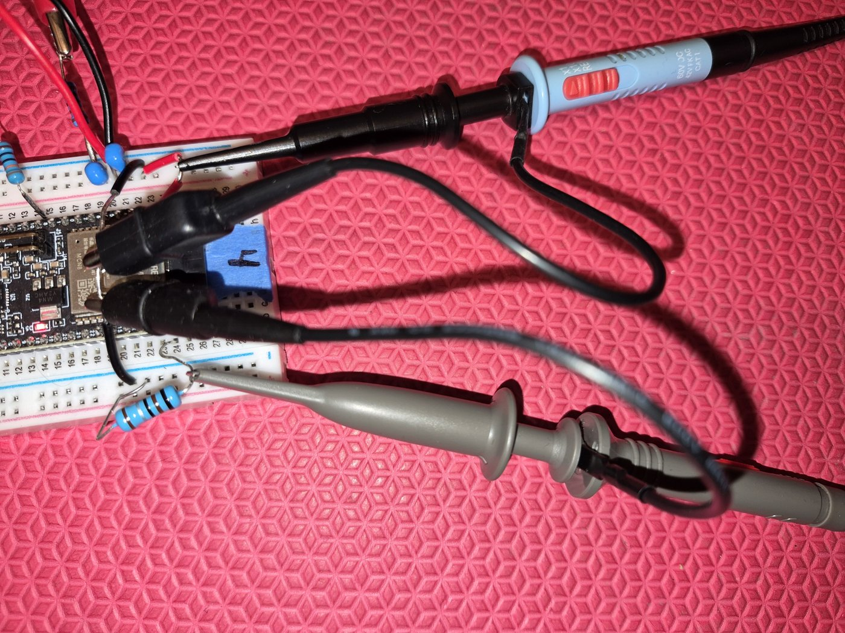
Scope probes only: CH0 on the rail, CH1 on the shunt.
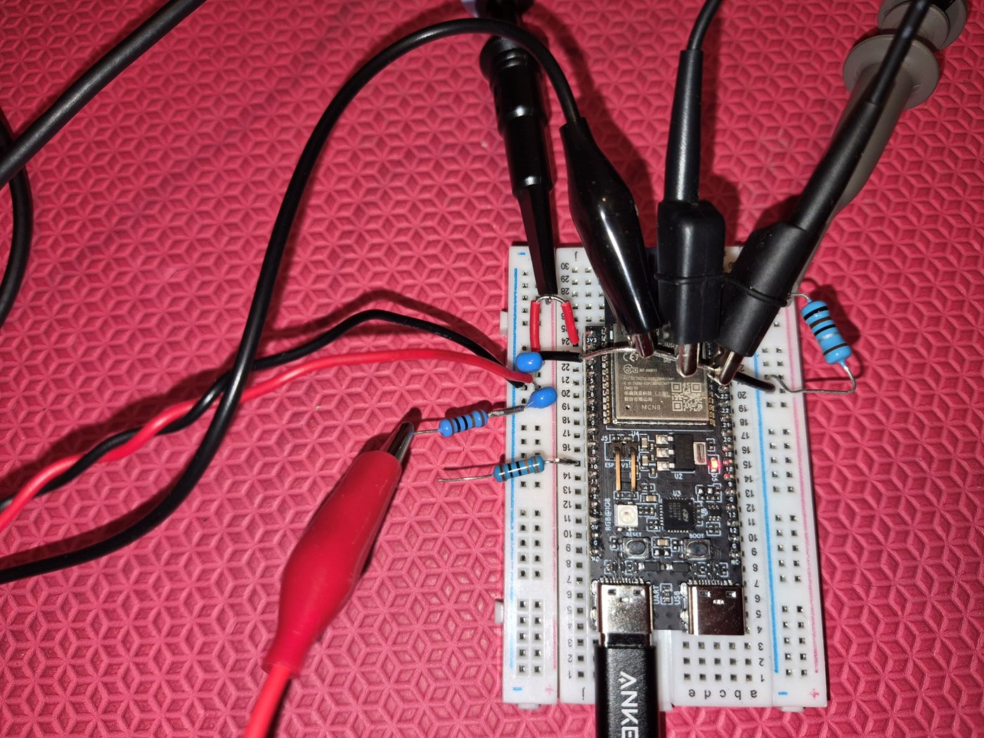
Arb: signal and return clips from the SMA to clip cable. The red clip goes on the 10 Ω resistor's free lead; the black clip goes on the ground wire.
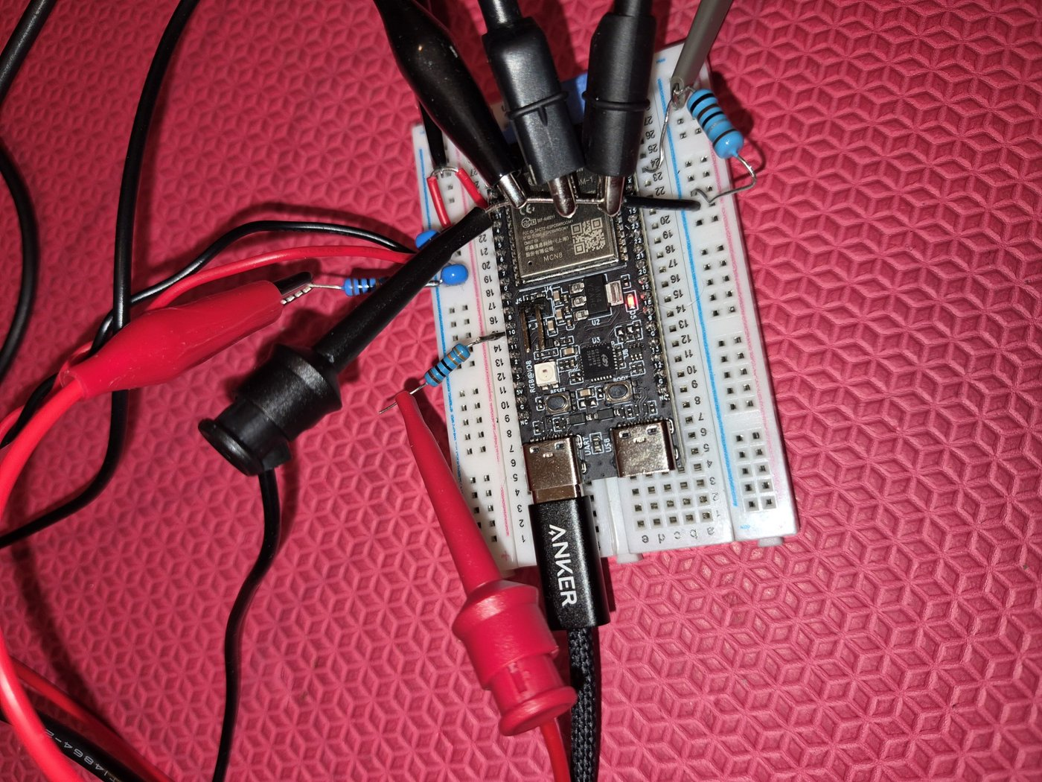
Trigger: signal and ground clips from the controller's TRIG connector (SMB to BNC to clip cable). The red clip goes on the 330 Ω resistor's free lead; the black clip goes on the ground wire.
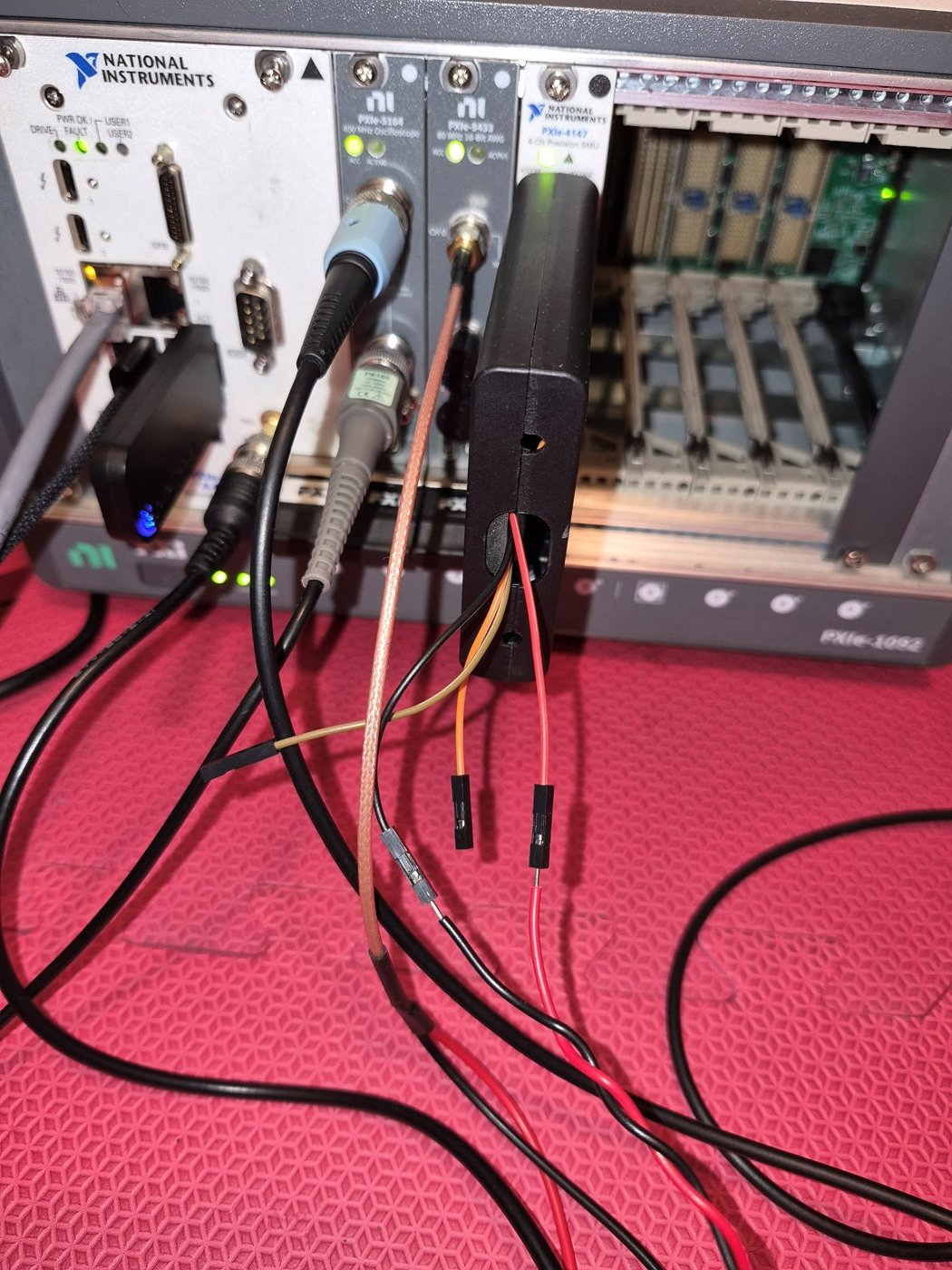
Chassis side: the SMU terminal block with Dupont headers for CH0 HI and CH0 LO, the arb SMA cable, the scope probes, and the SMB to BNC to clip cable from the controller.

4. Firmware packages and flashing on a clean machine
A customer station flashes prebuilt images with a standalone esptool.exe and monitors the serial output with esp-idf-monitor; it needs neither ESP-IDF nor a rebuild.
The prebuilt build folders are provided in C:\PXI_Training, with batch files that point to them. The complete ESP-IDF projects are in the repo's firmware folder, for anyone who wants to modify the firmware: deep_sleep_forever builds the sleep_current image, NimBLE_Beacon builds beacon, and NimBLE_Beacon_triggered builds beacon_triggered.
Folder layout
Clone the repo, or download it as a zip from the Git host, and copy its PXI_Training folder to C:\, so it sits at C:\PXI_Training (a short, space-free path). If you downloaded a zip, unblock it before extracting (right-click the zip → Properties → Unblock); otherwise Windows may warn about esptool.exe and the batch files. The three batch files must sit in this root folder, because they find everything relative to their own location.
C:\PXI_Training\
1_Flash_and_Monitor_SLEEP.bat
2_Flash_and_Monitor_BEACON.bat
3_Flash_and_Monitor_BEACON_TRIGGERED.bat
tools\esptool.exe
waveform\7kHz_ripple_10.5MHz_3p571ms.csv
exercises\sleep_current\build\
exercises\beacon\build\
exercises\beacon_triggered\build\
Each build folder is the output of an idf.py build command from a station with ESP-IDF installed. Appendix B covers installing ESP-IDF (B.2), working in the ESP-IDF terminal (B.3) and building and copying a new build folder (B.4).
Install the USB driver
Install the Silicon Labs CP210x driver if the DevKit does not appear as "Silicon Labs CP210x USB to UART Bridge (COMx)" under Ports (COM & LPT) in Device Manager once plugged in with a data-capable cable. Choose the download by Windows version:
- Windows 11: the CP210x Universal Windows Driver works.
- Windows 10: the Universal Windows Driver did not work. Use the earlier download labeled "Windows Drivers" instead, and install its 64-bit version.
One-time setup on each station
- esptool.exe is already contained in the C:\PXI_Training\tools\ folder; this is the version the batch files were tested with. Download a replacement from the esptool releases page only if it is missing.
- Install Python, then run pip install esp-idf-monitor.
- Plug the DevKit's UART port into the controller with a data-capable cable. In Device Manager, expand Ports (COM & LPT) and find the entry named Silicon Labs CP210x USB to UART Bridge (COMx); the number in parentheses is the DUT's COM port. Ignore any other COM ports listed, which belong to other devices. If the board appears under Other devices with a yellow warning icon instead, the CP210x driver is missing (see Install the USB driver above).
- Open each .bat file in a text editor and set SET PORT= to that COM port (for example COM4). The port is never compiled into the firmware, so changing it does not need a rebuild.
What each batch file does
Batch file | Firmware | Used in
1_Flash_and_Monitor_SLEEP.bat | sleep_current | Exercise 1
2_Flash_and_Monitor_BEACON.bat | beacon | Exercises 2 and 3
3_Flash_and_Monitor_BEACON_TRIGGERED.bat | beacon_triggered | Exercise 4
Each file runs esptool.exe --chip esp32c6 -p %PORT% -b 460800 write_flash @flash_args from the matching build folder, then opens the serial monitor at 115200 baud.
If the batch file flashes the DUT but the serial monitor does not open, and the window says idf-monitor is not recognized: the pip install worked, but pip put the idf-monitor command in a folder that Windows does not search. Run the monitor through Python instead, which always works, by typing this in a command window (replace COM4 with the DUT's COM port):
python -m esp_idf_monitor -p COM4 -b 115200 --target esp32c6
To make the plain idf-monitor command work instead:
- Run python -m site --user-site. It prints a folder path ending in site-packages.
- Go up one level from that folder. The Scripts folder there holds idf-monitor.
- Add that Scripts folder to the Windows PATH environment variable, then open a new command window.
When a rebuild is needed
The provided images cover all four exercises, so a rebuild is only needed to use different firmware or to modify a provided image. Appendix B covers installing ESP-IDF, building, and copying the new build folder into PXI_Training. Changing the COM port never needs a rebuild: edit SET PORT= in the batch file.

5. Exercise 1: Power the DUT and measure sleep current
What attendees do: power the DUT's 3.3 V rail from SMU channel 0 in the InstrumentStudio SMU panel, put the DUT to sleep by running 1_Flash_and_Monitor_SLEEP.bat, then lower the current limit to about 1 mA and read the sleep current.
Have ready
- The SMU is wired to the rail and ground as in Section 3, and the DUT is connected to the controller by USB.
- C:\PXI_Training is in place with the COM port set in each batch file (Section 4).
- The SMU rail is on before the batch file runs. The DUT cannot be flashed without the rail powered.
Expected result: a sleep current in the 10 to 20 µA range with the current limit at about 1 mA.
FAE notes
- The SMU in the system has 1 or 4 channels. Channel 0 is the one wired to the DUT.
- Attendees close the command window the batch file opened when they finish. The serial monitor in that window can hold the COM port, so the next flash fails while it is open.

6. Exercise 2: Monitor BLE advertising current and voltage
What attendees do: set the SMU current limit to 500 mA, flash the beacon firmware with 2_Flash_and_Monitor_BEACON.bat, and watch the current and voltage traces in the SMU panel. The firmware sends a sequence of three BLE advertising packets, one each on channels 37, 38 and 39. Attendees switch from Charting to Waveform mode, set the capture time to about 25 ms, and click SINGLE (typically 10 to 30 times) until one complete advertising sequence is captured.
Have ready
- The SMU rail is on, with the current limit at 500 mA, before the batch file runs. The current rises sharply once advertising starts, and the DUT cannot be flashed without the rail powered.
- After flashing, about a minute passes before the traces show the current spikes.
Expected result: a series of current spikes, one per advertising packet. Each burst lasts about 370 µs. The SMU acquires at 1.8 MS/s without a trigger, so each capture starts at a random time and several clicks are needed. Exercise 3 locks the capture to the event.
About the firmware
The beacon uses non-connectable, non-scannable advertising (BLE_GAP_DISC_MODE_NON, no scan-response data). With scannable advertising the radio also listens after each packet, and phones or equipment doing active scans trigger extra scan-response bursts. In a busy RF environment this makes captures look irregular. The non-scannable version gives clean, repeatable bursts.
Optional advertising check (not part of the customer exercise flow): to confirm the DUT is advertising, install the free nRF Connect for Mobile app from Nordic Semiconductor (iOS or Android) on a phone, open it, and select the Scanner tab. The DUT appears in the list of nearby devices. With the non-scannable beacon, the URI and address fields that would be included for a scannable version are not present.

7. Exercise 3: High-speed triggered rail-voltage and current capture
What attendees do:
- Create a Manual Layout with a large Oscilloscope panel and a small Waveform Generator panel. On CH0 (rail voltage) set 1 V per division, about 2 ms per division and AC coupling, with an edge trigger on the falling slope, to isolate the droop from each burst, then reduce volts per division until the voltage transient is clearly visible.
- Open the SMU panel, go to the SourceAdapt tuning parameters for channel 0, start from Fast, and try a voltage gain bandwidth of 100 kHz. They keep it if the transient shrinks without significant added ringing, and revert otherwise.
- Enable CH1 (the shunt voltage), set its scale and AC coupling, and turn on averaging (16 averages by default) to suppress noise. They read the peak current from a Maximum measurement on CH1: 8.5 mV across the 0.1 Ω shunt is about 85 mA.
- Export the scope's Reference Trigger to PXI_TRIG0, set the SMU trigger source to PXI_TRIG0, and set the SMU capture time to 6 ms, so the SMU current trace holds still.
- Capture the scope data to a .tdms file, open it in NI DIAdem, and use Band Zoom on the first burst to see the droop follow the current.
Have ready
- The beacon firmware from Exercise 2 is still running.
- NI DIAdem is installed on the station.
- PXI_TRIG0 is free. This exercise leaves the scope trigger exported on it, and the arb uses it in Exercise 4.
Expected result: a stable scope trace of the burst, a shunt current spike of roughly 85 mA, and a voltage droop that begins when the current steps up and recovers when it drops. Both traces ring briefly after the burst.
FAE notes
- The breadboard's resistance, capacitance and inductance distort the SMU's response as much as the DUT does. That is why this exercise tunes SourceAdapt, and why fixturing (short leads, local decoupling) still matters.
- The exercise starts the voltage gain bandwidth at 20 kHz . Section 8.3 gives the limits seen on the PXIe-4147: up to 100kHz was stable, and 200 kHz was unstable.
- With the SMU triggered from PXI_TRIG0, a trigger derived from the DUT's activity is safe here because the DUT keeps transmitting. Exercise 4 sets the SMU trigger back to Immediate.

8. Exercise 4: Induce rail ripple and observe brownout
What attendees do: start the rail at 3.4 V, set the SMU trigger to Immediate, and flash 3_Flash_and_Monitor_BEACON_TRIGGERED.bat, leaving the serial monitor open. They switch the scope to Sample mode with CH1 off, and trigger it digitally from the DUT's GPIO10 pulse. They run the arb in arbitrary-waveform mode, triggered from PXI_TRIG0, and raise its gain (0.1, then 2). Then they lower the SMU voltage in 0.01 V steps until the serial monitor shows a brownout reset.
Have ready
- Exercise 3 comes first. The arb is triggered from PXI_TRIG0, which Exercise 3 exports from the scope.
- The sine-wave file that the arb loads in arbitrary-waveform mode is on the station at C:\PXI_Training\waveform\7kHz_ripple_10.5MHz_3p571ms.csv
- The GPIO10 trigger reaches the controller's SMB TRIG connector (Section 3). Attendees select it in the scope as /<hostname>/TRIG_SMB, so they need the PC's host name (run hostname in a command prompt).
- Raise the SMU current limit from Exercise 2's 500 mA to 1 A.
Expected result: the serial monitor stays quiet at first. As the rail approaches the brownout point the DUT resets, and the monitor shows the line E BOD: Brownout detector was triggered. On the development DUT this happened at about 3.2 V with the ripple applied; the exact voltage varies from DUT to DUT and may vary with the SMU model. The firmware's brownout threshold is set to 3.1 V, below where brownout was observed, to leave margin; the ripple and advertising droop push the rail below that threshold before the DC level reaches it. Holding the ripple fixed and stepping the rail down gives a cleaner result than the earlier approach of sweeping the ripple amplitude.

8.1 Trigger and ripple behavior
- The GPIO10 pulse marks that an advertising event is coming, not its exact start. The BLE controller adds advDelay, a random 0 to 10 ms delay, afterward, so the transient moves from one capture to the next and the onset of brownout is soft.
- The firmware that generates the pulse adds a small current feature before the first burst. It ends before the burst and does not affect the brownout measurement.
- The arb outputs the whole sine waveform once per trigger, so every capture contains one burst of ripple aligned with the scope.
- After a brownout, raising the rail brings the DUT back only after several seconds, and some hysteresis is normal.

8.2 Brownout and recovery
The ESP32-C6-WROOM-1 is specified for a 3.0 to 3.6 V supply. The brownout detector (BOD) trips at one of a fixed set of levels chosen in the project's sdkconfig: 3.27, 3.10, 2.92, 2.76, 2.64 or 2.51 V. The provided Exercise 4 firmware uses 3.10 V; Appendix B.5 covers how to change it.
- Set the rail to 3.4 V (3.5 V if the monitor shows reset activity at the start).
- Set the SMU trigger to Immediate. The SMU has several triggers (for example Start and Source). Application code (Python, C#, LabVIEW) configures them individually, but InstrumentStudio configures them as a group. In this exercise you step the rail down to force a brownout, then back up to recover. A browned-out DUT stops transmitting, so if the SMU is waiting on a trigger derived from the DUT's activity, the voltage step never takes effect and the DUT stays in brownout. Immediate applies voltage changes right away.
- Lower the SMU voltage in 0.01 V steps (select the second decimal digit of LEVEL and use the arrow keys) and watch the serial monitor and the scope until the DUT resets.
- Raise the voltage again to bring the DUT back.

8.3 SMU transient response (SourceAdapt)
Brownout margin depends on the supply's transient response as well as its DC level. On a SourceAdapt-capable SMU such as the PXIe-4147, the key setting is the voltage gain bandwidth.
Gain bandwidth | Effect
20 kHz (Fast preset default) | Baseline behavior
100 kHz | Stable, and trims the droop on the advertising bursts
200 kHz | Unstable: the readout jumps, and the DUT cannot recover from brownout by raising the rail
Stay between 20 and 100 kHz. A pole-zero ratio adds damping; the current-loop parameters only matter when the SMU is in current limit.
Possible demonstration (not yet tested): set the rail just above the brownout edge at one gain bandwidth setting, then change only the gain bandwidth, for example from 100 kHz to 20 kHz. If the slower response lets the droop go deeper, the DUT could brown out with no change in DC level. This would show that transient response, not just DC level, sets brownout margin, but it has not been confirmed on the bench.
Exercise 3 uses 100 kHz. The exercise document has attendees try a voltage gain bandwidth of 100 kHz and revert if it adds ringing. The unstable behavior recorded here was at 200 kHz, where the DUT could not recover from brownout when the rail was raised. If a DUT will not recover in Exercise 4, set the gain bandwidth back to 20 to 50 kHz (Section 8.4).
PXIe-4138: it does not support SourceAdapt. Its only transient settings are Slow, Medium and Fast, with no separate control of the control-loop rate that this section adjusts. The exercises should still work with a 4138, but it is untested and may need troubleshooting.

8.4 If the DUT is stuck in brownout
- Turn the arb output off.
- Raise the SMU current limit if the over-range warning is showing (the icon can be clicked to read it).
- Set the gain bandwidth back to 20 to 50 kHz and the trigger to Immediate.
- Power-cycle the DUT by turning the SMU output off, then on.
The InstrumentStudio statistics accumulate over a session, so a maximum current that looks too high may be left over from an earlier episode. Reset the statistics before a new measurement.

9. Instructor-led automation demos
These are instructor-led demonstrations, not hands-on exercises. Both run the same measurements as the exercises under program control.
Starting the demos: double-click the launcher in the repo's Vibe Coded Demos folder. Run_Demo_A_Brownout.bat runs Brownout_Threshold\brownout_voltage_gui.py with Python, and Run_Demo_B_Droop.bat starts Transient_Analysis\release\PdnDroopDemo.exe. Each launcher finds its demo relative to its own location, so the demos run wherever the repo is cloned. Demo A needs Python and the demo's Python packages installed. Demo B runs from the prebuilt release folder, so it needs no build; rebuild it from the solution in Transient_Analysis only to change the code.
Demo A: Brownout threshold sweep (Python)
Finds the rail voltage at which the DUT first browns out under a fixed ripple, automating the manual search in Section 8.2. The DUT runs the beacon_triggered firmware (Exercise 4). The arb applies a fixed 7 kHz ripple at gain 1.0, and the SMU steps the rail from a start voltage toward a stop voltage (for example 3.3 V to 3.18 V in −0.01 V steps). At each step the GUI shows the scope's Ch0 capture (AC coupled) aligned to the GPIO10 advertising edge, and the script watches the DUT's serial port for brownout text. At the first brownout it stops, without stepping back up, and holds the SMU at that voltage, so InstrumentStudio shows the same value if it is opened afterward. The script configures the instruments itself; InstrumentStudio does not need to be open.
- Inputs: the start, stop and step voltages. The script finds the SMU, scope and arb on its own and defaults to the first of each, listing any others in a dropdown. It also finds the COM ports, defaults to the DUT's (shown as the Silicon Labs CP210x), and lists any others in a dropdown.
- Result: the brownout threshold, with the last healthy voltage one step above it. In the example run below the threshold was 3.210 V and the last healthy step 3.220 V, but this will vary.
- Plots: the last healthy capture, showing the advertising droop on top of the ripple, and the first brownout capture, which shows ripple only because the DUT has stopped advertising and no GPIO10 pulse arrives.
- Run again or Exit: Exit closes the instruments.
With SourceAdapt tuned, the threshold is fairly stable from run to run, so one capture per voltage step gives a meaningful number.
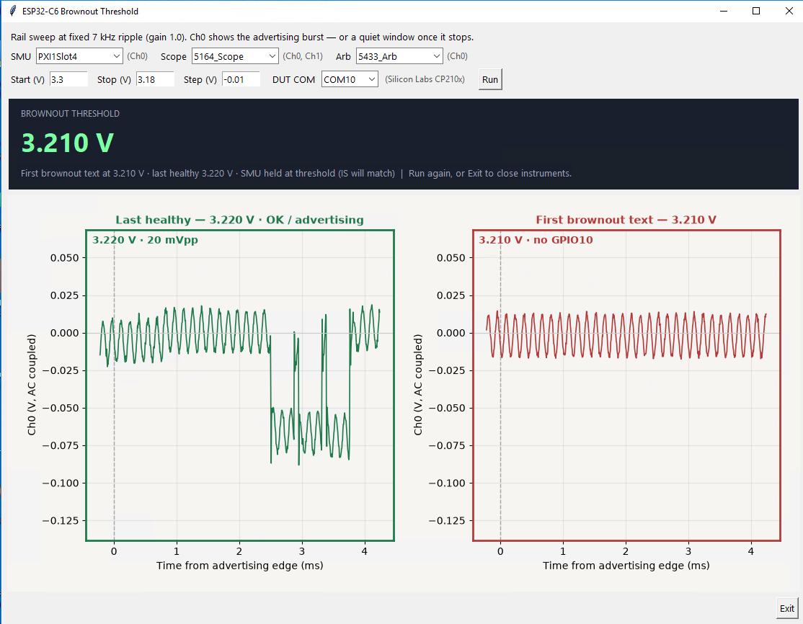
Demo A after a run: threshold 3.210 V. Left, the last healthy capture at 3.220 V with the advertising droop on the ripple. Right, the first brownout capture at 3.210 V, ripple only.
Demo B: Rail droop statistics (C#)
Measures the rail droop of each BLE advertising event over repeated trials and reports how consistently it stays within a droop limit. It holds the rail at a fixed 3.50 V with the scope AC coupled (20 MHz bandwidth). Each trial captures one advertising event (three ADV_IND packets, with no wait for scan requests), triggered by the GPIO10 pulse from the beacon_triggered firmware. The default run is 25 trials against a 140 mV peak-droop limit. Like Demo A, it finds the instruments and the DUT's COM port itself and does not need InstrumentStudio open.
- Latest event plot: the change in rail voltage from the quiet baseline against time from GPIO10, with the 140 mV limit, the GPIO10 edge and the end of each ADV_IND packet marked.
- Peak droop per trial: one point per trial against the limit line.
- Peak droop histogram and summary: trials passed, whether each trial saw the expected three ADV_IND packets, and the peak droop mean, standard deviation, minimum, maximum and Cpk, where Cpk = (limit − mean) / (3 × stdev). The summary also reports the burst-active width, from the first to the last ADV_IND packet.
In the example run below, all 25 trials passed, with a mean peak droop of 93.0 mV (stdev 0.8 mV, range 91.5 to 94.7 mV) and a Cpk of 18.57. Results will vary from setup to setup.
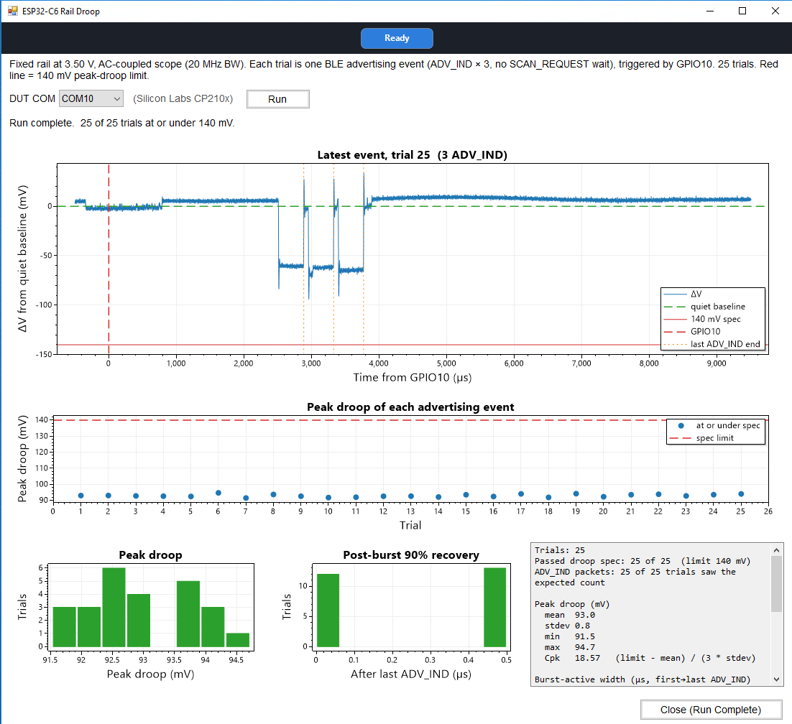
Demo B after a 25-trial run: all trials under the 140 mV limit, mean peak droop 93.0 mV, Cpk 18.57.

10. Troubleshooting and known issues
Symptom | Likely cause | Fix
bootloader.bin is not an ESP32-C6 image or "Expected 13 but value was 0" | Project built for another chip | idf.py set-target esp32c6, then rebuild
pip install idf-monitor fails | Wrong package name | pip install esp-idf-monitor
idf-monitor not recognized | Script folder not on PATH | python -m esp_idf_monitor ... (Section 4)
ESP-IDF terminal reports missing Python virtual environment | Environment not recreated on this machine | Re-run the EIM installation
esptool "No serial data received" | Wrong COM port, SMU power to the rail is not enabled, charge-only cable | Check that the batch file uses the port shown for Silicon Labs CP210x in Device Manager, try another data cable, then hold BOOT while tapping RESET and retry
Old firmware still runs after a fix | Batch file flashed a stale copied build folder | Rebuild, then replace the build folder in the package
SMU raise-voltage step has no effect in brownout | SMU waiting on a trigger the DUT no longer produces | Set the SMU trigger to Immediate (Section 8.2)
Readout jumps, DUT cannot leave brownout | Gain bandwidth too high (200 kHz) | Return to 20 to 50 kHz and power-cycle
Rare single-sample spike on CH1 | Probe pickup near GPIO10 | 330 Ω resistor in series at GPIO10
SMU over-range or clamped current | Current limit too low for the ripple path | Raise the limit to 1 A, turn the arb off, and power-cycle the output
Controller SMB TRIG (/<hostname>/TRIG_SMB) missing as a trigger source in InstrumentStudio, although MAX looks healthy. Seen after a Platform Services update and reboot, on several controllers at one site | MAX configuration data | Reset the MAX configuration database (in MAX, Tools » Reset Configuration Data). This consistently restored the trigger source. Exercise 4 depends on it, because the scope triggers from SMB TRIG and the arb is triggered through the scope

Appendix A: Quick reference
Item | Value
DUT supply range (ESP32-C6-WROOM-1) | 3.0 to 3.6 V
Available Brownout Threshold levels | 3.27, 3.10, 2.92, 2.76, 2.64, 2.51 V
Shunt | 0.1 Ω (10 mV per 100 mA)
SMU current limit for ripple tests | 1 A
SourceAdapt voltage gain bandwidth | 20 kHz default, 50-100 kHz stable, avoid 200 kHz
esptool command | esptool.exe --chip esp32c6 -p COMx -b 460800 write_flash @flash_args
Serial monitor | python -m esp_idf_monitor -p COMx -b 115200 --target esp32c6
Build commands | See Appendix B.3 (never run set-target on a provided project)
Wiring drawing | Section 3.2 (v5)
Documentation to-do before release
- Update the batch files so the monitor line reads python -m esp_idf_monitor.
- Re-copy the rebuilt build folders for both beacon projects into the repo's PXI_Training folder.

Appendix B: Advanced setup (modifying and rebuilding firmware)

B.1 When you need this
Never for running the session. The prebuilt images in PXI_Training cover all four exercises, and a station that only flashes them needs none of this appendix (Section 4). Use it only to change a provided image or to build different firmware. The complete ESP-IDF projects are in the repo's firmware folder; Section 4 lists which project builds which image.

B.2 Install ESP-IDF with EIM
ESP-IDF (Espressif IoT Development Framework) is Espressif's SDK for the ESP32 family: the libraries, compiler toolchain and the idf.py build and flash tool. Install it with Espressif's EIM (ESP-IDF Installation Manager) GUI on the machine where firmware will be changed. Espressif's instructions: Windows setup, online installation using the EIM GUI. The provided projects were built with ESP-IDF v6.0.2.
- Download EIM from Espressif's download page, or run winget install Espressif.EIM for the GUI.
- Open EIM, choose New Installation, then Start Installation. EIM checks for Git and Python and offers to install whatever is missing (ESP-IDF needs Python 3.10 or newer).
- Choose Easy Installation for the latest stable ESP-IDF with default settings, or Custom Installation to pick a version or install path.
- On the Ready to Install page, click Start Installation and wait for Installation Complete.
- If it fails, open the Logs view, fix what it reports, and click Try Again.
EIM saves an eim_config.toml in the install directory, which can be reused to install the same setup on another PC.

B.3 Working in the ESP-IDF terminal
Run every idf.py command in the ESP-IDF terminal that EIM sets up, not a plain PowerShell or Command Prompt window (Espressif's "Build Your First Project" section shows how to open it). When it is ready, the prompt starts with (venv) and the window prints "You can now use IDF commands and Python tools." Change to the project's top folder, the one that holds sdkconfig and CMakeLists.txt, before running a command.
Command | What it does | Notes
idf.py --version | Shows the ESP-IDF version | The provided projects use v6.0.2
idf.py menuconfig | Opens the project configuration menu and saves changes to sdkconfig | Arrow keys move, Enter opens a menu, / searches for a setting by name, S saves, Q quits
idf.py build | Builds the project into its build folder | The first build after a project is copied or moved rebuilds fully and takes a few minutes
idf.py -p COMx flash | Flashes the current build directly | Handy while developing; the session itself uses the batch files
idf.py -p COMx monitor | Opens the serial monitor | Exit with Ctrl+]
idf.py -p COMx flash monitor | Flashes, then opens the monitor
idf.py fullclean | Deletes the build output | Same as deleting the build folder; forces a clean rebuild
idf.py set-target esp32c6 | Sets the chip for a brand-new project | Regenerates sdkconfig from defaults, erasing all menuconfig settings. Never run it on a provided project
If the terminal reports a missing ESP-IDF Python virtual environment, re-run the EIM installation to recreate it.

B.4 Modifying a provided project
- Copy the project from the repo's firmware folder to a short path with no spaces.
- Open the ESP-IDF terminal and change to the project's top folder.
- Edit the source, or change settings with idf.py menuconfig (B.5).
- Run idf.py build. Do not run set-target; the provided projects are already set up for esp32c6.
- Optionally test with idf.py -p COMx flash monitor.
- Copy the new build folder over the matching one under C:\PXI_Training\exercises\ (for example beacon_triggered\build). The batch files flash that copy, so an old copy keeps running the old firmware. To share the change, also update the matching folder under PXI_Training in the repo.
For a brand-new project, run idf.py set-target esp32c6 once before the first build. If a build or flash reports a wrong-target image ("not an ESP32-C6 image"), the project was built for another chip, usually a new project that skipped set-target; set the target and rebuild, which resets sdkconfig.

B.5 Exercise 4 firmware settings (menuconfig)
The NimBLE_Beacon_triggered project, which builds the beacon_triggered image used in Exercise 4, changes two settings from the ESP-IDF defaults. Menu labels can shift between ESP-IDF versions, so confirm each one by its sdkconfig key, or press / in menuconfig and search for the key without the CONFIG_ prefix.
Setting | menuconfig location | sdkconfig key | Value used
Brownout detector level | Component config → Hardware Settings → Power Supplier → Brownout Detector | CONFIG_ESP_BROWNOUT_DET_LVL_SEL_3 | Level 3, about 3.10 V
NimBLE host log level | Component config → Bluetooth → NimBLE Options → Debugging/Testing | CONFIG_BT_NIMBLE_LOG_LEVEL_WARNING | Warning, so the monitor shows warnings and the brownout message instead of constant BLE stack output
The brownout levels available on the ESP32-C6 are listed in Appendix A. The global default log level (CONFIG_LOG_DEFAULT_LEVEL) and the bootloader log level stay at their default, Info. After changing a setting, save, rebuild, and copy the build folder as in B.4.

