MODULE2: Identity verification
Project Architecture
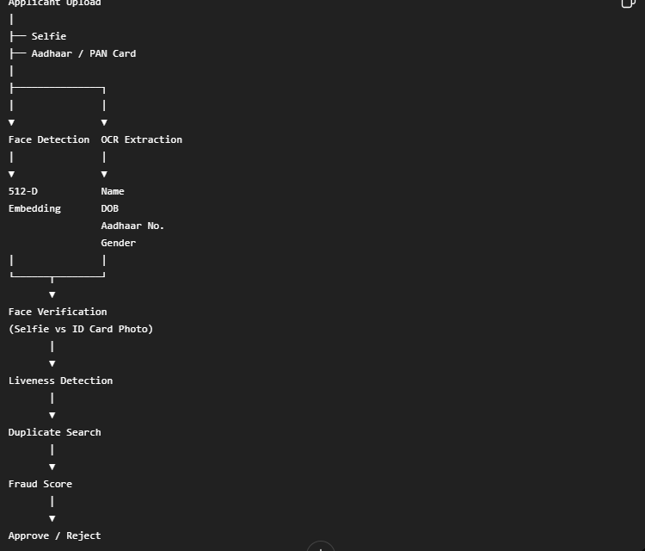
MODULE2 Architecture:
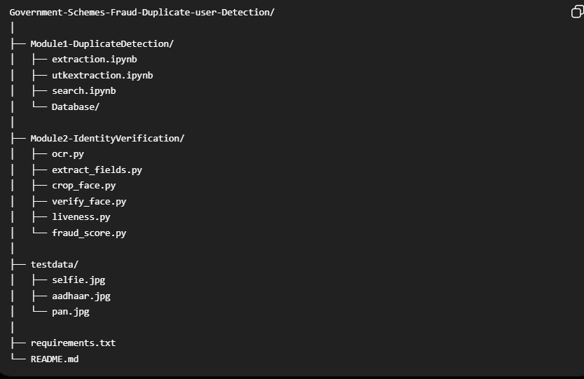
OCR
Optical Character Recognition (OCR) is used in this module to automatically extract textual information from uploaded government identity documents such as Aadhaar cards, PAN cards, voter IDs, or driving licenses. The system uses PaddleOCR to detect text regions in the document image, recognize the text, and convert it into machine-readable format. The extracted text is then processed to identify important fields such as the applicant's name, date of birth, gender, and identification number. Finally, the extracted information is validated and organized into a structured JSON format, which can be used by subsequent modules for identity verification, duplicate detection, and fraud analysis.

Face verification
Face Verification is a crucial step in the identity verification process that ensures the applicant uploading a government document is the same person shown in the document's photograph. In this module, InsightFace (buffalo_l) is used to detect the face from both the applicant's selfie and the uploaded identity document, and generate a 512-dimensional facial embedding for each image. The similarity between these embeddings is then computed using cosine similarity. If the similarity score is greater than a predefined threshold, the system confirms that both images belong to the same individual; otherwise, the identity verification fails. This step helps prevent identity fraud, impersonation, and the use of stolen or forged government documents before proceeding to duplicate detection and further fraud analysis
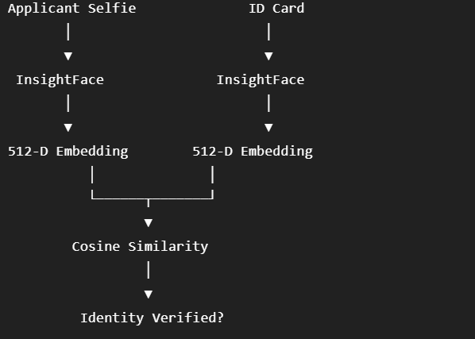

LIVENESS DETECTION
Liveness Detection is a security step that determines whether the uploaded face belongs to a real, live person or is an attempt to deceive the system using a printed photograph, a mobile screen replay, a screenshot, or other spoofing methods. It analyzes facial characteristics and image features to classify the input as Live or Spoof. In the Government Scheme Fraud Detection System, liveness detection helps prevent fraudulent applicants from bypassing face verification by using someone else's photograph, ensuring that only genuine users proceed to the next stages of verification.
