Exercise 1: Control Structures

Scenario 1: The bank wants to apply a discount to loan interest rates for customers above 60 years old.
Question: Write a PL/SQL block that loops through all customers, checks their age, and if they are above 60, apply a 1% discount to their current loan interest rates.
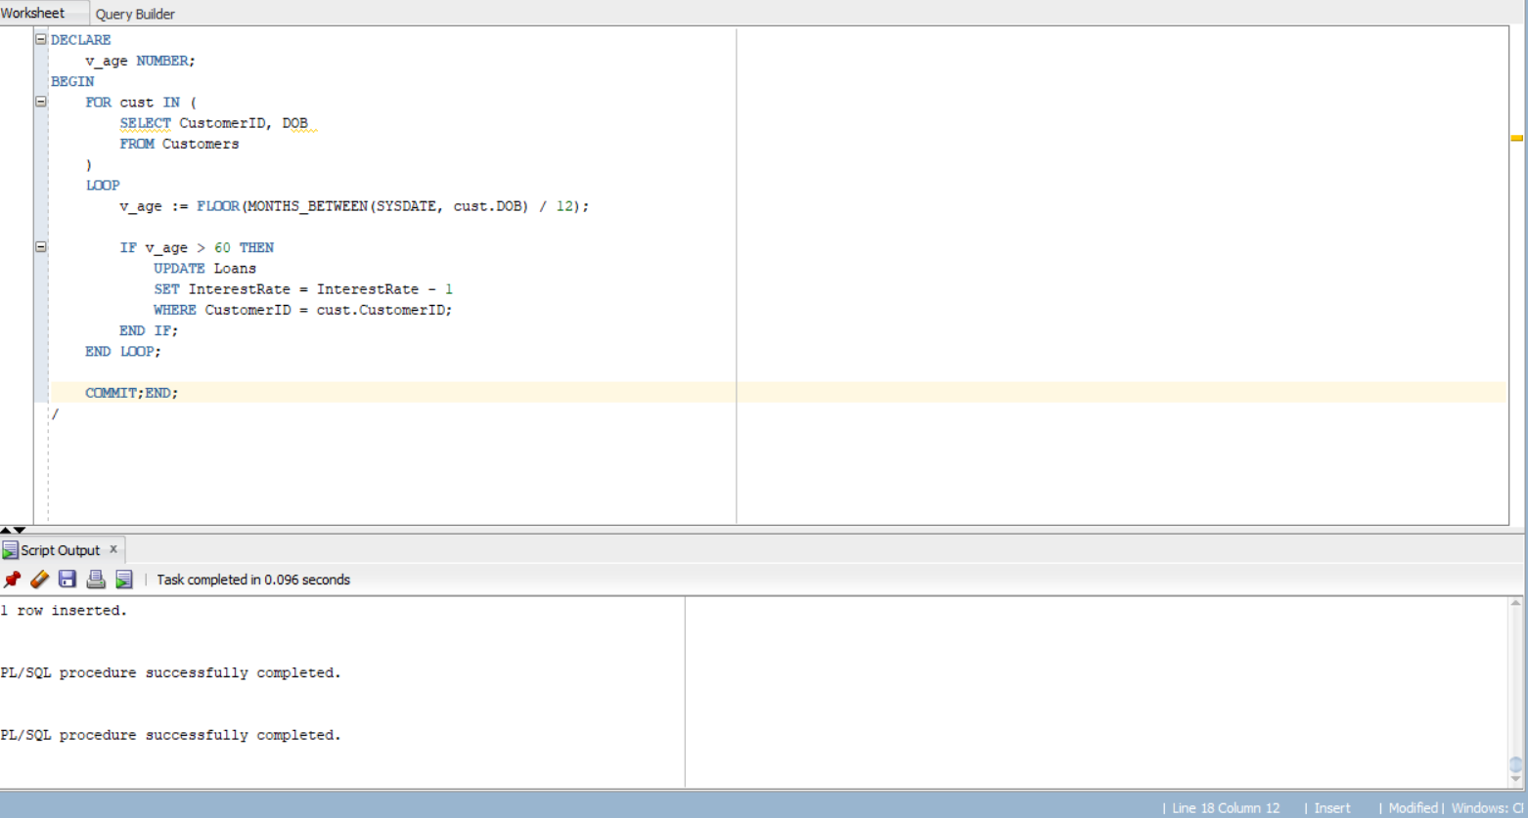

Scenario 2: A customer can be promoted to VIP status based on their balance.
Question: Write a PL/SQL block that iterates through all customers and sets a flag IsVIP to TRUE for those with a balance over $10,000.

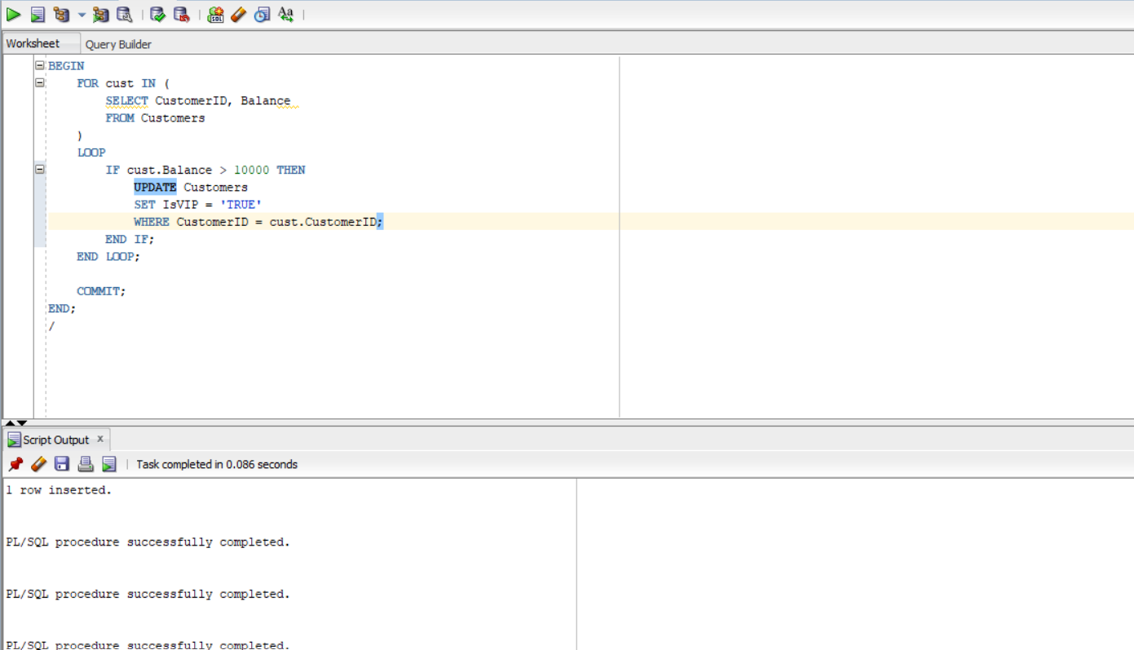

Scenario 3: The bank wants to send reminders to customers whose loans are due within the next 30 days.
Question: Write a PL/SQL block that fetches all loans due in the next 30 days and prints a reminder message for each customer.
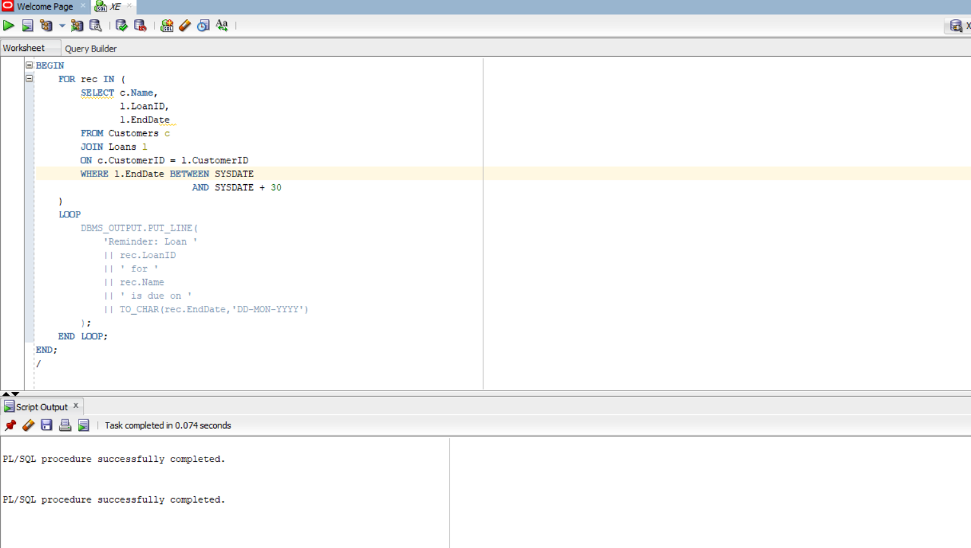

Exercise 2: Error Handling
Scenario 1: Handle exceptions during fund transfers between accounts.
Question: Write a stored procedure SafeTransferFunds that transfers funds between two accounts. Ensure that if any error occurs (e.g., insufficient funds), an appropriate error message is logged and the transaction is rolled back.
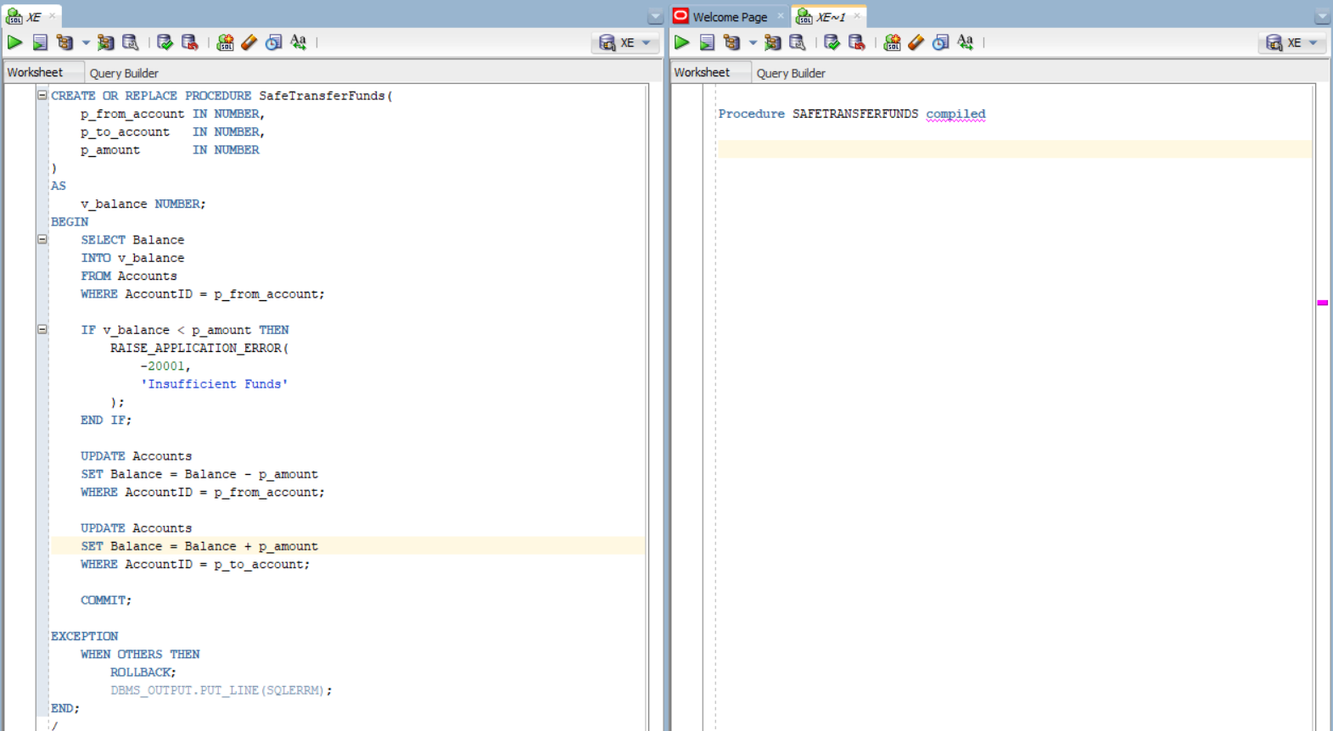
Scenario 2: Manage errors when updating employee salaries.
Question: Write a stored procedure UpdateSalary that increases the salary of an employee by a given percentage. If the employee ID does not exist, handle the exception and log an error message.
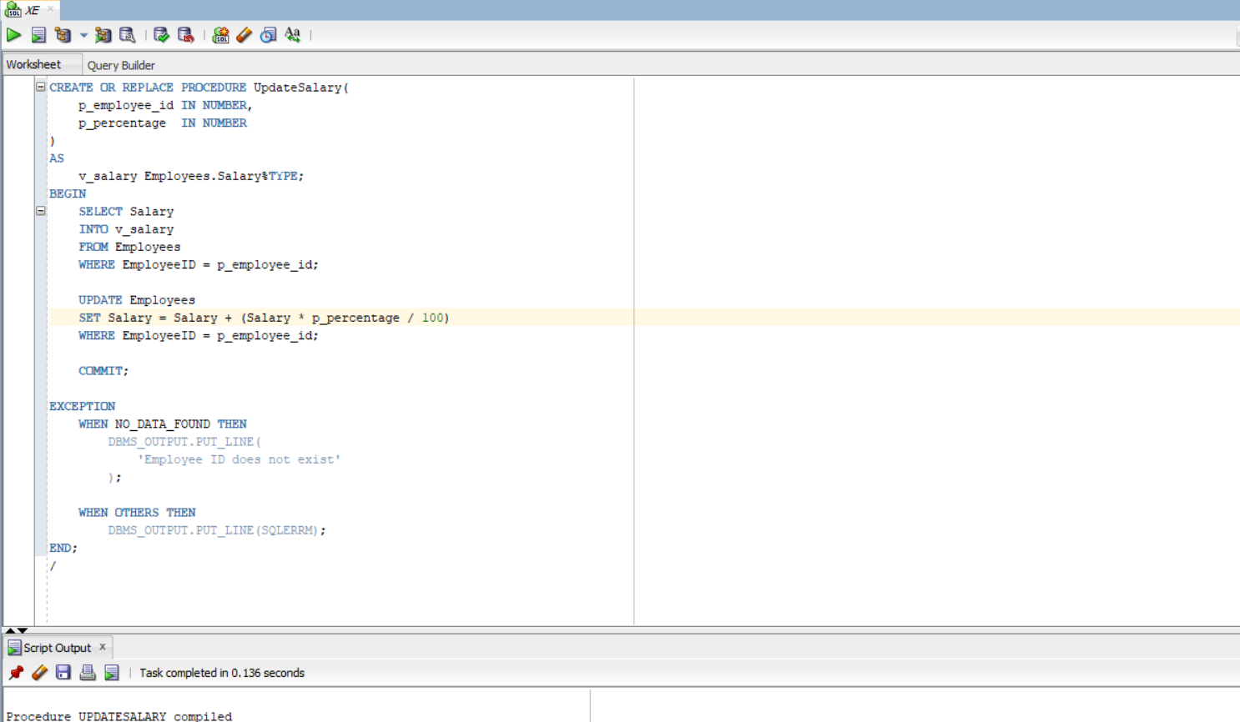
Question 3: Write a stored procedure AddNewCustomer that inserts a new customer into the Customers table. If a customer with the same ID already exists, handle the exception by logging an error and preventing the insertion.
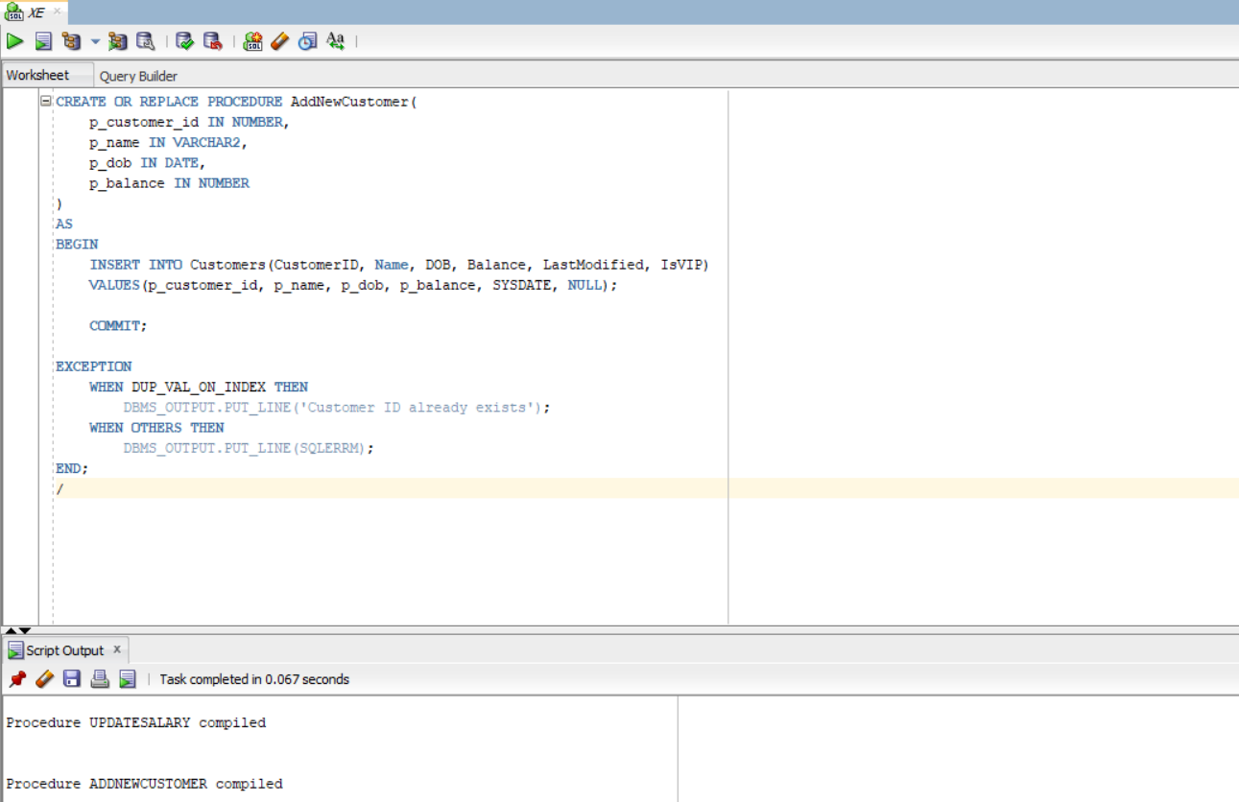
Exercise 3: Stored Procedures
Question: Write a stored procedure ProcessMonthlyInterest that calculates and updates the balance of all savings accounts by applying an interest rate of 1% to the current balance.
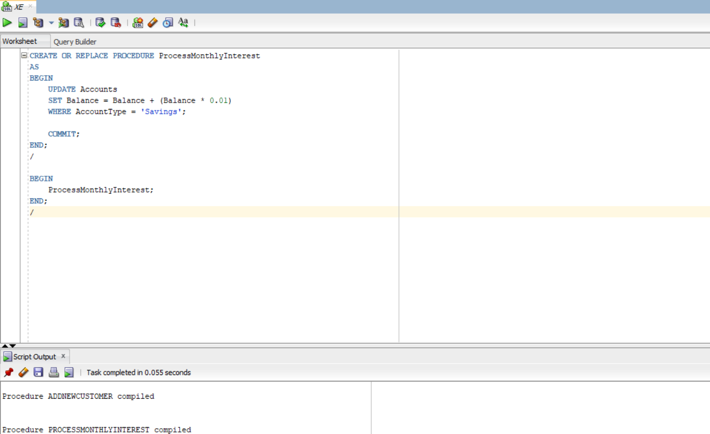
Question: Write a stored procedure UpdateEmployeeBonus that updates the salary of employees in a given department by adding a bonus percentage passed as a parameter.
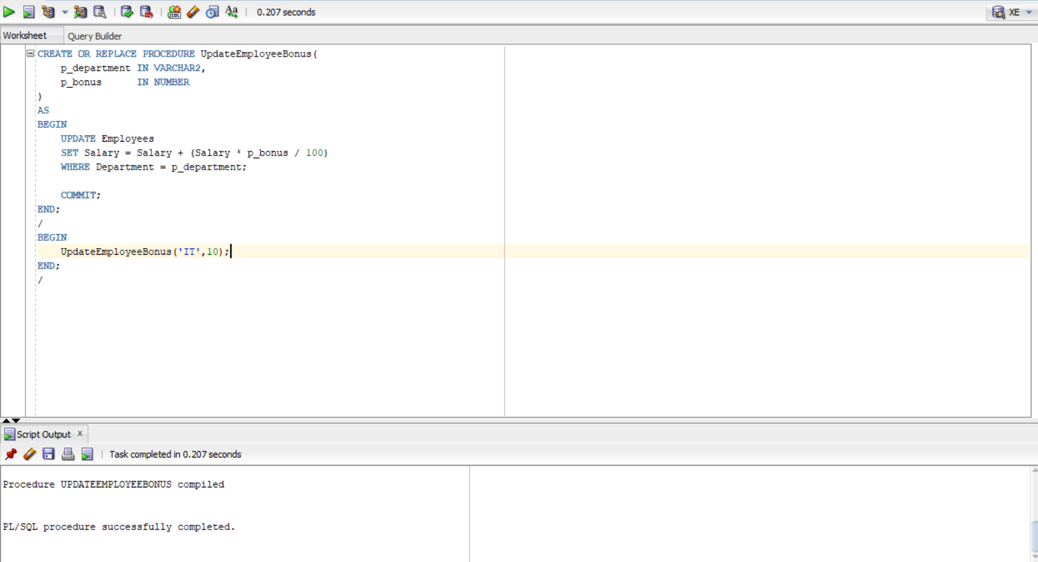

Question: Write a stored procedure TransferFunds that transfers a specified amount from one account to another, checking that the source account has sufficient balance before making the transfer.
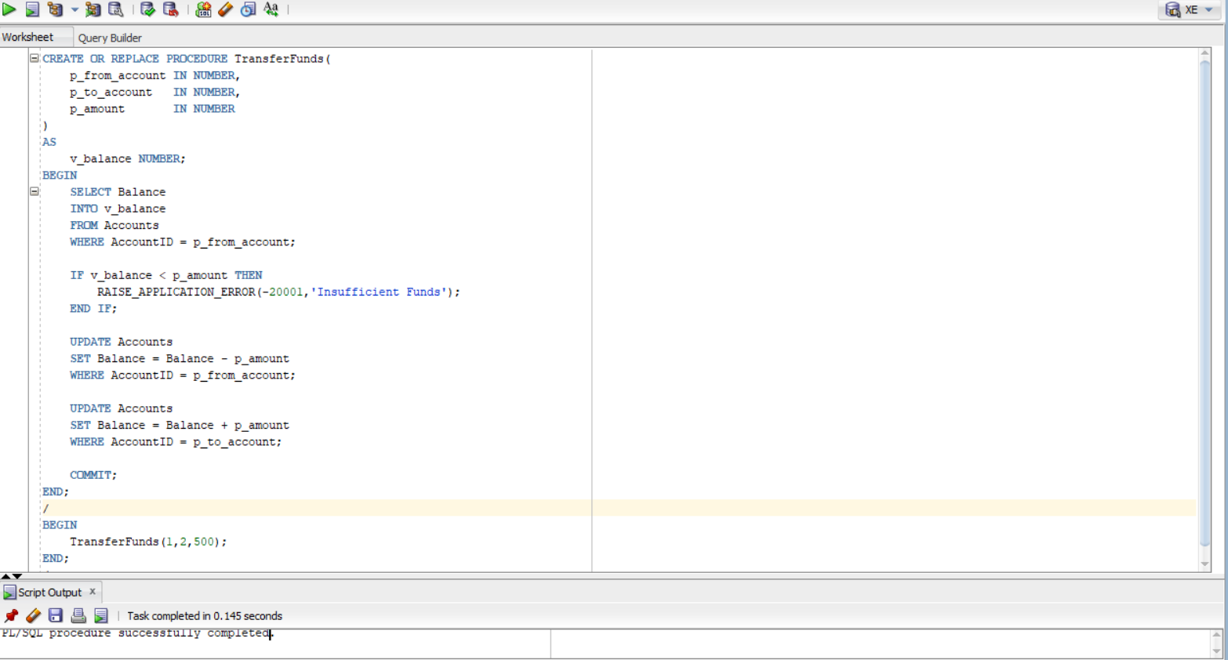

Exercise 4: Functions
Question: Write a function CalculateAge that takes a customer's date of birth as input and returns their age in years.
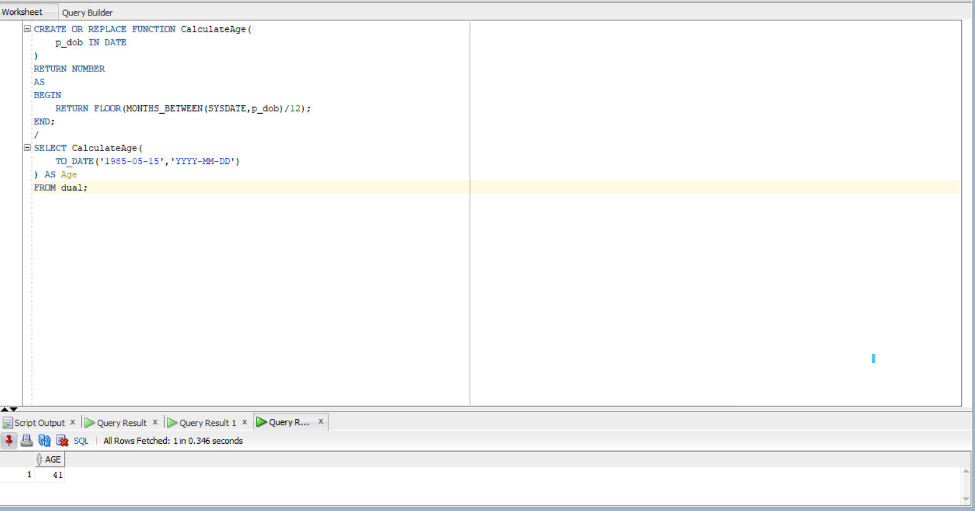
Question: Write a function CalculateMonthlyInstallment that takes the loan amount, interest rate, and loan duration in years as input and returns the monthly installment amount.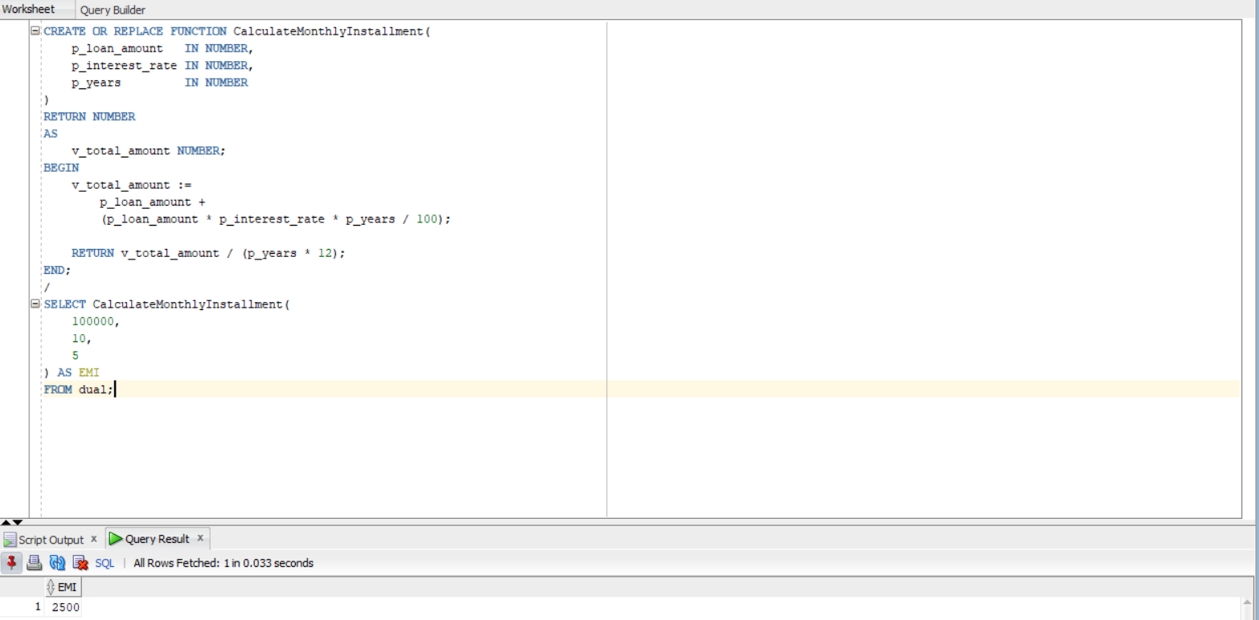

Question: Write a function HasSufficientBalance that takes an account ID and an amount as input and returns a boolean indicating whether the account has at least the specified amount.
