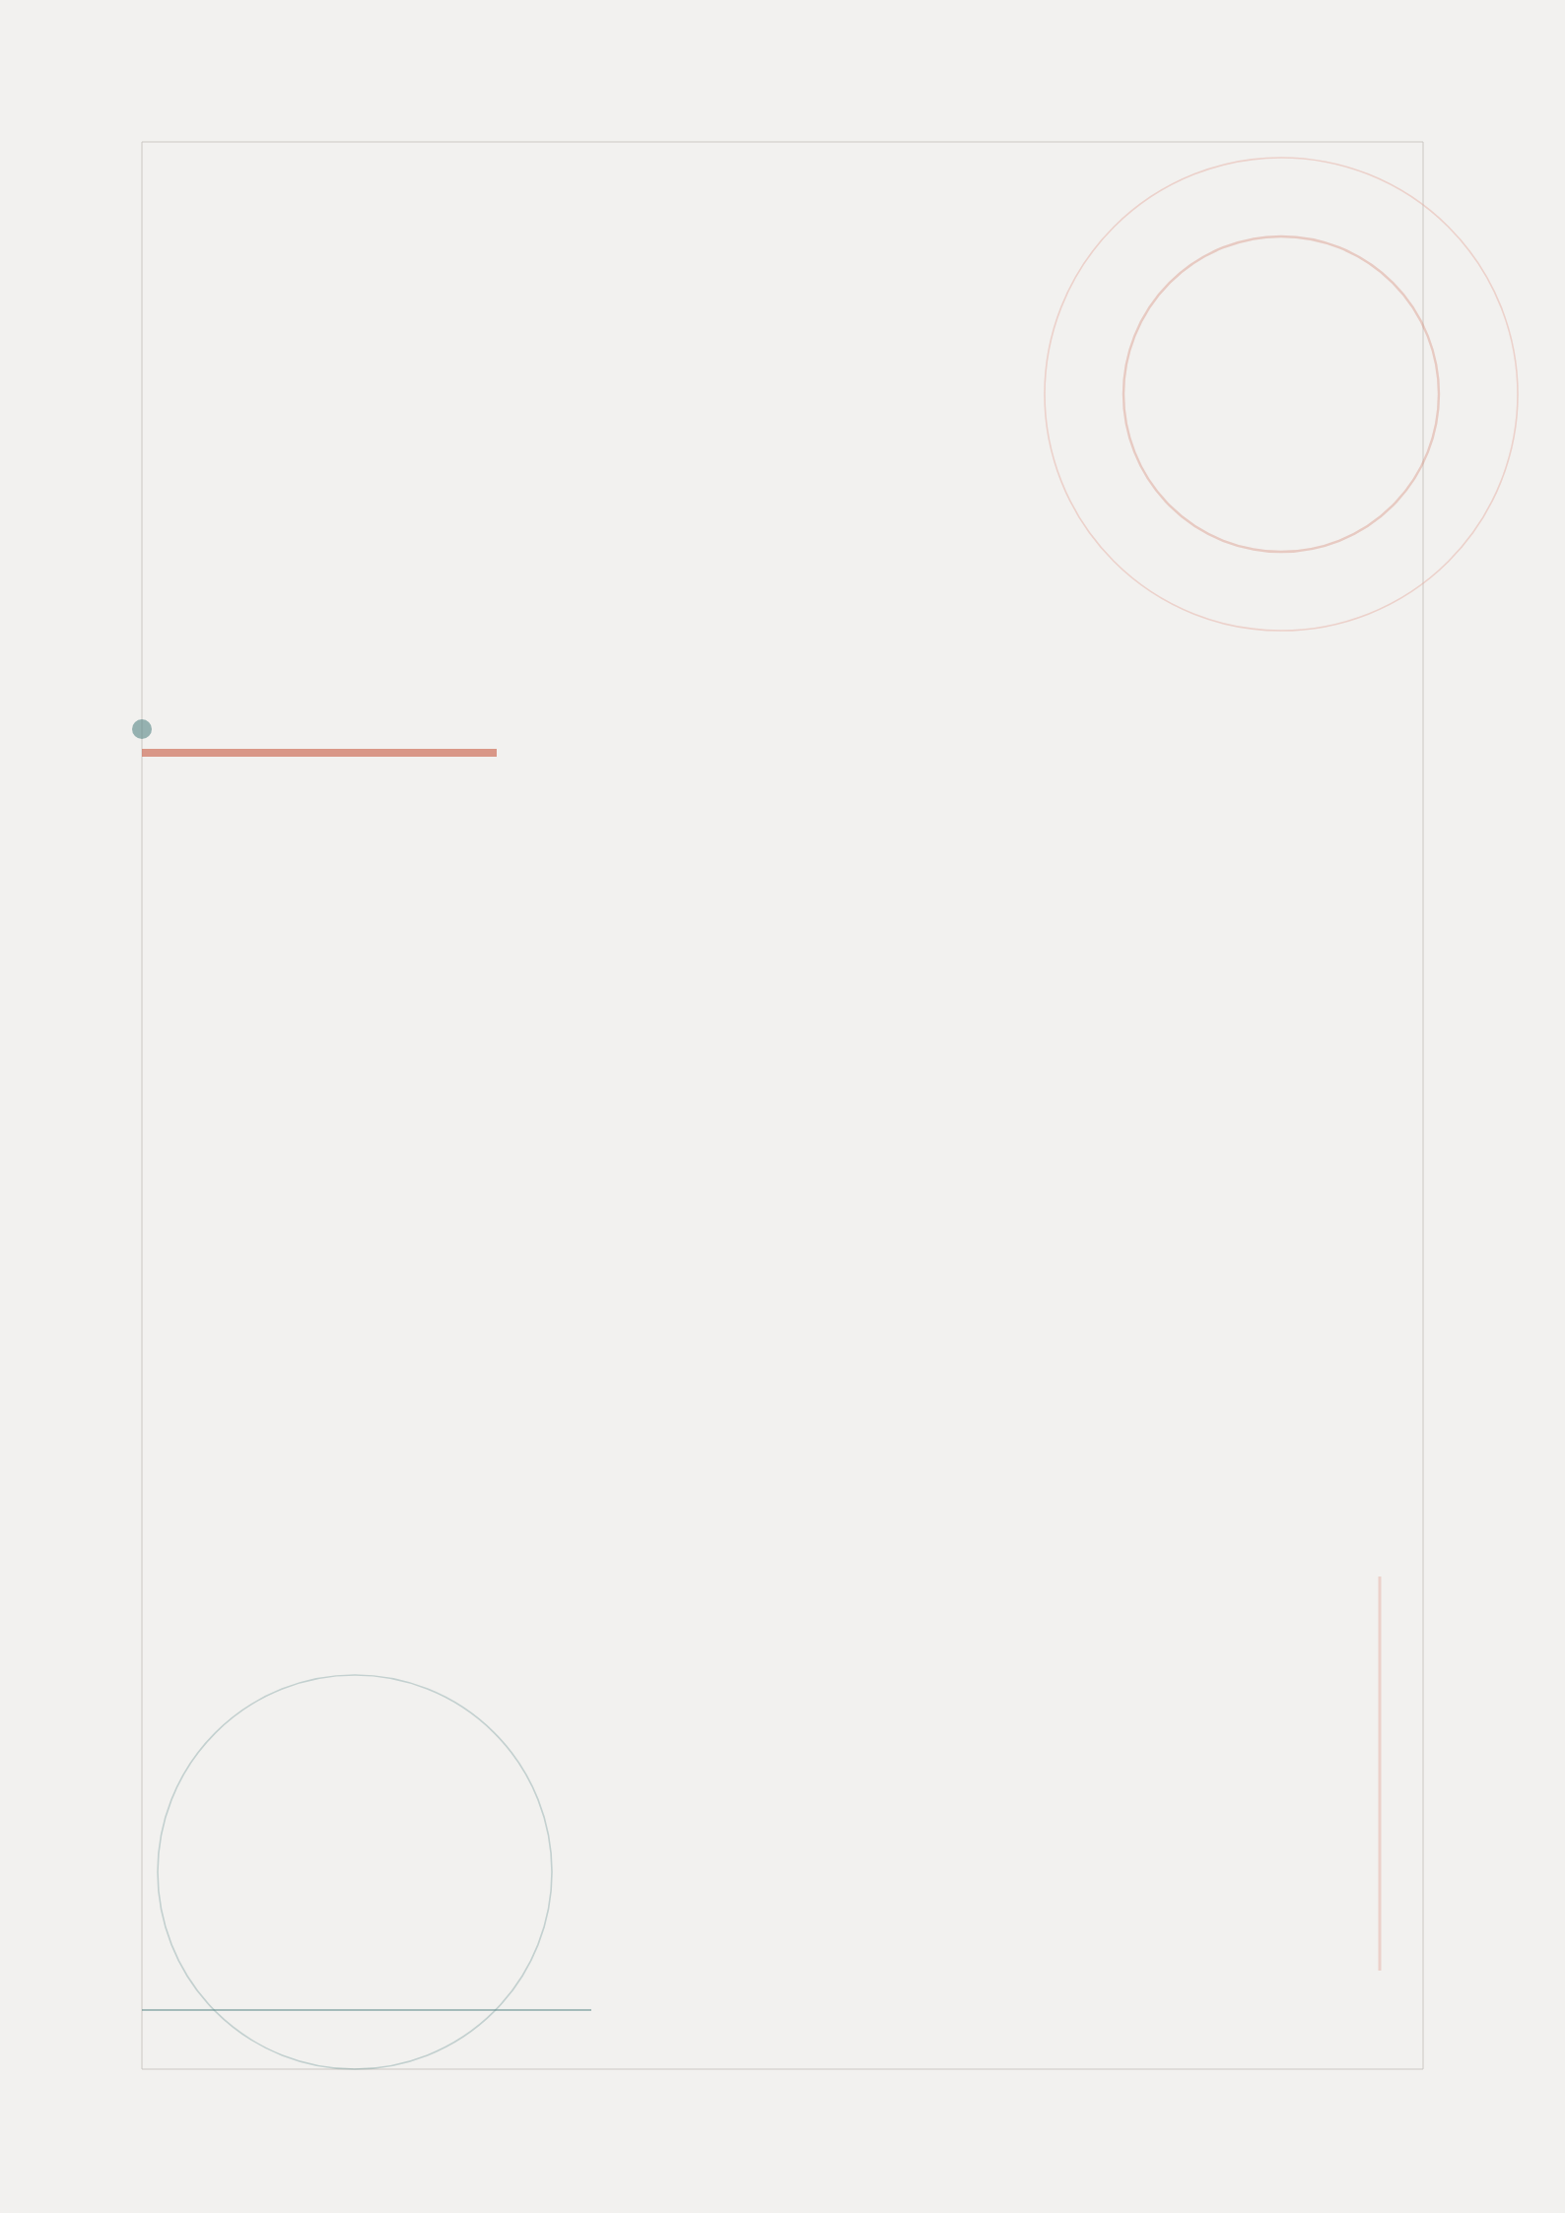

User Flows
FitTrack Mobile App
Mapping User Journeys Through the Application
FitTrack Design Team | May 2026

Table of Contents
Right-click and select "Update Field" to refresh page numbers

Introduction to User Flows 3
App Navigation Overview 4
Onboarding & Authentication Flow 5
Workout Session Flow 7
Progress Tracking Flow 9
Flow Design Principles 10

Introduction to User Flows
User flows map the complete journey a user takes through the FitTrack application to accomplish specific goals. These flows serve as the blueprint for wireframing, ensuring every screen and interaction is purposeful and aligned with user needs.
The following user flows have been designed based on insights from our user research and persona development. Each flow prioritizes simplicity, speed, and clarity to minimize friction and maximize user engagement.
Key principles guiding our flow design include:
• Reduce steps: Minimize the number of taps required to reach any primary goal
• Clear wayfinding: Every screen clearly indicates where the user is and how to proceed
• Graceful handling: Error states and edge cases are anticipated and designed for
• Contextual awareness: The app adapts based on user history and current context

App Navigation Overview
The overall app navigation follows a bottom-tab pattern with four primary sections: Home (Dashboard), Workouts, Progress, and Profile. This structure was chosen based on competitive analysis and user expectations for fitness apps.
The following diagram illustrates the high-level navigation architecture and key decision points throughout the application:
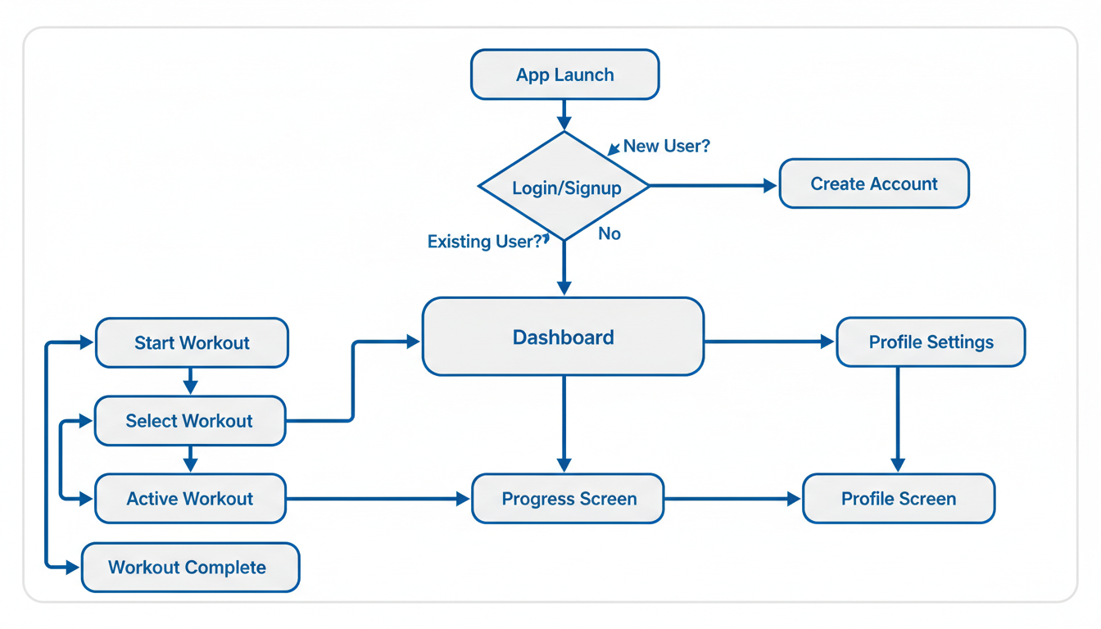
Figure 1: FitTrack App Navigation Overview
From the Dashboard, users can initiate their most common tasks: starting a workout, checking progress, or accessing their profile. The navigation is designed to keep primary actions within two taps from any screen.

Onboarding & Authentication Flow
The onboarding flow is critical for first-time user retention. Research shows that 60% of users abandon apps during onboarding if the process is too lengthy or complex. FitTrack's onboarding is designed to be quick, informative, and motivating.
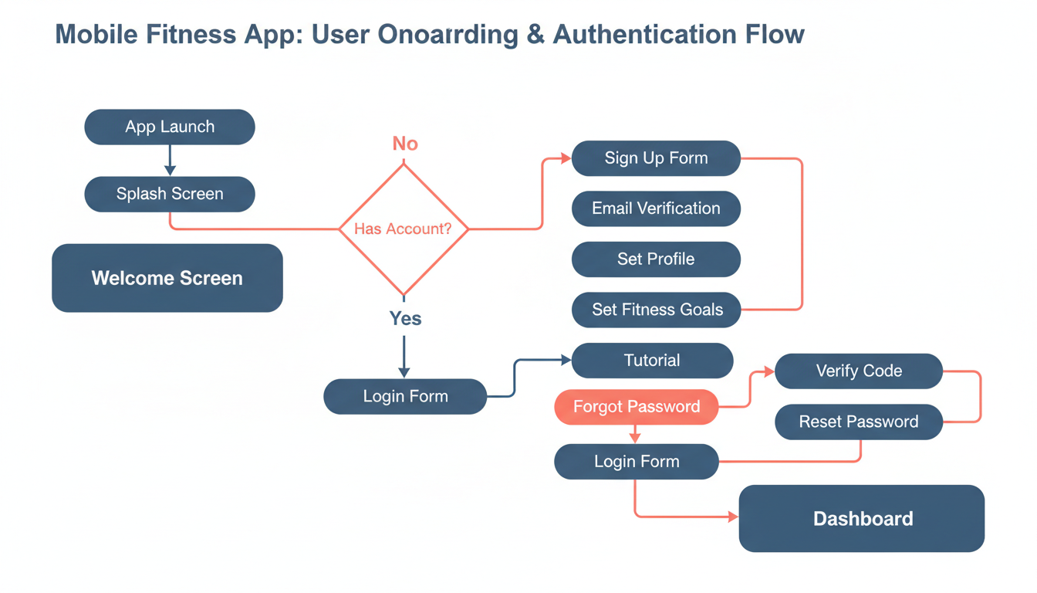
Figure 2: Onboarding & Authentication User Flow

Flow Description
When a user first launches the app, they are greeted with a welcome screen that highlights key features through a brief carousel. From there, the flow branches based on whether the user has an existing account.
New users proceed through account creation, email verification, profile setup (height, weight, fitness level), and goal setting. The entire onboarding process is designed to complete in under 3 minutes.
Existing users can log in via email/password or use biometric authentication (Face ID / fingerprint). A "Forgot Password" flow is available with email verification and reset capability.
Step | Screen | User Action | System Response
1 | App Launch | User opens FitTrack for the first time | Splash screen with branding
2 | Welcome Screen | User views feature highlights | 3-slide carousel with skip option
3 | Account Check | System checks for existing account | Branch to login or signup
4 | Profile Setup | New user enters basic information | Height, weight, birth date, fitness level
5 | Goal Setting | User defines fitness objectives | Weight goal, workout frequency, preferred activities
6 | Dashboard | User reaches main app screen | Personalized dashboard with recommendations

Workout Session Flow
The workout flow is the most critical user journey in FitTrack. Research indicates that users who complete a workout within their first 48 hours are 4x more likely to become long-term users. This flow prioritizes speed and simplicity.
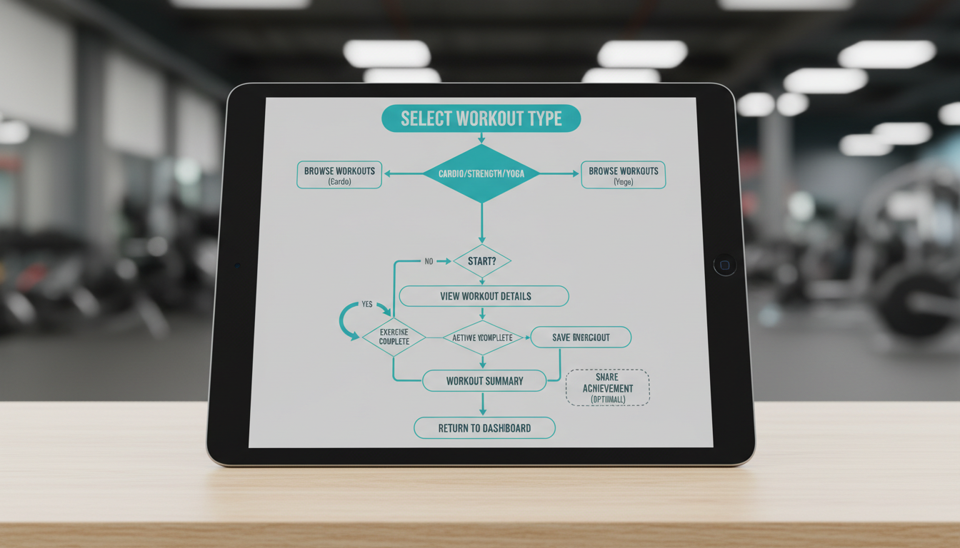
Figure 3: Workout Session User Flow

Flow Description
Users can start a workout from multiple entry points: the "Quick Start" button on the dashboard, browsing the workout catalog, or selecting from their favorites. This redundancy ensures users can always find their preferred path.
During an active workout, the interface is intentionally minimal to prevent distraction. Large timer displays, simple swipe gestures for exercise navigation, and voice prompts keep users focused on their workout rather than the screen.
Upon workout completion, users see a summary screen with key metrics and the option to share their achievement. The workout is automatically saved to their history.
Step | Screen | User Action | System Response
1 | Select Workout | User chooses a workout to perform | Browse catalog, quick start, or favorites
2 | Workout Preview | User reviews workout details | Exercises, duration, equipment needed
3 | Start Workout | User begins the session | Countdown timer with audio cues
4 | Active Exercise | User performs each exercise | Timer, rep counter, form guidance
5 | Rest Period | Brief rest between exercises | Auto-timed rest with skip option
6 | Workout Complete | User finishes all exercises | Summary with metrics and celebration

Progress Tracking Flow
The progress tracking flow allows users to monitor their fitness journey over time. This feature is crucial for long-term retention, as visual progress is the #1 motivator identified in our research.
Users can access progress data from the Progress tab or through contextual prompts after completing workouts. The flow includes:
• Weekly, monthly, and yearly trend views for all metrics
• Weight logging with photo progress tracking
• Achievement badges and milestone celebrations
• Personal record tracking for key exercises
• Export capabilities for data portability

Flow Design Principles
All user flows in FitTrack adhere to the following design principles:
Principle | Application
Three-Tap Rule | Any primary goal achievable within 3 taps from the home screen
Progressive Disclosure | Show essential information first, details available on demand
Context Preservation | Maintain user context when navigating between screens
Error Prevention | Design flows that prevent errors before they occur
Graceful Recovery | Provide clear paths forward when errors do occur
Accessibility First | All flows designed for screen readers and assistive technologies
These principles ensure that every user interaction is intentional, efficient, and aligned with user expectations established through our research phase.


FitTrack
Your Fitness Journey, Simplified
fittrack.app

