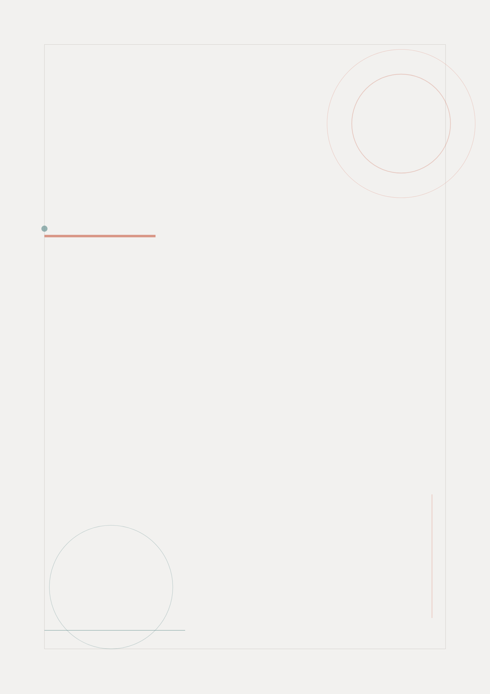

Design Thinking
Process
FitTrack Mobile App
From Empathy to Testing: Documenting the Design Journey
FitTrack Design Team | May 2026

Table of Contents
Right-click and select "Update Field" to refresh page numbers

Introduction to Design Thinking 3
Phase 1: Empathize 4
Research Activities 4
Key Insights 5
Phase 2: Define 6
Problem Statements 6
User Needs Definition 7
Phase 3: Ideate 8
Brainstorming Sessions 8
Feature Prioritization 9
Phase 4: Prototype 10
Low-Fidelity Wireframes 10
Phase 5: Test 11
Usability Testing Plan 11
Process Summary 12

Introduction to Design Thinking
Design Thinking is a human-centered approach to innovation that draws from the designer's toolkit to integrate the needs of people, the possibilities of technology, and the requirements for business success. This document outlines the Design Thinking process applied to the FitTrack mobile application.
The process follows the five-stage model developed at the Hasso Plattner Institute of Design at Stanford:
- Empathize - Understand the people who will use the product through observation and research
- Define - Synthesize research findings into a clear, actionable problem statement
- Ideate - Generate a wide range of creative solutions to the defined problem
- Prototype - Build tangible representations of selected ideas for testing
- Test - Evaluate prototypes with real users and iterate based on feedback
Each phase builds upon the previous, creating a continuous learning loop that drives the design toward genuine user needs.

Phase 1: Empathize
The Empathize phase focused on deeply understanding FitTrack's potential users. Through immersive research, the team stepped into users' shoes to uncover their true needs, frustrations, and desires.

Research Activities
Multiple research methods were employed to gather comprehensive user insights:
- User Interviews - 15 one-on-one interviews with fitness enthusiasts, beginners, and professionals to understand their fitness routines and app usage
- Contextual Inquiry - Observation of 5 users during their actual workouts to identify environmental factors and real-world constraints
- Competitive Analysis - Review of 8 existing fitness apps to identify market gaps and industry best practices
- Online Survey - Distribution of a detailed questionnaire to 50 respondents to validate qualitative findings with quantitative data
Phase Detail | Description
Phase | Empathize
Focus | Research & Discovery
Timeline | April 1-14, 2026

Key Insights
The research revealed several critical insights that shaped the entire design direction:
- Speed is Everything - Users abandon apps that take more than 3 taps to start a workout. The average user wants to begin exercising within 10 seconds of opening the app
- Visual Progress Drives Retention - Users who can see their progress visually (charts, streaks, badges) are 3x more likely to maintain long-term app usage
- Personalization Expectations - 78% of users expect the app to learn their preferences and adapt recommendations over time
- Social Accountability - Users with social connections in the app exercise 2.5x more frequently than isolated users

Phase 2: Define
In the Define phase, research findings were synthesized into clear, actionable problem statements. This stage transformed raw observations into focused design challenges.

Problem Statements
Three core problem statements were developed based on research insights:
User | Problem Statement
Fitness Beginners | Need a way to start workouts effortlessly because complex app navigation causes them to abandon fitness routines before forming habits
Regular Exercisers | Need clear progress visualization because vague feedback makes them question whether their efforts are producing results
Fitness Enthusiasts | Need personalized workout recommendations because generic programs don't match their specific goals and fitness levels

User Needs Definition
From the problem statements, the following user needs were prioritized:
- Efficiency Need - Users need to start workouts quickly without navigating through complex menus
- Motivation Need - Users need visual evidence of progress to maintain long-term engagement
- Personalization Need - Users need tailored workout recommendations that match their fitness level and goals
- Social Need - Users need ways to connect with friends for accountability and encouragement
Phase Detail | Description
Phase | Define
Focus | Synthesis & Problem Framing
Timeline | April 15-20, 2026

Phase 3: Ideate
The Ideate phase generated a wide range of creative solutions. Using structured brainstorming techniques, the team explored possibilities without constraints before converging on the most promising ideas.

Brainstorming Sessions
Three structured brainstorming sessions were conducted:
- Session 1: Onboarding Solutions - Generated 24 ideas for simplifying the first-time user experience, including guided tutorials, progressive disclosure, and smart defaults
- Session 2: Workout Experience - Produced 31 concepts for the workout flow, including voice commands, gesture controls, and adaptive rest timers
- Session 3: Retention Strategies - Developed 19 ideas for keeping users engaged, including achievement systems, social challenges, and AI-powered coaching

Feature Prioritization
Ideas were evaluated using an Impact vs. Effort matrix. High-impact, low-effort features were prioritized for the initial wireframes:
Feature | Impact | Effort | Priority
Quick Start Workout | High | Low | Must-have - P0
Progress Dashboard | High | Medium | Must-have - P0
Achievement Badges | High | Low | Must-have - P0
Workout Catalog | High | Medium | Must-have - P0
Social Sharing | Medium | High | Should-have - P1
AI Recommendations | High | High | Should-have - P1
Offline Mode | Medium | High | Could-have - P2
Phase Detail | Description
Phase | Ideate
Focus | Brainstorming & Prioritization
Timeline | April 21-25, 2026

Phase 4: Prototype
The Prototype phase transformed selected ideas into tangible, testable artifacts. Low-fidelity wireframes were chosen to enable rapid iteration while keeping the focus on structure and flow rather than visual polish.

Low-Fidelity Wireframes
Six key screens were wireframed to cover the primary user journeys:
• Login & Authentication - First impression and account access
• Dashboard - Central hub with quick actions and summary data
• Workout Catalog - Browse and discover workout content
• Active Workout - In-session tracking interface
• Progress Tracking - Visual progress and achievements
• User Profile - Settings, history, and personal data
The wireframes use a hand-drawn sketch style to signal that these are works-in-progress, encouraging feedback and iteration. Annotations highlight key interaction points and design rationale.
Phase Detail | Description
Phase | Prototype
Focus | Wireframing & Documentation
Timeline | April 26 - May 5, 2026

Phase 5: Test
The Test phase validates design decisions through real user feedback. Usability testing with wireframes catches fundamental issues early, before resources are invested in high-fidelity design and development.

Usability Testing Plan
A structured usability testing plan was developed:
Aspect | Details
Participants | 8 users (3 beginners, 3 intermediate, 2 advanced)
Method | Task-based usability testing with think-aloud protocol
Tasks | Account creation, workout start, progress review, profile setup
Metrics | Task success rate, time-on-task, error rate, SUS score
Deliverable | Usability report with prioritized recommendations
Phase Detail | Description
Phase | Test
Focus | Usability Testing & Iteration
Timeline | May 6-15, 2026

Process Summary
The Design Thinking process for FitTrack has been a journey from deep user understanding to tangible design solutions. Key outcomes include:
- User-Centered Foundation - All design decisions are grounded in real user research, not assumptions
- Clear Problem Definition - Three focused problem statements guide the entire design direction
- Prioritized Feature Set - Ideas systematically evaluated and ranked by impact and feasibility
- Testable Prototypes - Low-fidelity wireframes ready for usability validation
- Iterative Mindset - Process designed for continuous learning and improvement
The next phase involves conducting usability tests with these wireframes, gathering feedback, and iterating toward high-fidelity designs and eventual development.


FitTrack
Your Fitness Journey, Simplified
fittrack.app

