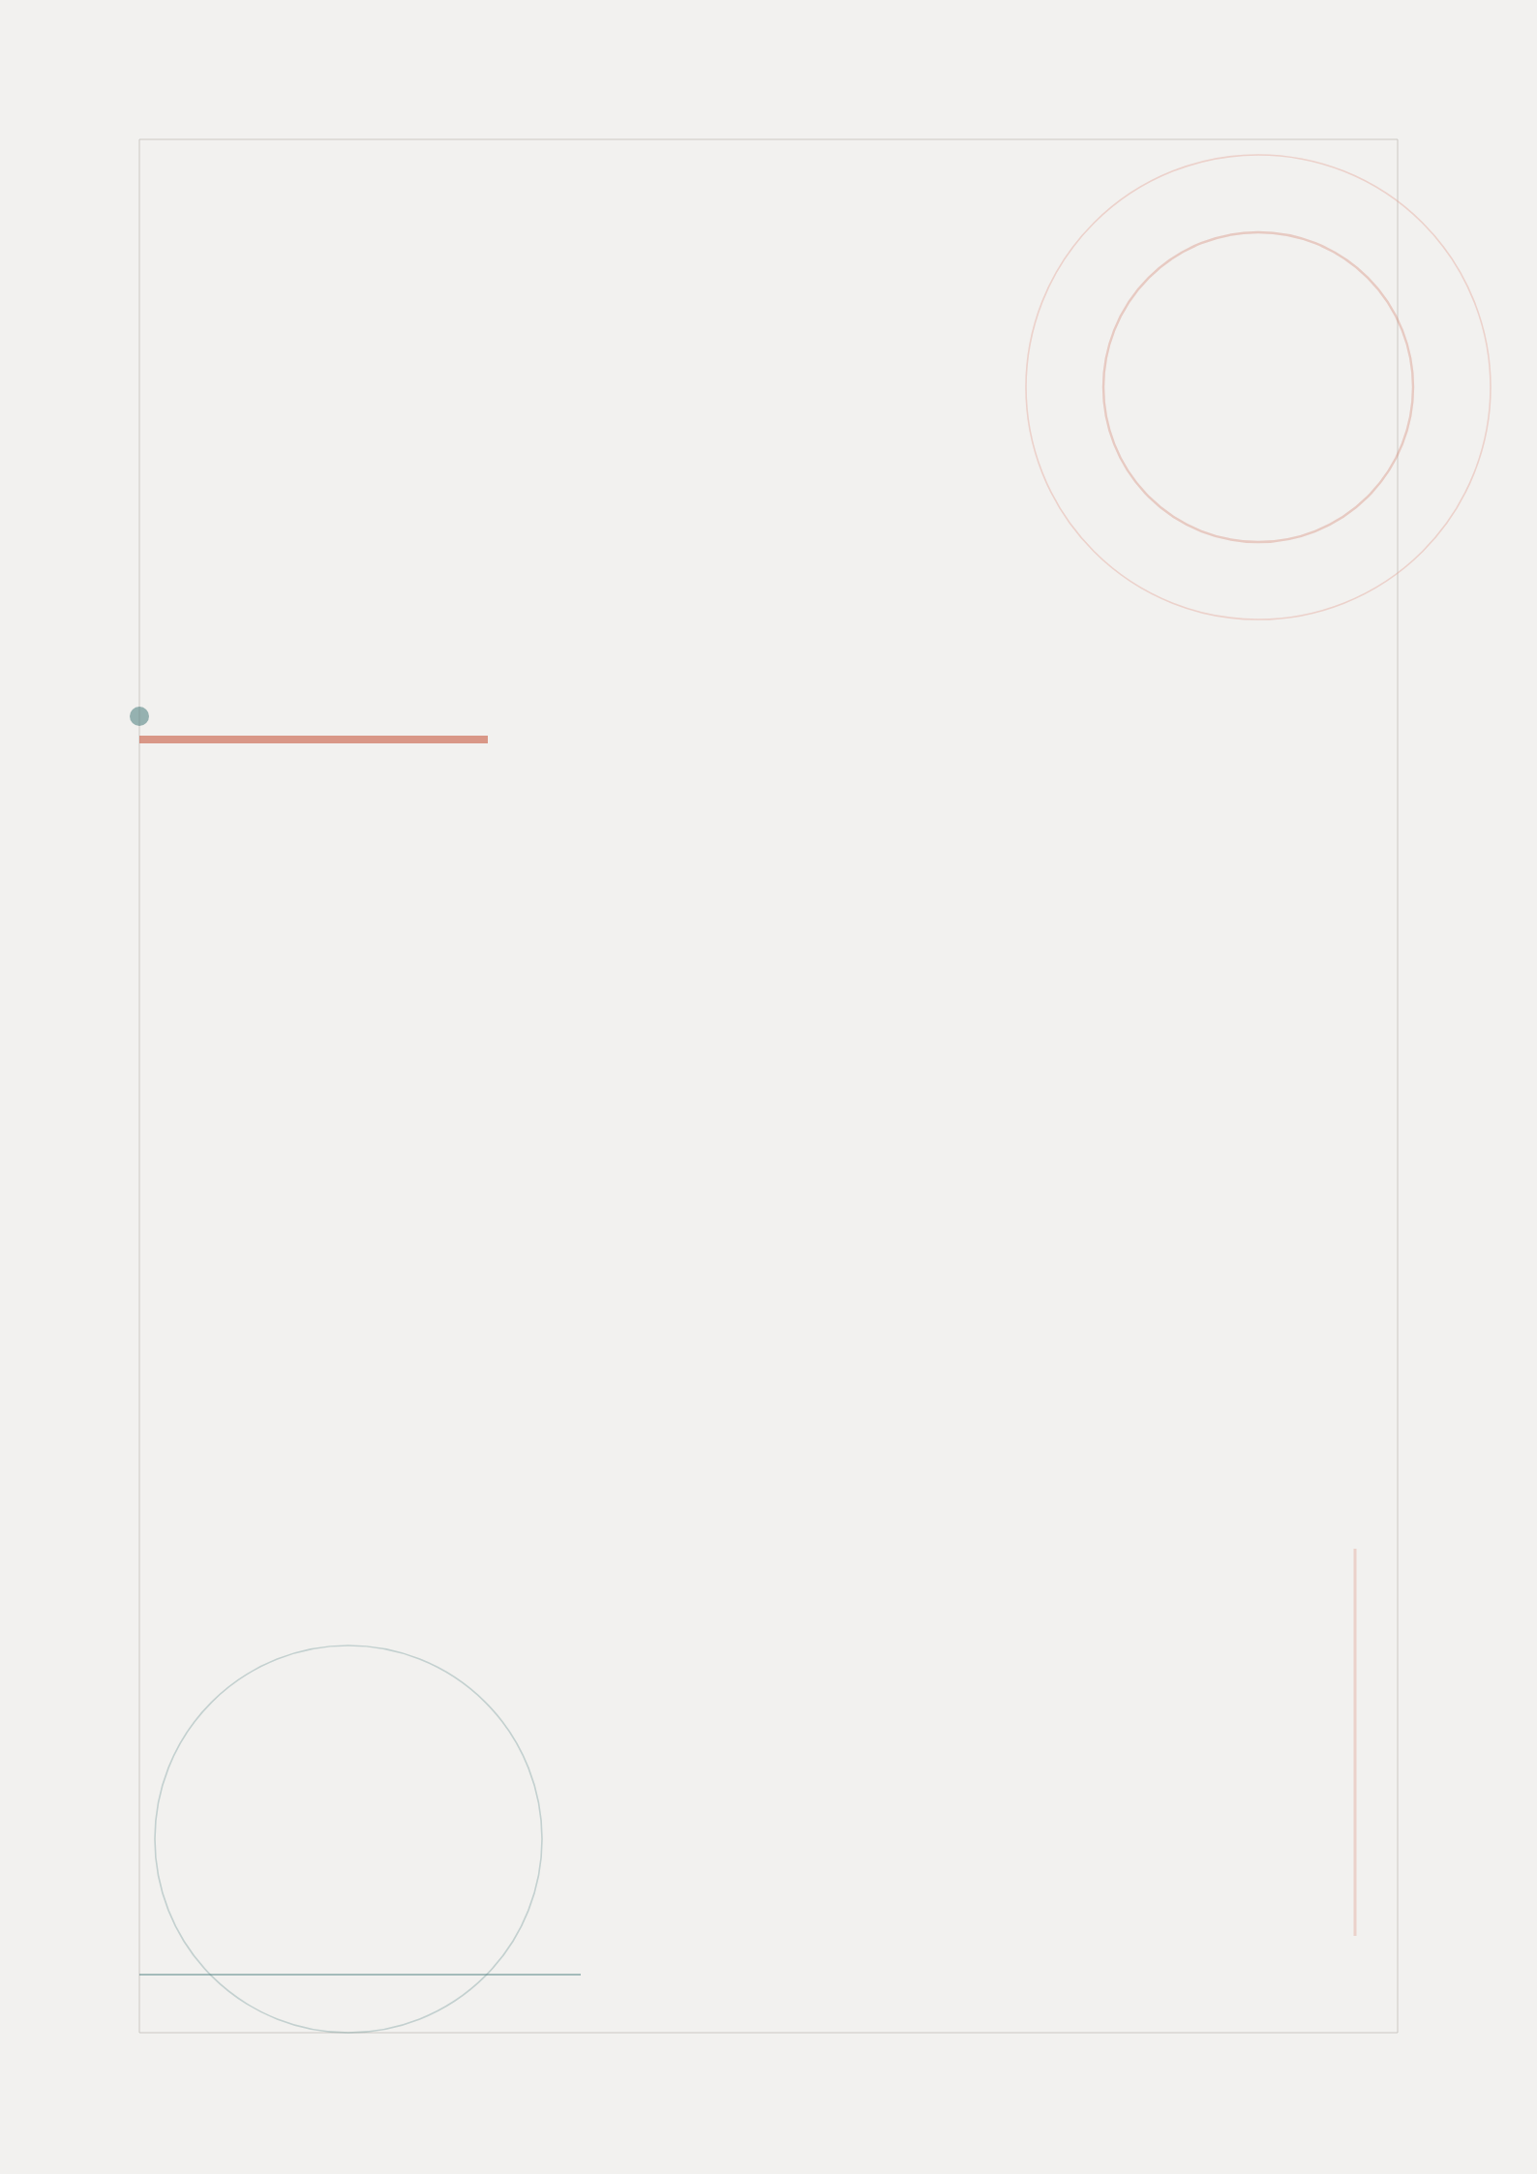

Project Index
FitTrack Mobile App
Complete Wireframing & UX Design Package
FitTrack Design Team | May 2026

Project Overview
This package contains the complete wireframing and user experience design documentation for the FitTrack mobile fitness application. FitTrack is designed to help users track workouts, monitor progress, and achieve their fitness goals through an intuitive, user-centered interface.
The project follows a structured UX design process encompassing user research, persona development, user flow creation, low-fidelity wireframing, and design thinking documentation.

Package Contents
This deliverable package includes the following documents and assets:
# | File/Folder | Type | Size
1 | README_Project_Index.docx | Document | Index
2 | 01_User_Research.docx | Document | Report
3 | 02_User_Personas.docx | Document | Report
4 | 03_User_Flows.docx | Document | Diagrams
5 | 04_Wireframes.docx | Document | Images
6 | 05_Design_Thinking_Process.docx | Document | Report
- | wireframe_images/ (6 images) | Folder | PNG Assets
- | user_flow_images/ (3 images) | Folder | PNG Assets

Document Descriptions

01_User_Research.docx
Comprehensive user research report documenting the methodology, participant recruitment, data collection methods, and key findings. Includes user needs analysis, pain points identification, and actionable recommendations for the design phase.

02_User_Personas.docx
Three detailed user personas representing the primary target audience segments. Each persona includes demographic information, goals, motivations, pain points, behavioral patterns, and a comparison matrix for design reference.

03_User_Flows.docx
User flow documentation with embedded flow diagrams showing the complete user journey through the application. Covers onboarding, authentication, workout sessions, and progress tracking flows with step-by-step descriptions.

04_Wireframes.docx
Low-fidelity wireframes for all six key screens of the FitTrack application. Each wireframe is accompanied by design rationale, key decisions, and component specifications. Includes the Login, Dashboard, Workout Catalog, Active Workout, Progress Tracking, and User Profile screens.

05_Design_Thinking_Process.docx
Complete documentation of the design thinking methodology applied to this project. Covers all five phases: Empathize, Define, Ideate, Prototype, and Test, with detailed activities, findings, and outcomes for each phase.

wireframe_images/
Folder containing six low-fidelity wireframe PNG images in mobile portrait format (9:16 ratio). These are the standalone image files of all wireframes embedded in the Wireframes document.

user_flow_images/
Folder containing three user flow diagram PNG images in landscape format (16:9 ratio). Includes the overall app navigation flow, onboarding/authentication flow, and workout session flow.

Project Information
Attribute | Details
Project Name | FitTrack Mobile App
Project Type | Mobile App Wireframing & UX Design
Platform | iOS & Android
Design Tool | Low-fidelity sketch-based wireframes
Project Timeline | April 1 - May 15, 2026
Team Lead | Sarah Chen
Team Members | Marcus Johnson, Priya Patel
Version | 1.0

How to Use This Package
For reviewing the complete project, follow this recommended reading order:
1. Start with this README for the project overview
2. Read the User Research document to understand the foundation
3. Review User Personas to understand who the app serves
4. Examine User Flows to understand navigation patterns
5. Study the Wireframes to see the visual interface design
6. Reference the Design Thinking Process for methodology details
All Word documents include table of contents that can be updated by right-clicking and selecting "Update Field" in Microsoft Word or compatible applications.


FitTrack
Your Fitness Journey, Simplified
fittrack.app

