- Create Database
CREATE DATABASE ecommerce;
USE ecommerce;

- Create tables
CREATE TABLE customers (
id INT AUTO_INCREMENT PRIMARY KEY,
name VARCHAR(100),
email VARCHAR(100),
address VARCHAR(255)
);

CREATE TABLE orders (
id INT AUTO_INCREMENT PRIMARY KEY,
customer_id INT,
order_date DATE,
total_amount DECIMAL(10,2),
FOREIGN KEY (customer_id) REFERENCES customers(id)
);

CREATE TABLE products (
id INT AUTO_INCREMENT PRIMARY KEY,
name VARCHAR(100),
price DECIMAL(10,2),
description VARCHAR(255)
);

- Insert data
INSERT INTO customers (name, email, address) VALUES
('Alice Johnson', 'alice@gmail.com', 'New York'),
('Bob Smith', 'bob@gmail.com', 'California'),
('Charlie Brown', 'charlie@gmail.com', 'Texas');

INSERT INTO products (name, price, description) VALUES
('Product A', 50.00, 'High-quality product A'),
('Product B', 120.00, 'Premium product B'),
('Product C', 40.00, 'Affordable product C'),
('Product D', 200.00, 'Luxury product D');

INSERT INTO orders (customer_id, order_date, total_amount) VALUES
(1, CURDATE() - INTERVAL 5 DAY, 160.00),
(2, CURDATE() - INTERVAL 35 DAY, 90.00),
(1, CURDATE() - INTERVAL 10 DAY, 240.00),
(3, CURDATE() - INTERVAL 2 DAY, 75.00);

- QUERY

SELECT DISTINCT c.*
FROM customers c
JOIN orders o ON c.id = o.customer_id
WHERE o.order_date >= CURDATE() - INTERVAL 30 DAY;
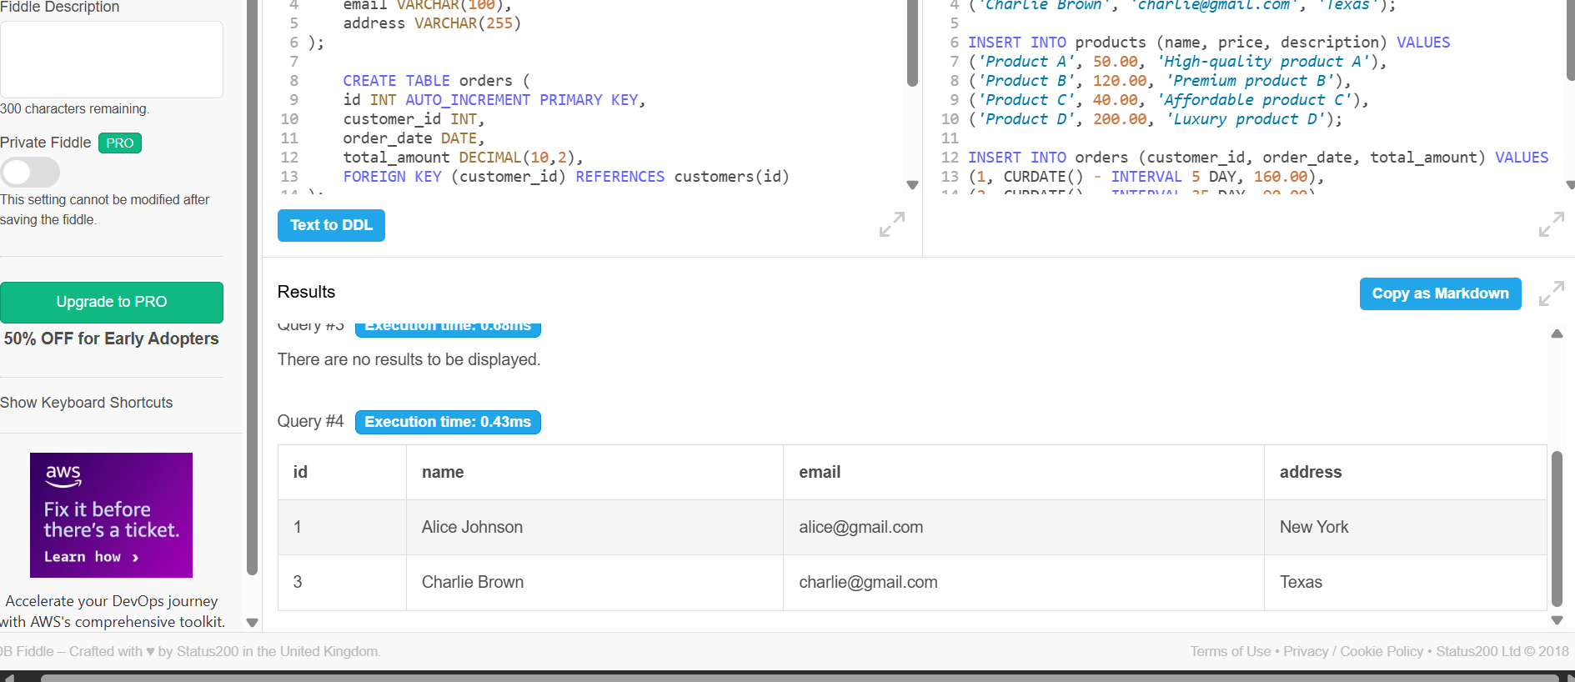

SELECT c.name, SUM(o.total_amount) AS total_spent
FROM customers c
JOIN orders o ON c.id = o.customer_id
GROUP BY c.id;
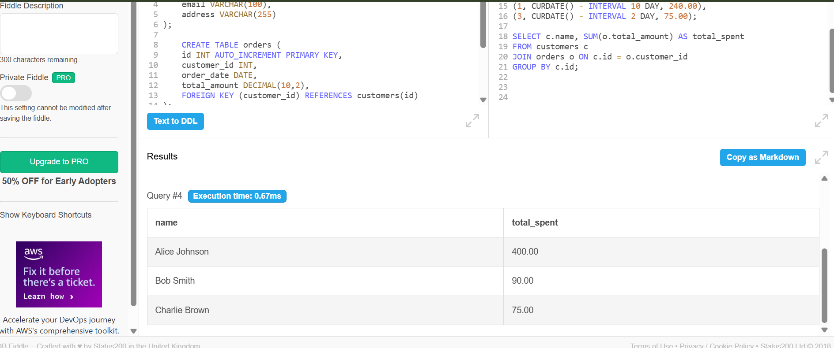

UPDATE products
SET price = 45.00
WHERE name = 'Product C';

ALTER TABLE products
ADD COLUMN discount DECIMAL(5,2) DEFAULT 0.00;

SELECT *
FROM products
ORDER BY price DESC
LIMIT 3;
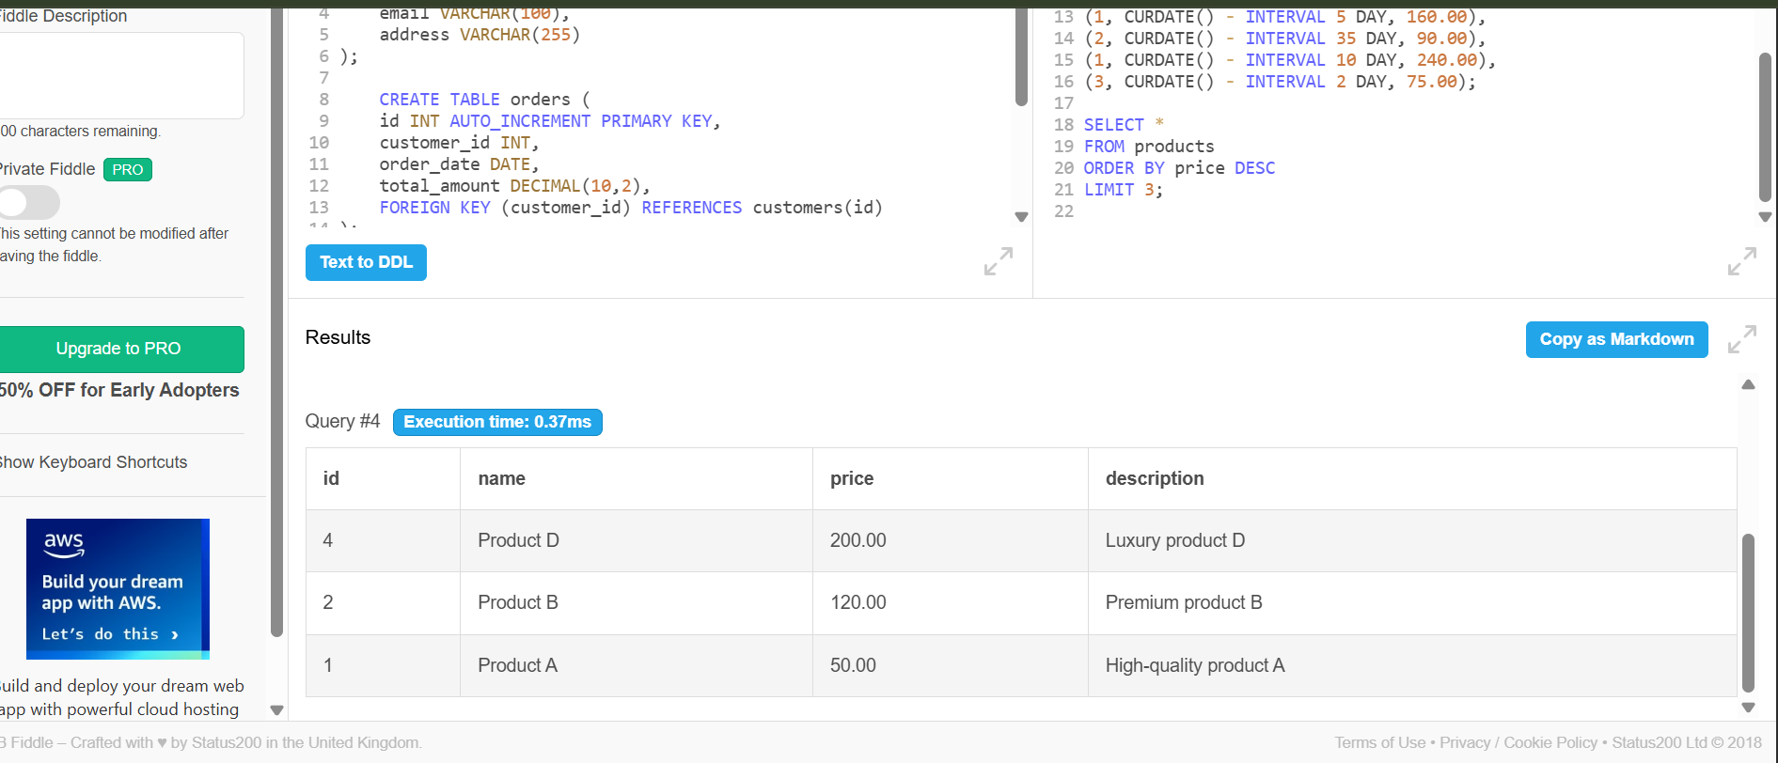
SELECT c.name, o.order_date
FROM customers c
JOIN orders o ON c.id = o.customer_id;
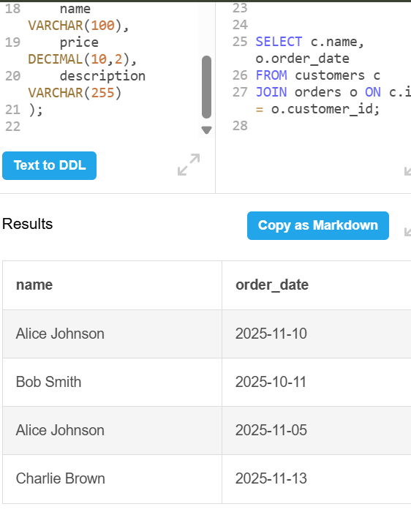

SELECT *
FROM orders
WHERE total_amount > 150.00;
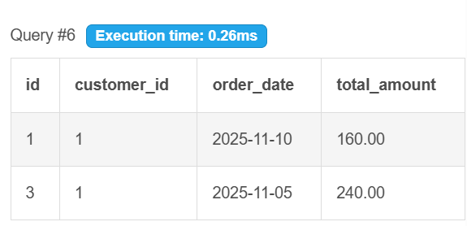

CREATE TABLE order_items (
id INT AUTO_INCREMENT PRIMARY KEY,
order_id INT,
product_id INT,
quantity INT,
FOREIGN KEY (order_id) REFERENCES orders(id),
FOREIGN KEY (product_id) REFERENCES products(id)
);

INSERT INTO order_items (order_id, product_id, quantity) VALUES
(1, 1, 2),
(1, 2, 1),
(2, 3, 1),
(3, 4, 1),
(4, 1, 1);

SELECT DISTINCT c.name
FROM customers c
JOIN orders o ON c.id = o.customer_id
JOIN order_items oi ON o.id = oi.order_id
JOIN products p ON oi.product_id = p.id
WHERE p.name = 'Product A';

SELECT AVG(total_amount) AS avg_order_total
FROM orders;

