# **LAB -01**

## NAME : NITHIN VEMULA

## H.NO : 2403A52355

## Prompt :

Write a comment: # Function to check if a string is a valid palindrome (ignoring  
spaces and case) and allow Copilot to complete it

## Code :

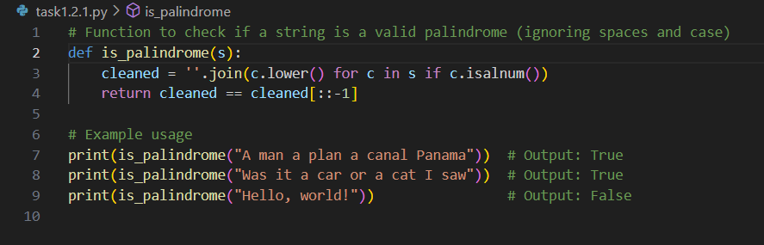

# Explaination.

A palindrome is a word or phrase that reads the same forwards and backwards (e.g., "madam" or "A man a plan a canal Panama").

s = ''.join(s.split()).lower()

* s.split() splits the string into a list of words (removing spaces).
  + Example: "A man a plan" → ["A", "man", "a", "plan"]
* ''.join(...) joins the words back into a single string with **no spaces**.
  + ["A", "man", "a", "plan"] → "Amanaplan"
* .lower() converts everything to lowercase.
  + "Amanaplan" → "amanaplan"

So, input "A man a plan a canal Panama" becomes "amanaplanacanalpanama".

**return s == s[::-1]**

* s[::-1] reverses the string.
* The function compares the original cleaned string to its reversed version.
* If they are the same → it's a palindrome → return True.  
  Otherwise → return False.

# Output

## Prompt :

Generate a Python function that returns the Fibonacci sequence up to n terms. Prompt with only a function header and docstring

## Code :

# Explaination

**Initialize** two starting values:

* a = 0 (first term), b = 1 (second term)

**Loop** n times to generate n terms:

* Add the current value of a to the list
* Update a to b, and b to a + b (the next Fibonacci number)

**Return** the list containing the sequence

# Output

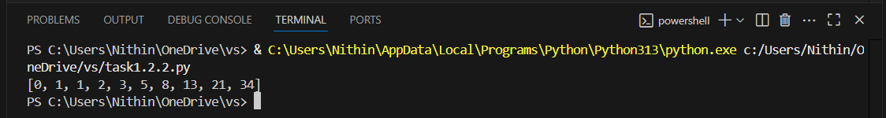

## Prompt :

Write a comment like # Function to reverse a string and use Copilot to generate the  
function

## Code :

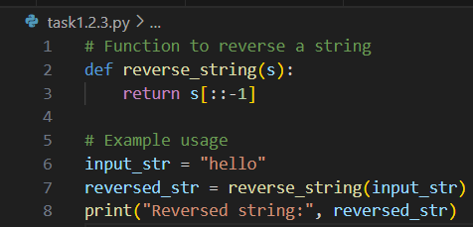

# Explaination

It takes a string s and returns it **reversed**.

* s[::-1] uses **Python slicing** to reverse the string.
  + s[start:stop:step] → With step = -1, it reads the string **backward**.

# Output

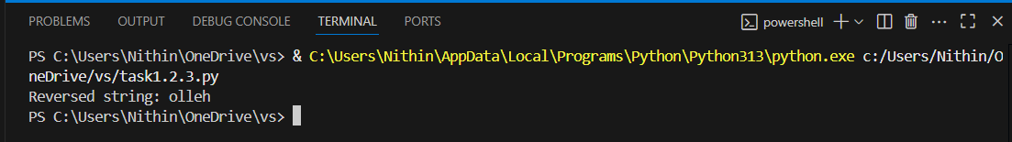

## Prompt :

Generate a program that simulates a basic calculator (add, subtract, multiply, divide).Write the comment: # Simple calculator with 4 operations and let AI complete it

## Code :

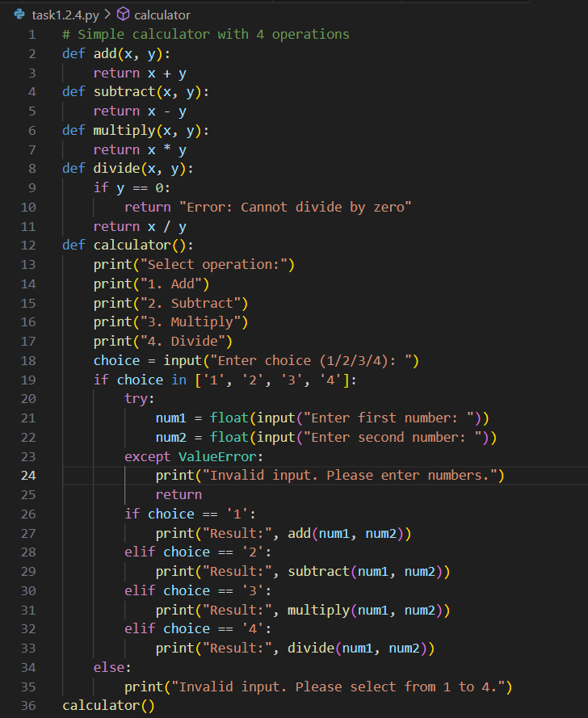

# Explaination

* Takes **two numbers** (a, b) and an **operation name** ("add", "subtract", etc.)
* If the operation is "subtract", it returns the difference.
* If the operation is "multiply", it returns the product.
* If the operation is "divide":
  + It checks if b is not zero (to avoid division by zero error).
  + If b is valid, it returns the quotient.
  + If b is 0, it returns an error message.
* If the user enters an operation not supported, it returns an error message.

# Output

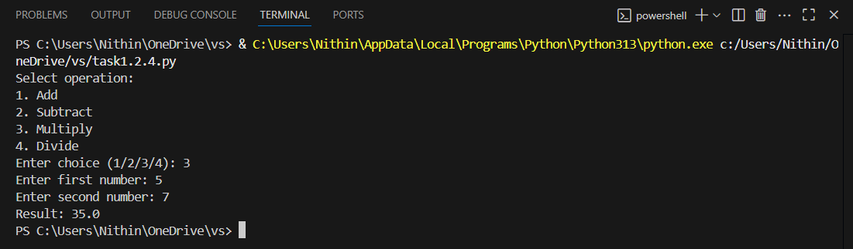

## Prompt :

Use a comment to instruct AI to write a function that reads a file and returns the  
number of lines

## Code :

# Explaination

**with open(filename, 'r') as file:**

* Opens the file with the given name in **read mode** ('r').
* The with statement ensures the file is **automatically closed** after reading.

**file.readlines()**

* Reads **all lines** of the file into a list.
* Each line is a separate string in the list.

**len(...)**

* Counts how many lines (strings) are in that list.

# Output

