ASSIGNMENT – 17.4
NAME : NITHIN VEMULA
ROLL:NO : 2403A52355
BATCH : AI 13

TASK-1: Generate a Python script using pandas that cleans an employee dataset by:
- Filling missing values in salary (median), department ("Unknown"), and joining_date ("1900-01-01")
- Converting joining_date to datetime
- Standardizing department names (e.g., "HR", "hr", "Human Resources" → "HR")
- Encoding department and job_role
The output should be a cleaned DataFrame with consistent departments, proper dates, and encoded features.
Code:
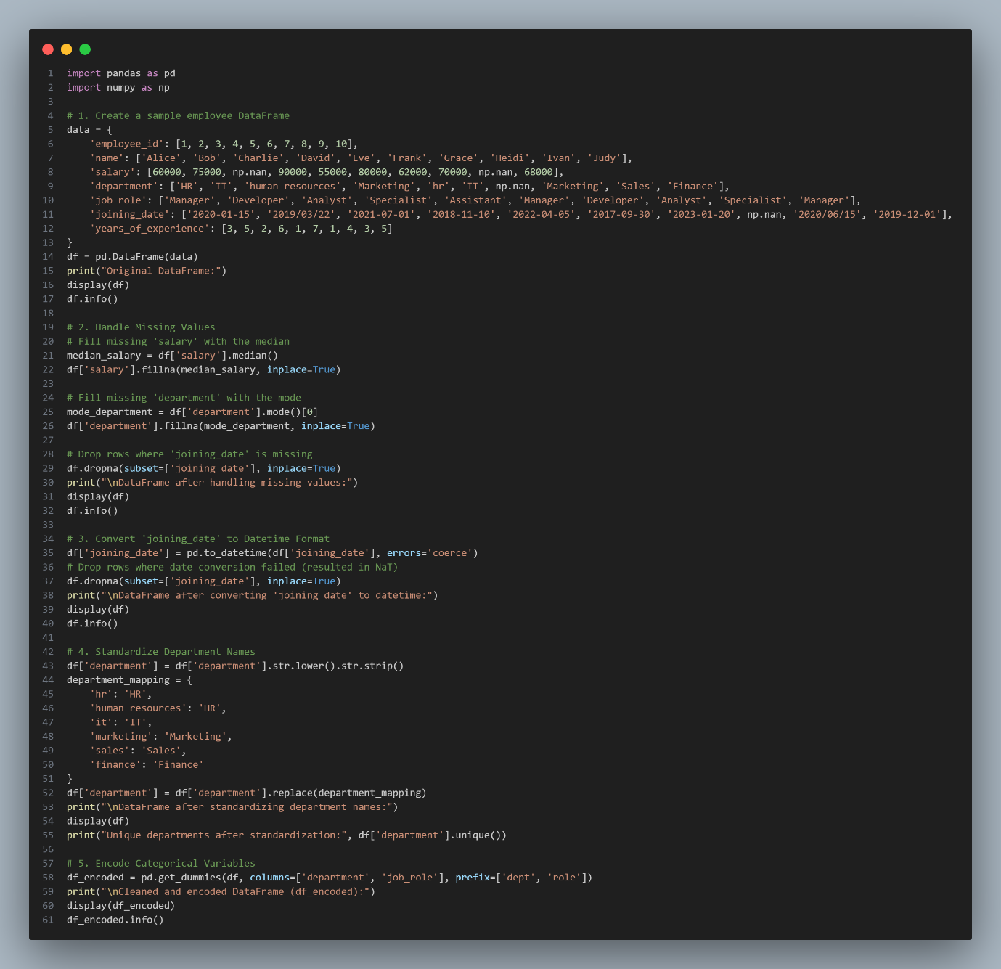
Output:
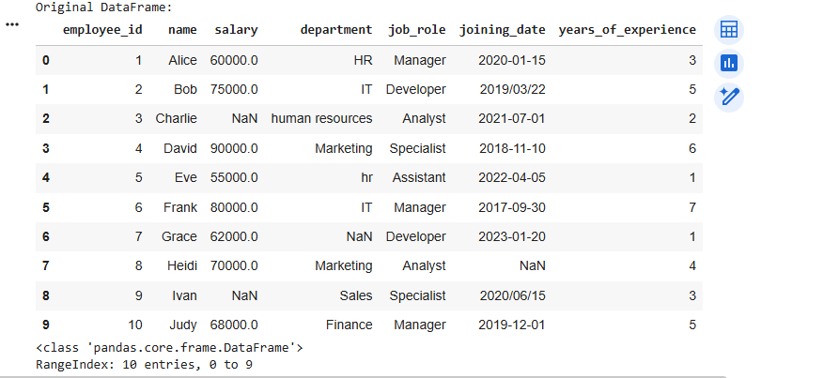
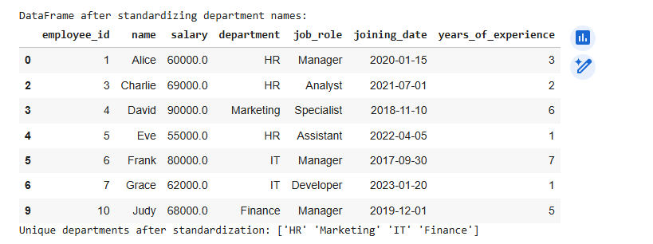
Explanation:
Sample Data Creation: We start by creating a pandas.DataFrame that simulates a real-world employee dataset. This dataset is intentionally designed to include common data quality issues such as missing values (NaN in salary and department), inconsistent date formats (2020-01-15 vs 2019/03/22), and varied categorical entries (HR, hr, human resources). This allows us to demonstrate a comprehensive cleaning process.
Handling Missing Values:
For the salary column (numerical), we filled missing entries with the median salary. The median is often preferred over the mean for numerical data with potential outliers, as it is less sensitive to extreme values.
For the department column (categorical), we filled missing entries with the mode (most frequent department). This ensures consistency for a categorical feature.
For the joining_date column, we chose to drop rows where the date was missing. Since joining_date is crucial for date-based analysis and conversion, and imputation could be complex without further business context, dropping these rows ensures data integrity for this specific column.
Converting 'joining_date' to Datetime Format:
We used pd.to_datetime() to convert the joining_date column into a proper datetime object. This is essential for performing any date-based operations (like extracting year, month, or calculating tenure).
The errors='coerce' argument is vital here: it tells pandas to convert any unparseable date strings into NaT (Not a Time) instead of raising an error. We then dropna() again on this column to remove any rows where the date conversion failed, ensuring all remaining joining_date entries are valid datetime objects.
Standardizing Department Names:
Categorical variables often have inconsistencies (e.g., 'HR' vs 'hr' vs 'human resources'). To address this, we first converted all department names to lowercase and stripped any leading/trailing whitespace.
Then, we created a department_mapping dictionary to map all variations of a department name to a single, standardized form (e.g., 'hr' and 'human resources' both map to 'HR'). This ensures all entries within a category are uniform.
Encoding Categorical Variables:
Machine learning algorithms typically require numerical input. Categorical variables like department and job_role need to be converted. We used one-hot encoding via pd.get_dummies().
One-hot encoding creates new binary columns for each unique category within the original categorical column. For example, if 'department' had 'HR', 'IT', 'Marketing', it would create dept_HR, dept_IT, dept_Marketing columns. A 1 in dept_HR would indicate the employee belongs to HR, and 0 otherwise. This approach avoids assigning arbitrary numerical order to categories.
The final output is df_encoded, a cleaned DataFrame with consistent data types, no missing critical values, standardized text, and numerically encoded categorical features, making it suitable for further analytical tasks.
TASK-2: Generate a Python script that preprocesses a sales transaction dataset by converting transaction dates to datetime, creating a “Month-Year” column, removing rows where transaction_amount is zero or negative, and applying Min-Max normalization to transaction_amount. The output should be a cleaned DataFrame with valid dates, normalized amounts, no invalid records, and the final shape printed.
Code:
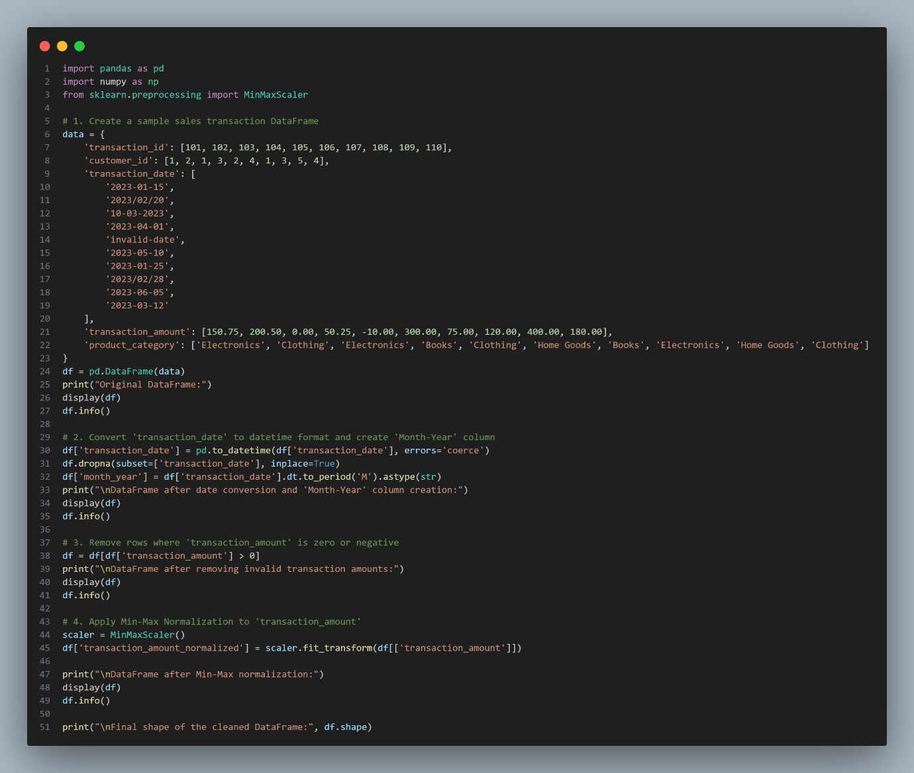
Output:
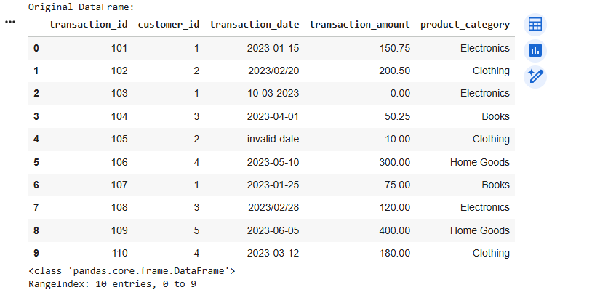
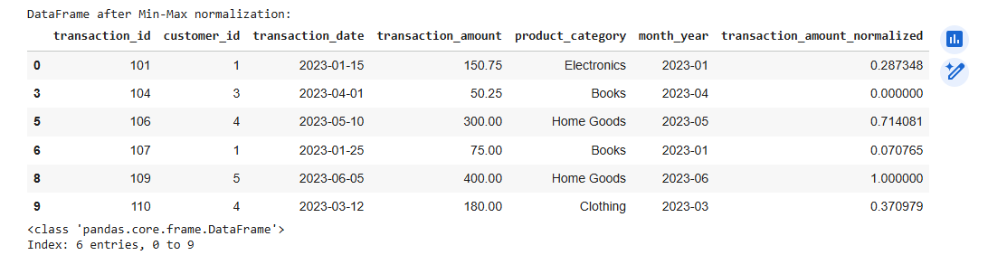
Explanation:
- Sample Data Creation: We begin by generating a sample pandas.DataFrame that mimics a sales transaction dataset. This dataset is designed to include real-world data issues, such as inconsistent date formats ('2023-01-15', '2023/02/20', '10-03-2023', 'invalid-date'), and problematic transaction amounts (zero and negative values). This allows us to effectively demonstrate the data cleaning and preprocessing techniques.
- Date Conversion and 'Month-Year' Column Creation:
  - The transaction_date column is converted to a proper datetime object using pd.to_datetime(). The errors='coerce' argument is crucial here; it instructs pandas to replace any unparseable date strings (like 'invalid-date') with NaT (Not a Time).
  - Following this, df.dropna(subset=['transaction_date'], inplace=True) is used to remove any rows where the date conversion resulted in NaT. This ensures that all remaining dates in the DataFrame are valid and correctly formatted.
  - A new column, month_year, is then created by extracting the year and month from the transaction_date using .dt.to_period('M') and converting it to a string (.astype(str)). This is useful for time-series analysis or aggregation by month.
- Removing Invalid Transaction Amounts:
  - Sales transactions should generally have positive amounts. We filter the DataFrame to keep only those rows where transaction_amount is greater than 0 (df = df[df['transaction_amount'] > 0]). This effectively removes transactions with zero or negative values, which are usually considered invalid or returns in sales data context.
- Min-Max Normalization of 'transaction_amount':
  - Normalization is a common preprocessing step for numerical features, especially when preparing data for machine learning algorithms. We use MinMaxScaler from sklearn.preprocessing to scale the transaction_amount column.
  - Min-Max scaling transforms values to a specific range, typically between 0 and 1. The formula used is (x - min(x)) / (max(x) - min(x)). This process helps prevent features with larger numerical ranges from disproportionately influencing model training.
  - The scaled values are stored in a new column called transaction_amount_normalized.
Finally, the script prints the DataFrame Info at various stages and the Final shape of the cleaned DataFrame to show the impact of each preprocessing step on the data's structure and contents. The result is a clean, validated, and scaled dataset ready for further analysis or modeling.

TASK-3: Generate a Python script that cleans healthcare patient records by filling missing numeric values with column means, converting height from centimeters to meters, standardizing gender labels (e.g., "M", "male", "Male" → "Male"), and dropping irrelevant columns such as patient_id. The output should be a cleaned dataset suitable for machine-learning training.
Code:
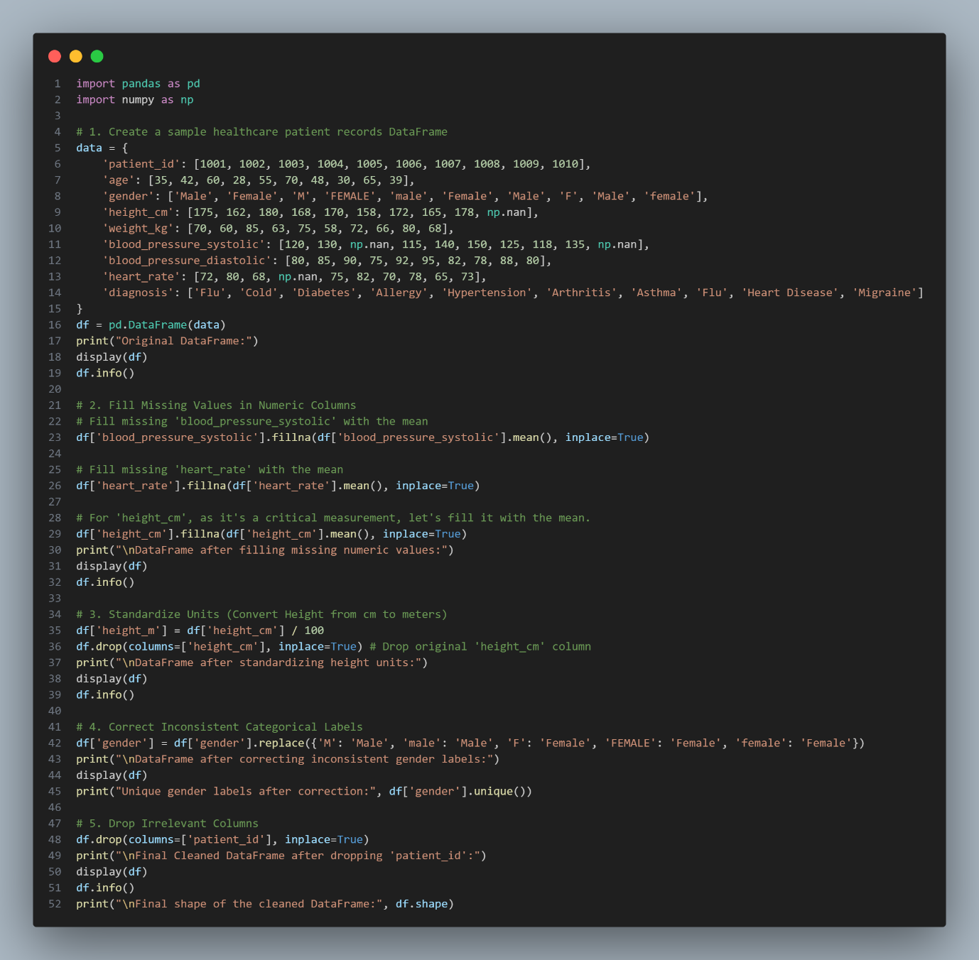
Output:
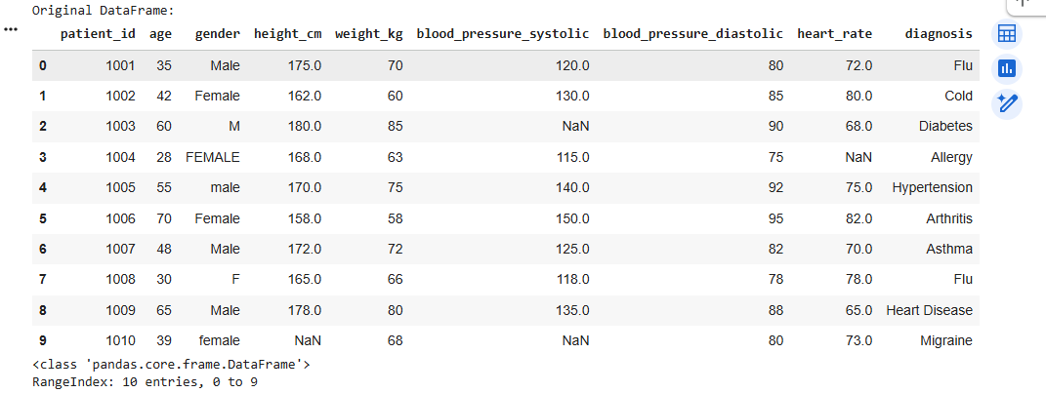

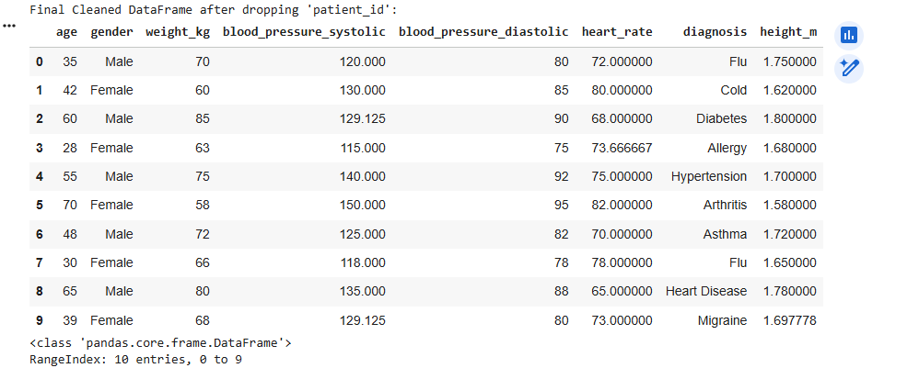
TASK-4: Generate a Python script to preprocess a social media text dataset by removing special characters, URLs, and emojis; converting text to lowercase; tokenizing; removing stopwords; and applying lemmatization. The output should be a clean text column ready for NLP sentiment analysis.
Code:
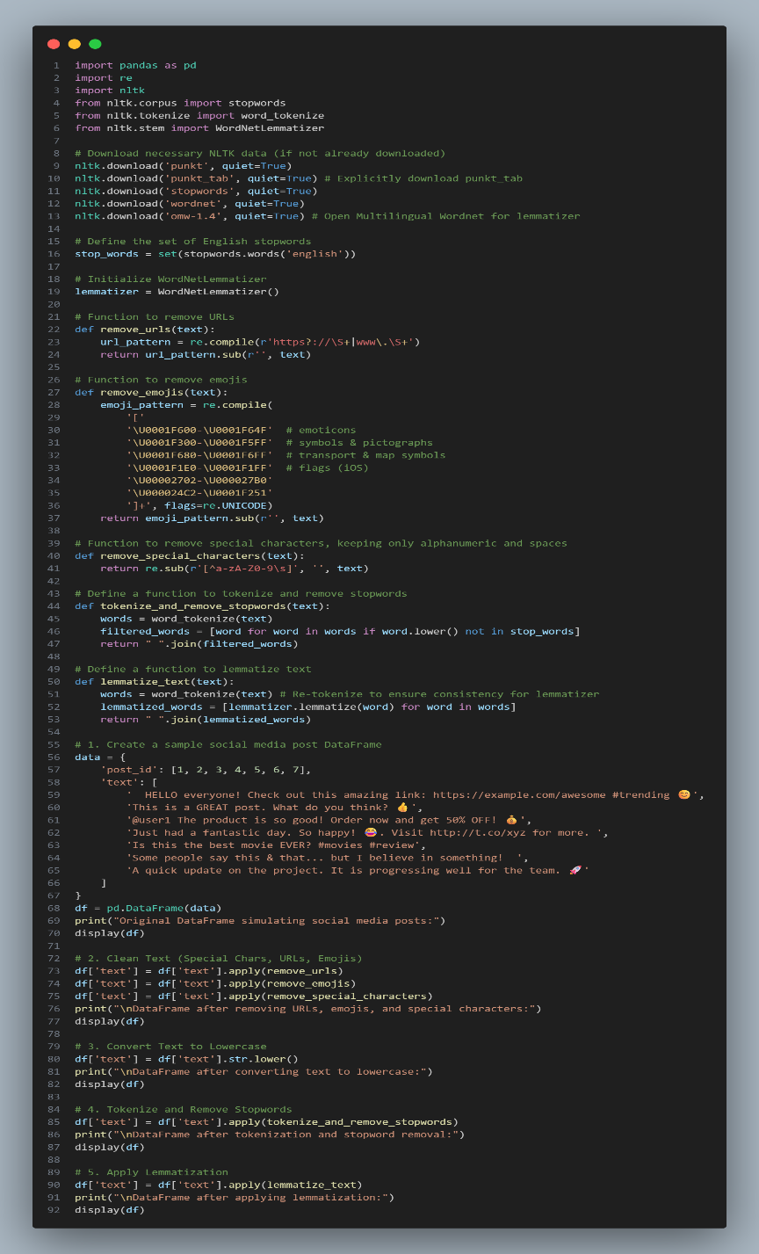
Output:
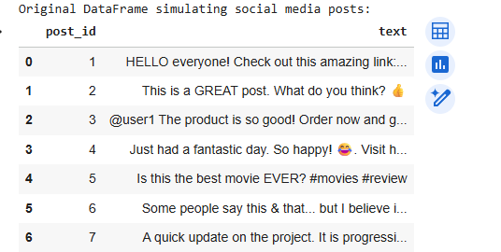

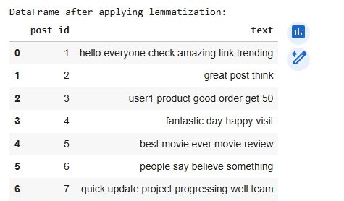

TASK-5: Generate a Python script to preprocess a financial dataset by handling missing values in stock_price and volume, creating 7-day and 30-day moving averages, normalizing continuous variables using StandardScaler, and encoding categorical columns (sector, company_name). The output should be a feature-engineered DataFrame ready for machine learning tasks.
Code:
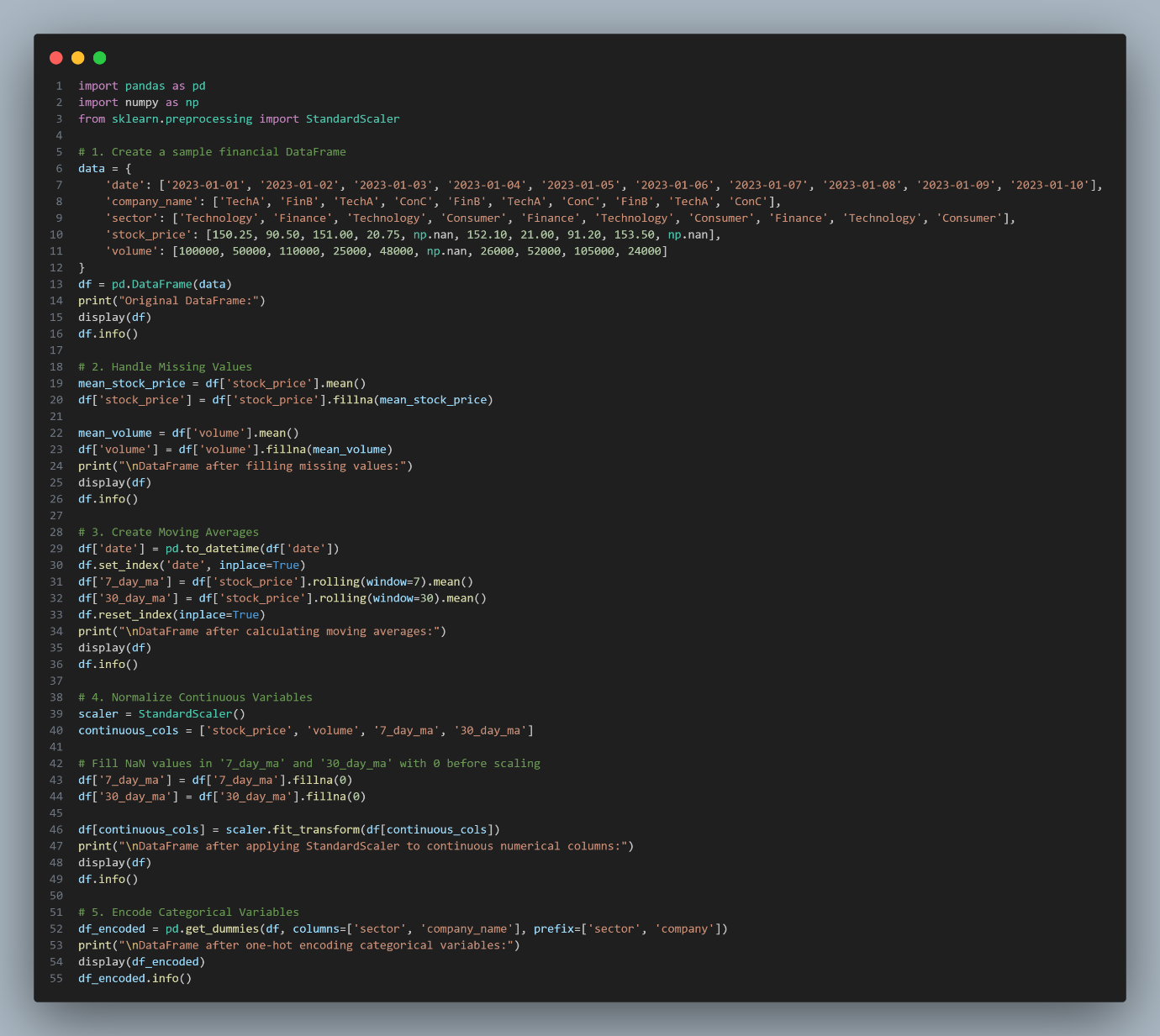
Output:
