**DAY 13**

**Virtualization:**

Creation of a virtual instance of anything is called virtualization.

**OS virtualization:**

Creating a virtual instance of OS on a single hardware is called OS virtualization where we can run more than 1 OS on single device.

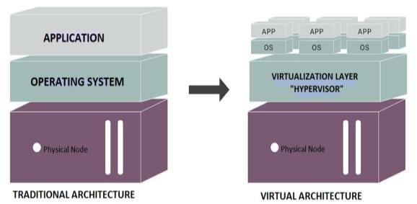

Installation of virtual box and kali linux:

**Social Engineering:**

This is a practice in order to manipulate humans mind using psychological techniques where the victim is tricked to believe what ever the attacker says/texts which leads the victim to reveal sensitive data like

* Credit card details
* Login credentials
* Emails
* Chat messages etc.

Few social engineering types:

1. Phishing

2. Vishing

3. Smishing

4. Identity theft

5. Tail gating

Openphish.com🡪can identify many phishing links

Tail gating:

The attacker poses himself as an authorised person and trick the people believing he is authorised person and bypass any restrictions where the attacker goes behind the authorised person

Phishing:

Generating fake links that looks like legitimate ones.

github.com/xHak9x/SocialPhish

Install social phish in kali linux