Design DOCUMENT

TTL FILE PARSING

Document history:

S.No | Version No. | Author | Section(s) Affected | Change(s) made | Approved Date | Approved by
1 | 1.0 | Prasanth P | All | Initial
2 | 1.1 | Prasanth P  Nithishkumar T  Vinitha K | All | Modification in contents

TABLE OF CONTENTS

1. INTRODUCTION 2
2. PROBLEM STATEMENT 2
3. OBJECTIVE 3
4. DESIGN SPECIFICATIONS 3
5. DESIGN PLAN 3
5.1 SYSTEM OVERVIEW 3
5.2 DESIGN 3
5.2.1 HIGH LEVEL DESIGN 3
5.2.2 LOW LEVEL DESIGN 4
6 REFERENCES 10

1. INTRODUCTION
This project focuses on developing a parser for TTL files to extract and decode hexadecimal commands and their associated parameters. It also writes the command names and bit definitions to a text file in a human-readable format.

2. PROBLEM STATEMENT
Create JSON and YAML files from the given ADSP21593 commands and parameters details file. Develop the code for parsing the TTL file as input to generate a human-readable format.

3. OBJECTIVE
- Extract and validate hexadecimal commands from TTL files.
- Match valid commands with a reference dictionary to identify command.
- Process parameters and bitfields to provide detailed definitions.
- Generate human-readable outputs for commands, parameters, and bitfield details.

4. DESIGN SPECIFICATIONS

Programming Language | C and Python
IDE | VS code, Python 3.13
Input | TTL file (.ttl format)
Output | Human-readable format (.txt format)

5. DESIGN PLAN

5.1 SYSTEM OVERVIEW
The TTL parser system is designed to process TTL files containing hexadecimal commands and parameters. It extracts commands, validates them against a reference dictionary, and decodes associated parameters and bitfields. The system then generates human-readable outputs in JSON and YAML formats. Key components include file parsing, command validation, parameter extraction, and output generation, with robust error handling throughout.

5.2 DESIGN
The design of the TTL parser system is organized into both high-level and low-level structures to ensure efficient parsing, validation, and output generation.

5.2.1 HIGH LEVEL DESIGN
At a high level, the TTL parser system reads TTL files, extracts hexadecimal commands, parameters, and bitfields, validates the commands against a reference dictionary, and processes the data. It then generates human-readable outputs in JSON and YAML formats.

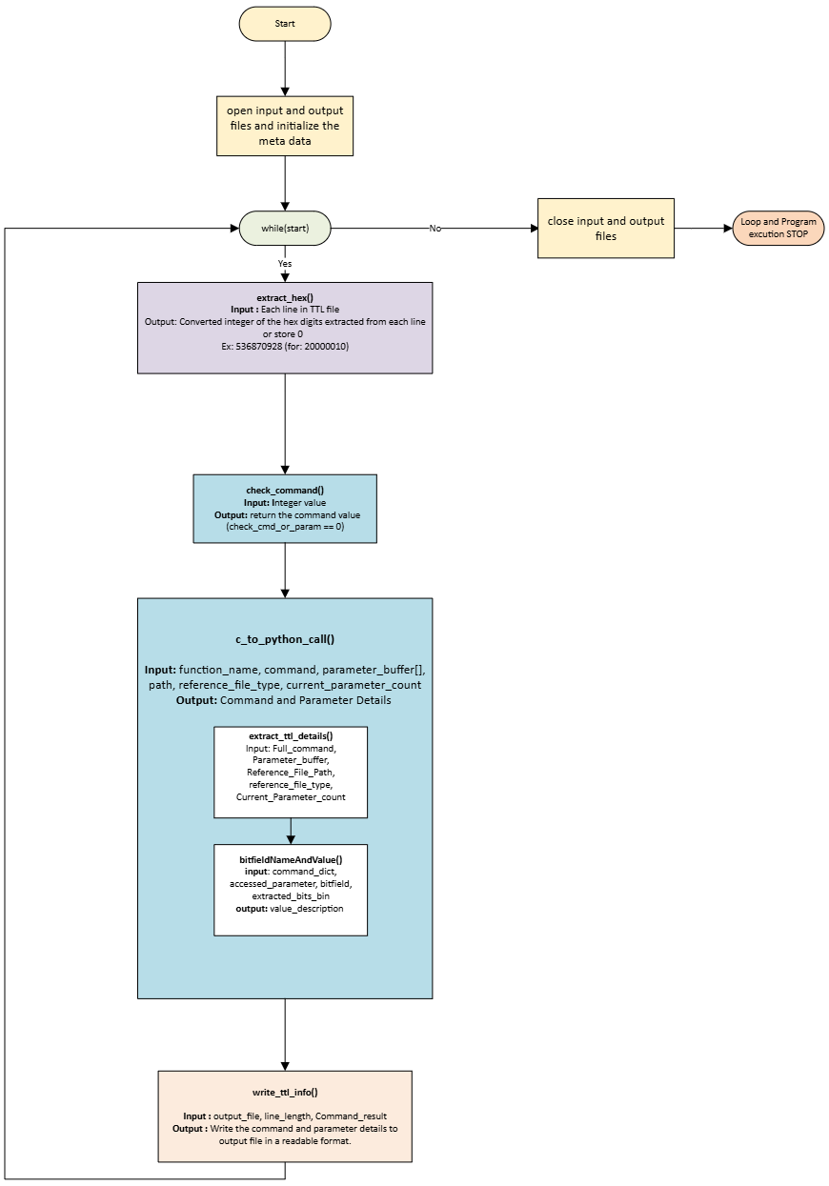

5.2.2 LOW LEVEL DESIGN
The high-level design of the TTL parser system is structured to efficiently process TTL files and output the extracted data in human-readable JSON and YAML formats. The system begins with an Input Module that reads and loads the TTL file. The Parsing and Extraction Module identifies and extracts hexadecimal commands, parameters, and bitfields from the file. These commands are then validated against a reference dictionary by the Command Validation Module. The Parameter and Bitfield Processing Module decodes the parameters and bitfields, while the Output Module generates the final JSON and YAML outputs. Robust Error Handling and Logging ensure the system operates smoothly, identifying issues and providing feedback. This modular design ensures flexibility, reliability, and ease of use.
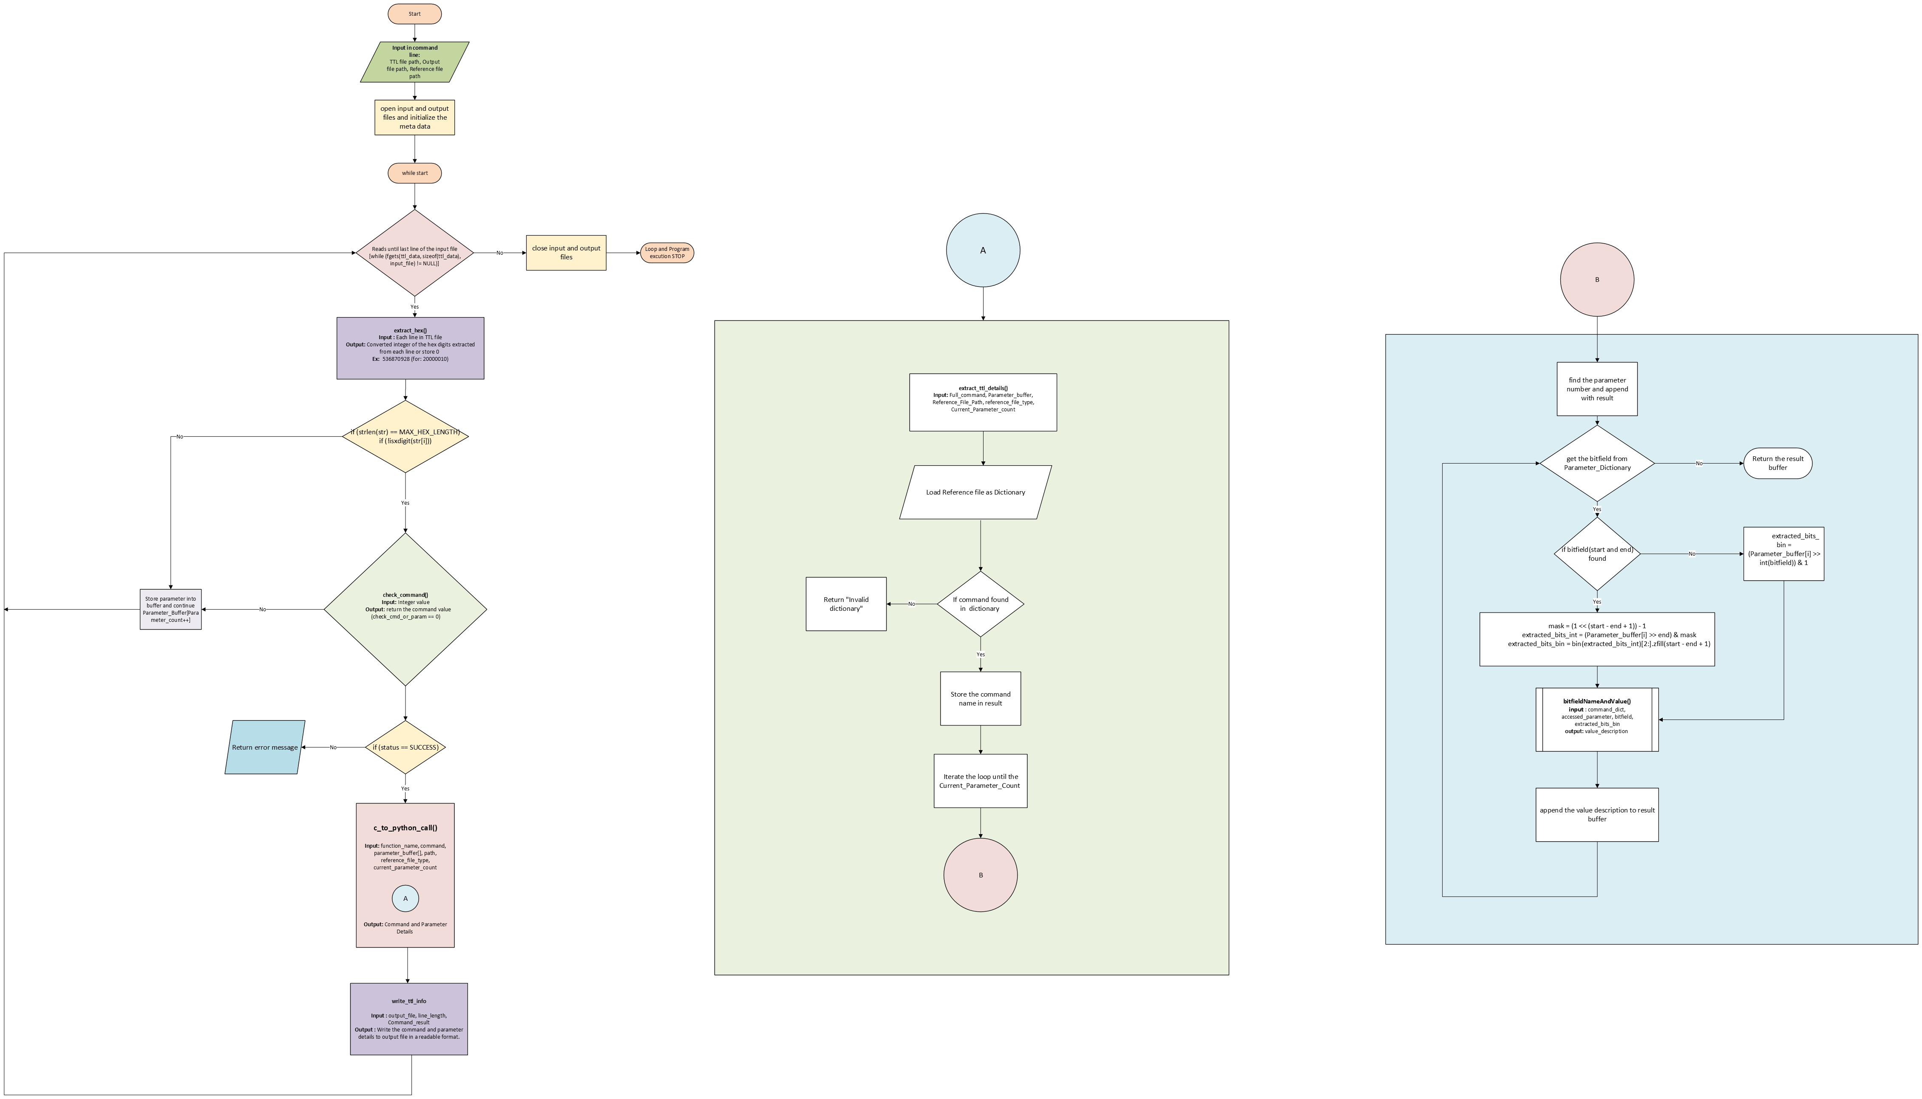
DESCRIPTION ON EACH MODULE:
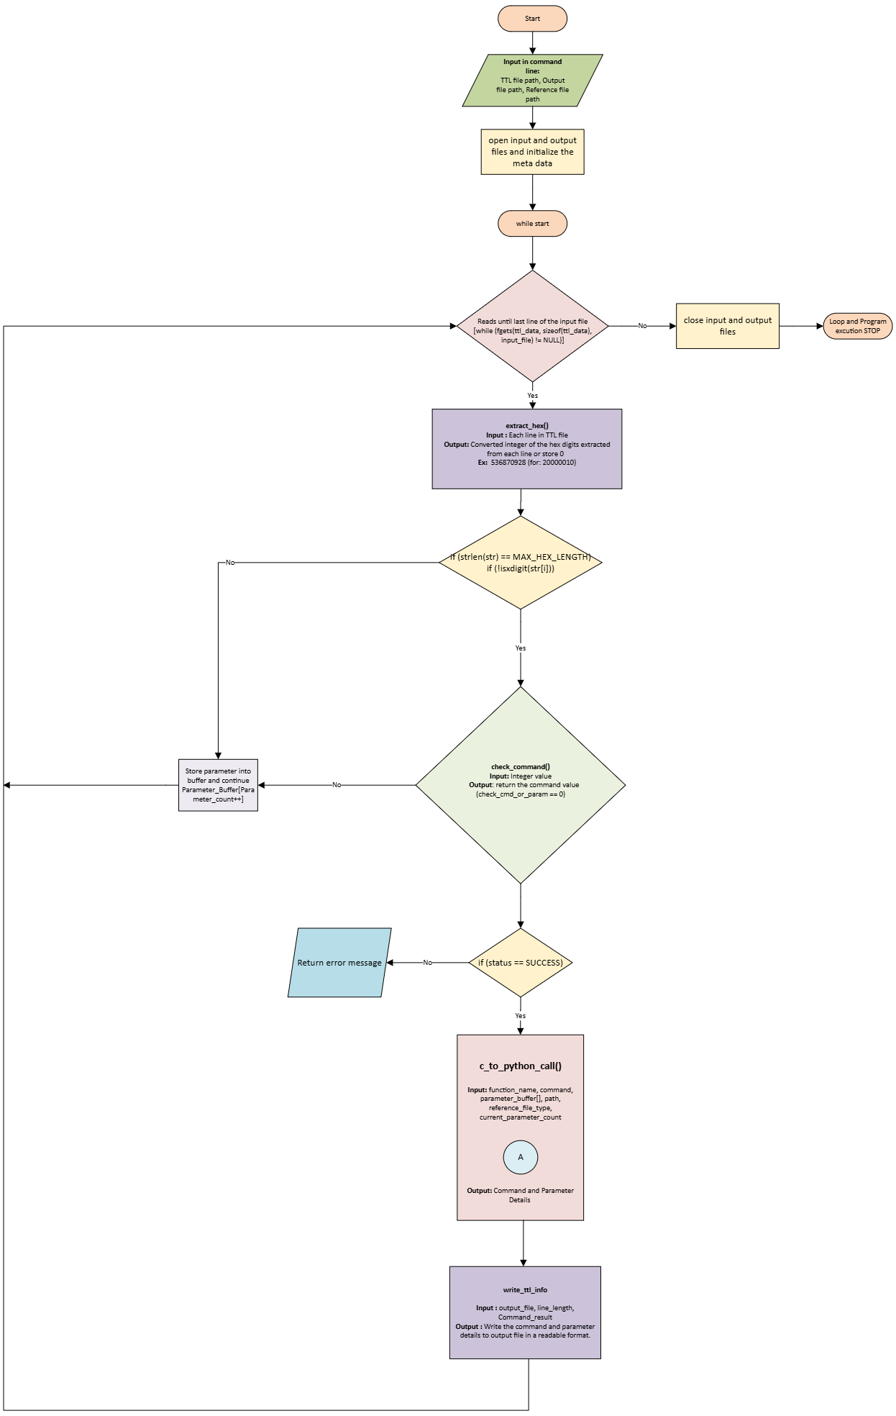

Start
Description: The entry point for the parsing process.
Function: Initiates the execution of the parsing workflow.

Open Input and Output Files
Description: Opens the necessary files for reading and writing.
Function: Prepares the input TTL file for parsing and initializes the output file for storing results.

While (Not EOF)
Description: A loop that continues until the end of the file is reached.
Function: Ensures that all lines in the TTL file are read and processed sequentially.

Read Input Line
Description: Reads the current line from the input file.
Function: Parses the line into segments for validation and processing.

Input Length > MAX_ROW_LENGTH or Invalid Format
Description: Checks the validity of the current line based on length and format.
Function: Ensures the input data adheres to the defined constraints for successful processing.

Return Error Message
Description: Handles invalid input cases by providing feedback.
Function: Outputs an error message and skips processing for the invalid line.

Run Transform Line Function
Description: Processes a valid input line and converts it into structured data.
Function: Parses and transforms the line into master data formats for further processing.

Close Input and Output Files
Description: Finalizes the process by releasing file resources.
Function: Closes the input and output files after all lines are processed.

End
Description: Marks the completion of the parsing workflow.
Function: Ends the execution of the workflow.
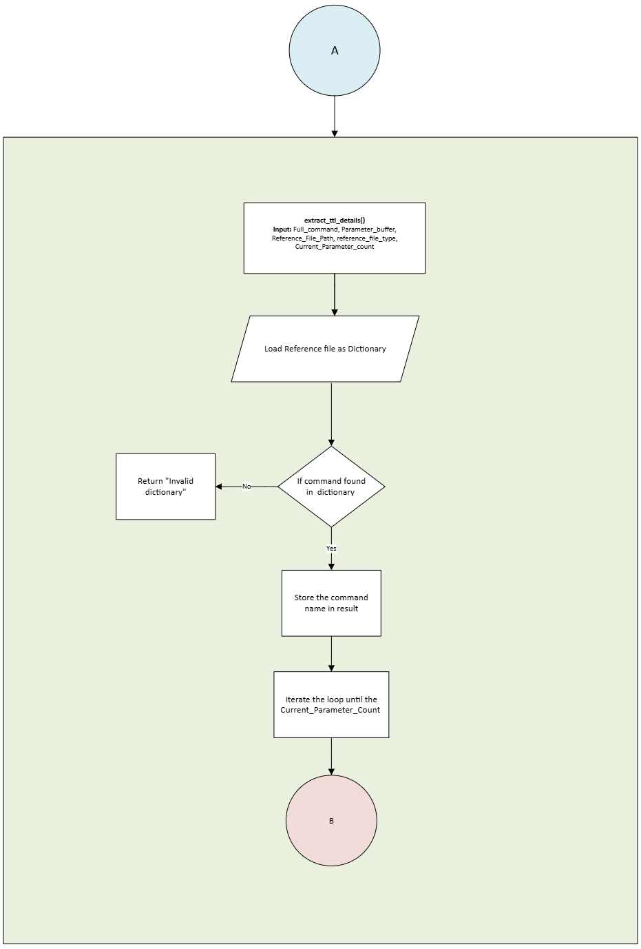

Reference Validation Module (A)
Load Reference Dictionary
Description: Loads the dictionary containing valid commands and terms.
Function: Provides the reference data used for validating commands in the TTL file.

Command Found in Dictionary?
Description: Verifies if the current command exists in the reference dictionary.
Function: Ensures the command is valid for processing.

Return "Invalid Dictionary"
Description: Handles cases where the command is not found in the dictionary.
Function: Outputs an error message indicating invalid command usage.

Scan Command and Initialize Variables
Description: Prepares valid commands for further processing.
Function: Initializes variables and prepares data structures required for parsing parameters.
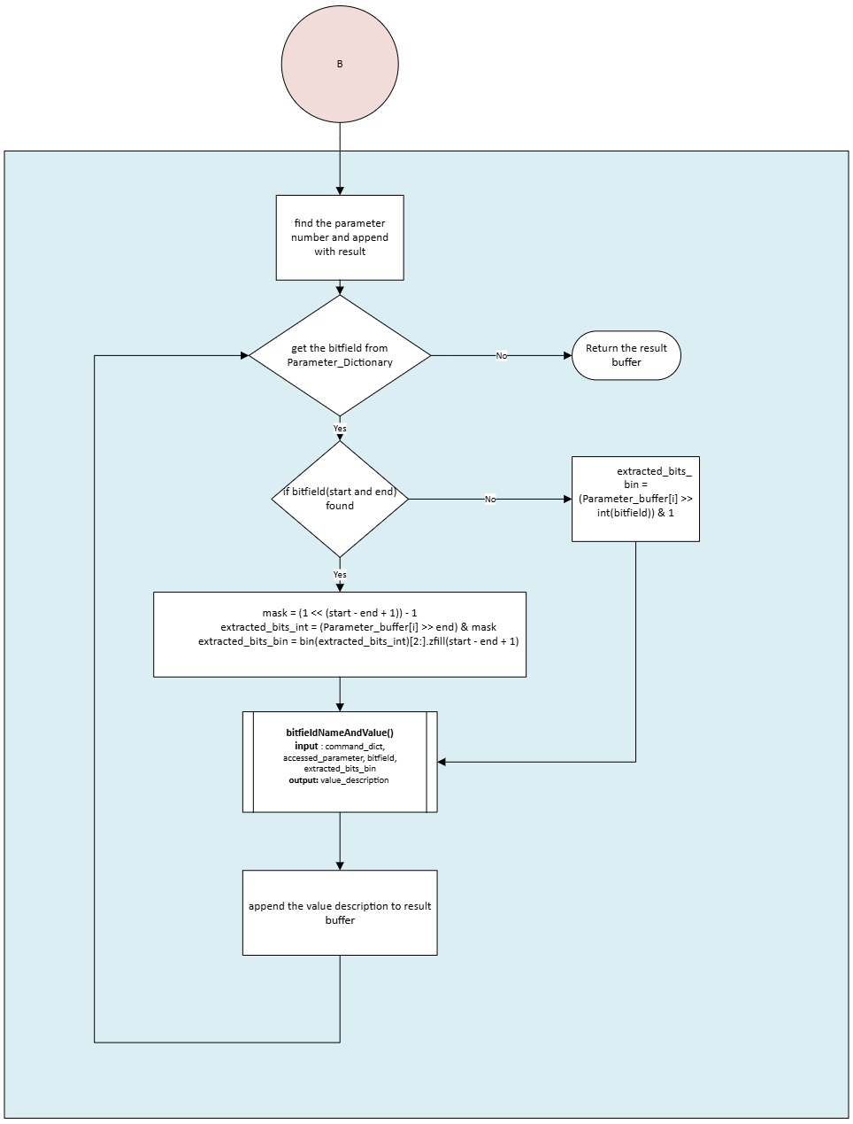

Parameter Parsing Module (B)
Find Parameters and Validate
Description: Extracts and validates key parameters from the command.
Function: Ensures parameters meet predefined constraints.

Use Validation and Embed into Transformed Information
Description: Processes validated parameters and embeds them into transformed data.
Function: Applies transformations and integrates the results into a structured output.

Store This Definition in Result Buffer
Description: Stores processed data in a temporary buffer.
Function: Prepares the data for final output writing.

Return Module Buffer
Description: Outputs the processed data from the module.
Function: Passes the result buffer back to the main workflow for further handling.

6 REFERENCES

The below is the reference of the TTL datas which are taken as the inputs.

DAHA1.8_on_ADSP21593_16Ch_SDK_Realtime_Command_Details_Status_Definitions.xlsx

