**NAME: NITHISHKUMAR T**

**REG NO:727721EUCS096**

**DAY:4**

**SELENIUM WEB-DRIVER**

1)

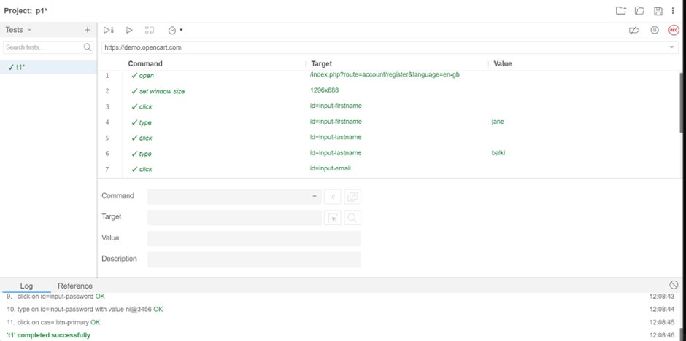

2)CODE:

package com.selenium.day3.ex1;

import org.openqa.selenium.By;

import org.openqa.selenium.JavascriptExecutor;

import org.openqa.selenium.WebDriver;

import org.openqa.selenium.WebElement;

import org.openqa.selenium.chrome.ChromeDriver;

import org.openqa.selenium.chrome.ChromeOptions;

import io.github.bonigarcia.wdm.WebDriverManager;

public class d3c2 {

public static void main(String[] args) throws InterruptedException {

WebDriverManager.chromedriver().setup();

ChromeOptions co=new ChromeOptions();

co.addArguments("--remote-allow-origins=*");

WebDriver driver=new ChromeDriver(co);

//open an url

driver.get("https://demo.opencart.com/index.php?route=account/register&language=en-gb");

//maximise

driver.manage().window().maximize();

// Thread.sleep(3000);

// JavascriptExecutor js = (JavascriptExecutor) driver;

// js.executeScript("window.scrollBy(0,100)","");

//accessing elements

WebElement fn=driver.findElement(By.id("input-firstname"));

fn.sendKeys("Jane");

WebElement fn1=driver.findElement(By.id("input-lastname"));

fn1.sendKeys("Balki");

WebElement fn2=driver.findElement(By.id("input-email"));

fn2.sendKeys("jane@gmail.com");

WebElement fn3=driver.findElement(By.id("input-password"));

fn3.sendKeys("12345");

WebElement fn4=driver.findElement(By.id("input-newsletter-yes"));

fn4.click();

//close

driver.quit();

}

}

OUTPUT:

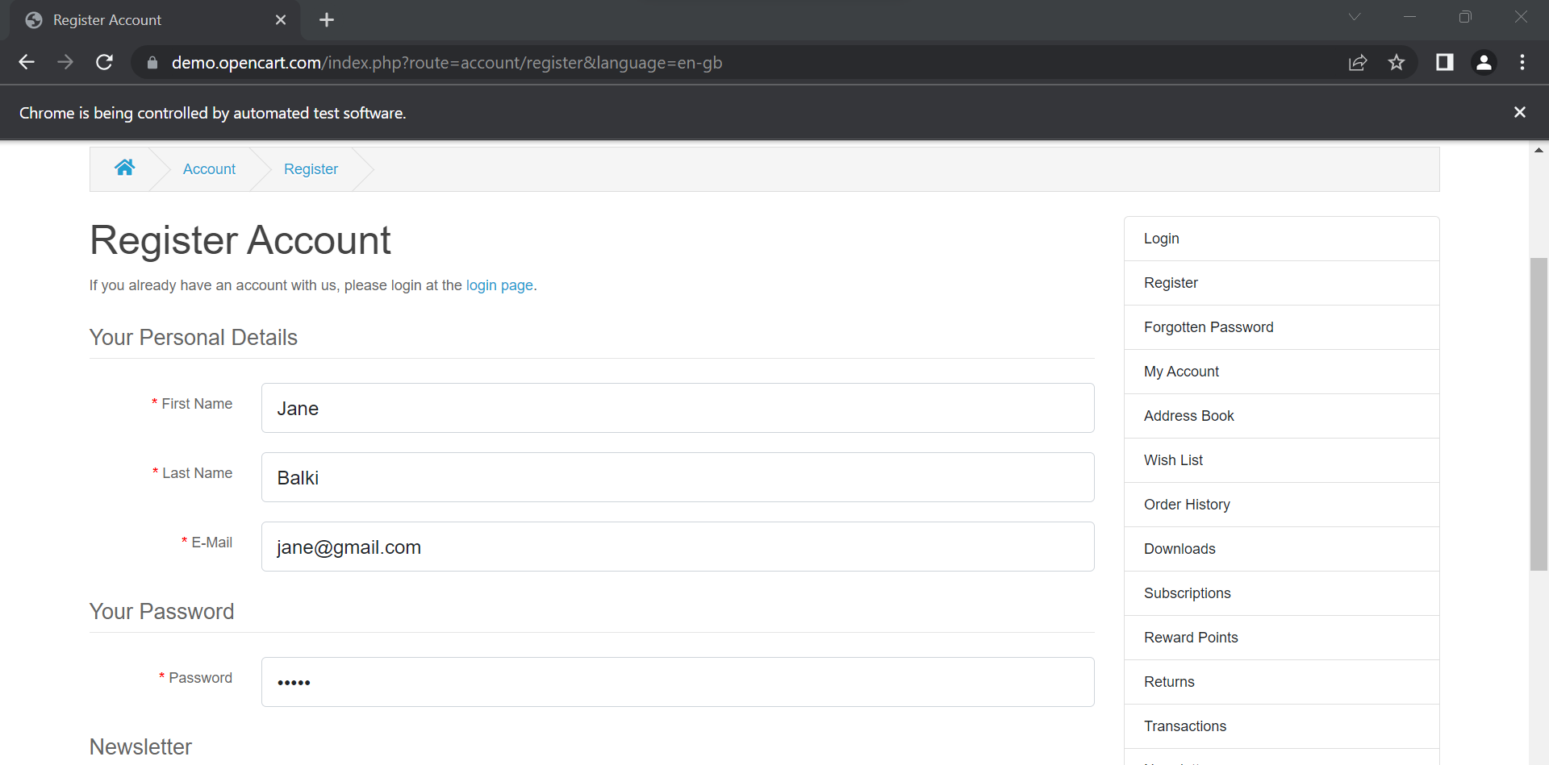

3)CODE:

package com.selenium.day3.ex1;

import org.openqa.selenium.By;

import org.openqa.selenium.JavascriptExecutor;

import org.openqa.selenium.WebDriver;

import org.openqa.selenium.chrome.ChromeDriver;

import org.openqa.selenium.chrome.ChromeOptions;

import io.github.bonigarcia.wdm.WebDriverManager;

public class d3c3 {

public static void main(String[] args) throws InterruptedException {

WebDriverManager.*chromedriver*().setup();

ChromeOptions co=new ChromeOptions();

co.addArguments("--remote-allow-origins=*");

WebDriver driver=new ChromeDriver(co);

//open an url

driver.get("https://j2store.net/free/");

//maximise

driver.manage().window().maximize();

//scroll

Thread.*sleep*(3000);

JavascriptExecutor js = (JavascriptExecutor) driver;

js.executeScript("window.scrollBy(0,1000)","");

//to access link

driver.findElement(By.*linkText*("Clothing (5)")).click();

//back

driver.navigate().back();

Thread.*sleep*(3000);

//forward

driver.navigate().forward();

Thread.*sleep*(3000);

//refresh

driver.navigate().refresh();

Thread.*sleep*(3000);

//close

driver.close();

}

}

OUTPUT:

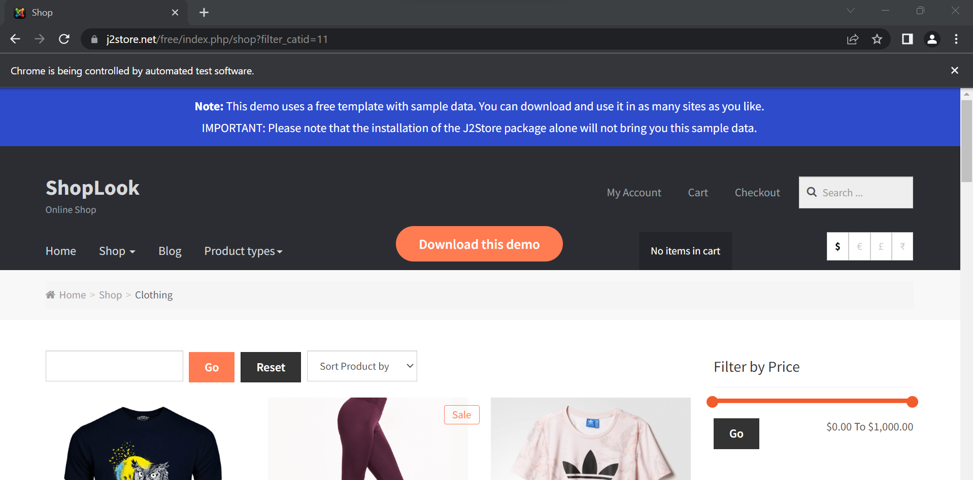

4)

package com.selenium.day3.ex1;

import java.util.List;

import org.openqa.selenium.By;

import org.openqa.selenium.JavascriptExecutor;

import org.openqa.selenium.WebDriver;

import org.openqa.selenium.WebElement;

import org.openqa.selenium.chrome.ChromeDriver;

import org.openqa.selenium.chrome.ChromeOptions;

import io.github.bonigarcia.wdm.WebDriverManager;

public class d3c5 {

public static void main(String[] args) throws InterruptedException {

WebDriverManager.*chromedriver*().setup();

ChromeOptions co=new ChromeOptions();

co.addArguments("--remote-allow-origins=*");

WebDriver driver=new ChromeDriver(co);

//open an url

driver.get("https://j2store.net/free/");

//maximise

driver.manage().window().maximize();

//scroll

Thread.*sleep*(3000);

JavascriptExecutor js = (JavascriptExecutor) driver;

js.executeScript("window.scrollBy(0,1000)","");

driver.findElement(By.*linkText*("Clothing (5)")).click();

//list

List<WebElement>l1=driver.findElements(By.*xpath*("//h2[@class='product-title']"));

for(WebElement mylist:l1) {

System.***out***.println(mylist.getText());

}

}

}

OUTPUT:

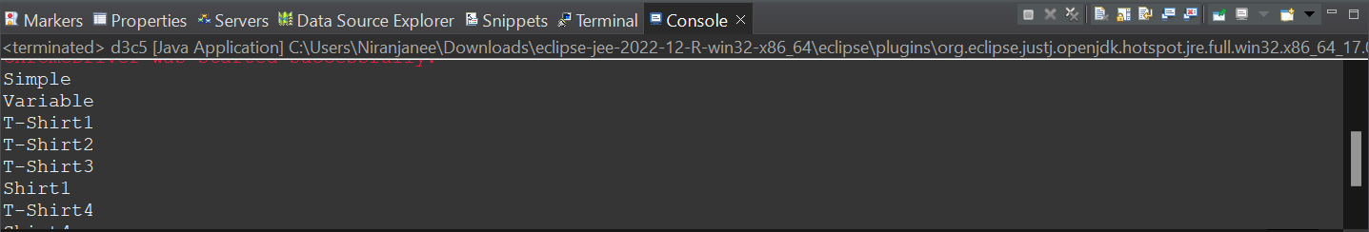

5)CODE;

package com.selenium.day3.ex1;

import org.openqa.selenium.By;

import org.openqa.selenium.Keys;

import org.openqa.selenium.WebDriver;

import org.openqa.selenium.chrome.ChromeDriver;

import org.openqa.selenium.chrome.ChromeOptions;

import io.github.bonigarcia.wdm.WebDriverManager;

public class d3c1 {

public static void main(String[] args) {

// to setup browser

WebDriverManager.chromedriver().setup();

ChromeOptions co=new ChromeOptions();

co.addArguments("--remote-allow-origins=*");

WebDriver driver=new ChromeDriver(co);

//open an url

driver.get("https://www.google.com");

//to maximise the screen

driver.manage().window().maximize();

//accessing the element to search

driver.findElement(By.name("q")).sendKeys("msd");

//driver.findElement(By.name("q")).sendKeys(Keys.ENTER);

driver.findElement(By.name("btnK")).submit();

//to close the browser

driver.quit();

}

}

OUTPUT:

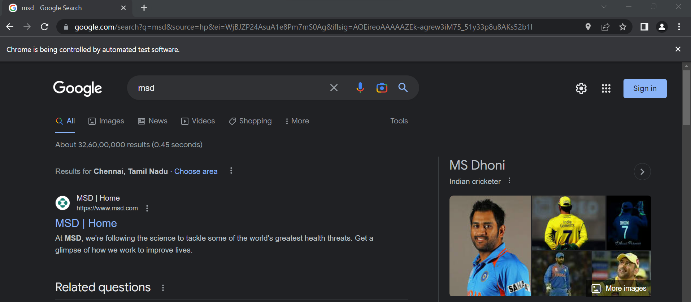

6)CODE:

package com.selenium.day3.ex1;

import org.openqa.selenium.By;

import org.openqa.selenium.JavascriptExecutor;

import org.openqa.selenium.WebDriver;

import org.openqa.selenium.chrome.ChromeDriver;

import org.openqa.selenium.chrome.ChromeOptions;

import io.github.bonigarcia.wdm.WebDriverManager;

public class d3c4 {

public static void main(String[] args) throws InterruptedException {

WebDriverManager.chromedriver().setup();

ChromeOptions co=new ChromeOptions();

co.addArguments("--remote-allow-origins=*");

WebDriver driver=new ChromeDriver(co);

//open an url

driver.get("https://j2store.net/free/");

//maximise

driver.manage().window().maximize();

//scroll

Thread.sleep(3000);

JavascriptExecutor js = (JavascriptExecutor) driver;

js.executeScript("window.scrollBy(0,1000)","");

String s1=driver.getCurrentUrl();

String s2="https://j2store.net/free/";

if(s1.equals(s2)) {

System.out.println(" same correct url");

}

else {

System.out.println("url not same");

}

driver.findElement(By.linkText("Clothing (5)")).click();

String s3=driver.getCurrentUrl();

if(s3.equals(s2)) {

System.out.println("same correct url");

}

else {

System.out.println("url not same");

}

}

}

OUTPUT:

