Step 1 – Create Database
Explanation
The CREATE DATABASE command creates a new database named bookflow_dbms. The USE command selects this database so that all subsequent SQL commands are executed within it. A successful execution confirms that the database has been created and activated.

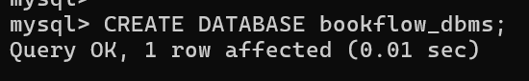

Step 2 – Create Books Table
Explanation
The Books table is created to store book information. It includes a PRIMARY KEY (book_id) to uniquely identify each book, a NOT NULL constraint on the title, a UNIQUE constraint on ISBN to prevent duplicate entries, and a CHECK constraint to ensure valid publication years.

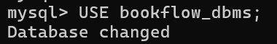
Step 3 – Insert Book Records
Explanation
Three sample book records are inserted into the Books table using a single INSERT INTO statement. The successful execution confirms that all records satisfy the defined constraints.
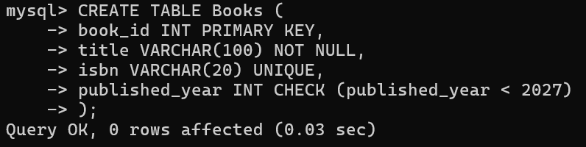

Step 4 – Display Books Table
Explanation
The SELECT * FROM Books; query displays all the records stored in the Books table. This verifies that the data has been inserted successfully.

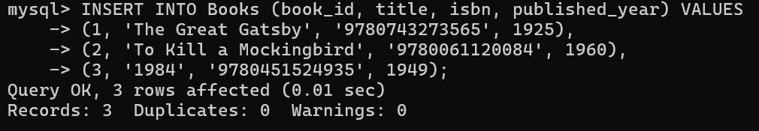
Step 5 – Create Members Table
Explanation
The Members table is created to maintain library member information. Each member has a unique member_id, while the email column is marked as UNIQUE to avoid duplicate registrations.

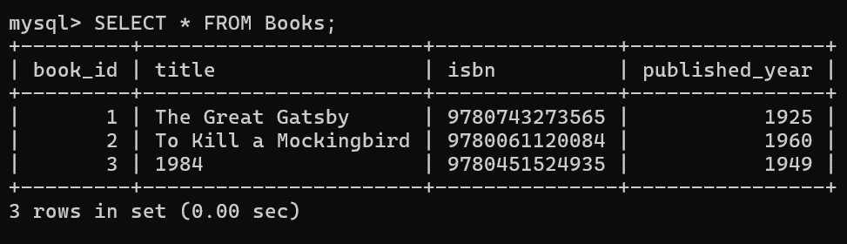
Step 6 – Display Members Table
Explanation
The SELECT * FROM Members; statement retrieves all member records. The output confirms that the member details have been stored correctly.

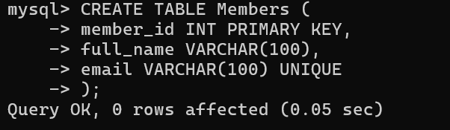
Step 7 – Create Loans Table
Explanation
The Loans table connects Members and Books using FOREIGN KEY constraints. It stores borrowing transactions while maintaining referential integrity between the related tables.

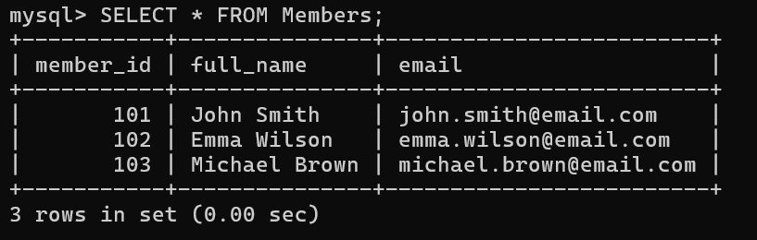
Step 8 – Insert Loan Records
Explanation
Ten borrowing transactions are inserted into the Loans table. Since all referenced members and books already exist, every record satisfies the foreign key constraints.

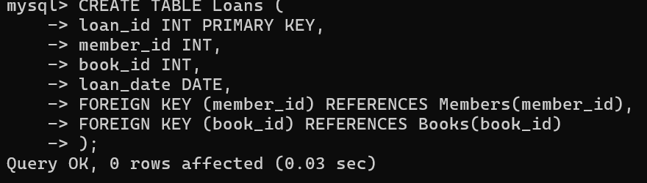

Step 9 – Display Loans Table
Explanation
The SELECT * FROM Loans; query displays all borrowing records, confirming that the loan information has been inserted successfully.

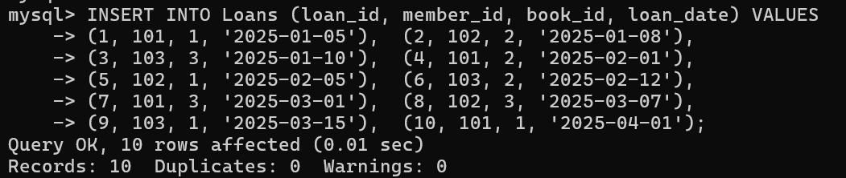

Step 10 – JOIN Query
Explanation
An INNER JOIN combines the Books, Members, and Loans tables to display readable information instead of numeric IDs. The output shows the member name together with the title of the borrowed book.

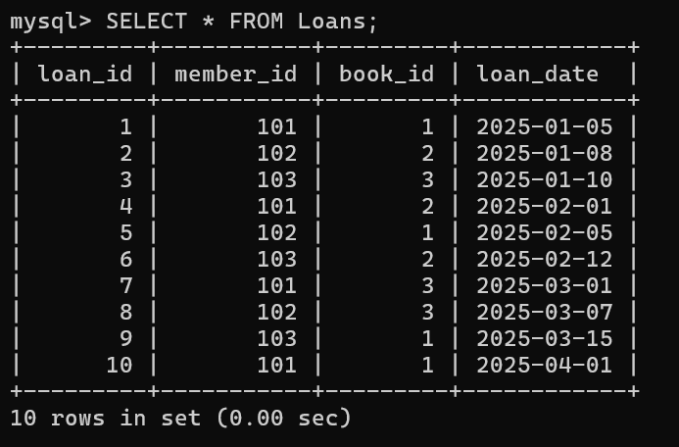
Step 11 – GROUP BY Query
Explanation
The GROUP BY clause groups books based on their publication year. The COUNT() function calculates how many books belong to each year, producing a summarized report.

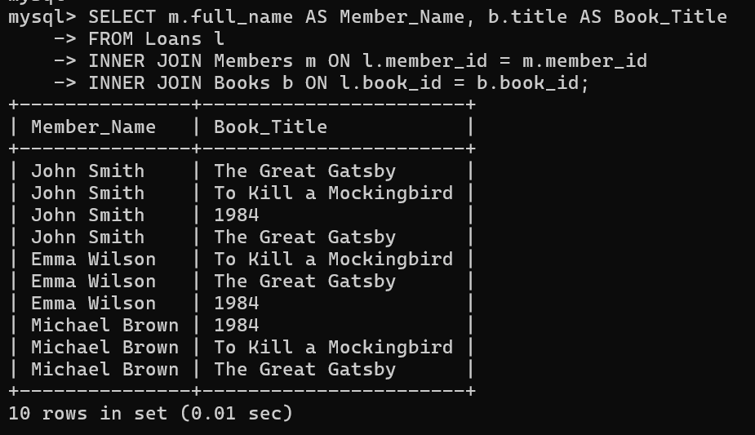

Step 12 – Create Donation History Table
Explanation
The Donation_History table records details of donated books. It maintains a relationship with the Books table through a foreign key.

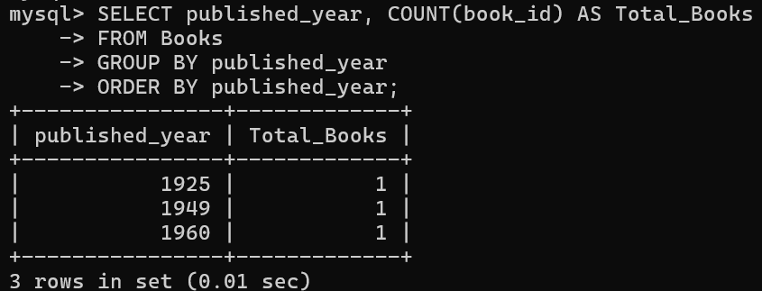

Step 13 – Start Transaction
Explanation
The START TRANSACTION statement begins an SQL transaction. Multiple database operations are treated as a single unit to maintain data consistency.

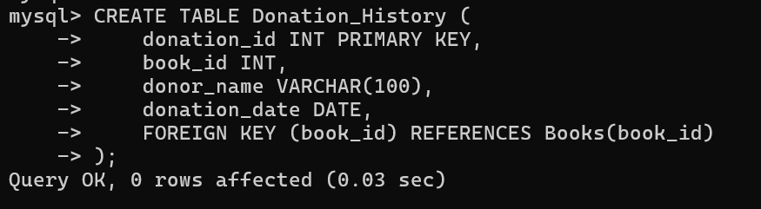
Step 14 – Insert New Book
Explanation
A new book (Animal Farm) is inserted into the Books table as part of the ongoing transaction.

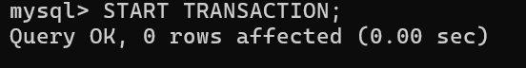
Step 15 – Insert Donation Record
Explanation
The donated book information is simultaneously recorded in the Donation_History table. Both operations belong to the same transaction.

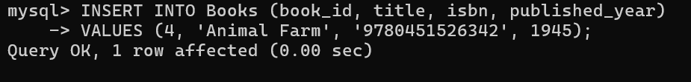

Step 16 – Commit Transaction
Explanation
The COMMIT statement permanently saves all changes made during the transaction. If any operation had failed, a rollback could have restored the database to its previous state.

Step 17 – Create Index
Explanation
An index named idx_books_isbn is created on the ISBN column. Indexing improves search performance by allowing MySQL to locate records more efficiently.

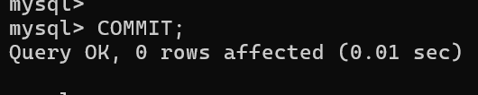

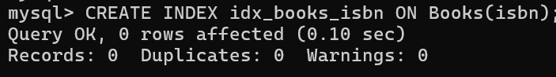
Step 18 – Search Using ISBN
Explanation
The SELECT query searches for a book using its ISBN value. Since an index exists on the ISBN column, the lookup is faster than performing a full table scan.

