A new database named bookflow_dbs was successfully created using the CREATE DATABASE IF NOT EXISTS command. After creating the database, the USE command was executed to make it the active database. The Books and Members tables were then created with appropriate constraints such as PRIMARY KEY, AUTO_INCREMENT, NOT NULL, UNIQUE, and CHECK to ensure data integrity and maintain accurate records.

Sample records were successfully inserted into both the Books and Members tables. The SELECT statements displayed all the inserted records, confirming that the data had been stored correctly. The output verifies that the tables were created successfully and all values satisfy the defined constraints.

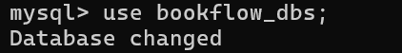
The CHECK constraint was tested by attempting to insert a book with an invalid publication year greater than the allowed limit. MySQL rejected the insertion and displayed an error message, proving that the CHECK constraint prevents invalid data from being stored in the database.
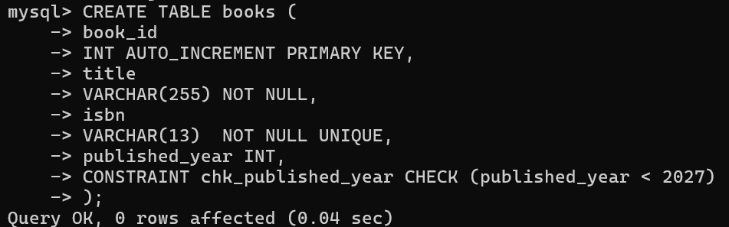

The UNIQUE constraint on the Email column was tested by inserting a duplicate email address. MySQL rejected the operation because duplicate values are not allowed in a column defined with the UNIQUE constraint. This ensures that every member has a distinct email address.
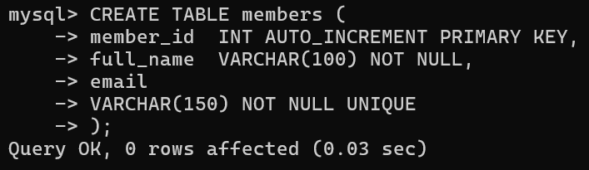

The UNIQUE constraint on the ISBN column was verified by attempting to insert another book with an ISBN value that already exists in the Books table. The database rejected the insertion and displayed an error, confirming that duplicate ISBN numbers are not permitted.

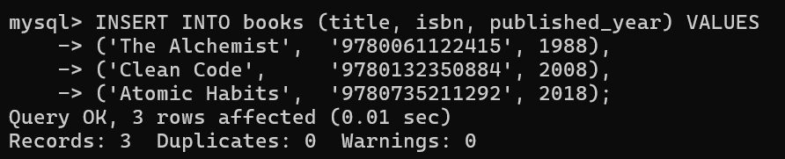

The NOT NULL constraint was tested by inserting a record with a NULL value in the Title column. Since the Title field is mandatory, MySQL rejected the operation and generated an error message. This confirms that essential fields cannot be left empty.

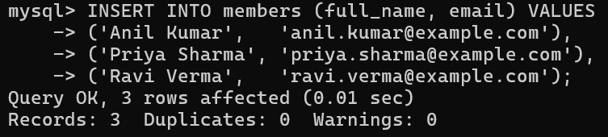
The BookFlow database was successfully created with the required tables and constraints. Sample data was inserted and displayed successfully. All constraints, including PRIMARY KEY, AUTO_INCREMENT, NOT NULL, UNIQUE, and CHECK, were verified by testing both valid and invalid data, producing the expected results.

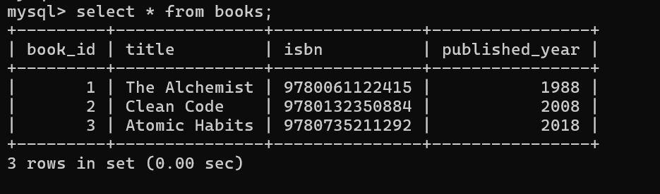

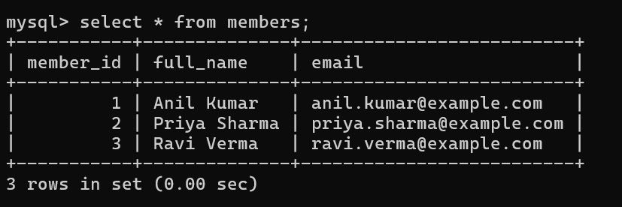

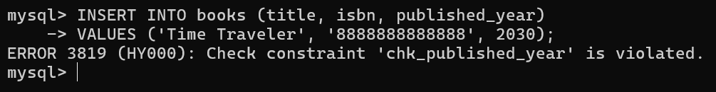
Testings

