“ICON_OSSP – System Call Demonstration and Monitoring System”
A Project Report Submitted in partial fulfillment of the requirements for the course
OPERATING SYSTEMS AND SYSTEMS PROGRAMMING (25CS2104E)
BACHELOR OF TECHNOLOGY
in
DEPARTMENT OF COMPUTER SCIENCE ENGINEERING
By
NITHISH S | 2520030346
SAI SATHWIK | 2520030328
VIVEK | 2520030532
Under the Esteemed Guidance of
K. Hema
Faculty – Operating Systems and Systems Programming
Section 7 · Team 13 · Academic Year 2026–27



K L (Deemed to be) University
DEPARTMENT OF COMPUTER SCIENCE ENGINEERING
DECLARATION
We hereby declare that the project report entitled “ICON_OSSP – System Call Demonstration and Monitoring System” is a record of the bonafide work carried out by Nithish S (2520030346), Sai Sathwik (2520030328), and Vivek (2520030532), Section 7, Team 13, as part of the course Operating Systems and Systems Programming (25CS2104E). The work presented in this report has been developed for academic demonstration of Linux file I/O, process management, synchronization, error handling, signals, /proc inspection, and system-call tracing. To the best of our knowledge, the results and implementation described here are our project work and have not been submitted to another department, university, or institute for another award.

Student | Roll Number | Signature
Nithish S | 2520030346 | ________________
Sai Sathwik | 2520030328 | ________________
Vivek | 2520030532 | ________________

K L (Deemed to be) University
DEPARTMENT OF COMPUTER SCIENCE ENGINEERING
CERTIFICATE
This is to certify that the project report entitled “ICON_OSSP – System Call Demonstration and Monitoring System” is a bonafide work carried out by Nithish S (2520030346), Sai Sathwik (2520030328), and Vivek (2520030532), Section 7, Team 13, in partial fulfillment of the academic requirements of Operating Systems and Systems Programming (25CS2104E) during the academic year 2026–27. The project demonstrates real Linux/POSIX operations through a C backend and presents their outputs through a desktop visual interface.

Signature of the Guide | Signature of the Course Coordinator | Signature of the HOD
________________ | ________________ | ________________

ACKNOWLEDGEMENT
We express our sincere gratitude to our faculty guide K. Hema for the guidance, encouragement, and technical feedback provided throughout the development of ICON_OSSP. The discussions on process creation, execution, synchronization, Linux system calls, testing, and demonstration helped us convert classroom concepts into a working systems-programming project.
We thank the Department of Computer Science Engineering, K L University, for providing the academic environment and facilities required to complete this work. We also thank the teaching and non-teaching staff who supported the course and project activities.
Finally, we thank our teammates, classmates, friends, and family members for their cooperation and support during implementation, debugging, documentation, and presentation preparation.
Student | Roll Number
Nithish S | 2520030346
Sai Sathwik | 2520030328
Vivek | 2520030532

ABSTRACT
ICON_OSSP (System Call Demonstration and Monitoring System) is a Linux-based systems-programming project designed to make operating-system concepts visible, practical, and traceable. Students often learn open(), read(), write(), fork(), exec(), waitpid(), errno, signals, and strace as separate theoretical examples. The project brings these mechanisms into one structured visual laboratory in which a user can trigger real operations and immediately observe file descriptors, process identifiers, process states, exit status, return values, error numbers, readable error messages, /proc information, and system-call traces.
The final system uses a native desktop interface as the visualization and control layer, a local API on 127.0.0.1, and a C backend running inside Ubuntu/Linux. The C backend performs the actual POSIX/Linux operations; the interface does not simulate operating-system results. The modules include File Lab, Process Lab, Exec Lab, Synchronization Lab, Interactive Error Lab, System Call Trace, and Signals & /proc. strace is used to observe kernel-facing activity such as openat(), clone()/clone3(), execve(), and wait4(), providing evidence of how user-space requests reach Linux kernel services.
The completed project provides a reproducible demonstration environment for Linux file I/O, process creation, program replacement, parent-child synchronization, error handling, signal-based process control, process inspection, and trace analysis. It supports classroom explanation, practical experimentation, project review, and viva preparation while keeping the implementation grounded in real C and Linux APIs.
Keywords: Linux, system calls, POSIX, C, fork, exec, waitpid, errno, strace, signals, /proc, process management.

INDEX
S. No. | Chapter / Topics | Page
 | Acknowledgement | 4
 | Abstract | 5
1 | Introduction | 8
1.1 | Background of the Project | 8
1.2 | Problem Statement | 8
1.3 | Scope of the Project | 9
1.4 | Objectives of the Project | 9
1.5 | Importance of the Application | 9
1.6 | Target Users / Audience | 9
2 | OS Concepts and Background Study | 10
2.1 | Operating System Concepts Related to the Project | 10
2.2 | Existing Methods / Algorithms | 10
2.3 | Proposed Approach | 11
2.4 | Advantages of the Proposed Approach | 11
3 | System Requirements | 12
3.1 | Hardware Requirements | 12
3.2 | Software Requirements | 12
3.3 | Operating System Environment – Ubuntu / WSL | 12
3.4 | Development Tools and Compilers | 12
4 | Technology and Tools Used | 13
4.1 | C Programming | 13
4.2 | GCC Compiler | 13
4.3 | Linux System Calls / POSIX APIs | 13
4.4 | POSIX Threads / Synchronization | 13
4.5 | Linux Commands and Utilities | 13
4.6 | Other Tools / Libraries Used | 14
5 | System Architecture and Design | 15
5.1 | Overall System Architecture | 15
5.2 | System Workflow | 15
5.3 | Flowchart / Data Flow | 16
5.4 | Module Description | 16
5.5 | Input and Output Design | 16
6 | Implementation | 17
6.1 | Module-wise Implementation | 17
6.2 | Algorithm / Pseudocode | 22
6.3 | Core C Implementation | 22
6.4 | Linux System Calls / APIs Used | 23
6.5 | Process / Thread Implementation | 23
6.6 | Synchronization Implementation | 23
6.7 | Memory Management Implementation | 24
6.8 | Desktop User Interface Implementation | 24
7 | Execution and Demonstration | 25
7.1 | Compilation in Ubuntu / WSL | 25
7.2 | Execution Commands | 25
7.3 | Sample Inputs and Outputs | 26
7.4 | Screenshots of Execution | 26
7.5 | Demonstration of OS Concepts | 27
8 | Conclusion | 29
8.1 | Summary of the Project | 29
8.2 | Objectives Achieved | 29
8.3 | Results Achieved | 29
8.4 | Skills and Learning Outcomes | 29
9 | References | 30

CHAPTER - 1
INTRODUCTION

1.1 Background of the Project
Operating systems provide controlled access to hardware and protected resources. A normal user-space program does not directly manipulate process tables, file-system metadata, or privileged kernel structures. Instead, it requests services using operating-system interfaces. In Linux systems programming, commonly used interfaces include open(), read(), write(), close(), fork(), exec(), waitpid(), kill(), and process information exposed through /proc.
Although these concepts are fundamental, they are often learned through separate small programs. That makes it difficult for a beginner to connect an application-level action with the corresponding process state, return value, error condition, or kernel-facing activity. ICON_OSSP was created to provide one integrated environment in which the same concepts can be executed and observed visually.
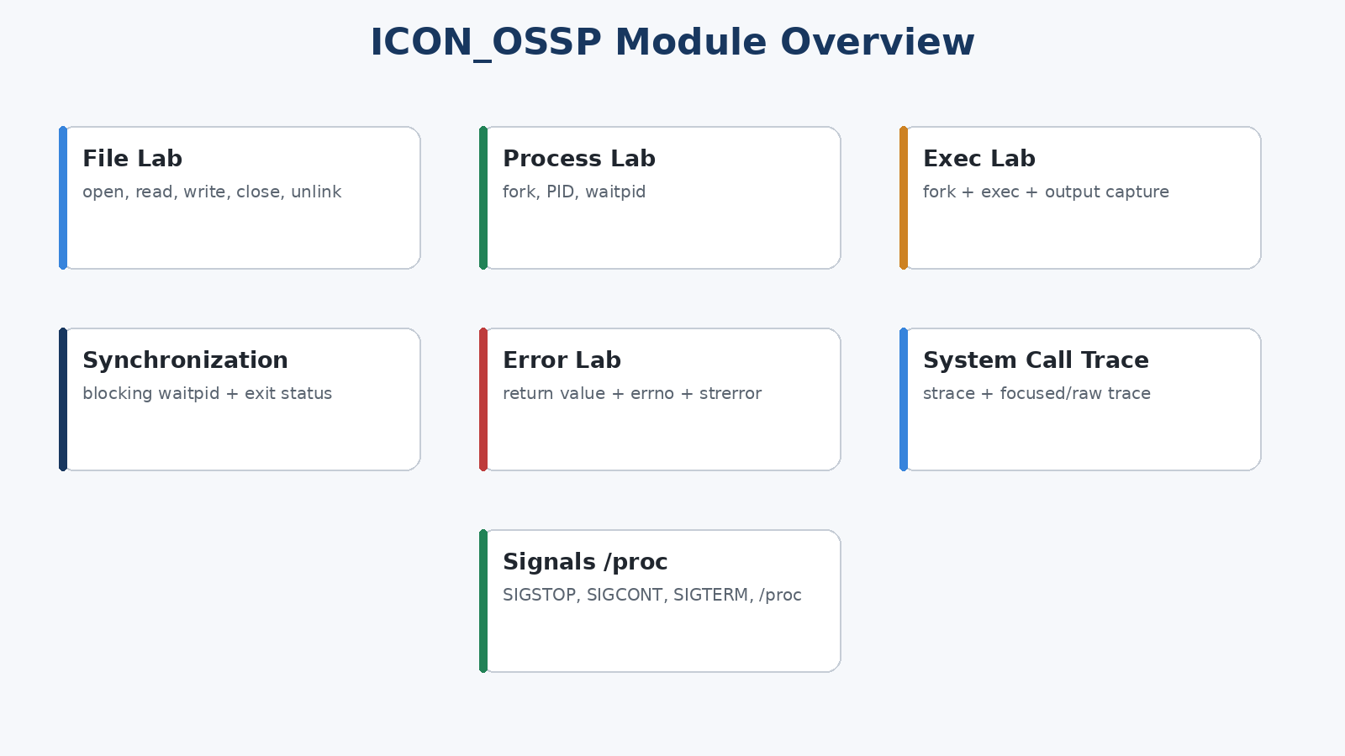
Figure 1.1 – Modules included in the ICON_OSSP visual laboratory

1.2 Problem Statement
The central problem addressed by the project is the gap between theoretical system-call knowledge and practical observation. Students may remember what fork(), exec(), or waitpid() is defined to do, but may still find it difficult to answer practical questions such as: Which PID belongs to the child? What does an open() call return? What happens after a descriptor is closed? How does a parent know a child has terminated? What error does Linux report for a missing file? Which lower-level calls appear when the program is traced?
ICON_OSSP addresses this problem by performing real Linux operations in a C backend, collecting their results, and presenting them through a visual interface. Controlled failure cases and real strace evidence are included so that successful and unsuccessful behavior can both be studied.

1.3 Scope of the Project
- Low-level file operations: create/open, write, append, read, close, inspect, and delete files.
- Process creation using fork() with visible parent/child PIDs and child state tracking.
- Program execution through fork() + exec(), with stdout/stderr captured for display.
- Parent-child synchronization using blocking waitpid() and exit-status collection.
- Controlled error demonstrations using return values, errno, and strerror().
- Real system-call monitoring using strace with focused and raw trace logs.
- Signal-based process control using SIGSTOP, SIGCONT, and SIGTERM.
- Live process inspection from /proc/<pid>/status.
- A desktop visual interface that acts as a control and visualization layer while the operating-system work remains in Linux C.

1.4 Objectives of the Project
- Demonstrate fundamental Linux file operations and their return values.
- Implement process creation, execution, and parent-child synchronization using fork(), exec(), and waitpid().
- Demonstrate controlled error conditions and explain them using errno and strerror().
- Observe and analyze kernel-facing system-call activity using strace.
- Provide a visual and reproducible environment for project review, testing, and viva demonstration.

1.5 Importance of the Application
The project makes otherwise invisible operating-system behavior observable. A file descriptor can be seen as an actual number returned by Linux; a child process can be identified by its PID; a parent can visibly transition from waiting to continued; errno can be linked to a failed operation; and a source-level API such as fork() can be compared with the clone()/clone3() activity reported by strace. This makes the project useful as an educational laboratory rather than only a code submission.

1.6 Target Users / Audience
The primary audience is students learning operating systems, Linux programming, and POSIX process management. The application is also suitable for classroom demonstrations, lab reviews, viva preparation, and instructors who want a compact demonstration of file and process mechanisms.

CHAPTER - 2
OS CONCEPTS AND BACKGROUND STUDY

2.1 Operating System Concepts Related to the Project
User space and kernel space form the basic context of ICON_OSSP. The desktop interface and C application logic execute in user space. When a protected service is required, Linux performs the requested operation in kernel context and returns a result to the calling process. The project focuses on observable interfaces to those services rather than modifying the kernel.
Concept | Project Usage | Key Observation
File descriptor | Returned by open(); used by read/write/close | Integer handle local to the process
Process | Created with fork() | Parent and child have separate PIDs
Program execution | Performed with exec family | Successful exec replaces the current program image
Synchronization | wait()/waitpid() | Parent collects child termination status
Error handling | errno + strerror() | Failure reason can be interpreted and displayed
Signals | kill(pid, signal) | Running process can be paused, resumed, or terminated
/proc | /proc/<pid>/status | Live process information exposed by Linux
System-call tracing | strace | Kernel-facing activity can be recorded and analyzed

2.2 Existing Methods / Algorithms
A conventional approach is to write one small C program for each topic: a file-I/O example for open/read/write/close, a separate fork example, another exec example, and a separate strace command in the terminal. These programs are technically correct but fragmented. Their outputs are usually raw terminal text, so a beginner must manually connect the code, process state, return values, and trace results.
ICON_OSSP does not introduce a new scheduling or operating-system algorithm. Instead, it integrates standard Linux/POSIX mechanisms into a single visual laboratory and adds controlled observation, logging, and trace presentation.

2.3 Proposed Approach
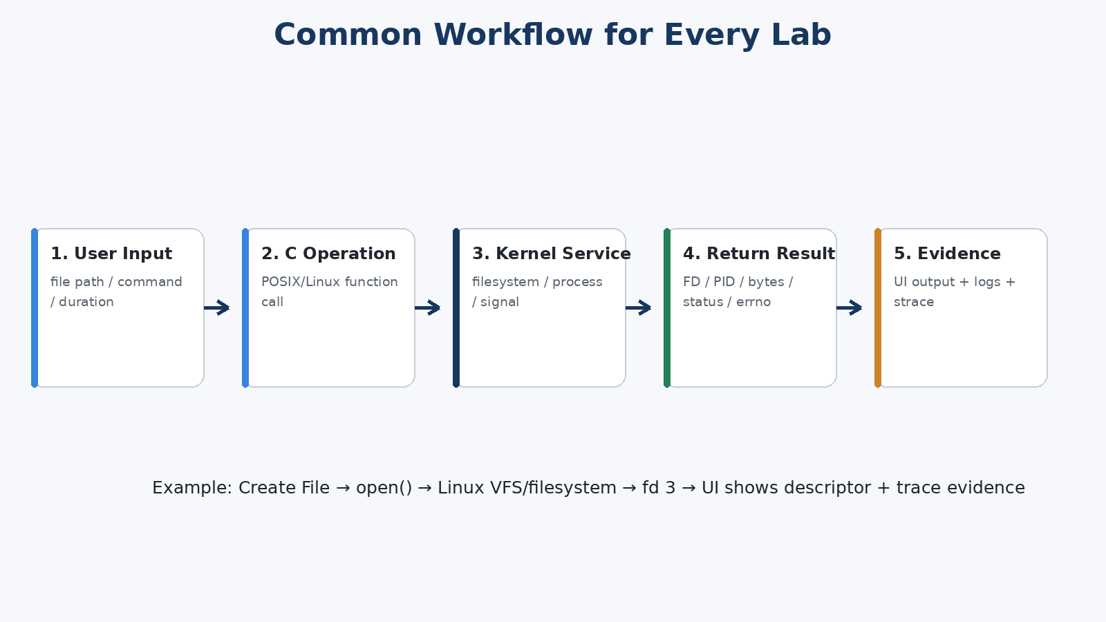
Figure 2.1 – Common input-to-kernel-to-evidence workflow used by the project
The proposed approach separates visualization from the operating-system implementation. User actions are sent from the desktop interface to a local backend. The backend executes the appropriate C/POSIX operation, obtains the real Linux result, and returns structured information for display. For trace demonstrations, strace is executed around a small controlled target or the full backend session, depending on the final launcher configuration.

2.4 Advantages of the Proposed Approach
- Combines multiple core OS concepts in one application.
- Uses real Linux/POSIX operations rather than simulated dashboard data.
- Makes PIDs, file descriptors, exit codes, return values, and errno visible.
- Keeps blocking waits away from the user-interface thread.
- Provides raw logs and focused trace evidence for reproducible demonstrations.
- Allows the same project to support implementation review, testing, and viva explanation.

CHAPTER - 3
SYSTEM REQUIREMENTS

3.1 Hardware Requirements
Component | Minimum / Recommended
Processor | 64-bit Intel/AMD processor; multi-core recommended
Memory | 4 GB minimum; 8 GB or more recommended
Storage | At least 500 MB free for source, compiler output, logs, and screenshots
Display | 1366 × 768 or higher
Network | Not required for normal local execution after dependencies are installed

3.2 Software Requirements
Software | Purpose
Ubuntu Linux / WSL2 Ubuntu | Runs the Linux C backend and POSIX demonstrations
GCC | Compiles C source files
GNU Make | Build automation
strace | System-call tracing
Windows PowerShell + .NET WinForms | Native desktop visual interface in the final WSL build
curl | Launcher readiness checks
iproute2 / ss | Checks available localhost port
Coreutils | Process/session utilities used by the launcher

3.3 Operating System Environment – Ubuntu / WSL
The final development and demonstration workflow is designed for Ubuntu/Linux and is compatible with Windows Subsystem for Linux (WSL). The Linux backend runs inside Ubuntu and exposes only a local loopback API. The native desktop interface opens on Windows and communicates with the backend through 127.0.0.1. This arrangement keeps the operating-system demonstrations in Linux while providing a reliable desktop presentation layer on the user’s Windows system.

3.4 Development Tools and Compilers
GCC compiles the core backend, command-line modules, and controlled trace target. GNU Make provides repeatable build commands. strace is used for trace capture. The project also uses standard Linux utilities and shell scripting to build, launch, test, and stop the application safely.

CHAPTER - 4
TECHNOLOGY AND TOOLS USED

4.1 C Programming
C is used for the actual systems-programming implementation because it provides direct access to POSIX/Linux APIs, file descriptors, process creation, signal handling, and low-level return values. The project keeps the core OS behavior in C even though the final interface is a desktop visual layer.

4.2 GCC Compiler
GCC is used through the Makefile to compile the backend and helper programs. The build enables warnings so implementation problems can be caught early. The final launcher performs a clean build before starting the application.

4.3 Linux System Calls / POSIX APIs
API / Call | Purpose in ICON_OSSP
open() | Create or open a file and obtain a descriptor
read() | Read bytes from files and /proc entries
write() | Write content to a file
close() | Release an open descriptor
unlink() | Delete a file path
lseek() | Move the current file offset
fork() | Create child processes
execlp()/exec family | Replace child program with selected executable
dup2() | Redirect stdout/stderr before exec
waitpid() | Collect child state/termination status
kill() | Send SIGSTOP, SIGCONT, or SIGTERM
stat()/fstat() | Read file metadata

4.4 POSIX Threads / Synchronization
The Synchronization Lab intentionally demonstrates a blocking waitpid(child_pid, &status, 0). To prevent this blocking call from freezing the visual application, the waiting work is performed in a worker thread. Shared synchronization state is protected before being read or updated by concurrent backend work.

4.5 Linux Commands and Utilities
- make / gcc – build the project.
- strace – capture system-call activity.
- curl – verify that the local backend is ready.
- ss – detect an available localhost port.
- bash – launch and coordinate build/start/cleanup steps.

4.6 Other Tools / Libraries Used
The final desktop UI uses Windows PowerShell with .NET Windows Forms. It acts only as the visual/control layer. Communication is local to the computer and the C backend remains responsible for the OS demonstrations.

CHAPTER - 5
SYSTEM ARCHITECTURE AND DESIGN

5.1 Overall System Architecture
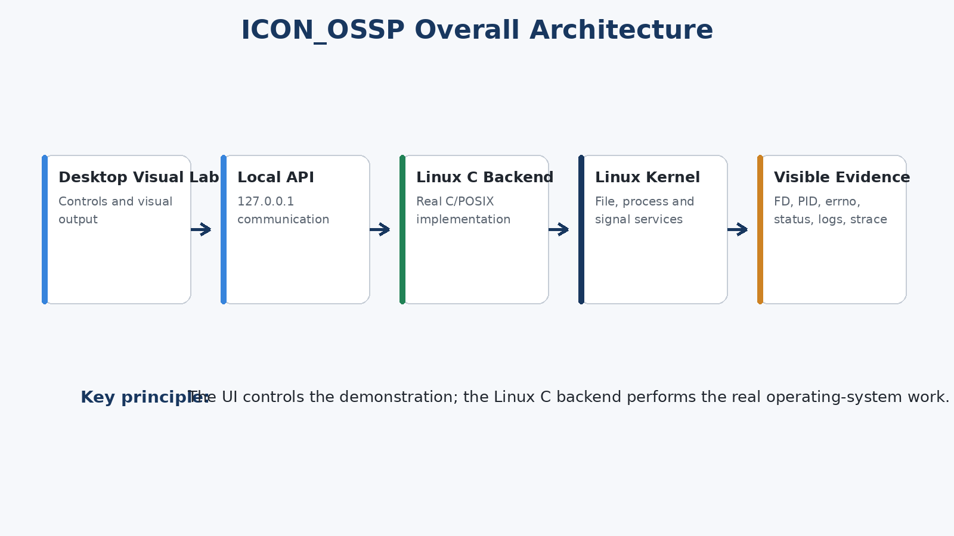
Figure 5.1 – Final ICON_OSSP architecture
The final architecture is deliberately layered. The desktop interface collects user input and shows results. A localhost API transfers requests to the Linux backend. The backend invokes POSIX/Linux operations and returns structured results. strace and log files provide supporting evidence. Because the UI does not generate fake PIDs, descriptors, or error numbers, the values shown originate from real backend execution.

5.2 System Workflow
Figure 5.2 – General workflow from user input to visible evidence

5.3 Flowchart / Data Flow
A typical request begins with a user action such as Create File, Create Process, Run Program, Start Synchronization, or Send Signal. The UI validates basic input, sends a localhost request, and waits for a backend response. The backend selects the corresponding module, performs the Linux operation, records state or output, and responds. For long-running child processes the UI polls status instead of blocking.

5.4 Module Description
Module | Input | Main Operation | Output
File Lab | Path + content | open/write/read/close/unlink | FD, bytes, preview, size, permissions
Process Lab | Child count + duration | fork + waitpid(WNOHANG) | PIDs, running/exited state, status
Exec Lab | Program + argument | fork + dup2 + execlp + waitpid | Captured stdout/stderr + exit status
Synchronization | Duration + exit code | fork + blocking waitpid | WAITING/RUNNING → CONTINUED/EXITED
Error Lab | Path + selected operation | real failing/successful calls | return value, errno, strerror explanation
System Call Trace | Trace mode/session history | strace | focused trace + raw log
Signals /proc | Lifetime + signal | kill + /proc read | state, PID, PPID, thread count

5.5 Input and Output Design
Input fields are intentionally small and directly related to the OS concept being demonstrated: file path and content, child count and duration, program and argument, synchronization duration and exit code, error-test path and operation, trace mode, and signal-demo child lifetime. Output is kept close to the action that produced it, with a shared Activity Timeline recording major events.
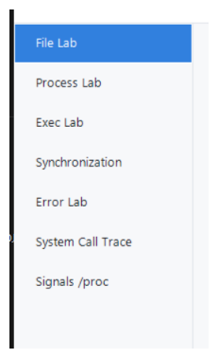
Figure 5.3 – Final navigation modules shown in the desktop application

CHAPTER - 6
IMPLEMENTATION

6.1 Module-wise Implementation

File Lab
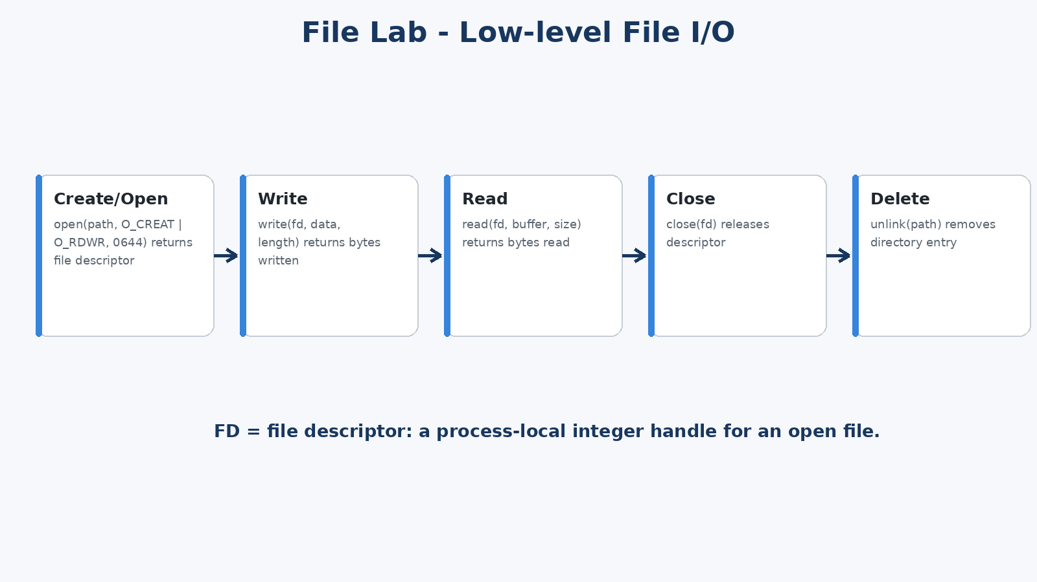
Figure 6.1 – File Lab implementation flow
The File Lab builds or accepts a path, opens it using low-level flags, and stores the returned descriptor as backend state. Write operations can reset the file position and write the supplied content. Read operations reposition the descriptor, obtain file size information, allocate a bounded buffer, read bytes, and return a preview. close() invalidates the current open handle while leaving the file on disk; unlink() removes the selected file path.
Core file-I/O pattern used by the project
int fd = open(path, O_CREAT | O_RDWR, 0644);
if (fd == -1) {
/* return errno and strerror(errno) */
}
ssize_t n = write(fd, content, length);
lseek(fd, 0, SEEK_SET);
ssize_t r = read(fd, buffer, capacity);
close(fd);

Process Lab
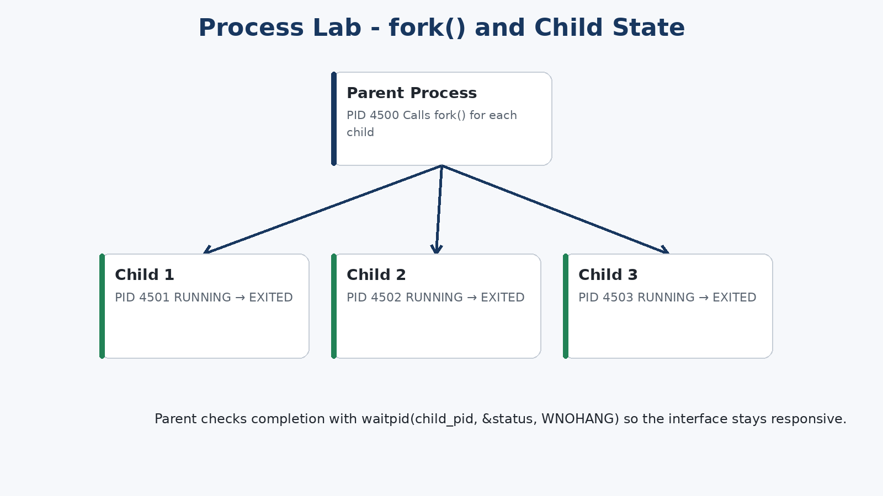
Figure 6.2 – Process creation and non-blocking state observation
The Process Lab creates one or more children with fork(). Each child remains alive for the selected duration and exits with a small status value. The parent stores every child PID. Status checks use waitpid(pid, &status, WNOHANG), allowing the backend to report RUNNING while a child is active and EXITED after the parent has reaped it.
Simplified fork() and non-blocking wait pattern
pid_t pid = fork();
if (pid == 0) {
sleep(duration);
_exit(exit_code);
}
int status = 0;
pid_t result = waitpid(pid, &status, WNOHANG);

Exec Lab
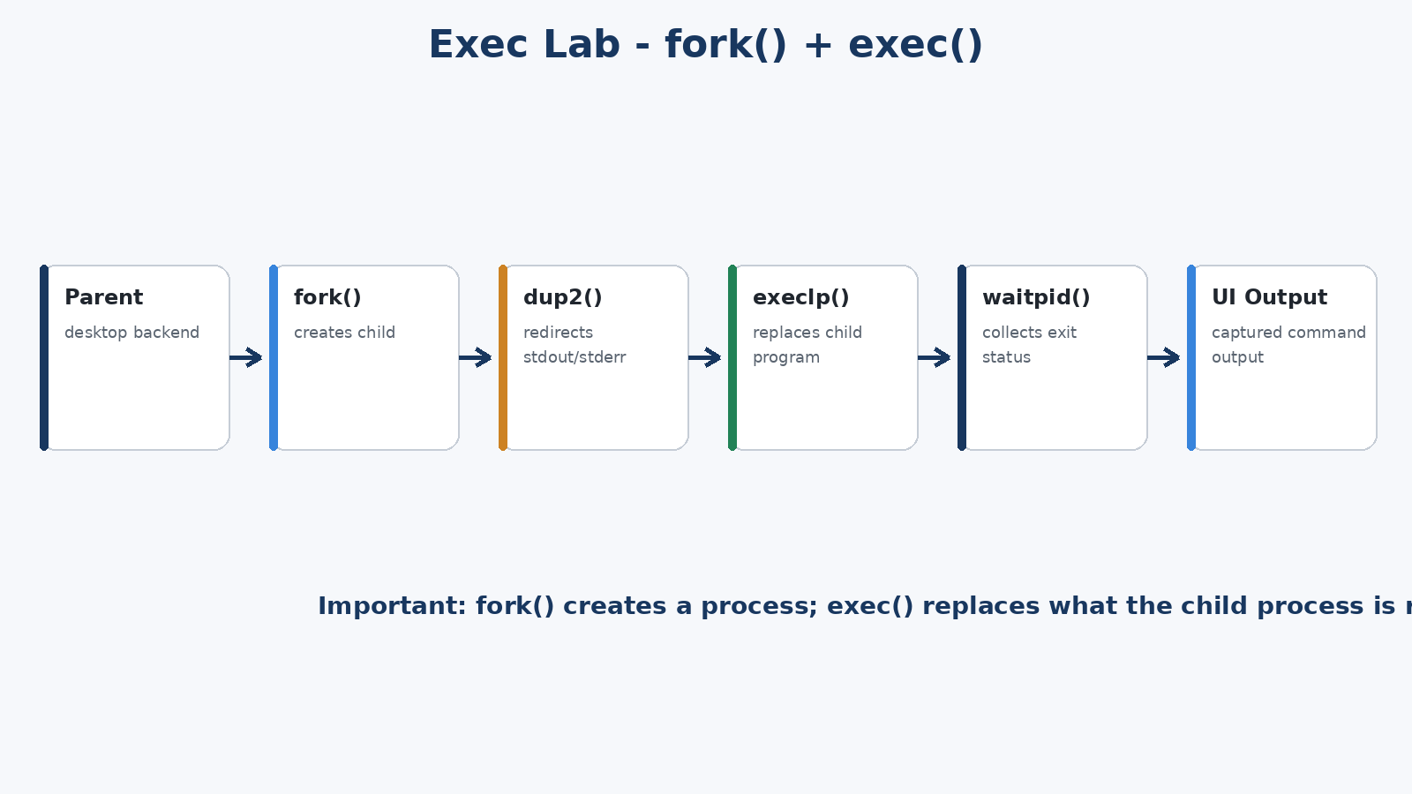
Figure 6.3 – Program execution flow
Exec Lab separates process creation from program execution. The parent first calls fork(). In the child, output is redirected with dup2() and the selected command is started with execlp(). A successful exec does not return to the old child code; the same child PID now runs the new program. The parent later uses waitpid() and reads the captured output for display.
Simplified fork–redirect–exec–wait sequence
pid_t pid = fork();
if (pid == 0) {
dup2(out_fd, STDOUT_FILENO);
dup2(out_fd, STDERR_FILENO);
execlp(program, program, argument, NULL);
_exit(127);
}
waitpid(pid, &status, 0);

Synchronization Lab
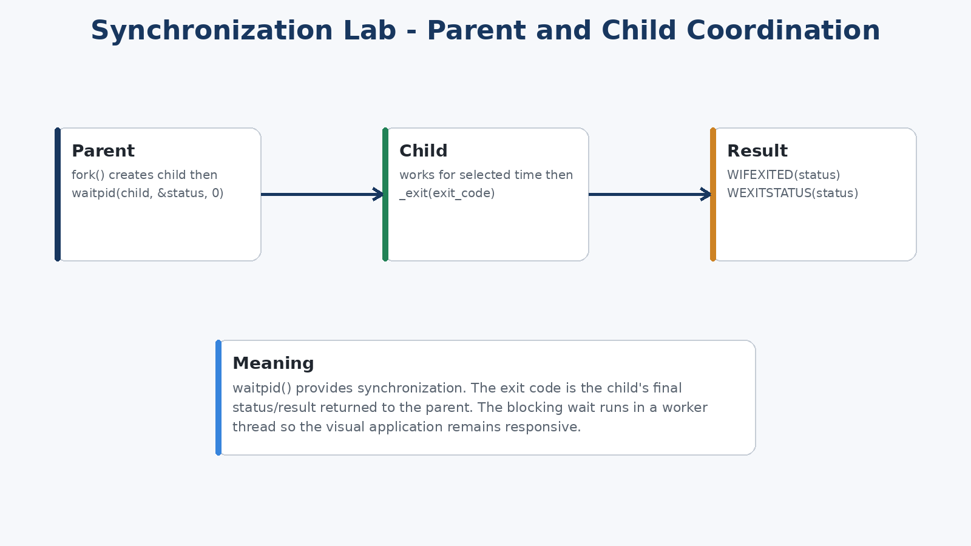
Figure 6.4 – Parent-child synchronization using blocking waitpid()
Synchronization uses waitpid(child_pid, &status, 0), which blocks until the selected child terminates. The child sleeps for the selected work duration and exits with the chosen exit code. The parent extracts the result with WIFEXITED(status) and WEXITSTATUS(status). In the final backend, the blocking wait is isolated from the main request-handling path so the desktop interface can remain responsive.

Interactive Error Lab
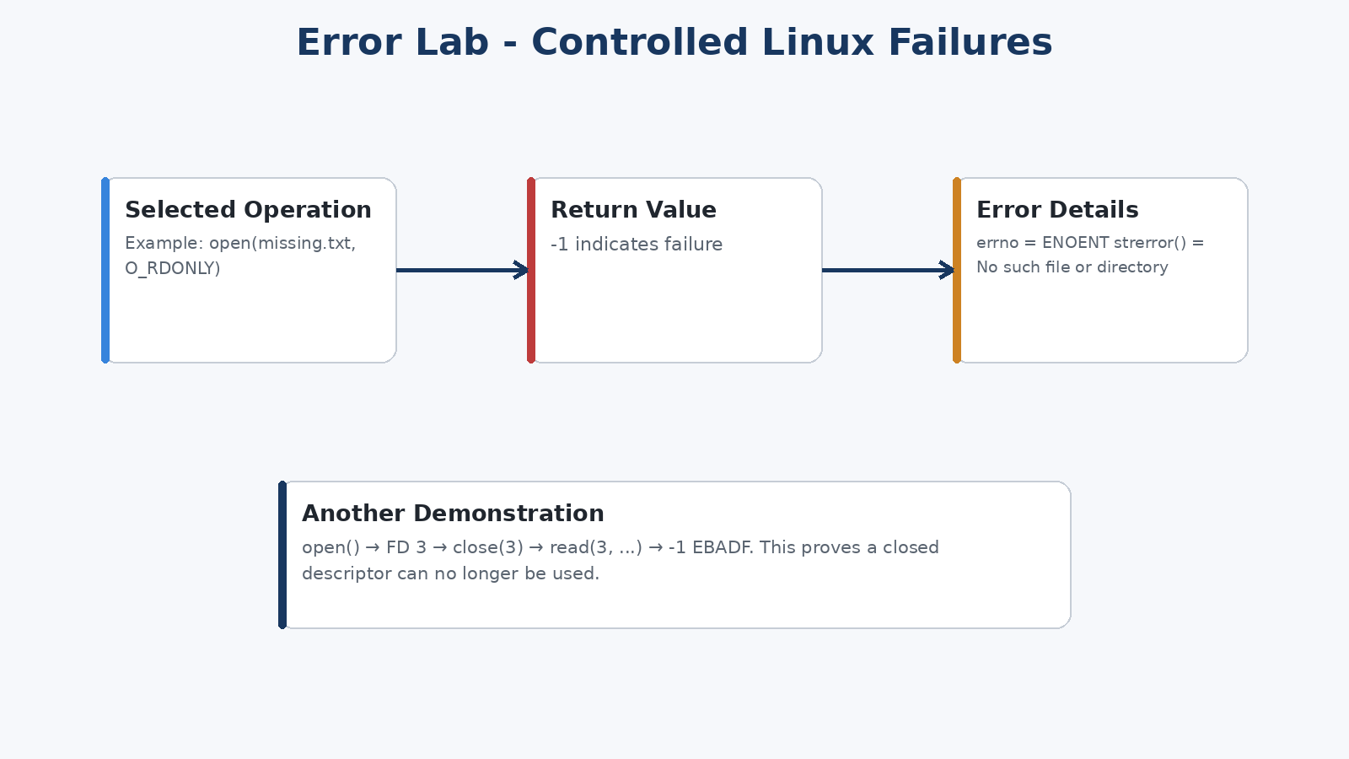
Figure 6.5 – Return value, errno, and readable error handling
The Error Lab accepts a real file or folder path and performs operations selected by the user. errno is cleared before the operation and captured immediately after failure. The application presents the numeric errno value, a symbolic short name where available, strerror(errno), and a short meaning. Tests include opening missing paths, opening with read/write permissions, reading a selected file, reading after close() to demonstrate EBADF, and using O_DIRECTORY.

System Call Trace
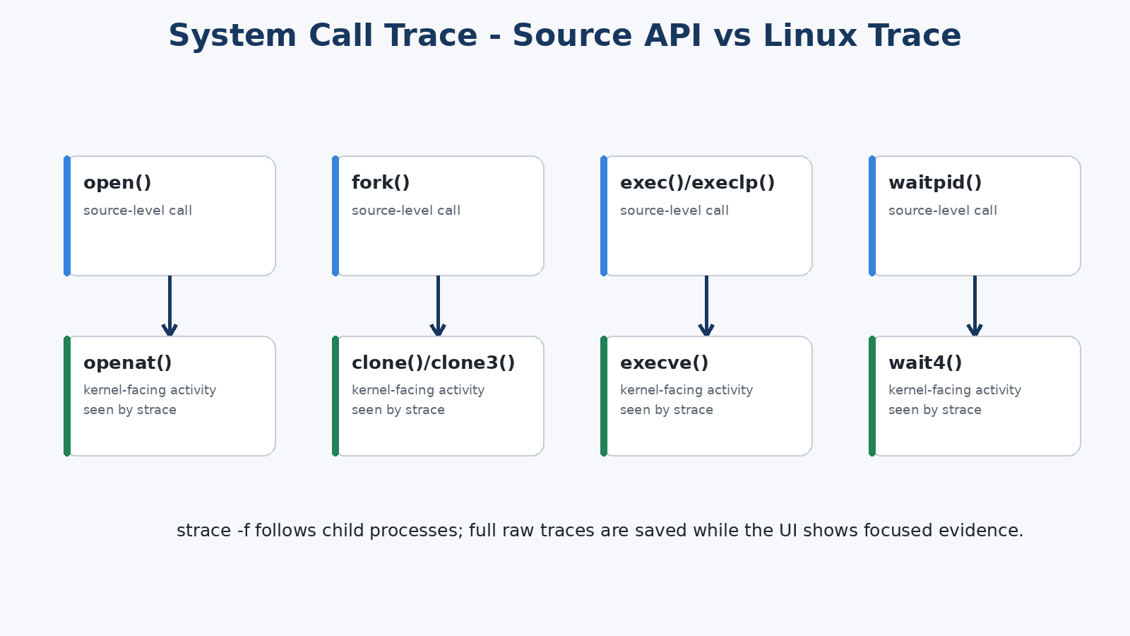
Figure 6.6 – Mapping from source APIs to kernel-facing trace activity
The trace module executes real strace with -f so child processes are followed. A controlled trace target can perform file, process, exec, or error demonstrations. The final launcher can also run the backend under a session-level trace so previously triggered operations are available in the trace history. Raw trace files are saved in the logs directory while the UI displays a focused subset for presentation.
Final launcher-level session tracing command
strace -f -qq -s 160 -o logs/session_trace.txt -e trace=openat,read,write,close,lseek,unlink,clone,clone3,execve,wait4,kill,dup2 ./icon_ossp_backend PORT

Signals & /proc
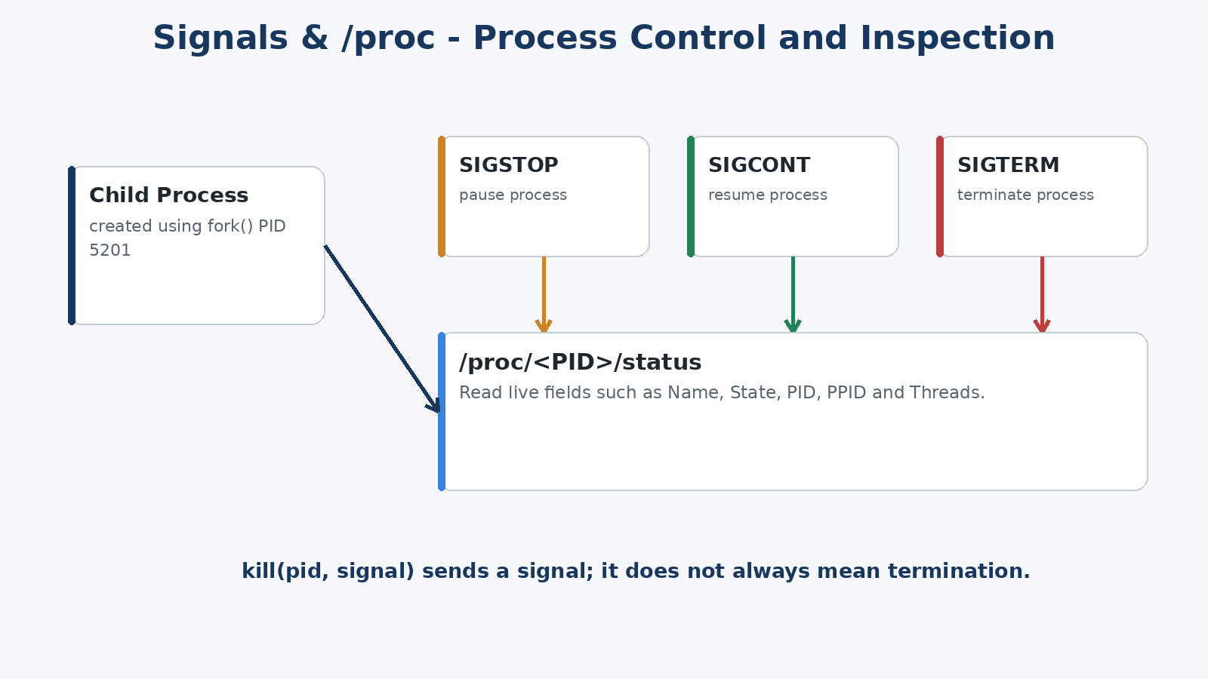
Figure 6.7 – Signal control and live /proc inspection
The module starts a child process, stores its PID, and sends signals using kill(pid, signal). SIGSTOP pauses the process, SIGCONT resumes it, and SIGTERM requests termination. The application opens /proc/<pid>/status and reads selected fields including Name, State, PID, PPID, and Threads, linking signal actions to observable Linux process information.

6.2 Algorithm / Pseudocode
High-level application algorithm
START application
BUILD C programs
START Linux backend on an available localhost port
START strace session logging
OPEN desktop UI
WHEN user selects a lab:
read input
send request to localhost backend
backend performs real Linux/POSIX operation
collect return value/state/output
send result to UI
update Activity Timeline
ON exit:
close child resources
stop backend/trace process group
END

6.3 Core C Implementation
The final backend is implemented in src/desktop_backend.c. It maintains limited state for the currently opened file descriptor, child-process sessions, exec jobs, synchronization state, and the signal-demo child PID. Requests are decoded, routed to the relevant operation, and returned as structured text/JSON to the desktop interface. The source retains the original standalone file/process/error modules for course demonstration and testing.
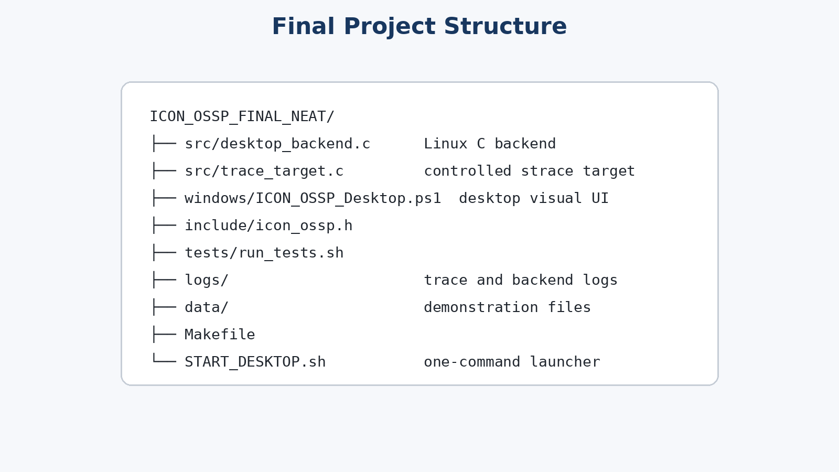
Figure 6.8 – Final project source structure

6.4 Linux System Calls / APIs Used
Category | Calls / APIs | Why Used
File I/O | open, read, write, close, lseek, unlink, stat/fstat | Create, manipulate, inspect, and remove real files
Process | fork, _exit, getpid | Create and identify child processes
Execution | execlp, dup2 | Run another program and capture its output
Synchronization | waitpid, WNOHANG, WIFEXITED, WEXITSTATUS | Observe or block for child completion and retrieve status
Errors | errno, strerror | Explain real failure causes
Signals | kill, SIGSTOP, SIGCONT, SIGTERM | Control a running child process
Process inspection | /proc/<pid>/status + read | Show live process metadata
Tracing | strace | Record kernel-facing call activity

6.5 Process / Thread Implementation
Process Lab uses non-blocking polling so multiple children can be observed without freezing the interface. Exec Lab also separates the parent from the child so the UI remains active while the child is replaced by another program. Synchronization deliberately demonstrates a blocking wait, but that wait runs in a worker thread so the local server can continue responding.

6.6 Synchronization Implementation
No shared-memory IPC mechanism is required for the core demonstration. Parent-child synchronization is achieved through waitpid() and process termination status. Thread-level synchronization in the backend protects shared synchronization state where required. The project therefore demonstrates both process synchronization and safe concurrent backend handling without introducing unnecessary IPC complexity.

6.7 Memory Management Implementation
Buffers are bounded before allocation and are released after use. String data received from requests is decoded into allocated buffers and freed when no longer needed. Process/session arrays use fixed maximum sizes to keep the demonstration predictable. File descriptors are explicitly closed, and child termination status is collected to avoid leaving completed children unreaped.

6.8 Desktop User Interface Implementation
The final desktop interface is implemented using PowerShell and .NET Windows Forms. It reproduces the simple Visual Lab structure with a left navigation panel, a content area for the selected module, and an Activity Timeline at the bottom. The interface communicates only with the local C backend and displays backend results. It does not replace the Linux implementation.
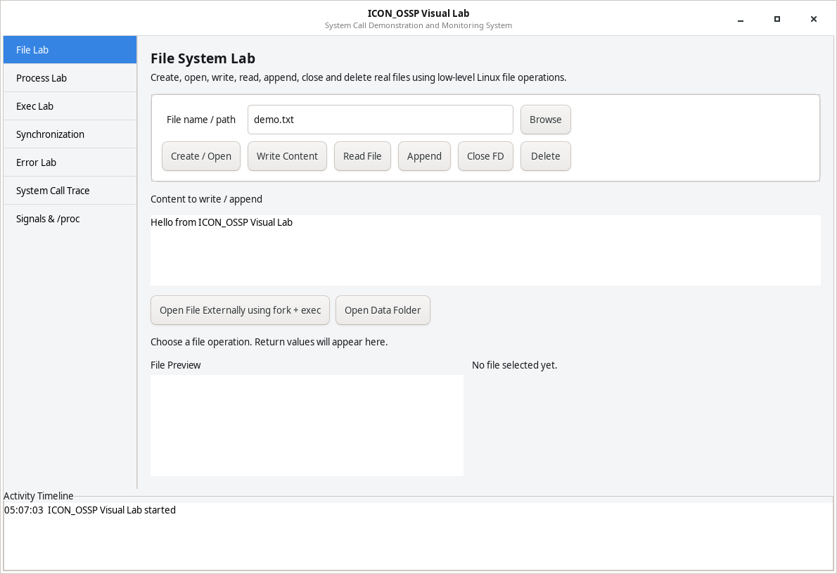
Figure 6.9 – Actual File Lab visual interface

CHAPTER - 7
EXECUTION AND DEMONSTRATION

7.1 Compilation in Ubuntu / WSL
The project is started from the Ubuntu/WSL terminal. START_DESKTOP.sh checks required tools, performs a clean build, selects an available port, starts the Linux backend under strace session logging, waits until the local API is ready, and then launches the native desktop interface.
Primary start command
cd ~/ICON_OSSP_FINAL_NEAT
bash START_DESKTOP.sh

The Makefile builds the original console program, the final desktop backend, and the controlled trace target. The launcher normally uses ports 8787–8799 and selects the first available port.
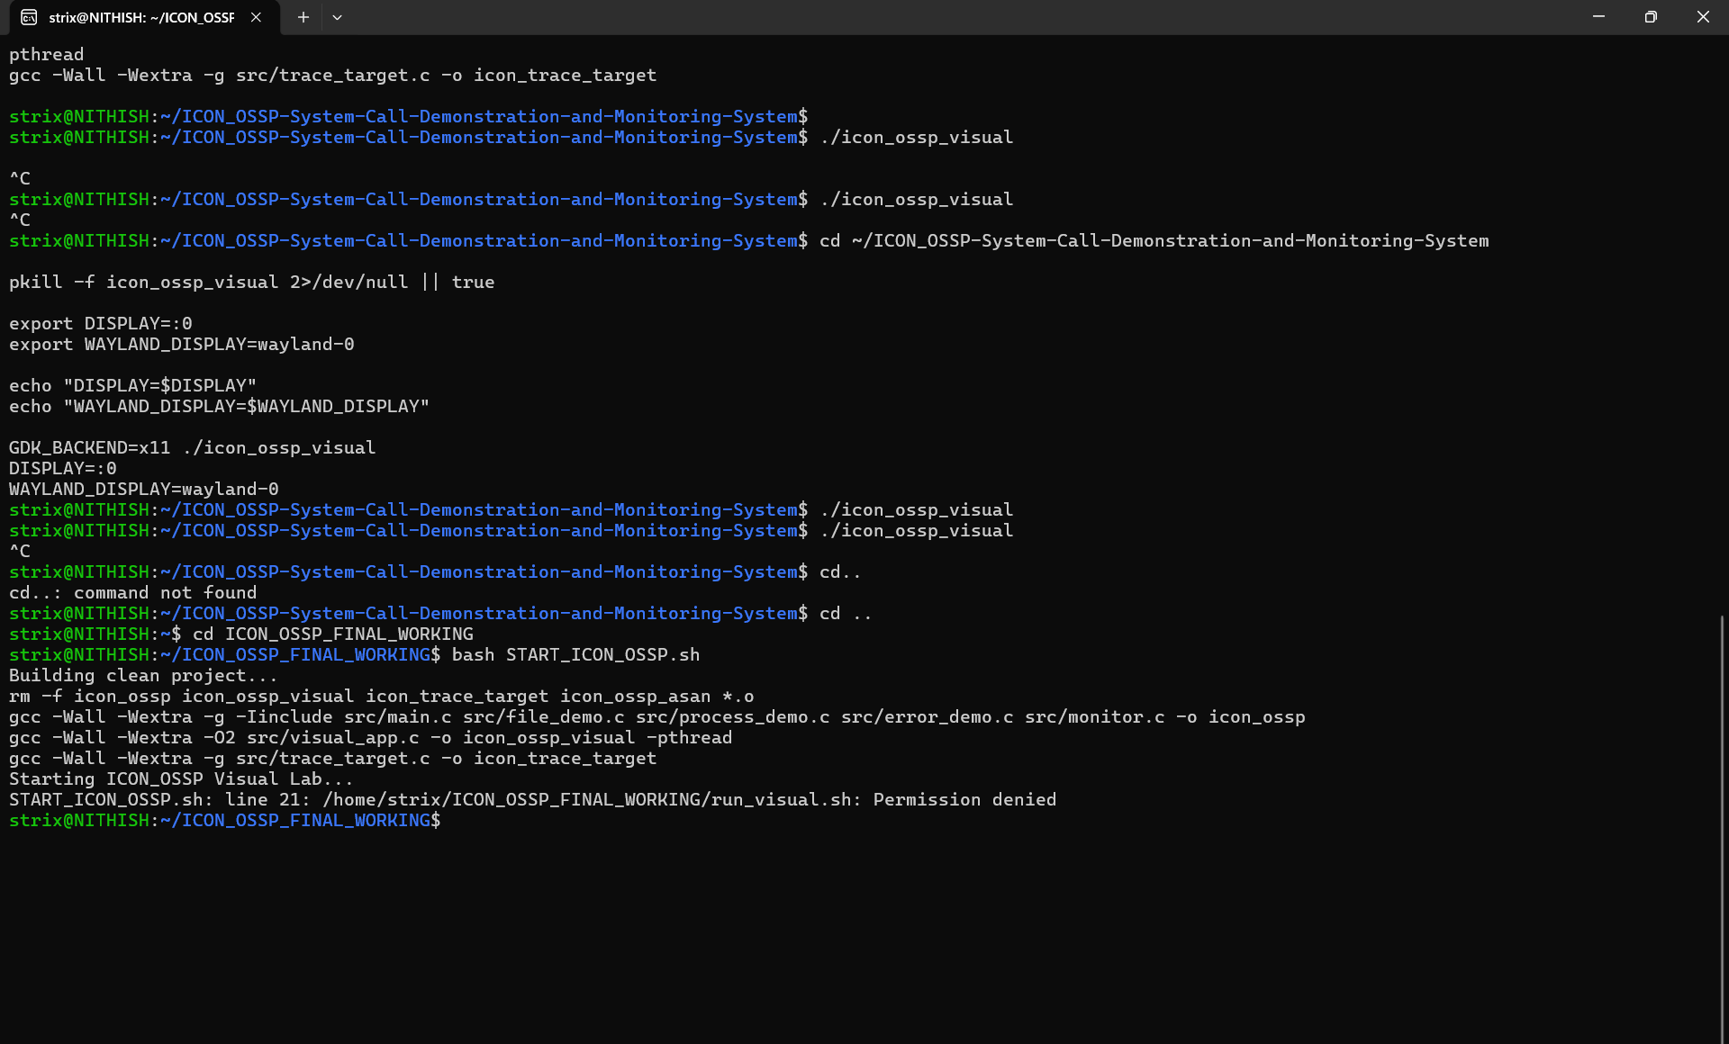
Figure 7.1 – Terminal build/start activity during project execution

7.2 Execution Commands
Purpose | Command
Start final desktop application | bash START_DESKTOP.sh
Clean and rebuild manually | make clean && make
Run backend regression checks | bash CHECK_BACKEND.sh
Run original console program | ./icon_ossp
Inspect raw session trace | less logs/session_trace.txt
Inspect focused trace log | less logs/trace_live.txt

7.3 Sample Inputs and Outputs
Module | Sample Input | Expected Visible Output
File Lab | demo.txt + “Hello ICON_OSSP” | File descriptor, bytes written/read, preview, permissions, descriptor state
Process Lab | 2 children, 5 s | Parent PID, two child PIDs, RUNNING then EXITED
Exec Lab | ls with -l | Captured directory listing and exit status 0
Synchronization | 3 s, exit code 7 | Parent WAITING / Child RUNNING, then Parent CONTINUED / exit status 7
Error Lab | missing path | Return -1, ENOENT, “No such file or directory”
Trace Lab | File operation or session history | Focused openat/read/write/close or process/exec trace lines
Signals /proc | 60 s child + SIGSTOP/SIGCONT/SIGTERM | State changes and /proc PID/PPID/Threads

7.4 Screenshots of Execution
Figure 7.2 – File Lab ready for create/write/read/close operations
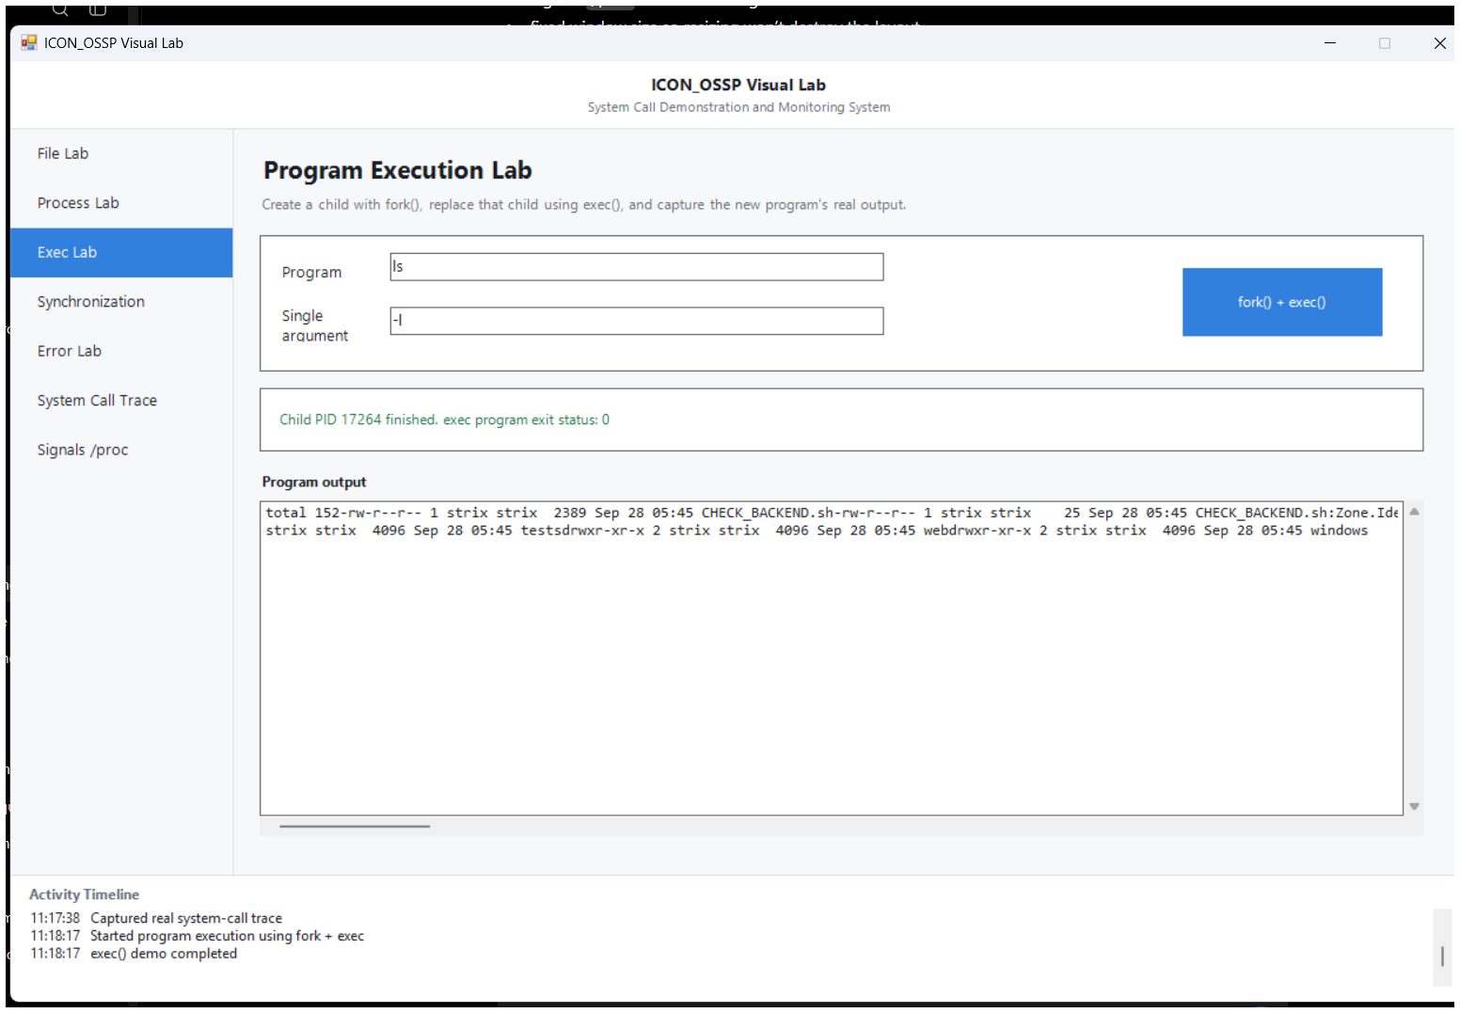
Figure 7.3 – Actual Program Execution Lab running a command and displaying captured output
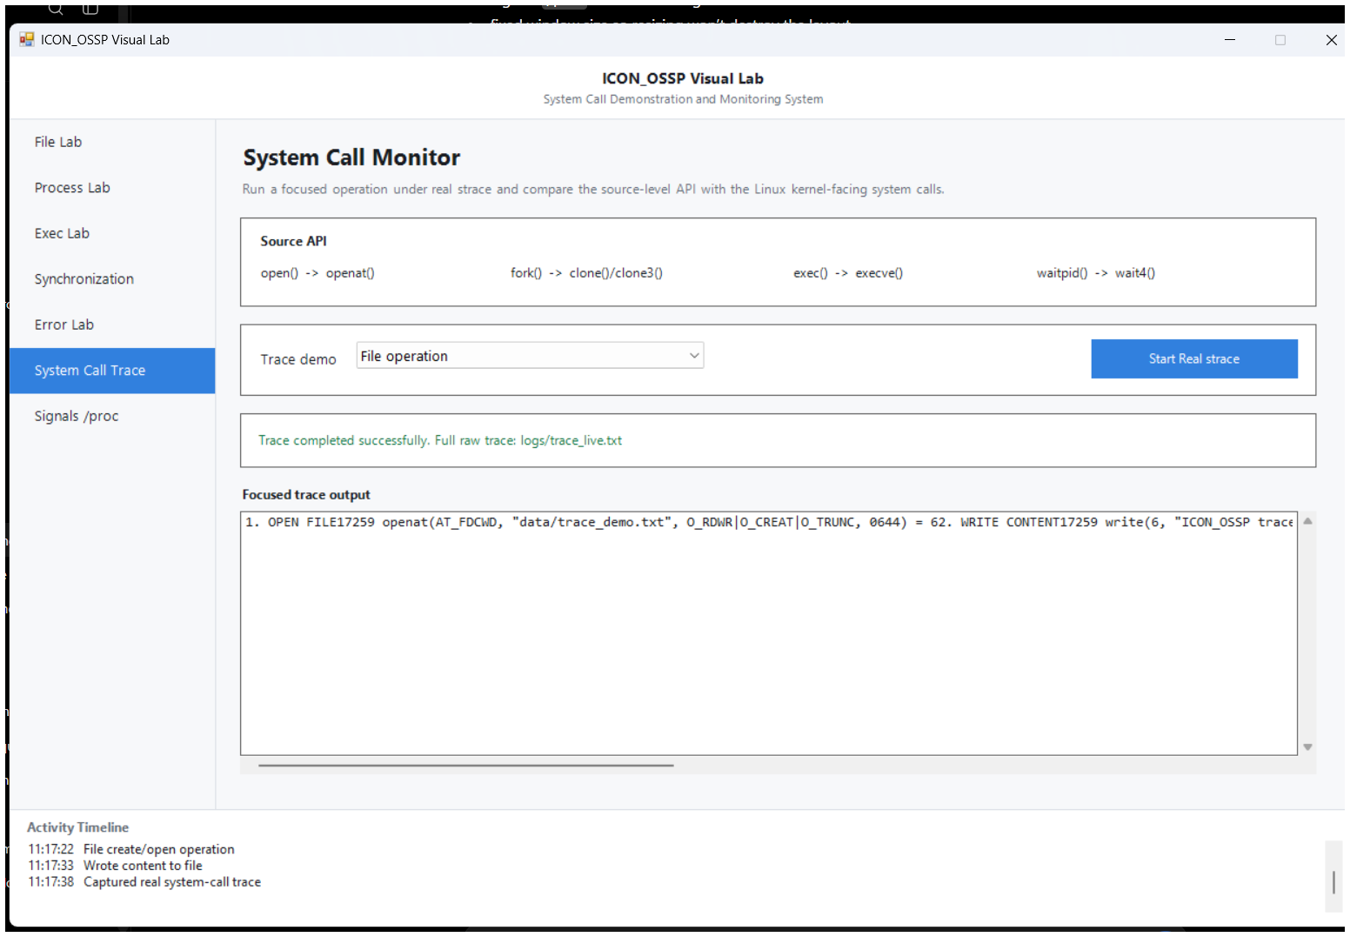
Figure 7.4 – Actual System Call Trace screen with real trace output

7.5 Demonstration of OS Concepts
Demonstration Step | OS Concept Explained
Create/write/read/close demo.txt | File descriptor life cycle and low-level file I/O
Create two children | fork(), parent/child PIDs, process state
Run ls -l | fork creates child; exec replaces the child program; dup2 captures output
Wait for child and return exit code | Blocking synchronization and termination status
Open missing file / read closed FD | System-call failure, errno, ENOENT, EBADF
Run strace | Difference between source-level API and kernel-facing system calls
SIGSTOP/SIGCONT/SIGTERM + /proc | Signal delivery, process state, PID/PPID inspection

Backend validation was performed with the included CHECK_BACKEND.sh script. In the final source used for this report, the core backend checks completed successfully. The launcher installs strace automatically on the target Ubuntu/WSL system if it is missing.

CHAPTER - 8
CONCLUSION

8.1 Summary of the Project
ICON_OSSP successfully integrates Linux file operations, process creation, program execution, synchronization, error handling, tracing, signals, and /proc inspection into a single visual system. The final architecture separates the user interface from the Linux backend so that the presentation remains clear while the operating-system behavior remains authentic.

8.2 Objectives Achieved
- Implemented real file operations and displayed their return values.
- Implemented process creation and visible PID/state observation.
- Implemented fork() + exec() program execution with captured output.
- Implemented parent-child synchronization and exit-status collection.
- Implemented controlled failures using errno and strerror().
- Integrated real strace monitoring and raw logs.
- Implemented signal control and live /proc inspection.
- Created a clean desktop presentation layer and one-command launcher.

8.3 Results Achieved
The project provides a working and repeatable demonstration in which each module produces observable evidence. File operations modify real files, fork() produces real child PIDs, exec() runs installed programs, waitpid() reaps real children, error tests use real errno values, signals affect real processes, /proc exposes real process metadata, and strace records the kernel-facing activity generated by the program.

8.4 Skills and Learning Outcomes
- Practical understanding of user space, kernel services, and POSIX/Linux APIs.
- File descriptor management and low-level file I/O.
- Parent/child process creation, program replacement, and termination handling.
- Blocking vs non-blocking wait behavior.
- Error diagnosis with return values, errno, and strerror().
- Signal-based process control and /proc inspection.
- System-call tracing with strace.
- Build automation, Linux command-line debugging, integration testing, and technical presentation.

CHAPTER - 9
REFERENCES

9.1 Books
- Abraham Silberschatz, Peter B. Galvin, and Greg Gagne, Operating System Concepts, Wiley.
- W. Richard Stevens and Stephen A. Rago, Advanced Programming in the UNIX Environment, Addison-Wesley.
- Michael Kerrisk, The Linux Programming Interface, No Starch Press.

9.2 Research / Background Reading
The project is primarily an implementation-based systems-programming laboratory. Background study focused on standard operating-system texts and Linux/POSIX documentation rather than a new research algorithm.

9.3 Linux / GNU Documentation
- Linux man-pages: open(2), read(2), write(2), close(2), fork(2), execve(2), waitpid(2), kill(2), proc(5).
- GNU C Library documentation for process creation, program execution, file descriptors, and error handling.
- strace manual page and documentation for tracing Linux system calls.

9.4 Online Resources
- https://man7.org/linux/man-pages/
- https://www.gnu.org/software/libc/manual/
- https://strace.io/
- https://gcc.gnu.org/

PROJECT QUICK REFERENCE
Item | Final Detail
Project | ICON_OSSP – System Call Demonstration and Monitoring System
Course | Operating Systems and Systems Programming (25CS2104E)
Section / Team | Section 7 · Team 13
Members | Nithish S (2520030346), Sai Sathwik (2520030328), Vivek (2520030532)
Guide / Faculty | K. Hema
Main language | C
Environment | Ubuntu Linux / WSL
Start command | bash START_DESKTOP.sh
Main backend | src/desktop_backend.c
Desktop UI | windows/ICON_OSSP_Desktop.ps1
Trace logs | logs/session_trace.txt and logs/trace_live.txt

Final demonstration order
File Lab → Process Lab → Exec Lab → Synchronization → Error Lab → Signals /proc → System Call Trace
Closing line: “ICON_OSSP makes Linux system calls visible, practical, and traceable by connecting user actions to real C/POSIX operations, kernel services, visible return values, and strace evidence.”

