OSSP (Operating Systems And Systems Programming) - 25CS2104E

PRACTICAL – 2 G. Sai Sathwik - 2520030328

Original file to be copied: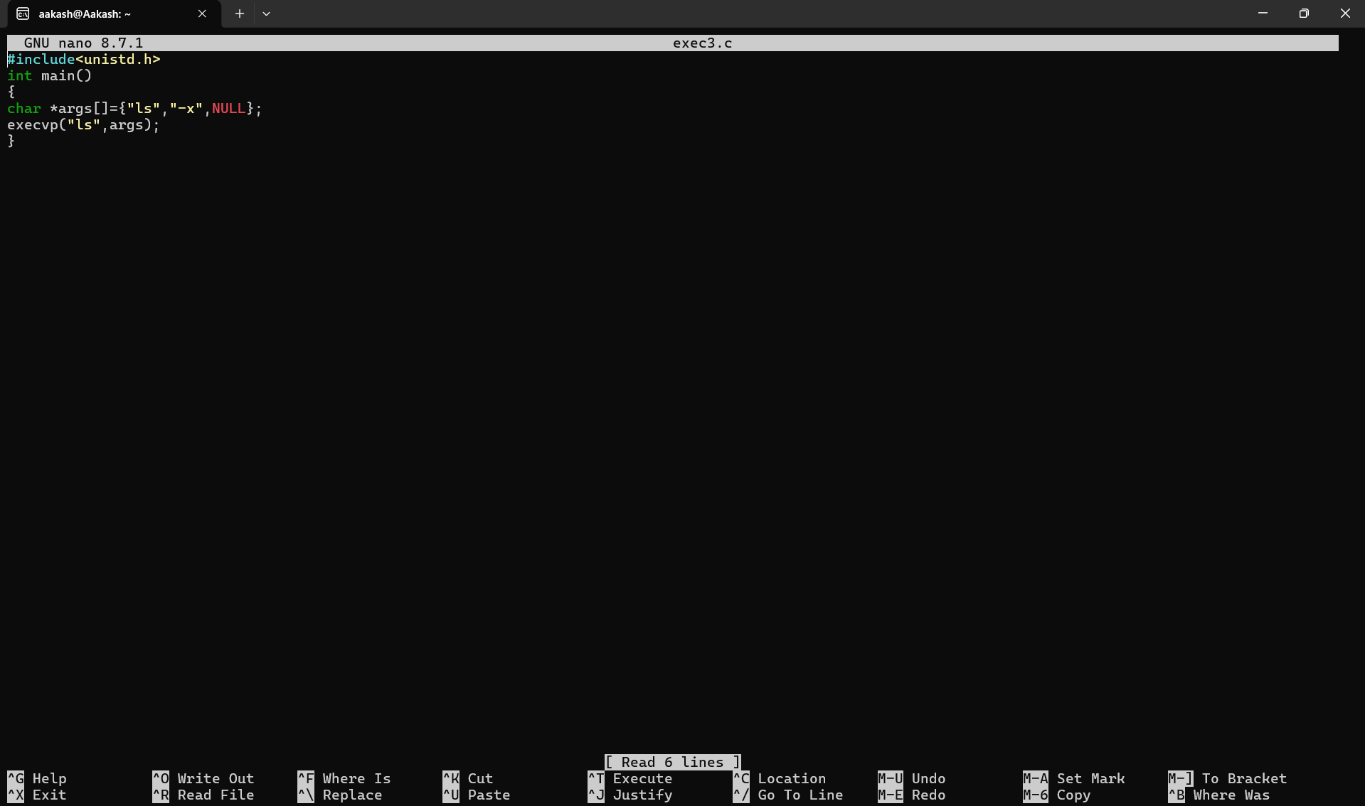

execution

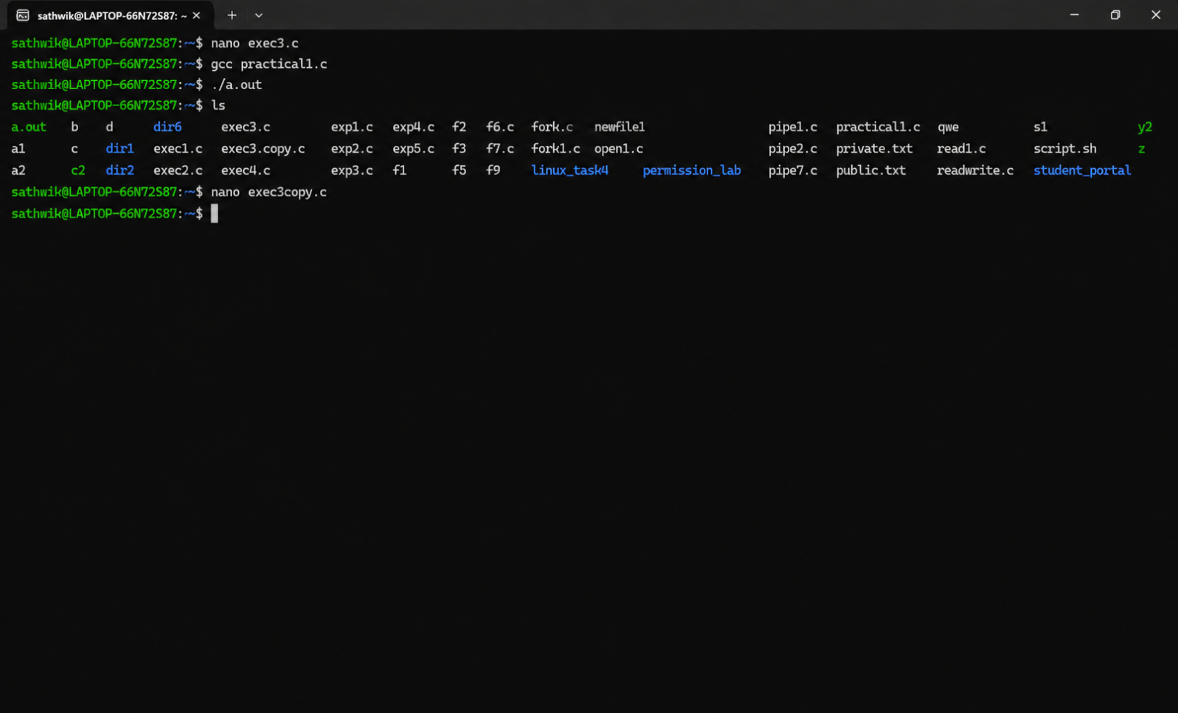

Copied file

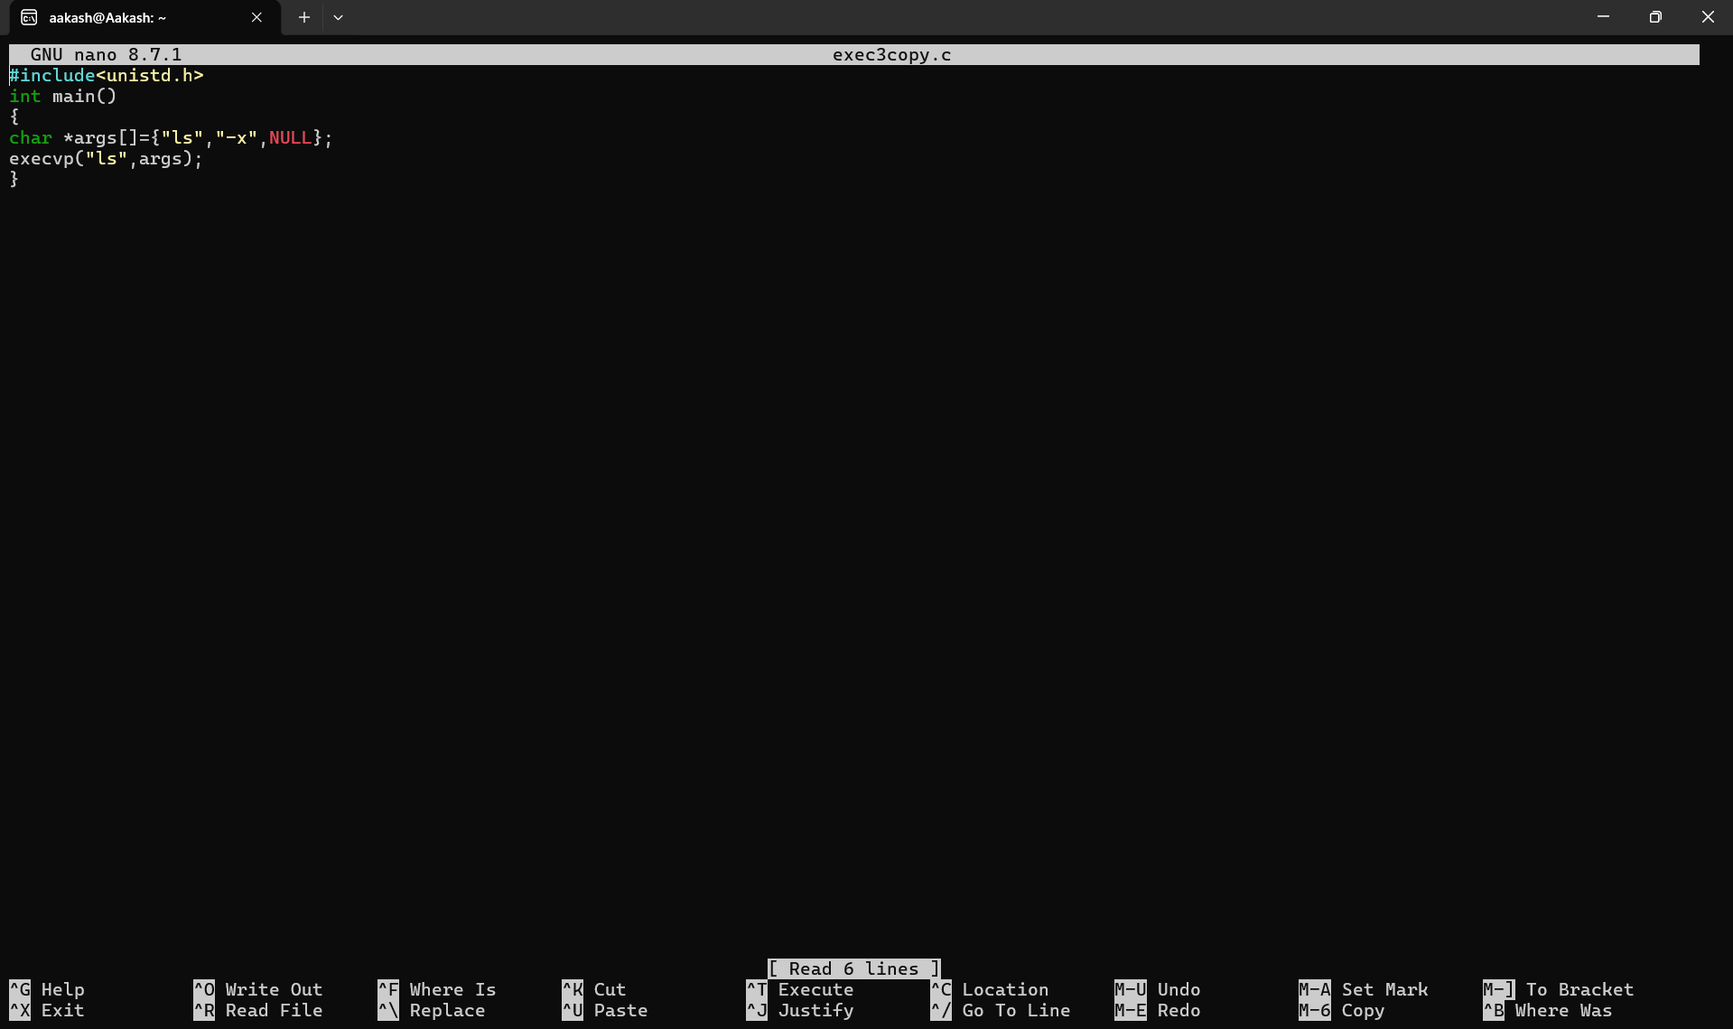

The C program executes in user space, but operations such as opening, reading, writing, and closing files are handled by the Linux kernel. When the program calls open(), control is transferred from user space to kernel space, where the kernel opens the required file and returns a file descriptor to the program. Similarly, read() requests the kernel to read data from the source file and transfer it into the user-space buffer. The write() system call transfers the data from the user-space buffer to the destination file through the kernel. Finally, close() requests the kernel to release the file descriptors and associated resources. Thus, the program repeatedly transitions from user space to kernel space during system calls and returns to user space after the requested operation is completed.

open() :
read()
write()
close()
