OSSP (Operating Systems And Systems Programming) - 25CS2104E

PRACTICAL – 1 Nithish S - 2520030346

O/P
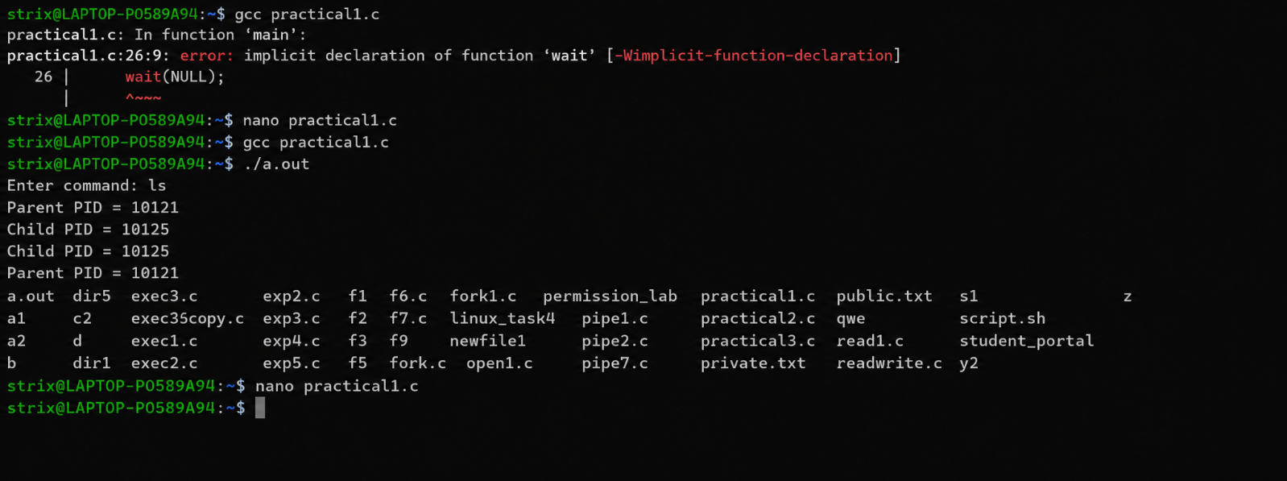

Lscpu output
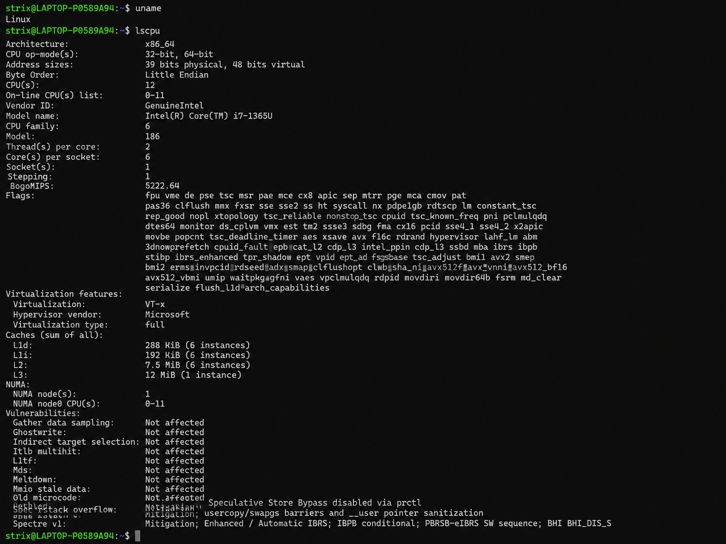

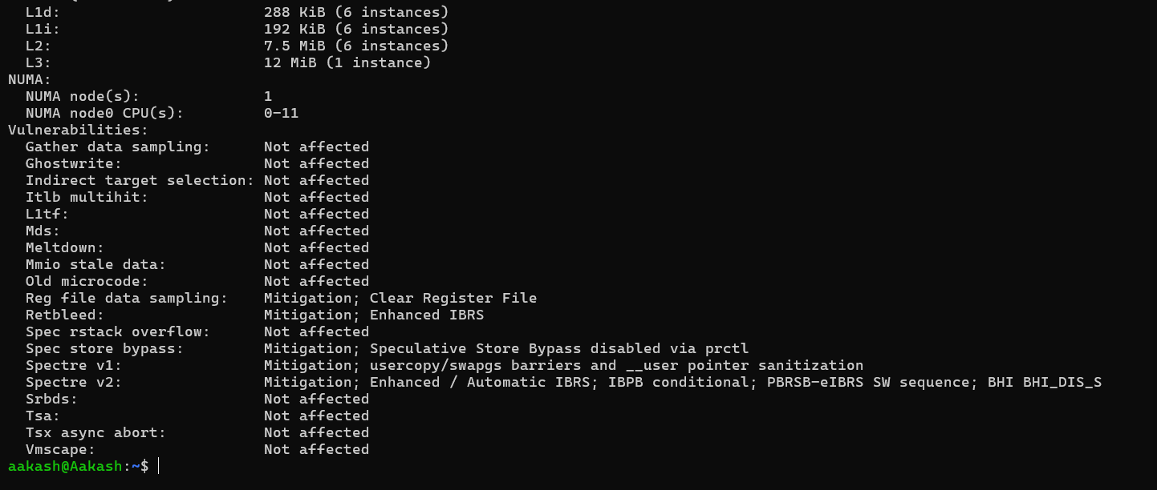

Lsblk output

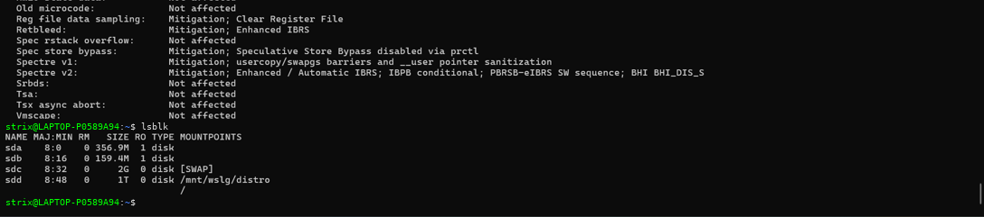

Ps output

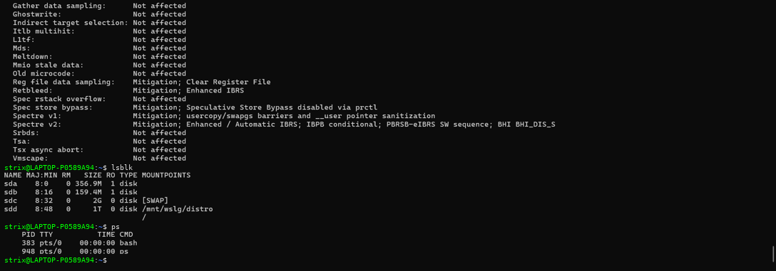

Top output

