Practical-4
2520030328
G.Sai Sathwik
S-7

C File for the Wait program-
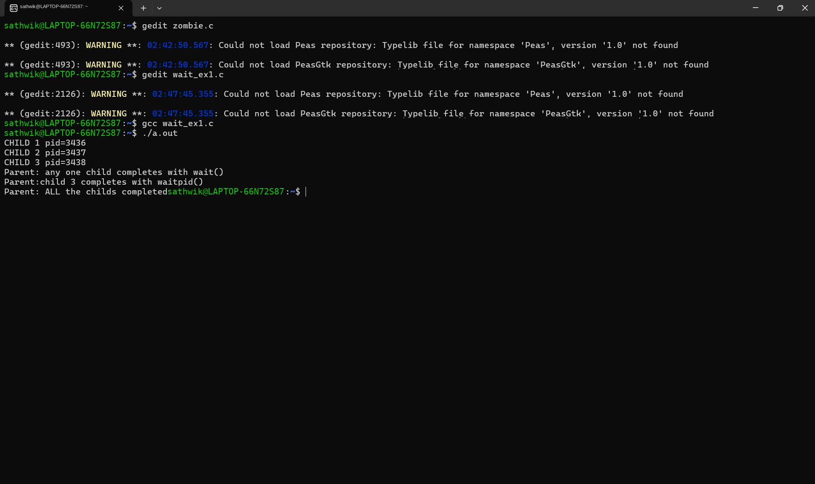

Output for the Zombie process experiment:

