Practical-2
2520030346
Nithish S
S-7

C file(the program):

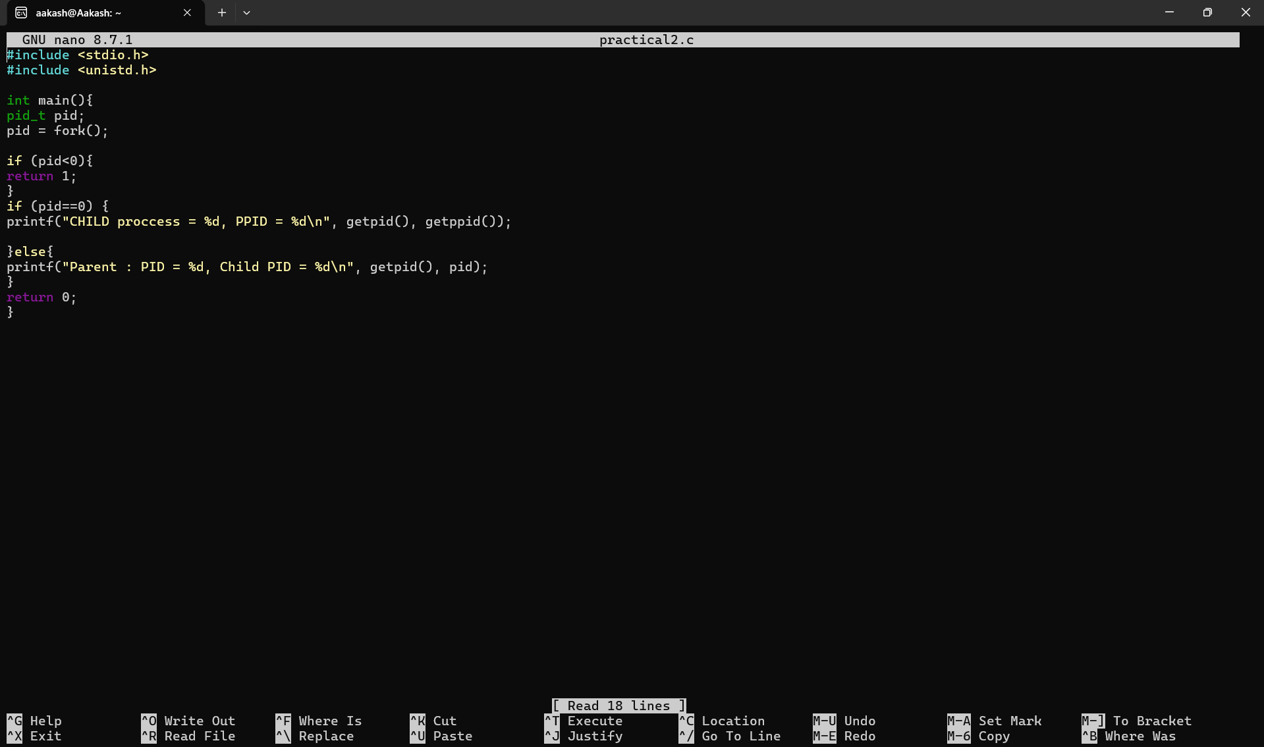

Output:

