Practical-4
2520030346
Nithish S
S-7

C File for the Wait program-
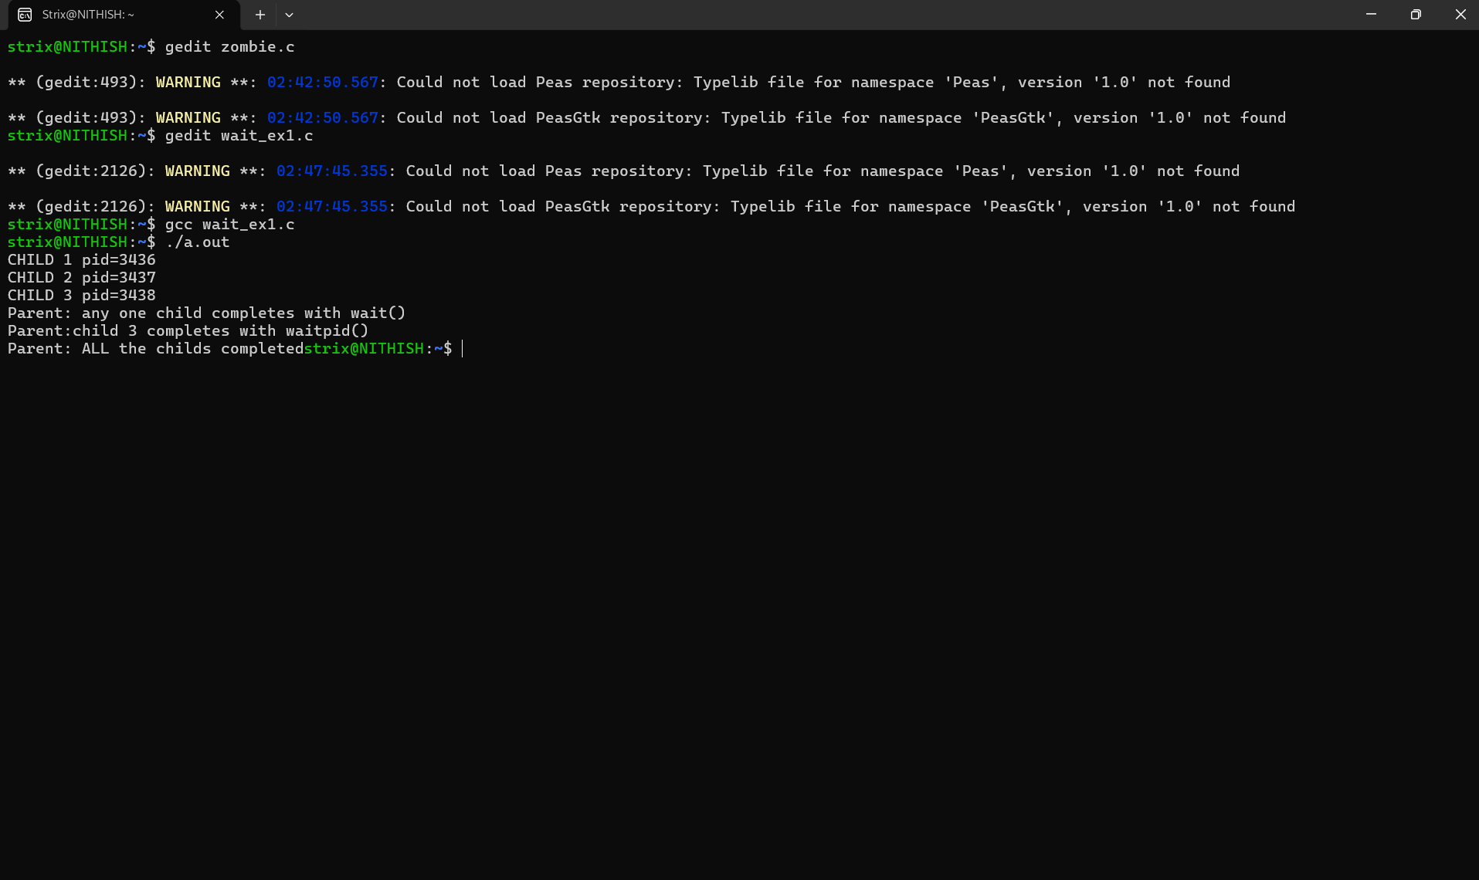

Output for the Zombie process experiment:

