www.anudip.org
PROJECT - 2

TWITTER SOCIAL MEDIA ANALYTICS

A Business Intelligence Dashboard Developed Using Microsoft Power BI for TWITTER SOCIAL MEDIA ANALYTICS

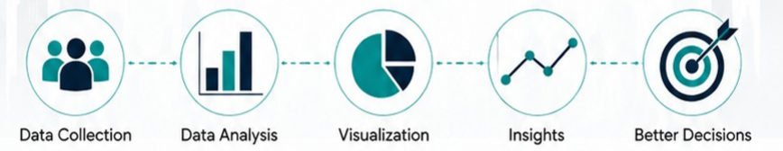

Project Guide: Mangali Rakesh Sir

Submitted By
Name: Yella Nithya
AF_Id: AF05220019
Batch: D6600
Course: DPBA

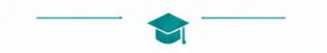

ABSTRACT
The Twitter Social Media Analytics Dashboard is developed using Microsoft Power BI to analyze tweet performance, user engagement, and social media trends. The project utilizes a dataset named tweets1, consisting of 100,000 records and 19 attributes related to tweets and user profiles.
The dashboard provides interactive visualizations that enable users to monitor tweet engagement, compare verified and non-verified accounts, analyze language distribution, evaluate user influence, and identify trending patterns. Power BI's data transformation capabilities, DAX measures, and interactive visuals are used to convert raw data into meaningful business insights.
The project demonstrates how Business Intelligence tools help organizations make informed decisions by transforming large datasets into visually appealing and interactive reports.

TABLE OF CONTENTS
- Project Description
- Project Overview
- Introduction
- Project Objectives
- Dataset Description
- Data Preprocessing
- Data Modeling
- DAX Measures and Calculations
- Dashboard Design and Visualizations
- Business Insights
- Conclusion
- Future Enhancements
- References

PROJECT DESCRIPTION
This project presents an interactive Twitter Social Media Analytics Dashboard developed using Microsoft Power BI. The dashboard is designed to analyze social media data collected from the tweets1 dataset containing 100,000 tweet records. It provides meaningful insights into tweet engagement, user activity, account performance, and audience behavior through interactive dashboards, Key Performance Indicators (KPIs), and dynamic visualizations.
The dashboard enables users to monitor social media performance, analyze tweet engagement, identify influential users, compare verified and non-verified accounts, evaluate language distribution, and understand user demographics. By transforming raw Twitter data into interactive reports, the project demonstrates the practical application of Business Intelligence for supporting data-driven decision-making in digital marketing and social media analytics.
Software Used:
- Microsoft Power BI Desktop
- Microsoft Excel / CSV Dataset
- Power Query Editor
- DAX (Data Analysis Expressions)
- Microsoft Word
Dataset Name: tweets1
- Number of Records: 100,000
- Number of Columns: 19
- Primary Key: Tweet Id
- Dataset Type: Social Media Analytics Dataset

PROJECT OVERVIEW
The Twitter Analytics Dashboard provides a comprehensive and visually engaging analysis of tweet performance, user engagement, and platform activity trends.
It is designed to help stakeholders:
- Understand engagement patterns
- Track user influence
- Monitor content performance
- Make data-driven social media decisions

INTRODUCTION
Business Intelligence (BI) is the process of collecting, analyzing, and visualizing data to support better decision-making. Organizations generate vast amounts of data every day, making it essential to transform raw information into meaningful insights.
Microsoft Power BI is one of the most popular Business Intelligence tools that enables users to connect to multiple data sources, clean and transform data, create interactive dashboards, and share reports. It offers powerful visualization capabilities and advanced analytical features that simplify data interpretation.
The growing influence of social media platforms such as Twitter (X) has created opportunities for organizations to analyze public conversations, user engagement, and digital marketing performance. This project focuses on building an interactive dashboard that provides valuable insights into tweet activity and user behavior.

PROJECT OBJECTIVES
The objectives of this project are:
- Analyzed tweet engagement using likes and retweets.
- Monitored tweet activity over time.
- Compared verified and non-verified accounts.
- Identified highly influential Twitter users.
- Analyzed tweet language distribution.
- Evaluated follower and following statistics.
- Created interactive Power BI dashboards.
- Supported business decision-making through data visualization.

DASHBOARD
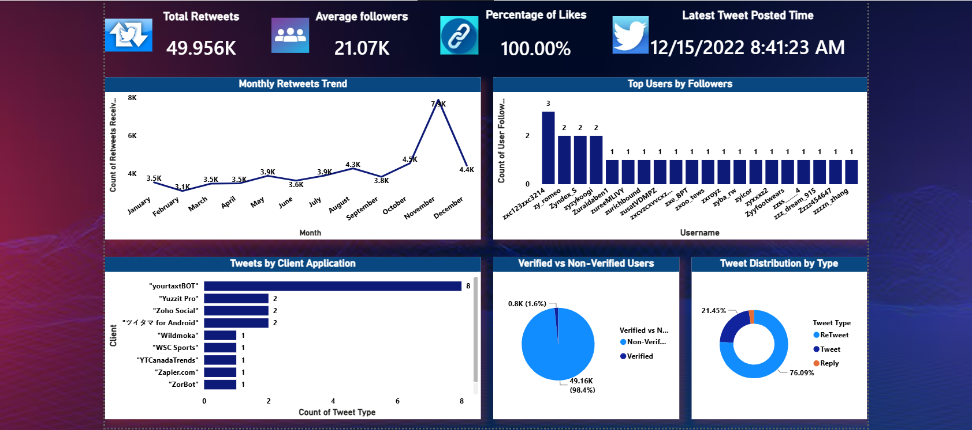

DASHBOARD DESIGN AND VISUALIZATIONS
Explain each visual separately:

KEY PERFORMANCE INDICATORS (KPIS)
KPI | Description | Insight
🔁 Total Retweets (49.956K) | Total number of retweets received | Indicates overall content reach
👥 Average Followers (21.07K) | Avg followers per user | Measures audience base strength
❤️ Percentage of Likes (100%) | Engagement rate | Shows strong user interaction
⏰ Latest Tweet Time | Most recent activity timestamp | Tracks platform activity recency
1. Total Retweets – 49.956K
- Represents the total number of retweets across all tweets in the dataset
- Indicates the virality and reach of content
- A high value suggests strong audience amplification
2. Average Followers – 21.07K
- Shows the average follower count per user
- Reflects the influence level of users contributing to tweets
- Useful for understanding audience scale
3. Percentage of Likes – 100%
- Indicates the engagement rate based on likes
- A perfect percentage suggests:
  - Highly engaging content
  - Or a dataset where all tweets received likes
4. Latest Tweet Posted Time
- Displays the most recent tweet timestamp
- Helps track data freshness and activity recency

VISUAL ANALYSIS OF CHARTS
1. Monthly Retweets Trend (Line Chart)
- A time-series line chart showing retweet counts for each month
- Helps identify patterns, seasonality, and growth trends
Insights:
- Retweets remain relatively stable between 3K–4.5K for most months
- A sharp spike occurs in November (~7.9K)
- Slight drop observed in December (~4.4K)
Interpretation:
- November likely had viral content or campaigns
- Indicates best time for marketing or promotions
2. Top Users by Followers (Colum Chart)
- Displays usernames ranked by follower count
- Helps identify highly influential users
Insights:
- A few users have higher follower counts, while many have similar levels
- Indicates a long-tail distribution of influence
Interpretation:
- Top users can be targeted for:
  - Influencer marketing
  - Brand collaborations
3. Tweets by Client Application (Bar Chart)
- Shows the number of tweets posted from different client applications
Insights:
- "yourtaxBOT" has the highest usage
- Other platforms like "Yuzit Pro" and "Zoho Social" show moderate usage
- Several apps are used minimally
Interpretation:
- High bot usage suggests:
  - Automation in tweeting
  - Scheduled or programmatic content
4. Verified vs Non-Verified Users (Pie Chart)
- Compares the proportion of verified and non-verified users
Insights:
- 98.4% users are non-verified (~49.16K)
- Only 1.6% are verified (~0.8K)
Interpretation:
- Majority of engagement comes from general users
- Verified users form a small but potentially influential segment
5. Tweet Distribution by Type (Donut Chart)
- Categorizes tweets into:
  - Retweets
  - Original Tweets
  - Replies

Insights:
- Retweets dominate (76.09%)
- Tweets account for 21.45%
- Replies form a very small portion
Interpretation:
- Content strategy is heavily focused on resharing existing content
- Limited direct engagement (replies)

DATASET DESCRIPTION

Dataset Overview
The dataset consists of 50,000 Twitter records capturing detailed information about tweets, users, and engagement metrics. It serves as the foundation for analyzing social media behavior, user influence, and content performance.
This dataset integrates both:
- Tweet-level data (content, type, engagement)
- User-level data (followers, verification, account details)

Dataset Information

Attribute | Details
📁 File Type | Excel (.xlsx)
📊 Total Records | 1,00,000 rows
🧾 Total Columns | 19 attributes
🕒 Time Coverage | Includes tweet timestamps
🌍 Data Scope | Global Twitter activity
🔄 Data Nature | Structured, tabular

Dataset Statistics
General Statistics
- Total Tweets: 1,00,000
- Unique Users: High diversity of users
- Verified Users: Very small percentage (~1–2%)
- Non-Verified Users: Majority (~98%)
🔹 Engagement Metrics
- Retweets: Wide distribution (low to very high values)
- Likes: Consistent engagement across tweets
- Followers: Range from low to high influencer-level accounts
🔹 Behavioral Insights
- Majority of tweets are:
  - Retweets (dominant)
  - Followed by original tweets and replies
- Peak activity observed during specific months

Dataset Attributes
Column Name | Description
Tweet Id | Unique identifier for each tweet
Tweet URL | Direct link to the tweet
Tweet Posted Time | Timestamp of tweet publication
Tweet Content | Actual tweet text
Tweet Type | Type: Retweet / Tweet / Reply
Client | Application used to post tweet
Retweets Received | Number of retweets
Likes Received | Number of likes
Tweet Location | Location from where tweet was posted
Tweet Language | Language of the tweet
User Id | Unique user identifier
Name | Full name of user
Username | Twitter handle
User Bio | Profile description
Verified or non-Verified | Verification status
Profile URL | User profile link
User Followers | Number of followers
User Following | Number of accounts followed
User Account Creation Date | Date user joined Twitter

Data Categories
The dataset can be logically grouped into the following categories:
1. Tweet Information
- Tweet Id
- Tweet Content
- Tweet Type
- Tweet Posted Time
👉 Focus: Content and activity tracking
2. Engagement Metrics
- Retweets Received
- Likes Received
👉 Focus: Performance measurement
3. User Information
- User Id
- Name
- Username
- User Bio
- Profile URL
👉 Focus: User identity & profiling
4. User Influence Metrics
- User Followers
- User Following
- Verified Status
👉 Focus: Influence and credibility analysis
5. Technical & Source Data
- Client (App used)
- Tweet URL
👉 Focus: Platform usage & automation insights
6. Contextual Data
- Tweet Location
- Tweet Language
- Account Creation Date
👉 Focus: Demographics & regional analysis

Business Purpose
This dataset is used to support data-driven decision-making in social media analytics.
🔹 Key Business Applications:
- 📈 Engagement Analysis
Understand what type of content drives more interaction
- 🤝 Influencer Identification
Detect users with high followers for collaborations
- 📊 Trend Analysis
Identify seasonal spikes in engagement
- ⚙️ Automation Monitoring
Analyze usage of bots and third-party tools
- 🌍 Audience Insights
Study user demographics (language, location)

Dataset Summary
- The dataset provides a comprehensive 360° view of Twitter activity
- Combines content, engagement, and user-level insights
Highly suitable for:
- Social media analytics
- Marketing strategy
- Business intelligence dashboards

DATA PREPROCESSING

INTRODUCTION
Data preprocessing is one of the most important stages in any Business Intelligence project. Raw datasets often contain missing values, duplicate records, inconsistent formatting, and unnecessary information that can affect the accuracy of analysis and visualization. Therefore, preprocessing is performed to clean and transform the data before creating reports and dashboards.
In this project, the tweets1 dataset containing 100,000 records and 19 columns was imported into Microsoft Power BI. The Power Query Editor was used to clean, organize, and transform the data into a structured format suitable for analysis.
The preprocessing process improved data quality, ensured consistency, and enhanced dashboard performance by eliminating redundant information and preparing the dataset for efficient reporting.

DATA IMPORT
The dataset was imported into Microsoft Power BI Desktop from a CSV/Excel file. During the import process, Power BI automatically identified the column names and detected the data types for each attribute.
Data Cleaning Process
After importing the dataset, several data cleaning techniques were applied to improve data quality.
The following preprocessing operations were performed:
- Imported the tweets1 dataset into Power BI.
- Verified all column names and their corresponding data types.
- Removed blank rows and unnecessary records.
- Eliminated duplicate tweet records based on Tweet Id.
- Checked for missing values in important columns.
- Standardized text formatting where necessary.
- Ensured numerical fields contained valid numeric values.
These cleaning steps ensured that the dataset was accurate, complete, and ready for further analysis.

HANDLING MISSING VALUES
Missing values can significantly impact the accuracy of dashboard visualizations and analytical results. Therefore, the dataset was examined carefully to identify incomplete records.
The following actions were performed:
- Missing values in optional fields such as Tweet Location and User Bio were retained only where appropriate.
- Blank rows were removed.
- Invalid or incomplete records were excluded from the analysis.
- Essential columns such as Tweet Id, Tweet Content, Likes Received, and Retweets Received were validated to ensure they contained meaningful data.

DATA TRANSFORMATION
Power Query transformations included:
- Renaming columns for better readability.
- Trimming extra spaces from text fields.
- Cleaning unwanted special characters.
- Formatting text values consistently.
- Standardizing categorical values.
These transformations improved the quality and consistency of the dataset.

DATA MODELING

INTRODUCTION TO DATA MODELING
Data modeling is the process of organizing and structuring data to establish relationships between different tables within a Business Intelligence environment. A well-designed data model improves report performance, simplifies data analysis, and enables efficient DAX calculations.
For this project, the tweets1 dataset was imported into Power BI and modeled to support interactive reporting. Since the dataset contains tweet information, user details, and engagement metrics, the data model provides a structured framework for analyzing social media activity and generating meaningful business insights.

DATA MODEL STRUCTURE
The tweets1 dataset consists of 100,000 records and 19 attributes. Each record represents a single tweet along with its associated user information and engagement statistics.
The dataset contains the following categories of information:
Tweet Information
- Tweet Id
- Tweet URL
- Tweet Posted Time
- Tweet Content
- Tweet Type
User Information
- User Id
- Name
- Username
- User Bio
- Verified or non-verified
- Profile URL
Engagement Metrics
- Likes Received
- Retweets Received
Location Information
- Tweet Location
- Tweet Language
User Statistics
- User Followers
- User Following
- User Account Creation Date
The structured organization of these attributes enables effective filtering, grouping, and visualization within the Power BI dashboard.

RELATIONSHIPS AND DATA ORGANIZATION
- Tweet Id uniquely identifies every tweet.
- User Id links multiple tweets to a specific user.
- Tweet Posted Time supports time-based analysis.
- Tweet Language enables language-wise analysis.
- Tweet Location facilitates geographical reporting.
- Verified or non-verified distinguishes official and regular user accounts.
This logical organization improves the efficiency of dashboard filtering and supports dynamic report interactions.

BENEFITS OF DATA MODELING
- Improves dashboard performance by organizing data efficiently.
- Enables faster report generation and filtering.
- Supports accurate DAX calculations and measures.
- Reduces redundancy by maintaining a structured dataset.
- Simplifies report maintenance and future enhancements.
- Enables interactive filtering using slicers and visualizations.
- Improves overall data consistency and reliability.
The well-structured data model serves as the foundation for creating interactive visualizations and meaningful business insights.

DAX MEASURES AND CALCULATIONS
- Total Tweets
- Total Likes
- Total Retweets
- Verified Users
- Non-Verified Users
- Average Likes
- Average Retweets
- Maximum Followers
- Total Followers
- Tweet Count by Language
Provide each DAX formula with its purpose.

BUSINESS INSIGHTS
- Most active Twitter users
- Languages with highest tweet volume
- Top tweets based on likes
- Top tweets based on retweets
- Verified vs non-verified engagement
- Users with highest followers
- Tweet posting trends
- Most frequently used client applications

CONCLUSION
The Twitter (X) Social Media Analytics Dashboard successfully demonstrates the capabilities of Microsoft Power BI in transforming large-scale social media data into meaningful visual insights. By analyzing 100,000 tweet records, the dashboard provides valuable information about user engagement, tweet performance, and audience characteristics.
The project highlights how Business Intelligence tools support efficient decision-making by presenting complex datasets through interactive and easy-to-understand visualizations.

FUTURE ENHANCEMENTS
Future improvements include:
- Real-time Twitter API integration.
- Sentiment analysis using AI.
- Predictive analytics with machine learning.
- Power BI Service deployment.
- Mobile-friendly dashboard.
- Automated data refresh.
- Advanced user segmentation.
- Geographic heat maps.
- Row-Level Security (RLS).

REFERENCES
- Microsoft Power BI Documentation.
- Microsoft Learn – Power BI Learning Paths.
- SQLBI – DAX Guide.
- Twitter (X) Developer Documentation.
- Kaggle Datasets.
- Research articles on Business Intelligence and Data Visualization.

