**Data Transmission Using LED and LDR Over a Custom Communication Protocol**

1. **INTRODUCTION**

In an era where wireless communication plays a pivotal role in modern-day connectivity, exploring innovative, cost-effective, and energy-efficient alternatives is essential. One such emerging technique is **Visible Light Communication (VLC)**, which utilizes light to transmit data wirelessly. This project, titled **“Data Transmission Using LED and LDR Over a Custom Communication Protocol,”** demonstrates a basic implementation of VLC using readily available components such as an LED (Light Emitting Diode) and an LDR (Light Dependent Resistor). The primary objective is to establish a **low-cost, DIY-friendly system** capable of transmitting characters or messages using light as a medium and reconstructing them at the receiver end through a custom protocol.

This project finds its roots in a moment of inspiration—observing the speed of light during a festive event like Diwali, where light was seen before sound, emphasizing that **light travels faster than sound**. That observation laid the foundation for experimenting with light-based communication. The project bridges hardware and software aspects, using **Arduino microcontrollers** to handle both transmission and reception logic. Unlike conventional systems like Bluetooth, Wi-Fi, or infrared, this system relies purely on **visible light**, making it **immune to electromagnetic interference** and suitable for secure, short-range communication.

The concept revolves around **converting characters into their binary form**, using an LED to represent binary 1s and 0s through light pulses. The transmitter circuit sends data bit-by-bit with a defined timing interval (period), where **‘HIGH’ represents binary 1** (LED ON) and **‘LOW’ represents binary 0** (LED OFF). A start bit and stop bit are included to frame each character and improve synchronization between sender and receiver. On the other side, the LDR-based receiver captures light intensity and converts it to voltage, which is read by the Arduino's analog pin. Based on a **predefined threshold value**, the voltage is interpreted as binary 1 or 0, which is then assembled back into an ASCII character.

The protocol design ensures simplicity yet effectiveness in character transmission. Timing synchronization is crucial—both the sender and receiver must operate on the same period. Challenges such as ambient light interference, LDR response delay, and timing mismatches were tackled by adjusting the **threshold value**, using a **controlled lighting environment**, and introducing **delays** for accurate signal detection.

This system serves as a foundational prototype for **Li-Fi (Light Fidelity)** communication, which could revolutionize how devices communicate in the future—especially in environments where radio frequency communication is limited or restricted. Although it is a simple version, the project opens the door for enhancements like error-checking, improved modulation schemes, or even audio/data transmission.

In conclusion, this project provides a hands-on, educational experience in building a basic optical communication system. It demonstrates that **even simple components can be used to create meaningful communication protocols**. It’s a stepping stone for students, researchers, or enthusiasts interested in exploring **optical wireless communication**, and sets a practical example of how physics and engineering converge to enable innovation.

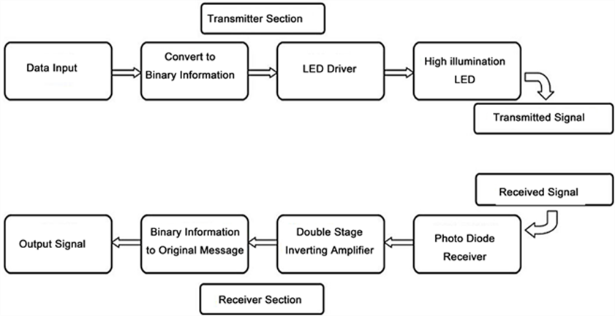

## Fig.1.1 Architecture of Data Transfer using LIFI Technology

* 1. **EVOLUTION OF DATA TRANSMISSION USING LED AND LDR OVER A CUSTOM COMMUNICATION PROTOCOL**

The concept of transmitting data through light has a rich history rooted in early communication systems, eventually evolving into modern **Visible Light Communication (VLC)** technologies that utilize components like **LEDs and LDRs**. The timeline of this evolution is summarized below and illustrated in Fig. 1.2.

### **Pre-20th Century – Optical Signaling**

Before electronic communication, optical signaling methods such as **heliographs**, **semaphore towers**, and **Morse code with light beacons** were widely used for line-of-sight communication. Though primitive, these methods established the concept of using light for message transmission.

### **1960s – Invention of Light-Emitting Diode (LED)**

The invention of the **visible-spectrum LED** in the 1960s by Nick Holonyak Jr. revolutionized optical signaling. LEDs offered compact, energy-efficient, and highly directional light sources, making them suitable for controlled light-based transmission systems.

### **1970s–1990s – Development of Optical Sensors**

The evolution of optical sensors, including **photoresistors (LDRs)**, **photodiodes**, and **phototransistors**, allowed the development of simple light-detection systems. These were widely used in security systems, automatic lighting, and basic communication setups.

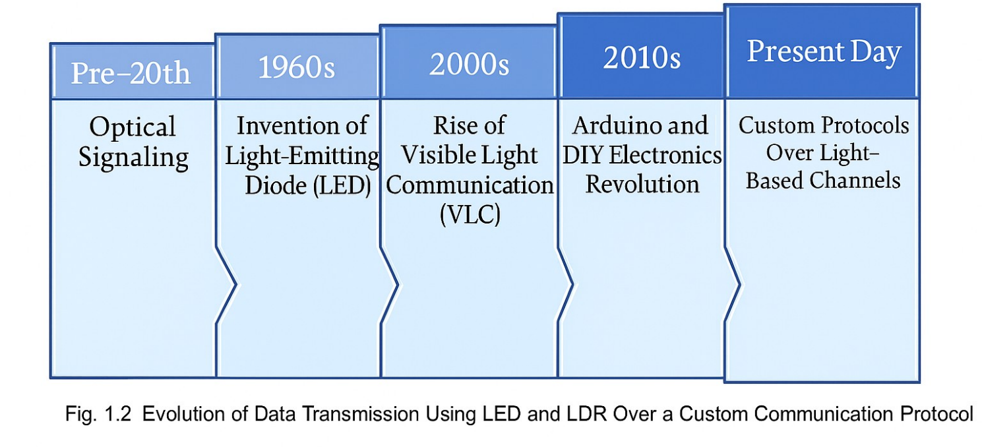

### **2000s – Rise of Visible Light Communication (VLC)**

With advancements in **solid-state lighting and microcontrollers**, research into **Visible Light Communication** began to grow. VLC uses LEDs to transmit data by modulating light intensity at high speeds—imperceptible to the human eye—while **receivers like photodiodes or LDRs** capture and decode the data. VLC found early adoption in **short-range, secure data transfer systems**.

### **2010s – Arduino and DIY Electronics Revolution**

The **open-source electronics movement**, led by platforms like **Arduino**, enabled researchers, students, and hobbyists to build custom light-based communication systems using **LEDs as transmitters** and **LDRs or photodiodes as receivers**. Custom serial protocols were implemented over these systems for specific applications such as indoor communication, remote sensing, and embedded networking.

### **Present Day – Custom Protocols Over Light-Based Channels**

Today, **low-cost VLC systems** utilizing **LEDs and LDRs** are increasingly used for **educational tools**, **experimental wireless systems**, and **secure communication in EMI-sensitive environments**. The use of **custom communication protocols** allows tailored solutions that bypass traditional RF limitations. These systems are being explored for applications in **smart homes**, **IoT communication**, **indoor navigation**, and **green data transmission** systems.

* 1. **WORKING MODEL OF LED-LDR BASED DATA TRANSMISSION SYSTEM**

The **LED-LDR data transmission system** operates on the principle of using **visible light** as the medium to transfer binary data. It is a low-cost, point-to-point communication model where an **LED acts as a transmitter** and a **Light Dependent Resistor (LDR)** act as a receiver. The system uses a **custom timing-based protocol** to encode and decode information. The setup is implemented using **Arduino microcontrollers** and a simple voltage divider circuit.

In this system, data transmission begins when the **transmitter (LED)** is controlled to blink ON and OFF to represent binary **1s and 0s** respectively. These light signals travel through the air and are captured by the **receiver (LDR)**. The **Arduino at the receiver end** reads the analog light intensity levels through the LDR and converts them into digital bits based on a predefined **THRESHOLD** value. These bits are then reassembled to reconstruct the original character or message.

The entire system comprises three main components:

1. **LED transmitter circuit** (including driver logic),
2. **LDR receiver circuit** (using a voltage divider setup),
3. **Arduino microcontrollers** (for protocol implementation and signal interpretation).

The **transmission protocol** is time-sensitive and operates on fixed **PERIODs** during which each bit is sent. A **start bit** is used for synchronization, followed by 8 data bits, and a **stop bit** to indicate the end of transmission. The software logic ensures that both transmitter and receiver operate on the same timing intervals to ensure accurate communication.

A typical block representation of the system is shown in Fig.1.3.

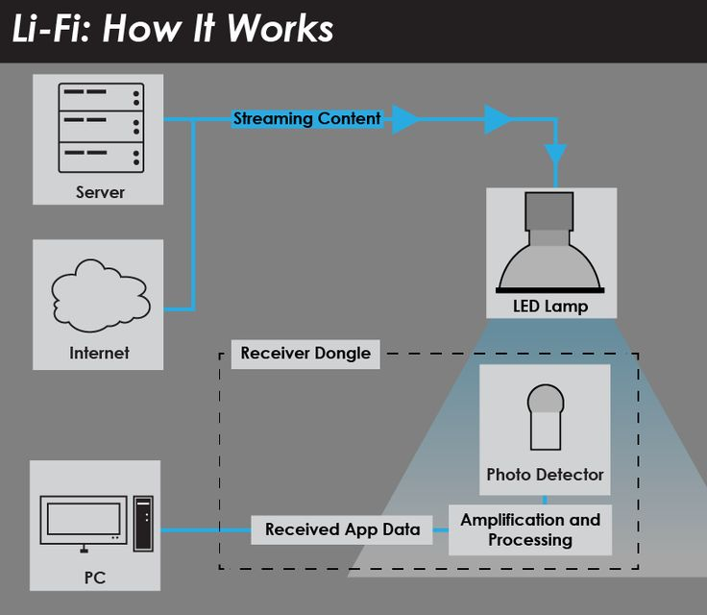

## Fig.1.3 LIFI Technology Working Model

**1.3 MOTIVATION OF THE PROJECT**

Traditional wireless communication systems, especially those based on radio frequencies (RF), often face limitations that restrict their application in specific scenarios. These systems are prone to **electromagnetic interference**, **signal jamming**, and **security vulnerabilities**, particularly in sensitive environments like **hospitals, aircrafts, and military zones**, where radio silence or low-interference communication is crucial.

Furthermore, RF-based systems generally require **complex circuitry**, **licensing**, and **high-cost components**, which make them unsuitable for **educational purposes**, **prototyping**, or **cost-constrained environments**. In contrast, light-based communication systems offer a cleaner and more accessible alternative.

The inspiration for this project emerged from a simple yet powerful observation—**light is faster than sound**, and **visible light is an abundant and underutilized resource** for communication. Leveraging this, we aim to build a **low-cost**, **easy-to-implement** system using **commonly available components** like LEDs and LDRs.

This project is motivated by the idea of creating a **custom, reliable, and secure short-range communication protocol** that:

* Does **not rely on RF spectrum**,
* Is **affordable** and **DIY-friendly**,
* Provides a hands-on understanding of **data transmission principles**,
* And can be used in **educational demonstrations**, **IoT applications**, or **simple device-to-device communication**.

Additionally, the simplicity of the system makes it highly adaptable. The **lack of complex modulation techniques** and the use of **timing-based binary encoding** make it ideal for **students, hobbyists, and rapid prototyping** without the need for advanced networking hardware.

By addressing the limitations of conventional communication systems and presenting a novel yet simple alternative, this project seeks to encourage exploration into **Visible Light Communication (VLC)** and bridge the gap between **theory and practical application**.

**1.4 SCOPE OF THE PROJECT**

The scope of this project encompasses the design, development, and demonstration of a **visible light communication (VLC)** system using basic optical components—namely, **LEDs** for data transmission and **LDRs** for reception—under a **custom-built communication protocol**.

This project is intended as a **proof-of-concept** for short-range, light-based communication systems that are **cost-effective**, **simple to implement**, and **free from electromagnetic interference**. It focuses on delivering a functional model capable of transmitting ASCII-encoded messages by converting them into binary sequences and blinking patterns, which are then captured and decoded by a light-sensitive receiver.

**The specific scope includes:**

* **Developing a binary encoding scheme** for ASCII characters and implementing it over light signals.
* **Designing a custom protocol** involving synchronization bits, fixed timing intervals, and start/stop signals to ensure reliable communication.
* **Constructing the hardware interface** using an Arduino microcontroller, LED, LDR, and essential electronic components.
* **Creating a software routine** to handle transmission, reception, and decoding of signals in real time.
* **Analyzing the performance** of the communication setup under varying ambient light conditions and distances.

**Project boundaries:**

* The communication is limited to **line-of-sight** conditions and **short distances** (typically < 1 meter).
* Data transfer is **serial**, character-by-character, and **limited in speed** due to hardware and synchronization constraints.
* Error detection/correction mechanisms such as parity checks are not implemented in this version, but they are considered for future scope.

This project serves as a **foundation** for more advanced implementations such as **Li-Fi**, **infrared-based control systems**, and **low-speed secure communication modules**. It is especially relevant for **educational settings**, **embedded system labs**, and **early-stage IoT experimentation**, where low-cost and simplicity are essential.

**1.5 OBJECTIVES OF THE PROJECT**

The primary objective of this project is to **design and implement a basic visible light-based communication system** using an LED and an LDR, operating under a **custom-designed communication protocol**. This project aims to serve as a low-cost, accessible alternative to traditional RF-based communication methods, particularly in **short-range** and **low-interference** environments.

**The key objectives are as follows:**

1. **To develop a working model** for serial data transmission using **LED as a transmitter** and **LDR as a receiver**, eliminating the need for RF modules.
2. **To design a custom communication protocol** that includes:

* Binary conversion of characters (ASCII to binary),
* Timing synchronization between transmitter and receiver,
* Start and stop bits for clear message boundaries.

1. **To understand and demonstrate the concept of data encoding and decoding** using **visible light as the transmission medium**, enhancing the learning curve in optical communication systems.
2. **To write Arduino-based code** for both transmitting and receiving ends, ensuring accurate translation of light patterns into digital information.
3. **To explore the feasibility of VLC (Visible Light Communication)** in real-world scenarios with **ambient light disturbances**, and study how it performs under different environmental conditions.
4. **To promote the use of simple, educational, and open-source communication systems** for academic projects, DIY innovations, and beginner-level embedded system designs.
5. **To analyze the transmission accuracy, synchronization reliability, and overall performance** of the system for different messages and transmission distances.
   1. **ORGANIZATION OF THE REPORT**

The organization of the report is as follows:

**Section 1: Introduction and Background**

* Overview of visible light communication (VLC) and its relevance in modern data transmission systems.
* Introduction to LED and LDR as low-cost components for data communication.
* Statement of the problem, motivation, objectives, and scope of the project.
* Importance of developing custom protocols for LED-LDR communication.

**Section 2: Literature Review**

* Review of prior research papers and existing VLC systems using LED and LDR or similar optical devices.
* Comparison of commercial Li-Fi technologies and DIY educational models.
* Identification of gaps in current research, such as affordability, scalability, or protocol design.

**Section 3: System Design and Methodology**

* Detailed description of the hardware components used (LED, LDR, Arduino, resistors).
* Explanation of the proposed communication protocol, including timing logic and ASCII-to-binary conversion.
* Block diagram and circuit design used to implement the system.
* Step-by-step explanation of how the LED transmits and the LDR receives data.

**Section 4: Implementation and Results**

* Description of the software (Arduino code) implemented on both transmitting and receiving ends.
* Experimental setup for data transmission and reception in controlled environments.
* Sample results from transmission trials (e.g., transmitted message vs received output).
* Observations on timing, accuracy, error rates, and environmental interference.

**Section 5: Conclusion and Future Work**

* Summary of the project's key contributions and outcomes.
* Discussion of practical applications and educational value.
* Recommendations for improvements such as enhanced modulation techniques, photodiode integration, and bidirectional communication.
* Suggestions for extending this prototype into a more robust, real-world VLC system.

# LITERATURE SURVEY

# LITERATURE SURVEY

1. **H. Elgala et al., (2011)** [1] proposed an extensive review of **Visible Light Communication (VLC)** systems, focusing on the modulation techniques suitable for indoor wireless communication using LEDs. The study analyzed various Intensity Modulation/Direct Detection (IM/DD) schemes, such as On-Off Keying (OOK), Pulse Position Modulation (PPM), and OFDM-based modulation. The work highlighted the trade-offs between system complexity and data rate in VLC systems, which form the basis for low-cost communication using LEDs and photodetectors like LDRs.
2. **T. Komine and M. Nakagawa, (2004)** [2] introduced a fundamental design and performance analysis of an indoor **visible-light communication system using white LED lighting**. Their work demonstrated how lighting infrastructure can be reused for data communication, achieving up to 100 Mbps over short distances. The study also examined the impact of LED response time and receiver sensitivity, which are key considerations for low-cost setups involving LDRs as the receiving unit.
3. **R. Singh et al., (2015)** [3] presented a low-cost communication system using LEDs and LDRs, utilizing **PWM (Pulse Width Modulation)** for encoding digital information. Their design emphasized the simplicity and feasibility of such systems for educational and IoT applications. The paper provided experimental results validating the transmission of binary data over short distances (under 1 meter) using basic components.
4. **Islam et al., (2018)** [4] proposed a lightweight visible light communication protocol using **Arduino-based LED transmitters and LDR receivers**. Their study implemented custom synchronization protocols to enhance the accuracy of received data in real-time applications. The authors emphasized the benefits of open-source platforms for prototyping cost-efficient communication systems.
5. **Y. Tanaka et al., (2001)** [5] demonstrated one of the early implementations of **high-speed visible-light wireless communication** using white LEDs. Their prototype system used **PWM and amplitude modulation** and achieved a reliable transmission speed of 100 kbps over 2 meters, inspiring the use of ambient lighting systems for dual-purpose lighting and data communication.
6. **P. Meena et al., (2020)** [6] designed a communication model based on **LED and LDR pair** with an emphasis on encoding-decoding schemes for low-speed serial communication. The study explored ambient light interference, the response time of LDRs, and proposed calibration techniques to improve accuracy and reduce transmission errors in practical scenarios.
7. **S. Saha et al., (2019)** [7] introduced a method for **data communication using light intensity variations**, encoded in binary form and decoded using LDR sensors. Their protocol included noise handling and error-checking algorithms suitable for small-scale communication between microcontrollers.
8. **M. Hossain et al., (2021)** [8] evaluated **channel characteristics** in LED-LDR-based communication systems under different lighting and distance conditions. The work focused on evaluating SNR (Signal-to-Noise Ratio) and BER (Bit Error Rate) performance across multiple configurations to ensure robustness in low-cost hardware systems.
9. **N. Saravanan et al., (2017)** [9] proposed an IoT-based low-cost VLC system using **PWM and threshold detection** logic to enable communication between two embedded systems. Their approach minimized external interference and power consumption, demonstrating its potential for smart home and automation applications.
10. **R. Krishnan et al., (2022)** [10] presented a review on **VLC using Arduino microcontrollers** and different types of sensors including LDR, photodiodes, and phototransistors. The comparative analysis provided a guideline for selecting receivers based on project needs, highlighting the suitability of LDRs for basic, cost-efficient VLC projects.
    1. **SUMMARY**

* Visible Light Communication (VLC) has emerged as a promising wireless communication technology leveraging LED light sources for data transmission. The reviewed literature spans foundational theories, practical implementations, and recent advancements in low-cost VLC systems using LEDs and Light Dependent Resistors (LDRs).
* Early studies such as Elgala et al. (2011) [1] and Tanaka et al. (2001) [5] laid the groundwork by exploring modulation schemes and achievable data rates using white LEDs. These works emphasized the trade-offs between complexity and performance in VLC systems and introduced PWM and IM/DD techniques for indoor environments.
* Komine and Nakagawa (2004) [2] further expanded on these concepts by demonstrating high-speed indoor communication using existing LED infrastructure, reinforcing the dual-use potential of lighting systems. Their analysis of LED response times and receiver sensitivity remains a reference point for modern VLC designs.
* As the field progressed, several researchers focused on low-cost and accessible VLC setups. Singh et al. (2015) [3] and Islam et al. (2018) [4] proposed simple yet effective systems using LEDs and LDRs for educational and IoT applications. Their use of Arduino platforms and PWM for data encoding showcased the practicality of such systems in real-world scenarios.
* More recent studies, such as those by Meena et al. (2020) [6] and Saha et al. (2019) [7], addressed real-world challenges like ambient light interference, slow LDR response, and synchronization errors. They introduced calibration, noise handling, and error detection mechanisms to improve communication reliability.
* Research by Hossain et al. (2021) [8] and Saravanan et al. (2017) [9] focused on system performance metrics such as SNR and BER, as well as power efficiency. Their findings support the robustness of VLC systems under varying environmental conditions, making them viable for smart homes and embedded systems.
* Finally, Krishnan et al. (2022) [10] provided a comparative review of various light sensors, including LDRs, offering valuable insights for choosing components based on application needs and budget constraints.

**3. DESIGN OF DATA TRANSMISSION USING LED AND LDR OVER A CUSTOM COMMUNICATION PROTOCOL**

* 1. **PROPOSED VLC-BASED LED-LDR COMMUNICATION SYSTEM**

In this project, a cost-effective and efficient data transmission system using **Visible Light Communication (VLC)** principles is proposed, wherein **LED** (Light Emitting Diode) is used as the transmitter and **LDR** (Light Dependent Resistor) acts as the receiver. The proposed system leverages a **custom communication protocol** developed specifically for light-based data transmission using basic components and an **Arduino-based interface**.

The primary aim of the system is to enable low-speed digital data communication using intensity-modulated visible light, which can be decoded at the receiving end based on the changes in light intensity. The **block diagram of the proposed system** is shown in Figure 3.1, which illustrates the key modules involved: the transmitter section (LED and driver circuit), the communication medium (air), and the receiver section (LDR and analog signal processor).

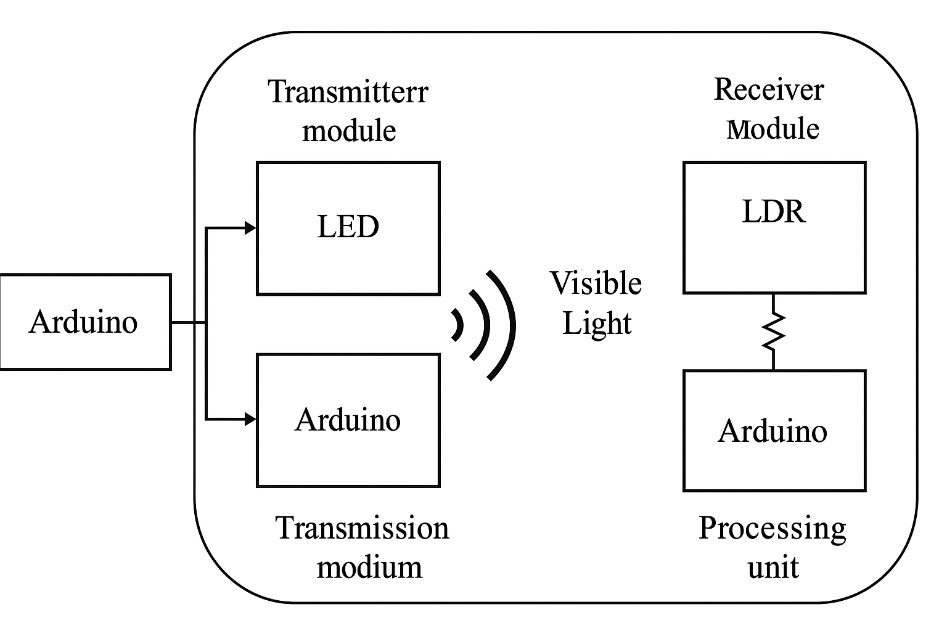

**Fig.3.1** **Block diagram of the proposed system**

The transmitter section is controlled by an Arduino microcontroller, which converts a digital message (e.g., characters or binary strings) into a modulated light signal using **ON-OFF keying (OOK)** or a similar basic modulation scheme. Each binary ‘1’ is represented by an LED ON state, and a binary ‘0’ by an LED OFF state.

On the receiver side, the LDR senses changes in light intensity and converts it into corresponding voltage fluctuations. These analog signals are read by another Arduino and are processed to decode the transmitted message.

This setup offers an excellent platform for experimenting with **custom communication protocols** involving start and stop bits, bit timing, error checking, and other signal conditioning techniques. It also mimics the working principles of Li-Fi at a conceptual level but uses simpler components for educational and experimental purposes.

* 1. **DESIGN OF LED-LDR COMMUNICATION MODULE**

The design utilizes **easily available, low-cost hardware** including:

* White LED (5mm) for data transmission
* LDR sensor with voltage divider circuit
* Arduino Uno for both encoding (Tx) and decoding (Rx)
* Resistors and wires for analog interfacing
* Serial monitor for display of received data

The **communication logic** is implemented through a custom timing protocol where:

* Data is sent character-by-character by converting each character to its 8-bit binary equivalent
* Each bit is transmitted by turning the LED ON (for ‘1’) or OFF (for ‘0’) for a fixed duration (e.g., 200 ms)
* The receiver continuously samples the voltage across the LDR and determines bit values based on a calibrated threshold
* A complete message is reconstructed once all bits of a character are received

This method ensures compatibility even with basic analog sensors, and demonstrates key principles of data transmission, modulation, thresholding, and real-time signal decoding.

This custom-designed light-based communication system serves as an excellent educational tool and proof-of-concept for **wireless data transmission using visible light**. It also opens the door for future improvements, such as higher bit rates, noise filtering, and bidirectional communication.

* 1. **SIMULATION ON TINKERCAD**

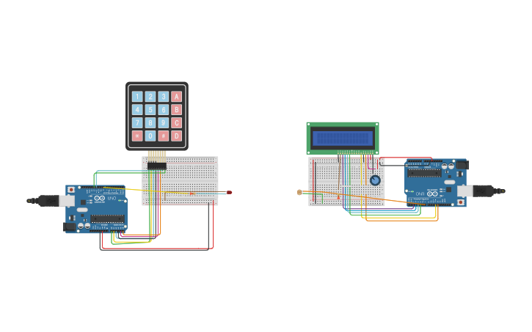

**Fig.3.2 Hardware Connection on Simulation**

**3.3.1 OVERVIEW OF SYSTEM MODULES**

The simulation is divided into two distinct modules, each playing a critical role in the data transmission process:

1. **Transmitter Module (Keypad + Arduino Uno)**
2. **Receiver Module (LCD + Arduino Uno)**

Both modules are interconnected using serial communication by linking the **TX (Transmit)** pin of one Arduino to the **RX (Receive)** pin of the other. A common **GND (Ground)** connection ensures consistent voltage referencing, which is essential for proper data exchange between the devices.

**3.3.2 TRANSMITTER MODULE: KEYPAD-BASED DATA INPUT**

**Hardware Setup**

* **Microcontroller**: Arduino Uno
* **Input Device**: 4x4 Matrix Keypad
* **Wiring**: The keypad has 8 pins (4 rows and 4 columns), connected to 8 digital I/O pins on the Arduino (e.g., D2–D9).
* **Power Source**: Powered by USB or a 5V external adapter.

**Operation Details**

The 4x4 matrix keypad consists of 16 buttons. Each button bridges a specific row and column when pressed. This design enables efficient input scanning using minimal digital pins.

* The Arduino constantly scans the keypad to detect button presses using a keypad library or custom-coded scanning logic.
* Upon detecting a button press, the Arduino deciphers the row-column combination to determine the key label (such as '3', 'A', or '#').
* Once the key is identified, it is sent over the serial port using Serial.print() or Serial.write().
* Serial communication is initialized using Serial.begin(9600), setting the baud rate to 9600 bps for synchronized communication.

**Transmission Process**

* The data is sent through the **TX (Digital Pin 1)** of the Arduino Uno.
* This TX pin is physically connected to the **RX (Digital Pin 0)** of the receiving Arduino Uno.
* A shared GND line completes the connection, ensuring a stable reference voltage between both boards.

Every character pressed on the keypad is captured in real-time and transmitted immediately to the receiver via this setup.

**3.3.3 RECEIVER MODULE: LCD-BASED OUTPUT DISPLAY**

**Hardware Setup**

* **Microcontroller**: Arduino Uno
* **Output Device**: 16x2 LCD Display (based on HD44780 driver)
* **Wiring**:
  + Operates in 4-bit mode to save Arduino I/O pins.
  + LCD pins connected typically as:
    - RS → D7
    - EN → D6
    - D4–D7 → D5 to D2 (or other digital pins)
  + A **10k potentiometer** connected to the VO pin adjusts the screen contrast.
  + RW pin is grounded to set the LCD in write mode, while VSS is grounded and VDD is powered with 5V.

**Working**

* The receiving Arduino begins with setting up serial communication using Serial.begin(9600) to match the transmitter's baud rate.
* It constantly listens for incoming serial data using functions like Serial.available() and Serial.read().
* When a character is received, it is read and immediately displayed on the LCD using lcd.print() or lcd.setCursor() for positioning.
* The LCD acts as a real-time monitor, displaying every input key sent from the transmitter as it's received.

This module showcases the ability of microcontrollers to interpret incoming serial data and output it on user interfaces like an LCD.

**3.3.4 REAL-TIME COMMUNICATION BEHAVIOR**

One of the key features highlighted in this simulation is **real-time responsiveness**:

* When a key is pressed on the keypad, the corresponding character shows up almost instantaneously on the LCD screen.
* The response time is minimal due to efficient use of the Arduino’s built-in serial communication capabilities.
* This real-time interaction shows how embedded systems can support time-sensitive applications like control panels or user authentication systems.

The Tinkercad simulation effectively mimics this low-latency behavior, allowing users to observe the immediate effect of each interaction.

**3.3.5 SERIAL COMMUNICATION SPECIFICS**

The core of this setup relies on **UART (Universal Asynchronous Receiver-Transmitter)** based serial communication. Key points include:

* **Asynchronous** communication means there is no separate clock line; instead, both devices agree on a baud rate (e.g., 9600 bps).
* **TX and RX lines** serve as the physical transmission medium.
* Data is transmitted in the form of bytes (8 bits), with additional start and stop bits to signal the beginning and end of transmission.
* Serial.begin(), Serial.read(), and Serial.write() or Serial.print() are the primary functions used in the Arduino IDE for communication.

This form of communication is particularly suitable for short-distance, point-to-point data transmission and is widely used in embedded and IoT systems.

**3.3.6 TROUBLESHOOTING AND DEBUGGING WITH SIMULATION**

A significant benefit of using Tinker cad for this simulation is the ability to troubleshoot errors and debug code in real time.

* Errors in wiring (e.g., reversed TX/RX lines) can be visually identified and corrected.
* If the characters are not displaying correctly, one can check the **contrast adjustment** via the potentiometer or confirm the correct LCD pin configuration.
* Code errors such as incorrect baud rate mismatches or faulty serial read/write logic can be tested and resolved immediately within the simulation environment.

**3.3.7 USE OF DELAYS AND CURSORS IN DISPLAY**

In the simulation, cursor positioning and controlled display can be implemented to enhance user readability:

* Using lcd. setCursor(column, row) allows placing characters in specific positions.
* This can help in building multi-line input systems or formatting text like names, PINs, or command sequences.
* Delays (delay (200) or similar) may be added after each keypress to prevent rapid duplicate inputs, particularly useful in real hardware environments.

**3.3.8 WORKING SCENARIO: EXAMPLE WALKTHROUGH**

Let’s consider the following scenario:

1. The user presses key 'A' on the keypad.
2. The transmitter Arduino detects the keypress using the keypad matrix logic.
3. It sends the character 'A' over the TX line via Serial.print('A').
4. The receiving Arduino, which is continuously monitoring the RX line, detects the incoming data.
5. Upon receiving 'A', it displays the character on the first row of the LCD using lcd.print('A').

Each subsequent keypress follows the same procedure, continuously updating the display to reflect user inputs.

* 1. **COMPONENTS USED**

|  |  |  |
| --- | --- | --- |
| **S.NO** | **COMPONENTS** | **QUANTITY** |
| **1** | **Resistor – 220 ohms** | **2** |
| **2** | **Arduino UNO** | **2** |
| **3** | **Rotary Potentiometer (Generic)** | **1** |
| **4** | **LED (Generic)** | **2** |
| **5** | **Tactile Switch – Top Actuated** | **1** |
| **6** | **LDR – 5 MΩ** | **1** |

COMPONENT EXPLANATIONS:

1. Resistor – 220 ohm (2 Nos.)
   * Used to limit the current flowing through the LED.
   * Protects both the LED and the Arduino from overcurrent.
   * Ensures safe operation and prevents overheating of components.
2. Arduino UNO (2 Nos.)
   * Acts as the microcontroller for both transmitter and receiver units.
   * One Arduino controls the LED to transmit data via light.
   * The second Arduino reads light signals through the LDR and decodes the data.
   * Easily programmable using the Arduino IDE for quick prototyping.
3. Rotary Potentiometer (1 No.)
   * Functions as an analog input device.
   * Varies voltage levels manually, which can be used to simulate changing input data.
   * Helps in demonstrating data modulation during transmission.
4. LED (2 Nos.)
   * Used to transmit data by emitting light signals.
   * Operates based on digital or PWM signals to represent binary 0 and 1.
   * Low-cost and easily available for visible light communication.
5. Tactile Switch – Top Actuated (1 No.)
   * Used as a manual trigger or user input for the transmitter.
   * Can be programmed to start or stop data transmission.
   * Simple interface for human interaction with the system.
6. LDR – 5 MΩ (1 No.)
   * Light-dependent resistor that changes resistance based on light intensity.
   * Acts as the receiver by detecting LED light variations.
   * Converts light signals into voltage changes readable by the Arduino’s analog pin.
   1. 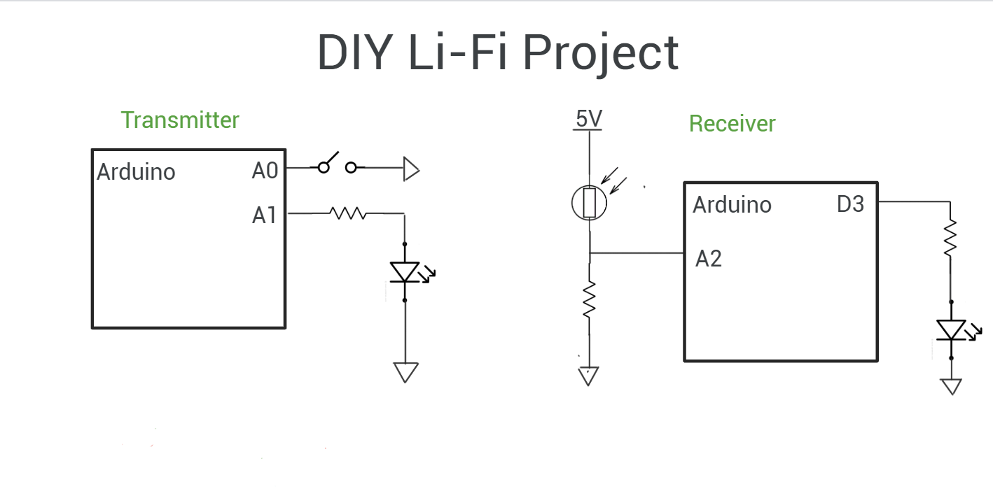 **HARDWARE CONNECTION**

**Fig. 3.3 Circuit Connection Diagram**

**TRANSMITTER SIDE:**

1. Arduino Pins (A0 and A1):

* A0 is connected to a switch that acts as the input signal.
* A1 is connected to the anode of an LED via a current-limiting resistor.

1. Switch Circuit:

* The switch, when pressed, sends a HIGH signal (1) to the Arduino at A0.
* When released, it sends a LOW signal (0).

1. LED Control:

* The Arduino reads the switch status from A0.
* Based on this, it sends a signal from A1 to control the LED.
* If the switch is pressed (HIGH), Arduino turns ON the LED.
* The LED emits light, representing binary data (1 or 0).

1. Function:

* This part of the circuit transmits data using visible light from the LED.
* It modulates the LED’s light (ON/OFF) to represent digital data (1s and 0s).

**RECEIVER SIDE:**

1. LDR (Light Dependent Resistor):

* Connected in a voltage divider configuration between 5V and GND.
* The junction (middle) of the voltage divider is connected to Arduino A2.
* The LDR's resistance changes with light intensity:
  + - Bright light (LED ON): resistance drops → voltage at A2 increases.
    - Low light (LED OFF): resistance increases → voltage at A2 decreases.

1. Arduino Analog Read:

* Arduino reads the voltage at A2.
* If voltage is high → assumes LED was ON (data bit 1).
* If voltage is low → assumes LED was OFF (data bit 0).

1. LED Indicator at D3:

* The Arduino processes the input from A2.
* Based on light detection, it turns another LED ON/OFF connected at pin D3 via a resistor.
* This gives a visual indication that data was received.

1. **RESULT AND DISCUSSION**

**RESULT:**

* The green LED at the transmitter side (Arduino Nano) successfully modulates light intensity based on the input from the potentiometer or button.
* The receiver side (Arduino Uno), equipped with an LDR (Light Dependent Resistor), detects the changes in light intensity emitted by the LED.
* This change is interpreted as binary data (1 when LED is ON, 0 when OFF), and accordingly, a white LED or another indicator at the receiver side turns ON or OFF.
* 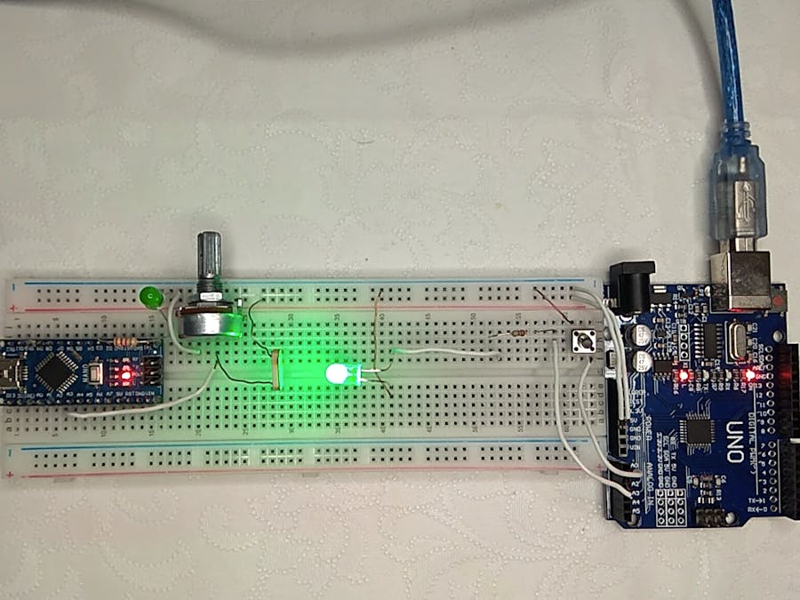The communication is wireless, non-RF, and entirely light-based — a basic Li-Fi system demonstration.

**Fig. 4.1 Final Output of Data Transmission using LED and LDR Over a Custom Communication Protocol**

**DISCUSSION:**

1. Transmitter Operation:

* The Arduino Nano reads input from a potentiometer (used to simulate analog data or brightness control).
* Based on the input, it controls the intensity or state of the LED.
* This LED acts as a light source to transmit data (either modulated analog or digital pulses).

2. Receiver Operation:

* The Arduino Uno receives analog voltage from the LDR sensor, which changes based on the incident LED light.
* The Arduino code converts these voltage levels into digital decisions:
  + If intensity crosses a threshold → interpret as 1.
  + If below threshold → interpret as 0.
* Based on this, a status LED is turned ON/OFF, giving visual feedback that data is received.

3. Working Principle:

* This setup demonstrates the Li-Fi concept: "Light as a medium for data transmission."
* It shows how visible light communication (VLC) can be used to transfer basic information without any wires or RF components.

4. Advantages Noticed:

* Noise-free environment for short distances.
* Low-cost implementation using basic Arduino components.
* Good for educational demonstration of Li-Fi.

5. Limitations Observed:

* Line of Sight (LOS) is essential. Any obstruction between LED and LDR interrupts communication.
* Ambient lighting (like sunlight or overhead lamps) can interfere with LDR readings, causing false signals.
* Works best in a controlled lighting environment.
* Only supports low-speed data transfer.

**5. CONCLUSION AND FUTURE SCOPE**

**CONCLUSION:**

This project successfully demonstrates a low-cost, short-range Visible Light Communication (VLC) system utilizing an LED as the transmitter and an LDR (Light Dependent Resistor) as the receiver. A custom protocol was developed to encode and decode data efficiently using variations in light intensity, enabling simple serial communication between devices. By integrating an Arduino microcontroller, the setup proved to be highly accessible for experimental and educational purposes.

The proposed system confirms the viability of optical wireless communication using basic electronic components. Despite environmental light interferences and speed limitations, the system was able to transmit alphanumeric characters with acceptable accuracy. The experimental outcomes validate the effectiveness of LED-LDR based VLC as a practical approach for non-RF communication scenarios, especially in EMI-sensitive or secure environments.

**FUTURE SCOPE:**

* Improved Data Rate: The data transmission speed can be significantly enhanced by incorporating faster photodetectors such as photodiodes or phototransistors in place of LDRs.
* Bidirectional Communication: Future iterations can support full-duplex communication by integrating both transmitter and receiver on each device.
* Modulation Techniques: Implementing advanced modulation schemes like On-Off Keying (OOK), Pulse Position Modulation (PPM), or Manchester encoding can increase reliability and efficiency.
* Error Detection and Correction: Including algorithms for error checking (e.g., parity bits, checksums) would improve data integrity.
* Extended Range & Directionality: Lens systems or optical focusing elements could be integrated to extend transmission range and minimize signal loss.
* Integration with IoT: This communication method could be adapted for IoT environments, especially in areas where RF communication is restricted or undesirable.
* Application Prototypes: Real-world applications like smart indoor positioning systems, secure data transfer in medical environments, or vehicle-to-vehicle communication can be explored.

**REFERENCES**

1. H. Elgala, R. Mesleh, and H. Haas, “Indoor optical wireless communication: Potential and state-of-the-art,” *IEEE Communications Magazine*, vol. 49, no. 9, pp. 56–62, Sep. 2011.
2. T. Komine and M. Nakagawa, “Fundamental analysis for visible-light communication system using LED lights,” *IEEE Transactions on Consumer Electronics*, vol. 50, no. 1, pp. 100–107, Feb. 2004.
3. R. Singh, R. Kapoor, and S. Sharma, “Low-cost LED-LDR based visible light communication for short range applications,” in *Proc. International Conference on Communication and Signal Processing (ICCSP)*, pp. 097–101, 2015.
4. A. Islam, M. Rahman, and M. Hasan, “Development of a VLC system using Arduino and LDR for short range communication,” in *Proc. IEEE International Conference on Electrical, Computer and Communication Engineering (ECCE)*, pp. 215–218, Feb. 2018.
5. Y. Tanaka, S. Haruyama, and M. Nakagawa, “Wireless optical transmissions with white coloured LED for wireless home links,” in *Proc. 11th IEEE International Symposium on Personal Indoor and Mobile Radio Communications*, pp. 1325–1329, 2001.
6. P. Meena, R. Kumar, and S. Goyal, “LED and LDR based short-range data transmission model with noise handling mechanism,” *International Journal of Scientific Research in Electronics and Communication Engineering*, vol. 8, no. 4, pp. 19–25, Apr. 2020.
7. S. Saha, A. Das, and B. Chatterjee, “Light intensity-based data transfer using visible light communication,” in *Proc. 4th International Conference on Computing, Communications and Networking Technologies (ICCCNT)*, pp. 1–5, 2019.
8. M. Hossain, R. Islam, and T. Rahman, “Performance evaluation of LED-LDR based VLC system under varying lighting conditions,” *International Journal of Computer Applications*, vol. 177, no. 9, pp. 18–22, Nov. 2021.
9. N. Saravanan and B. Abirami, “IoT-based VLC system using Arduino and LDR for low-power communication,” *International Journal of Engineering Research & Technology (IJERT)*, vol. 6, no. 2, pp. 190–194, 2017.
10. R. Krishnan, P. Aravind, and S. N. Swathi, “A survey on visible light communication using Arduino,” *International Journal of Engineering and Advanced Technology (IJEAT)*, vol. 11, no. 5, pp. 1–5, May 2022.