**SCREEN SHOTS**

1. Admin login

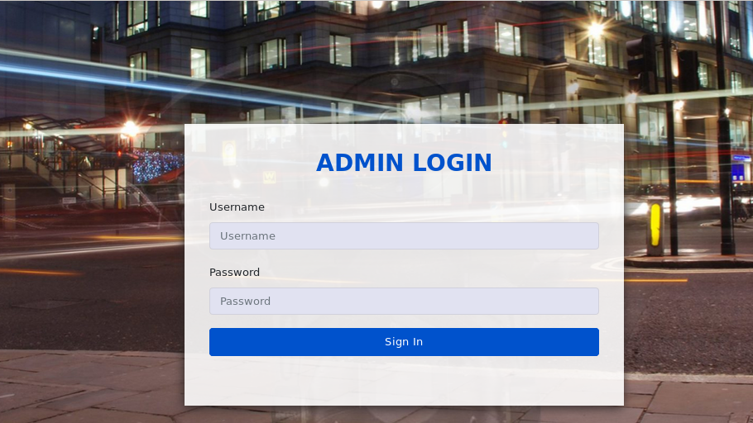

Figure 8.2.1 admin login

1. Add officer

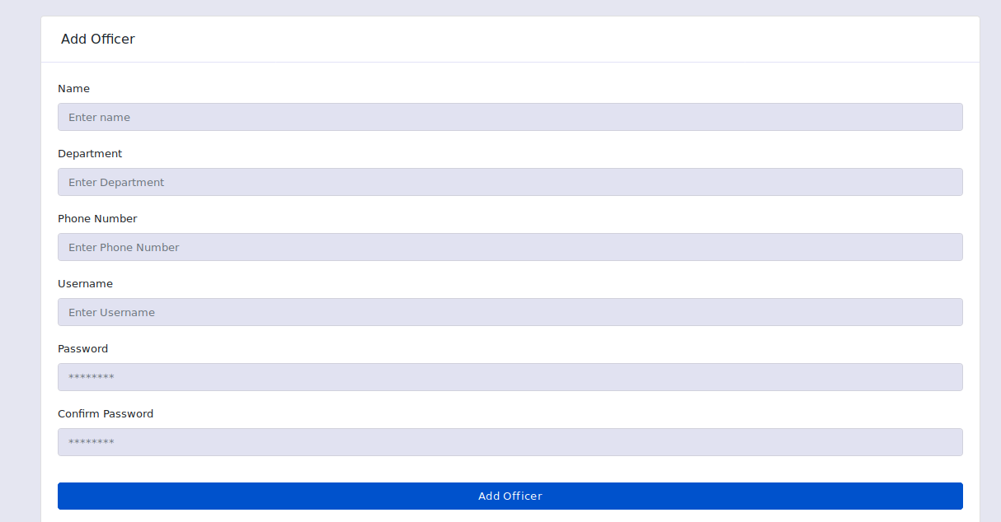

Figure 8.2. Add officer

1. Add camera

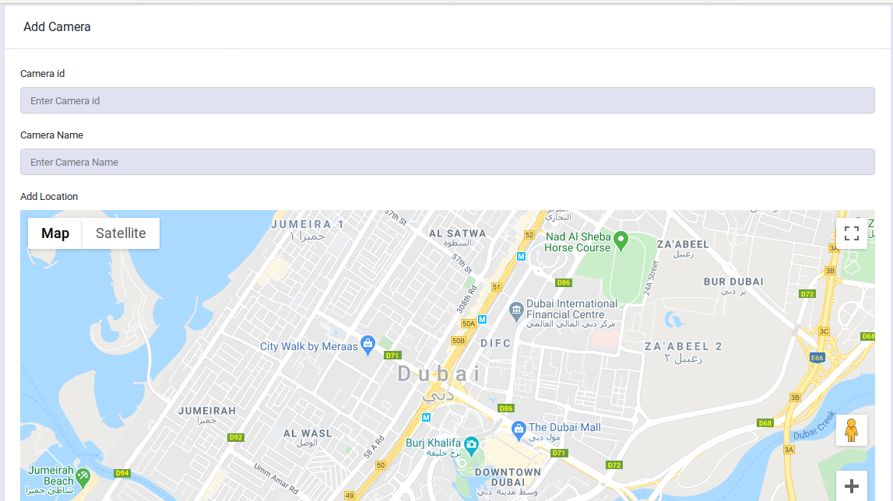

Figure 8.2.3 Add camera

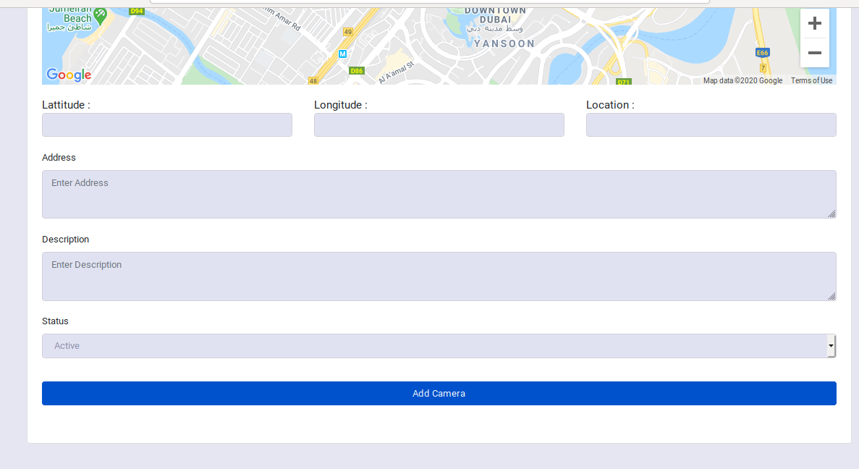

Figure 8.2.4Add camera

1. View camera

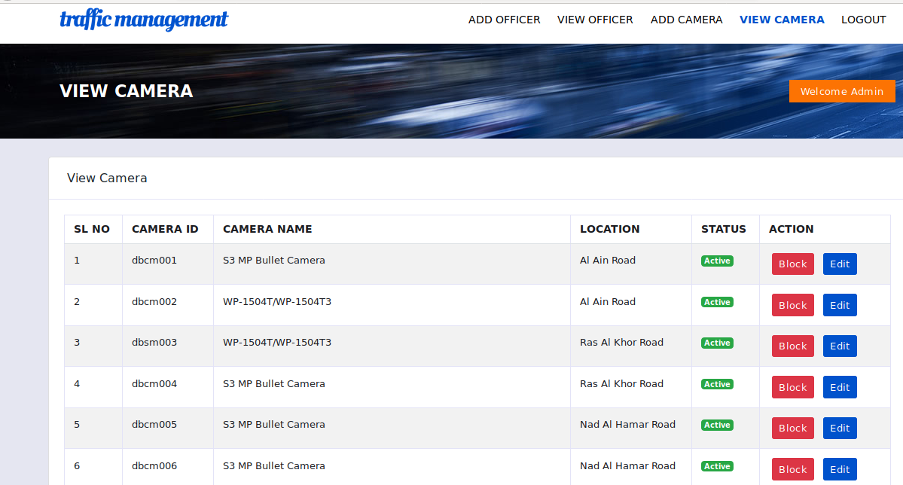

Figure 8.2.5 View camera

1. Add vehicle

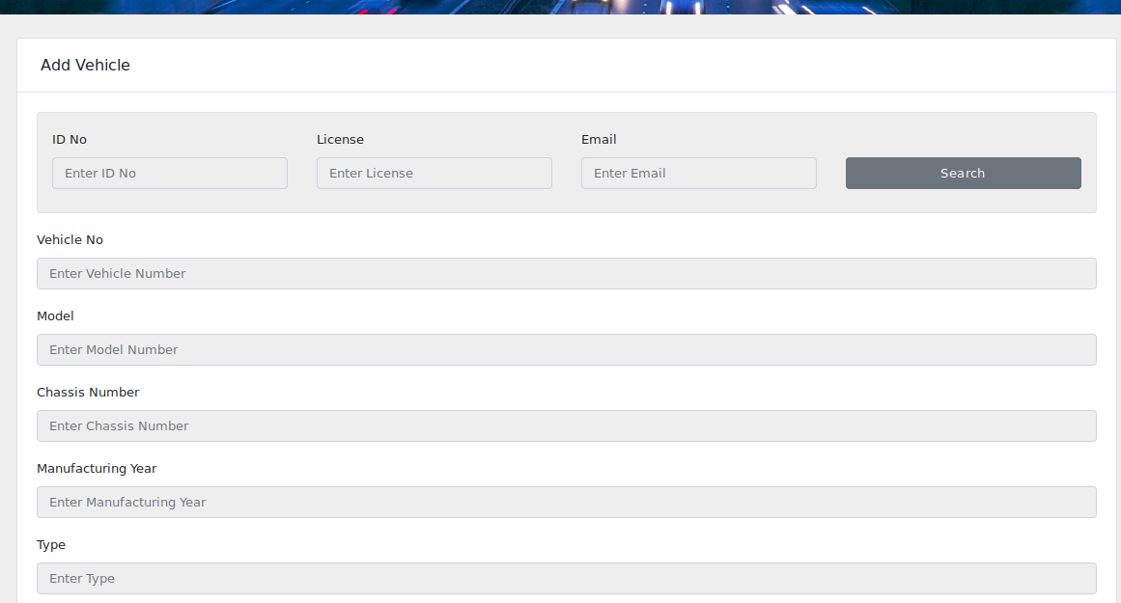

Figure 8.2.6 Add vehicle

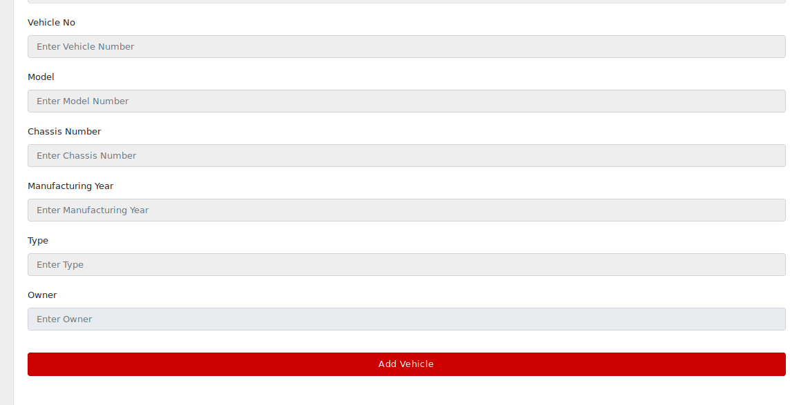

Figure 8.2.7 Add vehicle

1. Edit vehicle

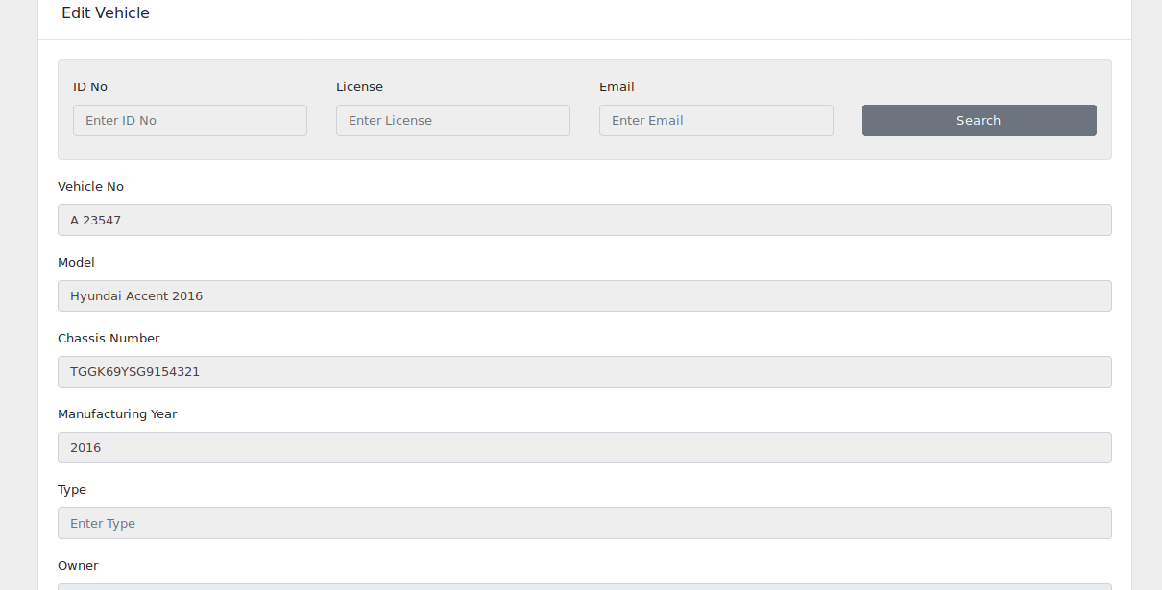

Figure 8.2.8 Edit vehicle

1. Add owner

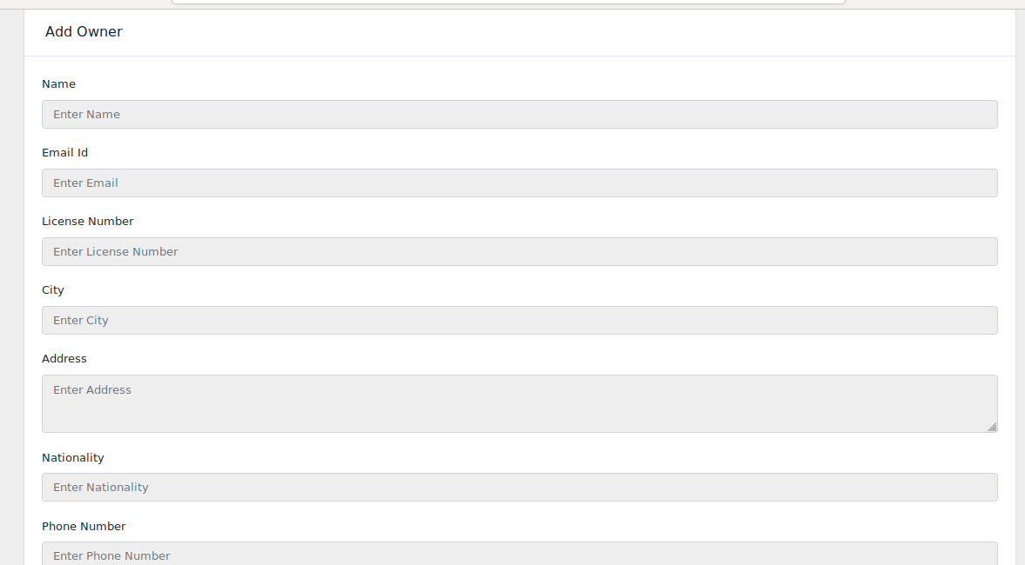

Figure 8.2.9 Add owner

1. View owner

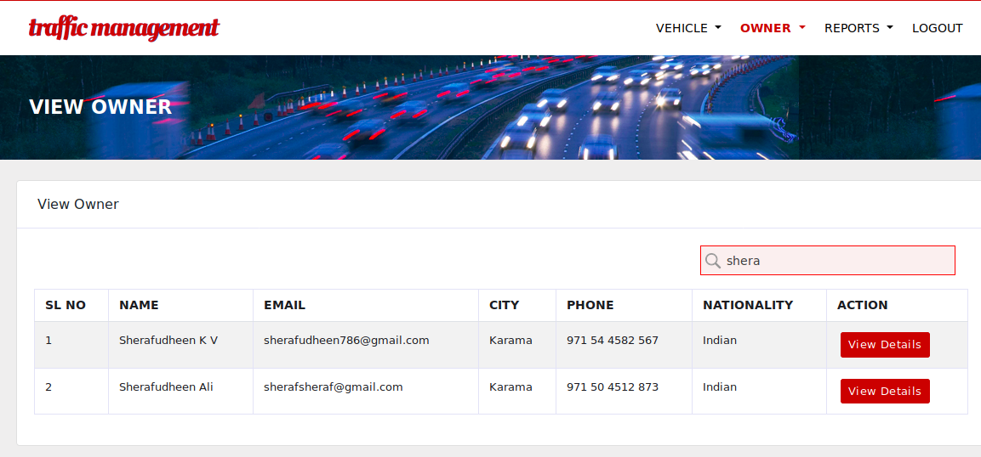

Figure 8.2.10 View owner

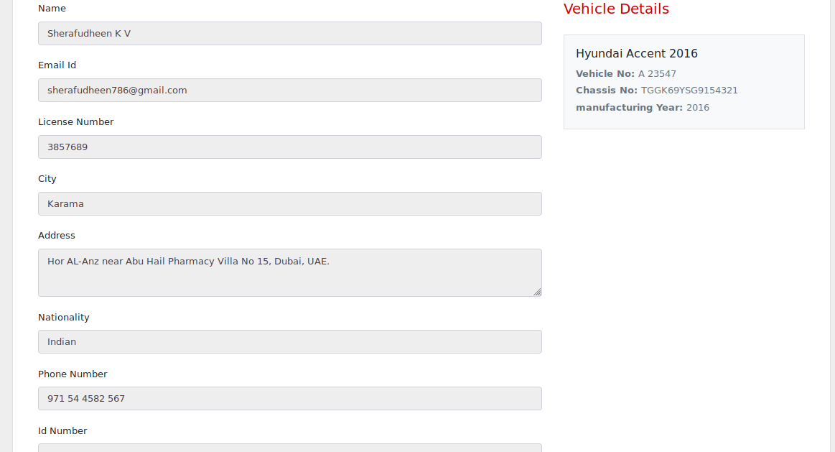

Figure 8.2.11 View owner