**Project DFD /UML**

**Context Level / Level 0**



Figure 5.1.2 Context diagram (Level 0)

**Level 1 Admin**

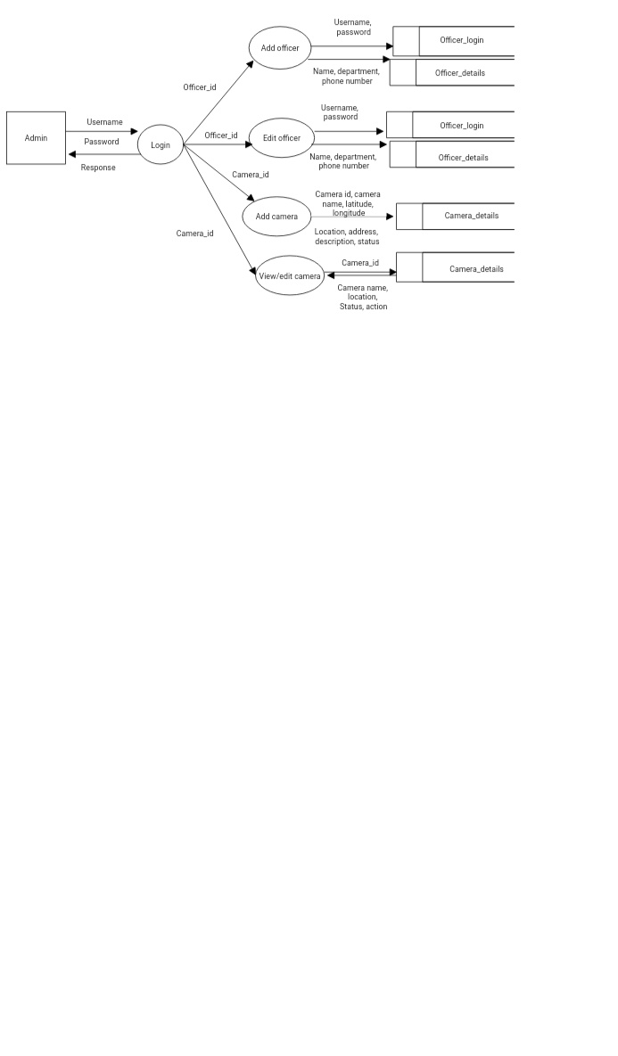

Figure 5.1.3 level 1 admin

**Level 1 officer**

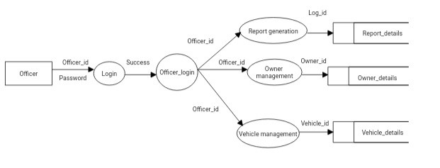

Figure 5.1.4 Level 1 officer

**Level 2 officer (Vehicle Management)**

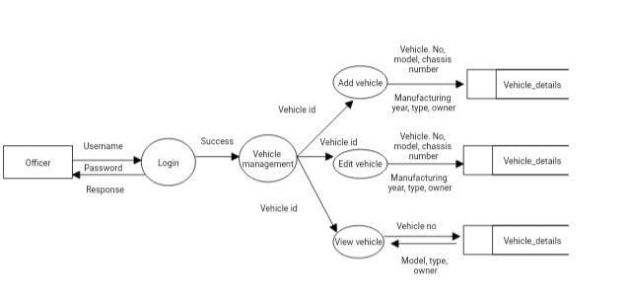

Figure 5.1.5 Level 2 officer-vehicle management

**Level 2 officer (Owner management)**

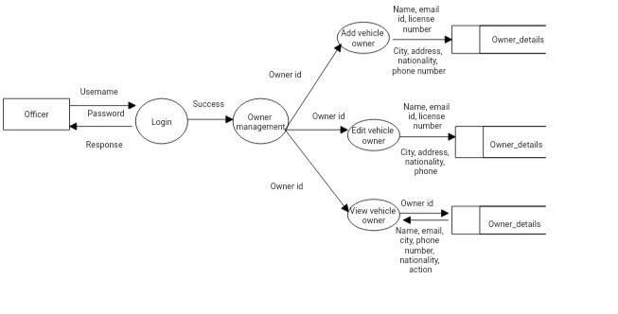

Figure 5.1.6 Level 2 officer-owner management

**Level 2 officer (Report generation)**

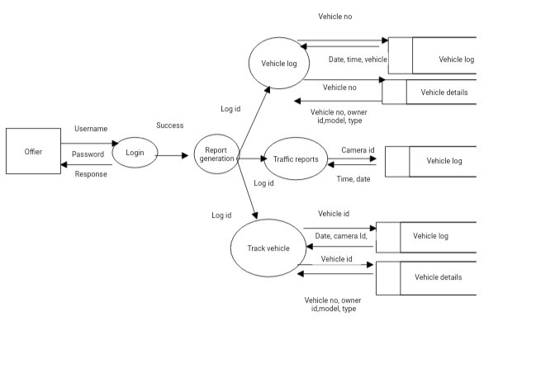

Figure 5.1.7 Level 4 officer-report generation