Experiment No: 3
NAME:K.NITHYASHREE
Roll No: 240701369

Survey Report on Emerging Trends in Low-Code Application Development
1. AIM
The aim of this survey is to study the emerging trends in low-code application development, understand how low-code platforms differ from traditional application development, identify their benefits and challenges, and compare commonly used low-code platforms.

2. Traditional Application Development vs Emerging Trends in Low-Code Application Development
Traditional Application Development
In traditional application development, applications are developed mainly by writing code manually. Developers need knowledge of programming languages, databases, frameworks, APIs, testing, deployment, and server management.
Typical process:
Requirement
↓
Design
↓
Coding
↓
Testing
↓
Debugging
↓
Deployment
↓
Maintenance
For example, a developer creating a Student Attendance System may manually write HTML, CSS, JavaScript, backend code, database queries, authentication logic, and server-side code.
Low-Code Application Development
Low-code development uses visual development environments, drag-and-drop components, pre-built templates, workflows, connectors, and automated features to reduce the amount of manual coding required.
Requirement
↓
Visual Design
↓
Drag & Drop Components
↓
Configure Logic
↓
Connect Database/API
↓
Test
↓
Deploy
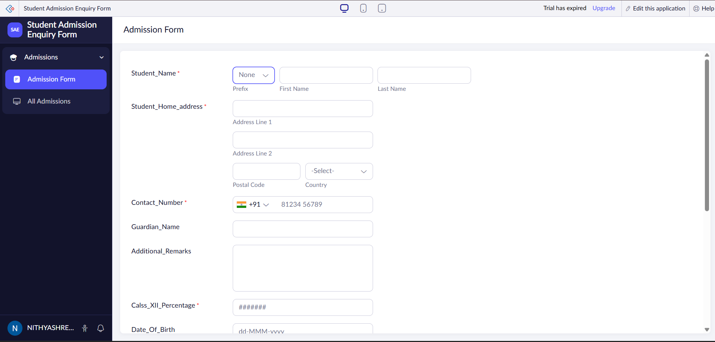
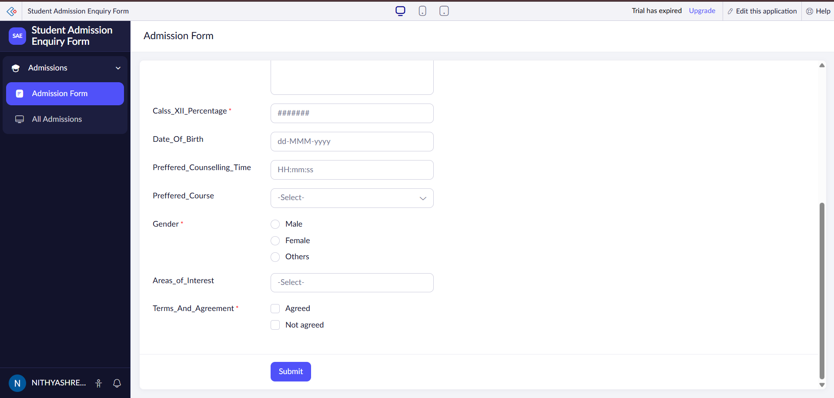
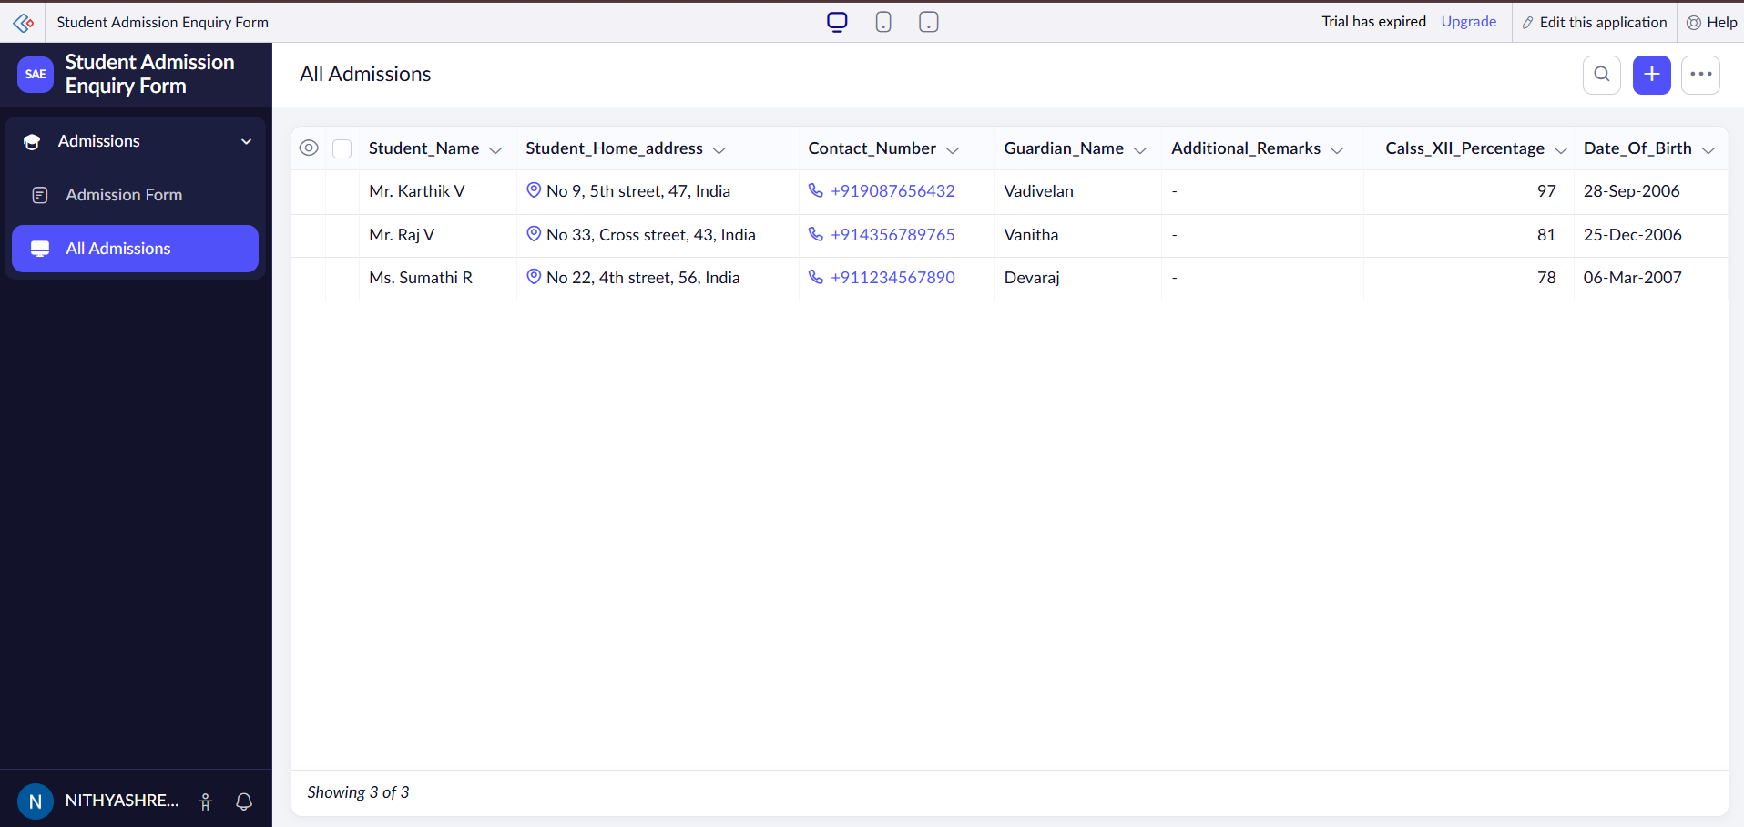
Emerging Trends
Trend | Description
Visual Development | Applications are created using drag-and-drop interfaces and visual designers.
Reusable Components | Pre-built components and templates reduce development time.
Cloud-Based Development | Applications can be developed, deployed and managed through cloud platforms.
Workflow Automation | Repetitive business processes can be automated using visual workflows.
API Integration | Applications can connect easily with external services and APIs.
Mobile App Development | Many platforms support development of responsive and mobile applications.
Citizen Development | Non-professional programmers can create applications with limited coding knowledge.
AI-Assisted Development | Modern platforms increasingly provide AI-based assistance for generating application components, logic, or code.
Rapid Prototyping | Functional prototypes can be created quickly for testing ideas.
Low-Code + Pro-Code | Developers can combine visual development with custom programming when advanced functionality is required.

3. Benefits and Challenges in Low-Code
Benefits
1. Faster Development
Low-code platforms reduce the amount of code that developers have to write manually.
2. Less Coding Required
Visual components, templates and pre-built functions simplify application development.
3. Easy Prototyping
Developers can quickly create prototypes and demonstrate ideas.
4. Increased Productivity
Developers can concentrate on application logic and business requirements instead of repetitive coding tasks.
5. Easy Integration
Many platforms provide ready-made connectors for databases, APIs and external services.
6. Reduced Development Cost
Less development time can reduce the overall cost of building applications.
7. Accessibility for Beginners
People with basic programming knowledge can create simple applications.
8. Easy Maintenance
Visual workflows and reusable components can make certain applications easier to modify and maintain.
Challenges
1. Limited Customization
Highly complex applications may require custom code that the platform does not easily support.
2. Vendor Lock-In
Applications may become dependent on a particular low-code platform.
3. Security Concerns
Applications still require proper authentication, authorization, data protection and security testing.
4. Performance Limitations
Some applications may not perform as efficiently as highly optimized traditionally coded applications.
5. Learning the Platform
Although coding requirements are reduced, developers still need to understand the platform, its components and workflows.
6. Licensing Cost
Some enterprise low-code platforms can have significant subscription or licensing costs.
7. Scalability
Applications with very large workloads may require careful architecture and platform-specific optimization.
4. Comparison of Existing Low-Code Platforms
Feature | Microsoft Power Apps | Zoho Creator | OutSystems | Mendix
Developer | Microsoft | Zoho | OutSystems | Siemens
Development Style | Visual/low-code | Visual/low-code | Low-code/pro-code | Low-code
Web Applications | Yes | Yes | Yes | Yes
Mobile Applications | Yes | Yes | Yes | Yes
Database Support | Dataverse and connectors | Built-in database and integrations | Multiple data sources | Multiple data sources
Workflow Automation | Yes | Yes | Yes | Yes
API Integration | Strong connector ecosystem | Supported | Supported | Supported
Custom Coding | Available when required | Available | Strong support | Available
Cloud Support | Strong | Strong | Strong | Strong
Target Users | Businesses, developers, citizen developers | Businesses and application developers | Professional development teams | Enterprise development teams
Main Strength | Integration with Microsoft ecosystem | Rapid business application development | Enterprise application development | Enterprise-grade visual development
Brief Description
Microsoft Power Apps:
A Microsoft low-code platform used to build business applications and connect them with Microsoft services and other data sources.
Zoho Creator:
A low-code application development platform that allows users to create forms, reports, dashboards, workflows and business applications with relatively little coding.
OutSystems:
An enterprise low-code platform designed for developing and deploying web and mobile applications, with support for custom development when required.
Mendix:
An enterprise low-code platform focused on rapid application development, collaboration and integration with enterprise systems.
5. RESULT
The survey shows that low-code application development is emerging as an important approach for rapid software development. Compared with traditional application development, low-code platforms reduce manual coding through visual development, reusable components, workflow automation and ready-made integrations.
Low-code platforms such as Microsoft Power Apps, Zoho Creator, OutSystems and Mendix provide different features for developing business and enterprise applications.
However, low-code development does not completely replace traditional programming. Complex applications may still require custom coding, database knowledge, API integration and professional software development skills.
Therefore, the major trend is toward a combination of low-code and traditional development, where low-code tools speed up application development while professional developers handle complex logic, customization, security and scalability.

