Project Documentation

**Store Manager : Keep track of inventory**

## Project Title

• Project Title: Store Manager : Keep track of inventory  
• Team ID:   
• Team Leader: Name : NITHYASWARI K ; E-mail : [nithyabca2024@gmail.com](mailto:nithyabca2024@gmail.com)

• Team Members:  
 Name : PAVITHRA C ; E-mail : [pavithra86100@gmail.com](mailto:pavithra86100@gmail.com)

Name : SAILAJA N ; E-mail : [Sailajabca2006@gmail.com](mailto:Sailajabca2006@gmail.com)

Name : SANTHI P ; E-mail : [santhi2007vel@gmail.com](mailto:santhi2007vel@gmail.com)

## Project Overview

* **Purpose:**

Store Manager helps businesses keep track of their inventory efficiently by allowing users to add, update, and monitor stock levels in real time.

* **Features:**  
   Add, update, and delete inventory items  
   Real-time stock monitoring  
   Search and filter items  
   User-friendly dashboard  
   Alerts for low stock levels

## Architecture

**• Frontend:** React.js for building interactive UI  
• **Backend:** Node.js and Express.js to handle server logic  
• **Database:** MongoDB to store inventory data

## Setup Instructions

• **Prerequisites:**  
 – Node.js (Download from https://nodejs.org/en/download/)  
 – Git  
 – React.js  
 – MongoDB  
 – Visual Studio Code  
  
• **Installation Steps:**  
# Clone the repository  
git clone <repo-link>  
  
# Install dependencies  
npm install  
  
# Start the development server  
npm start

## Folder Structure

Store-Manager/  
|-- client/ # React frontend  
| |__ components/  
| |__ pages/  
|-- server/ # Node.js backend  
| |__ routes/  
| |__ models/  
| |__ controllers/

## Running the Application

• **Frontend:**  
cd client  
npm start  
  
• **Backend:**  
cd server  
npm start  
  
**• Access:** Visit http://localhost:3000

## API Documentation

• **Inventory:**  
 – /api/items (GET, POST)  
 – /api/items/:id (PUT, DELETE)

## Authentication

• JWT-based authentication for secure access to inventory data  
• Role-based access for admin and staff

## User Interface

• Dashboard  
• Inventory List Page  
• Add/Edit Item Form

## Testing

• Manual testing of CRUD operations  
• Tools: Postman, Chrome Dev Tools

## Screenshots or Demo

Attach relevant screenshots

**OUTPUT :**

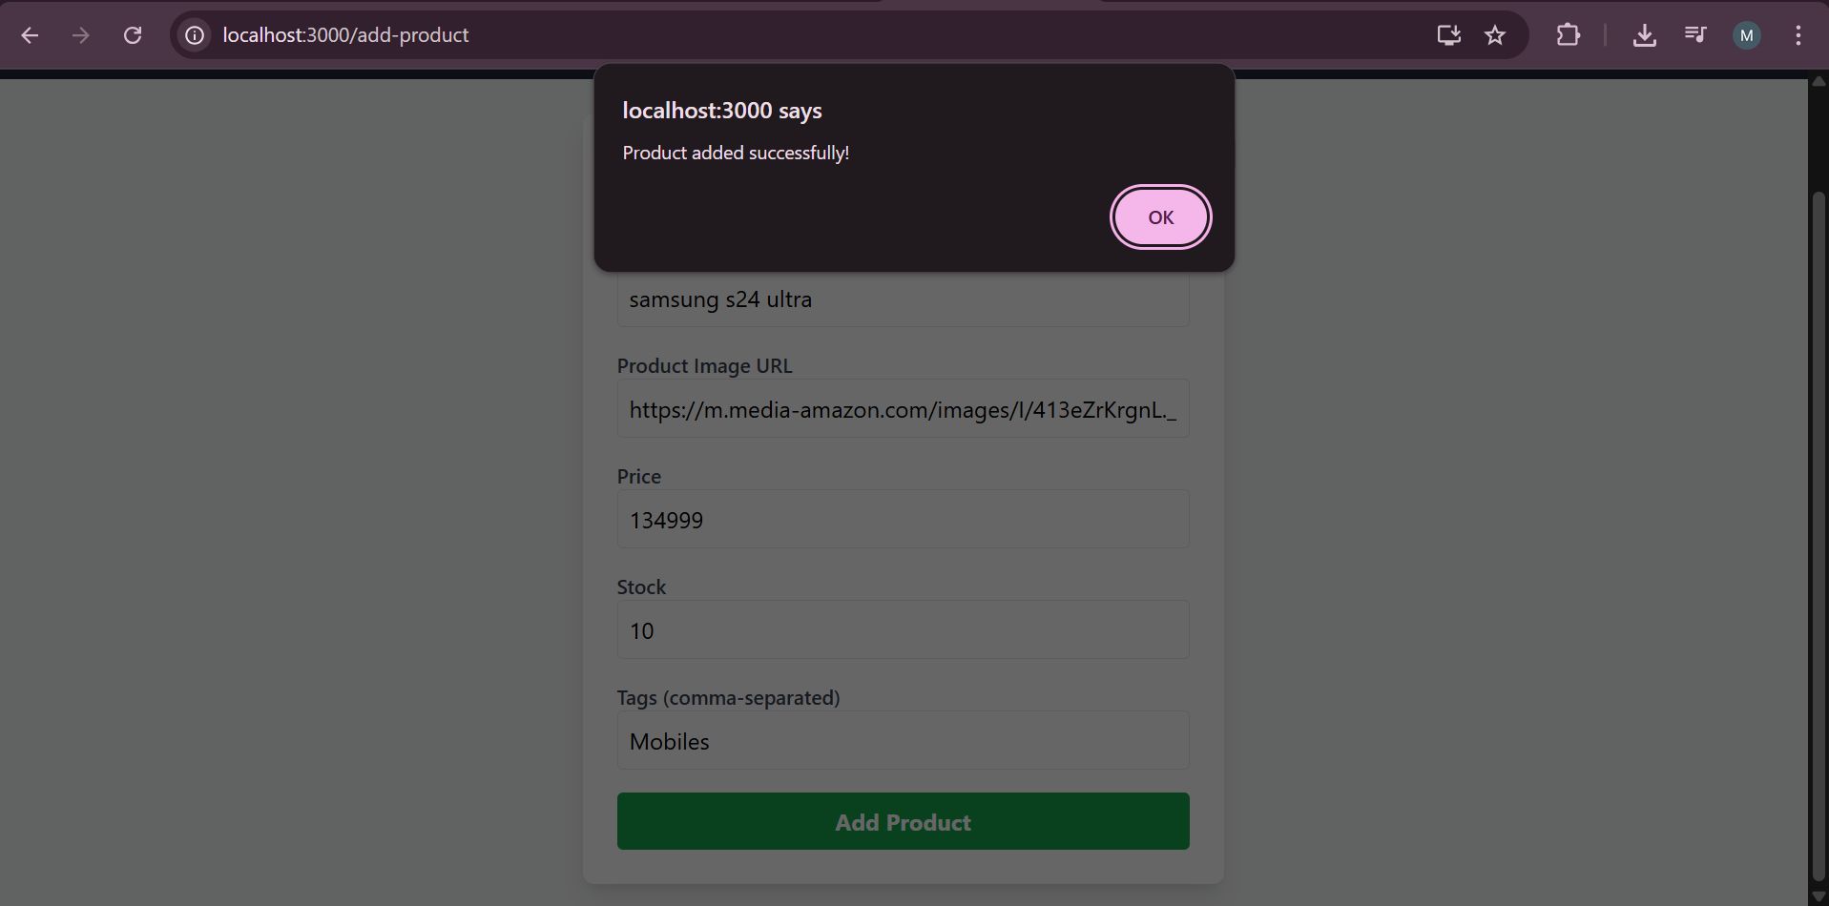

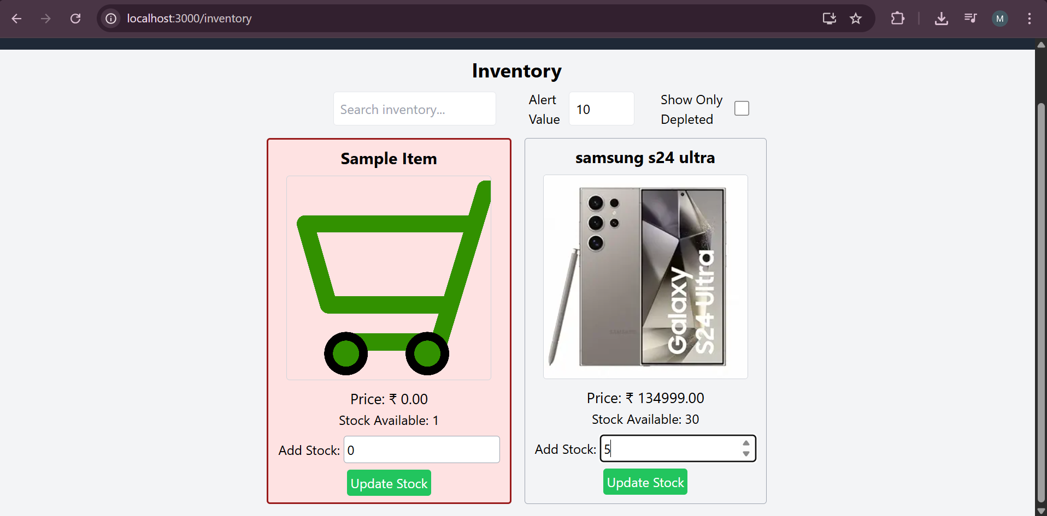

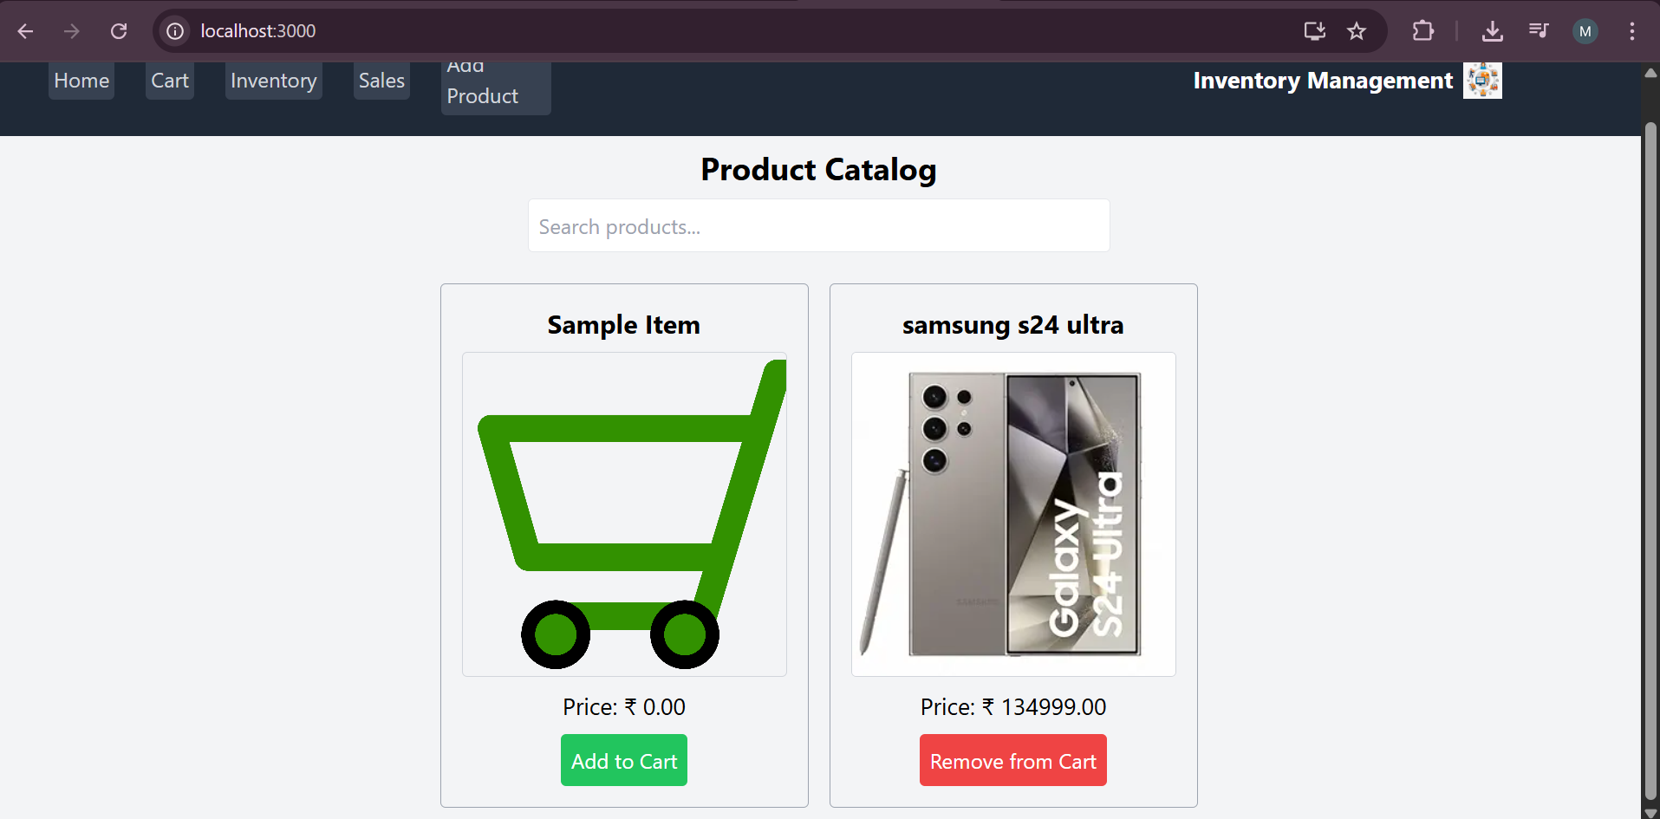

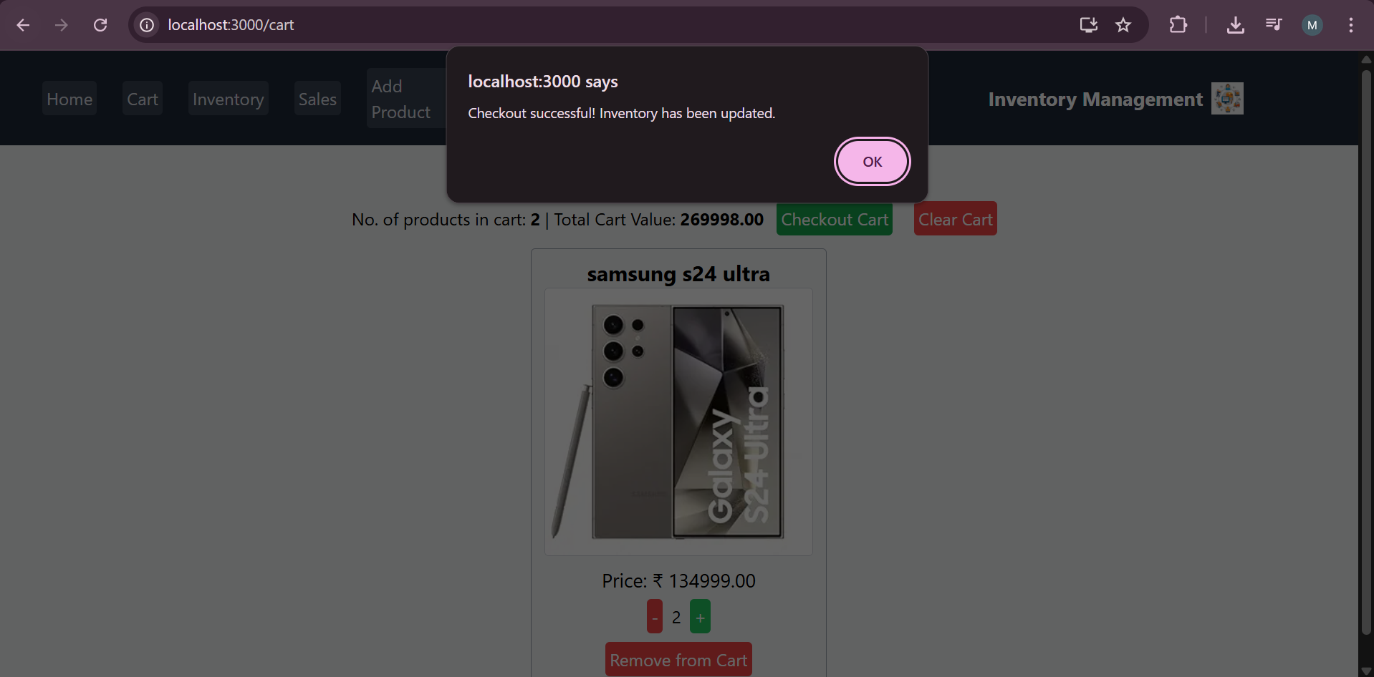

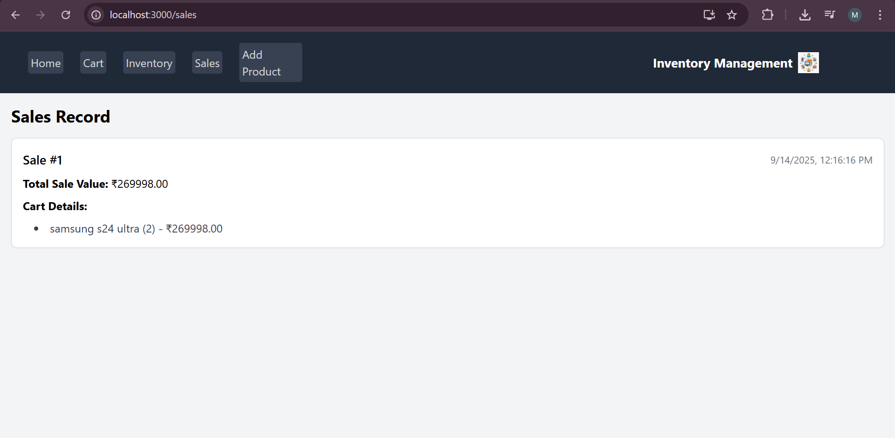

## Known Issues

• Some browsers may have caching issues  
• UI may not be fully responsive on small screens

## Future Enhancements

• Add barcode scanning support  
• Implement inventory forecasting using AI  
• Multi-warehouse support