Lambda

Class no:27

What is AWS Lambda?

AWS Lambda is a Serverless compute service. "Serverless" doesn't mean there are no servers; it means AWS handles all the server management, patching, and scaling for you, so you only provide the code.

Purpose & Use Cases

- Purpose: To simplify development by removing infrastructure overhead and ensuring applications scale automatically.
- Use Cases:
  - Automated Backups: Triggering a backup when a file is uploaded.
  - Image Processing: Resizing images as soon as they hit an S3 bucket.
  - Web APIs: Powering the backend of mobile or web apps.
  - Scheduled Tasks: Like the script we wrote to release Elastic Ips and Cron jobs.

Lambda vs. EC2: Cost & Billing

Feature | AWS Lambda | AWS EC2
Billing Unit | Number of requests + execution duration (ms). | Hourly or per-second "Up-time."
Cost at Idle | $0.00. You are never charged if the code isn't running. | Full Price. You pay even if the CPU is at 0% usage.
Scaling | Automatic and nearly instant. | Manual or via Auto Scaling Groups (takes minutes).
Ideal For | Short tasks, unpredictable traffic, and automation. | Steady-state workloads, legacy apps, and long-running processes.

Points to remember:

The applications that can be used in lambda must execute within 15 minutes or 900 seconds.
It can not handle large complex realtime applications.
It can store apllications 128 Mb to 10240 Mb.
Hands on: To create a Lambda function to release idle elactic ip address.

Step no:1 Create IAM Execution Role

Lambda needs permissions for EC2 actions.
- Go to IAM console > Roles > Create role.

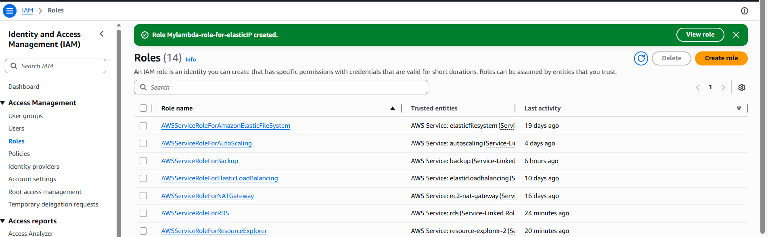

- Select Lambda as trusted entity.

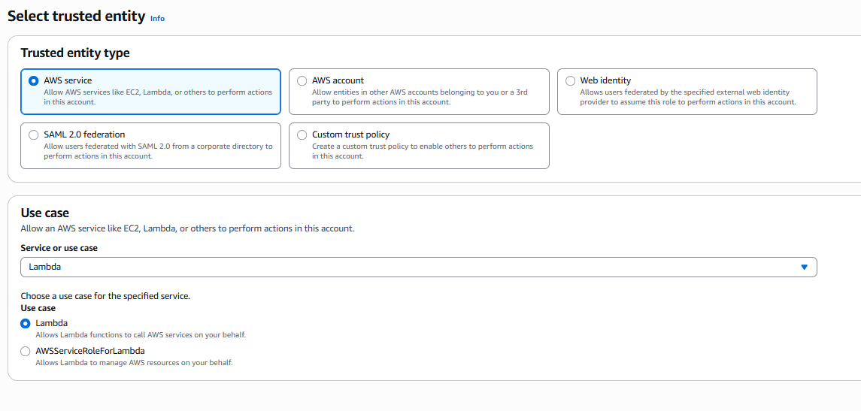

- Attach administrator access policy. So they role can perform all tasks.
Or Create and attach a custom inline policy.

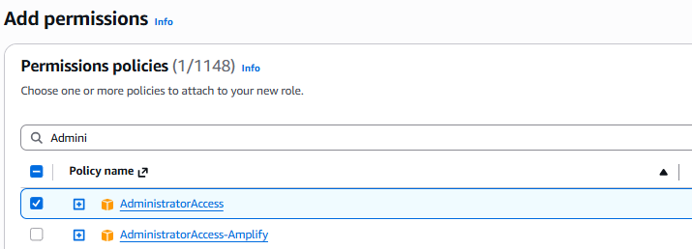
- Name the role (e.g., MyLambda-Role-for-ElasticIP).
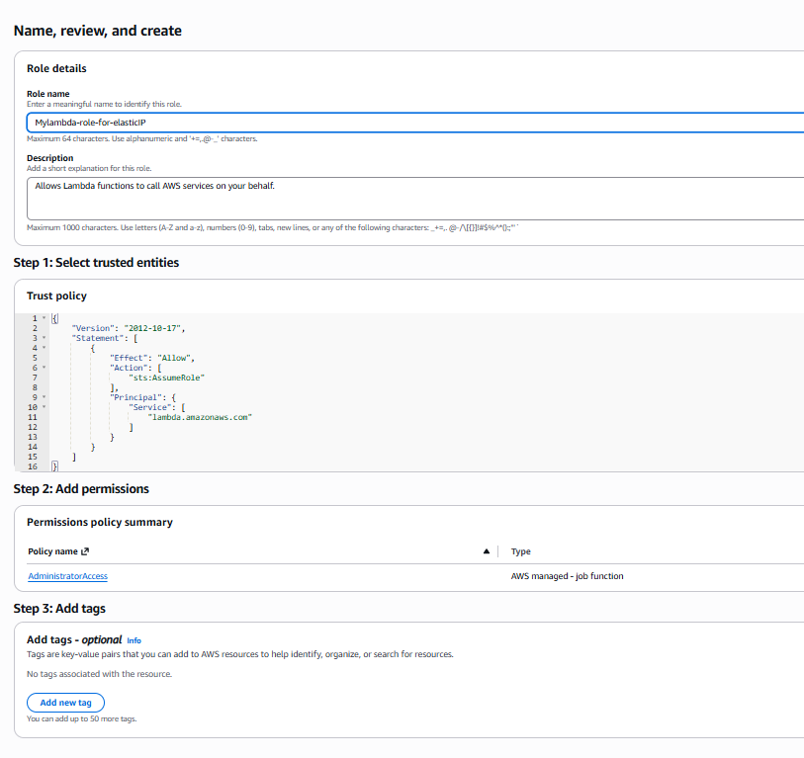

Step no: 2 Create Lambda Function
- Go to Lambda console > Create function.
- Choose Author from scratch, Python 3.12 runtime.
- Paste the code below into the editor.
- Assign the IAM role from Step 1.
- Deploy.

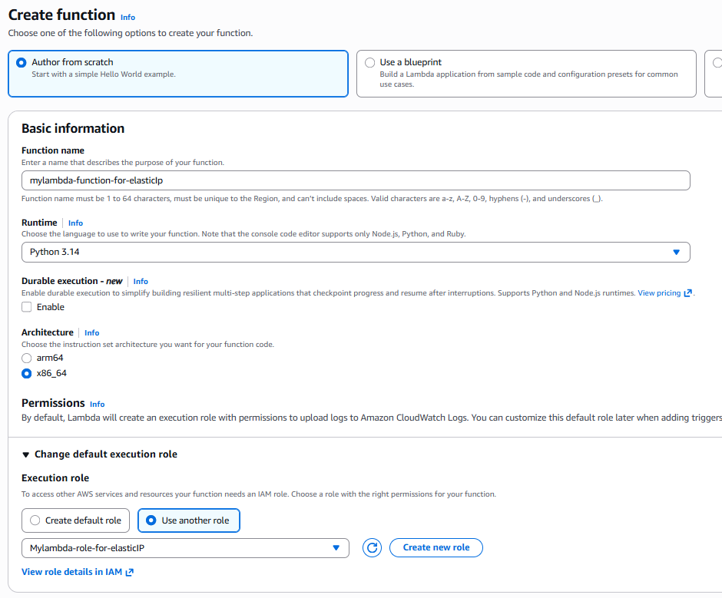

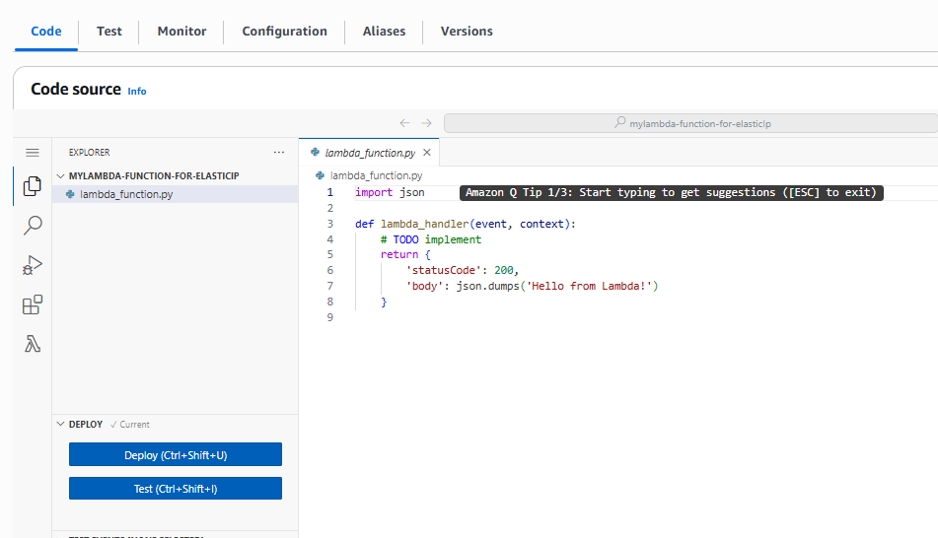
Sample Code

This code releases a specific EIP by AllocationId (preferred). Pass it via event (e.g., from CloudWatch Event or test event: {"allocation_id": "eipalloc-xxx"}). Handles disassociation first if needed.

Python code:

import boto3
from botocore.exceptions import ClientError

def lambda_handler(event, context):
# Initialize the EC2 client
ec2 = boto3.client('ec2')

# Replace with your specific Allocation ID
# In a production scenario, you might pass this via the 'event' object
allocation_id = event.get('allocation_id', 'eipalloc-YOUR_ID_HERE')

try:
print(f"Attempting to release Elastic IP: {allocation_id}")

# Release the address
response = ec2.release_address(AllocationId=allocation_id)

return {
'statusCode': 200,
'body': f"Successfully released Elastic IP: {allocation_id}"
}

except ClientError as e:
print(f"Error: {e}")
return {
'statusCode': 400,
'body': f"Failed to release IP: {str(e)}"
}
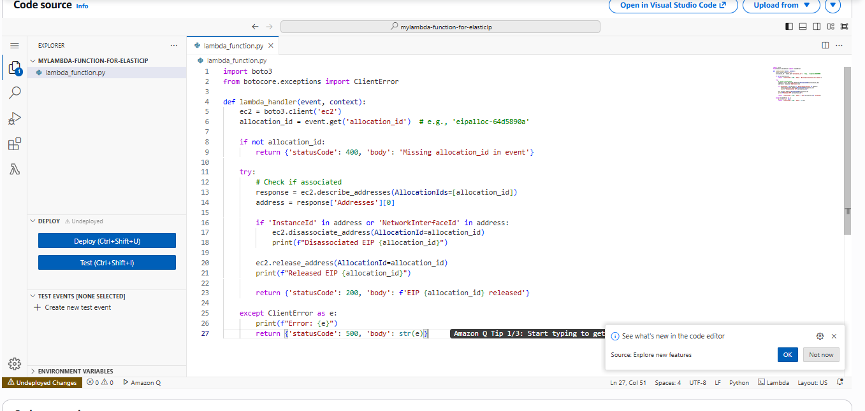

For release by PublicIp (EC2-Classic): Replace AllocationId=allocation_id with PublicIp=public_ip in release_address. (eipalloc-033efe573fe42b972)

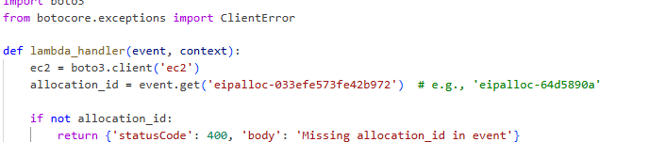

I have created an elastic Ip in the EC2 console.
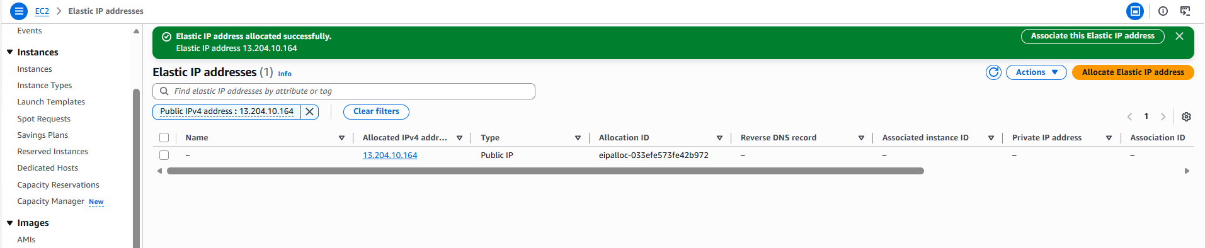

Note: Go to configuration of lambda function change execution timeout as : 3 minutes to avoid any execution related errors.

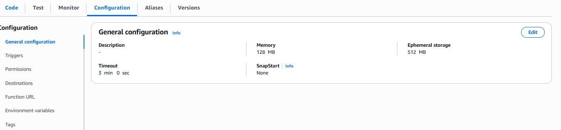
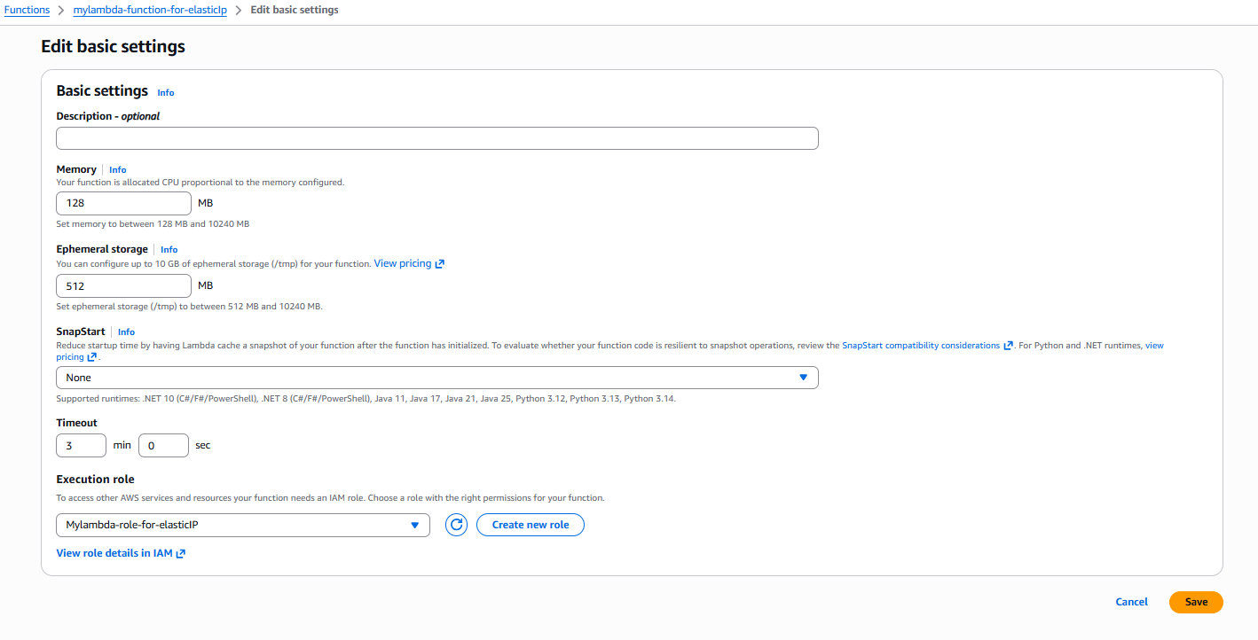
Go to Test tab create an event to test.

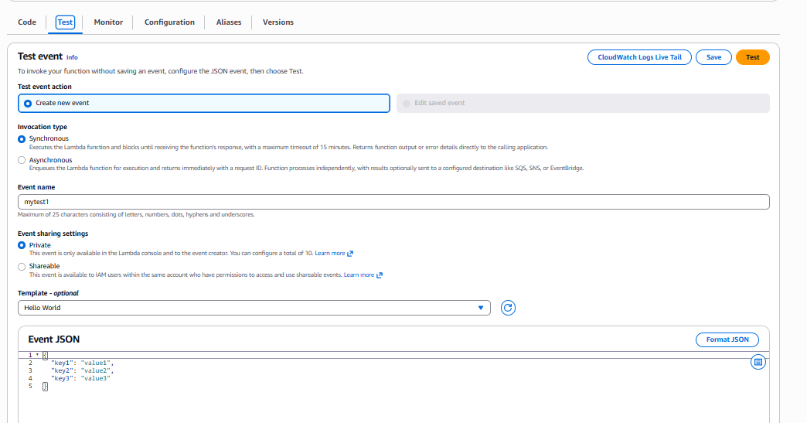

Now go to the Ec2 console the elastic ip will be released.
