Problem Number: 01
Leetcode number: 66

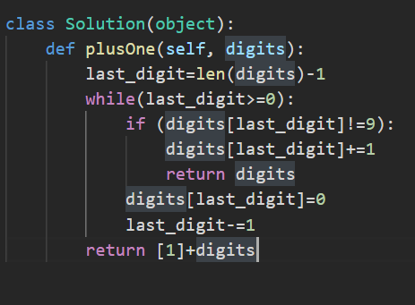
Concepts:
Overflow Handling by appending new sub array
Procedural steps instead of datatype conversion
Direct source transformation instead of additional memory
Optimal condition creation

Problem Number: 02
Leetcode Number: 119
Time Taken: 30 Mins
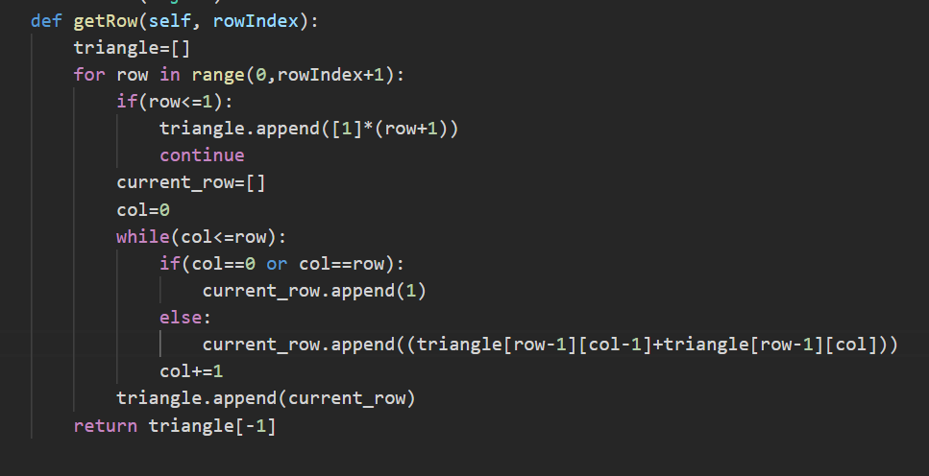
Concepts:
Setting default values for static cases
Direct procedural solving implementation
Row and col increment and access handling

Problem Number: 03
Leetcode Number: 46
DS - Array
https://leetcode.com/problems/group-anagrams/solutions/127405/group-anagrams-by-leetcode-a1yo
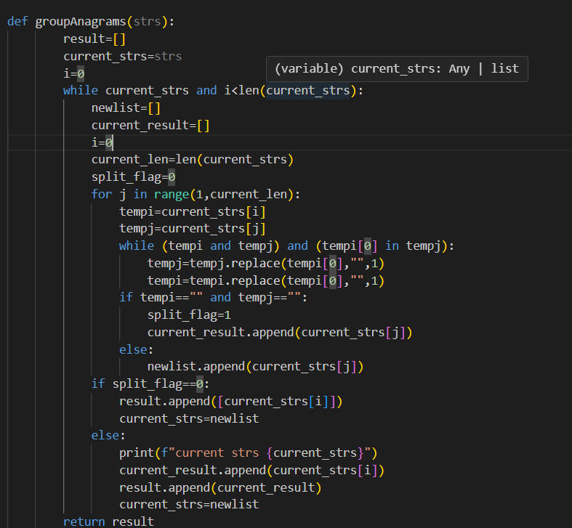
Concepts:
Source List updating while iterating
Order wise dependent values updating
Anagram Comparison
Flags implementation
Divide and Conquer – Solution found/not found and yet to found

Problem Number: 04
Leetcode number: 88
DS - Array
https://leetcode.com/problems/merge-sorted-array/description/
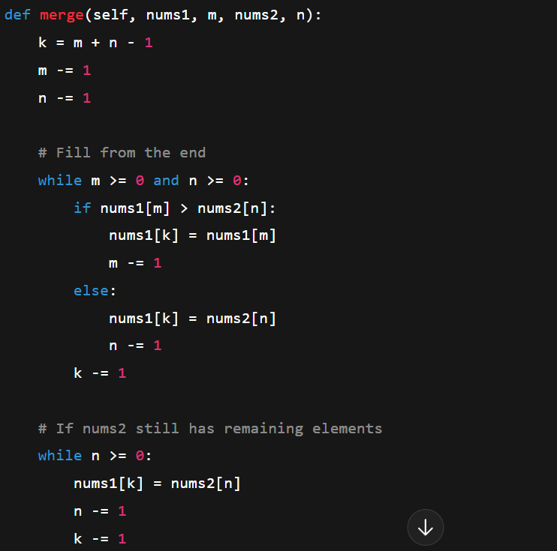
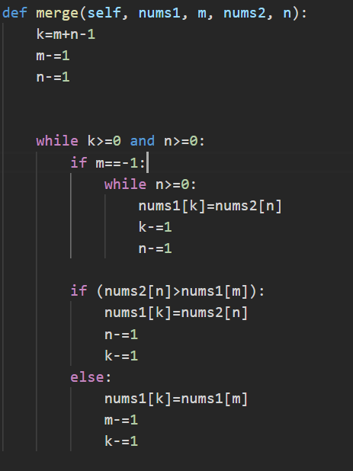

Concepts
Using the given memory instead ignoring it
Partition the cases
Placing the partitions in order to minimise comparison without compromising the logic

Bucketing Concept
For each iteration – try to match patterns
If matches
Put the current iteration value to the Bucket
Else
Create a new bucket with the new pattern
Return the bucket with required return type

Problem: https://leetcode.com/problems/group-anagrams/

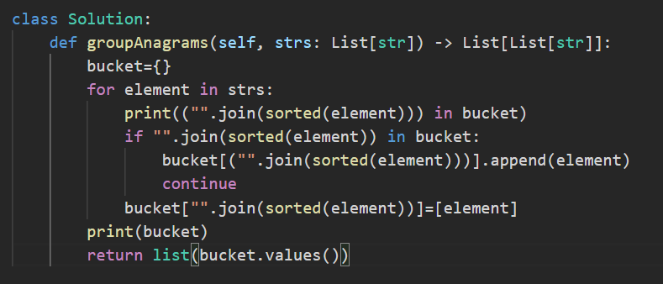

Kadane’s Algorithm:
Run the values dynamically and store the results meanwhile
If harmful values occur, reset to initial value

Problem – Leetcode 53
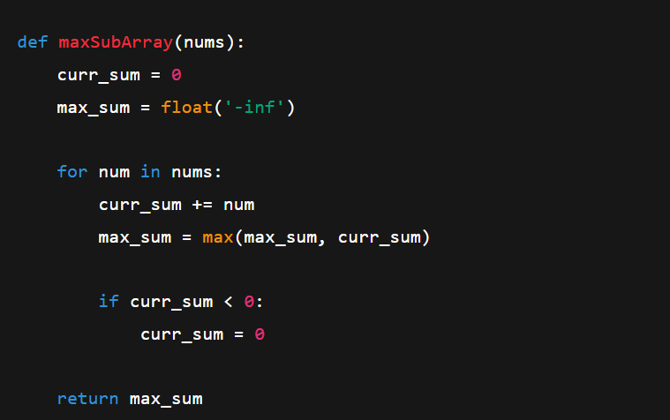

Monotonic Stack Technique:
This is a problem-solving approach that helps us to deal with problems involving
- Finding next greater/smaller element
- Buffering elements sequentially until the condition satisfies
- Pattern Finding
- future elements affecting the current elements
- Area based shapes problems
Types
Increasing
Decreasing
Core Logic:

