**WINDOW LEVEL:**

* **BALANCED:**

1. **BALANCED BACKBONE:**

Fold 1 Confusion Matrix:

[[ 5090 12272]

[ 366 16186]]

Fold 2 Confusion Matrix:

[[ 6585 11744]

[ 322 15262]]

Fold 3 Confusion Matrix:

[[11492 5462]

[ 5740 11219]]

Fold 4 Confusion Matrix:

[[13153 2176]

[13063 5521]]

Fold 5 Confusion Matrix:

[[ 5207 11602]

[ 869 16235]]

* **UNBALANCED:**

1. **UNBALANCED BACKBONE:**

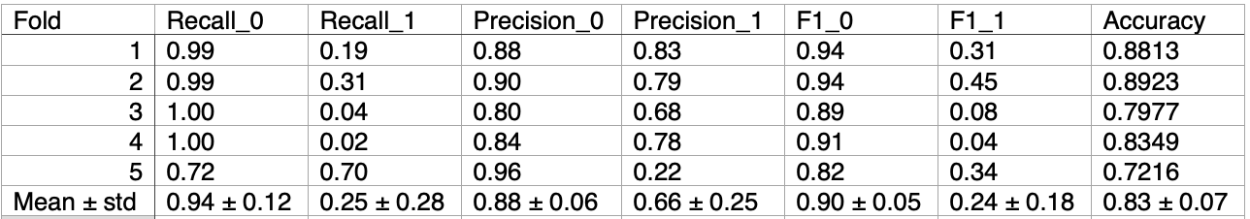

Fold 1 Confusion Matrix:

[[53795 349]

[ 7116 1652]]

Fold 2 Confusion Matrix:

[[53380 727]

[ 6049 2756]]

Fold 3 Confusion Matrix:

[[49658 246]

[12480 528]]

Fold 4 Confusion Matrix:

[[52310 63]

[10322 217]]

Fold 5 Confusion Matrix:

[[40879 15593]

[ 1922 4517]]

1. **UNBALANCED FLATTEN:**

Fold 1 Confusion Matrix:

[[49950 4100]

[ 5447 3415]]

Fold 2 Confusion Matrix:

[[48749 5214]

[ 5709 3240]]

Fold 3 Confusion Matrix:

[[46444 3433]

[ 8567 4468]]

Fold 4 Confusion Matrix:

[[49599 2748]

[ 6816 3749]]

Fold 5 Confusion Matrix:

[[54274 2145]

[ 5297 1195]]

**PATIENT LEVEL:**

Fold 1 Confusion Matrix:

[[1866 1614]

[ 0 3480]]

Fold 2 Confusion Matrix:

[[ 379 3061]

[ 351 3089]]

Fold 3 Confusion Matrix:

[[1359 929]

[ 585 1703]]

Fold 4 Confusion Matrix:

[[1677 643]

[ 147 2173]]

Fold 5 Confusion Matrix:

[[ 675 3285]

[ 552 3408]]