Software Engineering

Practices

Curse 2023-24

UAB

Document:  
**S.R.S. Template**

(version 1.0)

(Date: 2023-09-20)

**History of revisions**

|  |  |  |  |
| --- | --- | --- | --- |
| **Date** | **Version** | **Description** | **Author** |
| 20/09/2023 | 1.0 | Template preparation | Daniel Soto |
|  |  |  |  |
|  |  |  |  |
|  |  |  |  |
|  |  |  |  |
|  |  |  |  |
|  |  |  |  |
|  |  |  |  |
|  |  |  |  |

**About this document**

*This document describes...*

**Table of contents**

1.System requirements 5

1.1.User requirements 5

1.2.Requirements list 5

1.3.System requirements description 5

2.Use case diagram 6

# **1.System requirements**

*This section lists the functional and non-functional requirements. Next, we present a complete description of each system requirement.*

## **1.1.User requirements**

*Here is the list of requirements collected from the user:*

* Requirement 1: …
* Requirement 2: …
* …

## **1.2.Requirements list**

*Following if the simple table of the system requirements:*

|  |  |
| --- | --- |
| **Function Requirements** | **Non-Functional Requirements** |
| F001 - Req XXX | NF001 - |
| F002 - Req ZZZ |  |
|  |  |

## **1.3.System requirements description**

*Here is the full description of the system requirements…*

# **2.Use case diagram**

*This section describes the Use Case diagram…*

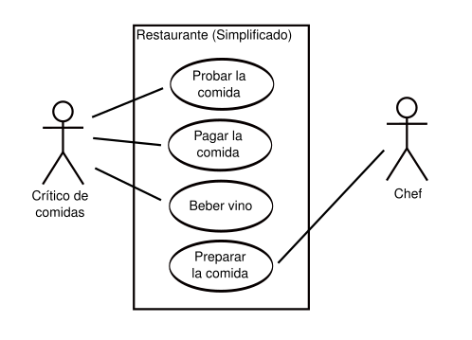

Use case diagram[1]

In the diagram it can be seen that the identified actors are…

1. source: <https://es.wikipedia.org/wiki/Diagrama_de_casos_de_uso>